    Joint Video Experts Team (JVET)  of ITU-T SG 16 WP 3 and ISO/IEC JTC 1/SC 29  38th Meeting, by teleconference, 26 March – 4 April 2025 | Document: JVET-AL0147-v1

Title: | AHG16: Refined parameter translator of generative face video coding
Status: | Input document to JVET
Purpose: | Proposal
Author(s) or  Contact(s): | Shanzhi Yin  Shiqi Wang  Zihan Zhang  Bolin Chen  Yan Ye  Ru-Ling Liao  Jie Chen | Email: | shanzhyin3-c@my.cityu.edu.hk  shiqwang@cityu.edu.hk  zhzhang38-c@my.cityu.edu.hk  chenbolin.chenboli@alibaba-inc.com  yan.ye@alibaba-inc.com  ruling.lrl@alibaba-inc.com  jiechen.cj@alibaba-inc.com
Source: | City University of Hong Kong and Alibaba Group
_____________________________

Abstract
In JVET-AG0048, we investigated the issue of interoperability among different GFVC systems and solved the interoperablity problem by adding face parameter translators to the AHG16 software. With these translators, it was shown that three different types of face parameters from different GFVC algorithms can be effectively adapted to one another while retaining promising coding performance. During 34th to 37th JVET meetings, several updates have been made to the GFVC models in the AHG16 software, including more algorithms, more diverse training data, multi-resolution models etc., which resulted in the existing parameter translators in the latest AHG16 software becoming outdated (e.g. inability to handle 512x512 resolution). In this contribution, we propose to update face parameter translators in the AHG16 software with a refined difference translation scheme. Experimental results show that refined translators can achieve translations between 4 multi-resolution models on both 256×256 and 512×512 resolutions while retaining promising coding performance.

Introduction
To enable translablity of different GFVC face features and interoperability between different encoders and decoders, AHG16 software included face parameter translators that are used at the decoder side to convert different types of received face parameters to decoder-specific ones from JVET-AF0048 [1] and JVET-AG0048 [2]. These parameter translators in AHG16 software can be used to translate features between any pairs of CFTE [3], FOMM [4], FV2V [5] models. As shown in Figure 1, for example, if decoder of type B receives feature bitstream of feature type A, AtoB translator can be utilized to convert face features from type A to type B, which are compatible with decoder B for subsequent decoding process.
However, from the 34th to the 37th JVET meetings, several updates have been adopted into the AHG16 software. These changes include: 1) DAC [9] with pure 2D keypoint facial representations [6] was added, 2) models trained using more diverse training data [7] were included to replace previous models and improve robustness of reconstruction and, 3) multi-resolution models were built for CFTE, FOMM, FV2V, DAC to handle both 256×256 and 512×512 resolutions in a single model [8]. These updates make the existing face parameter translators in the current AHG16 software obsolete and incompatible with the updated models.
In this contribution, we propose to enable translatability for multi-resolution models in latest AHG16 software with a refined difference translation scheme. We train 12 face parameter translators to realize one-to-one translation for face features between any pairs of CFTE, DAC, FOMM, FV2V multi-resolution models. We evaluate the RD performance of translated GFVC and show that decoder interoperability of these models can be achieved with promising results.
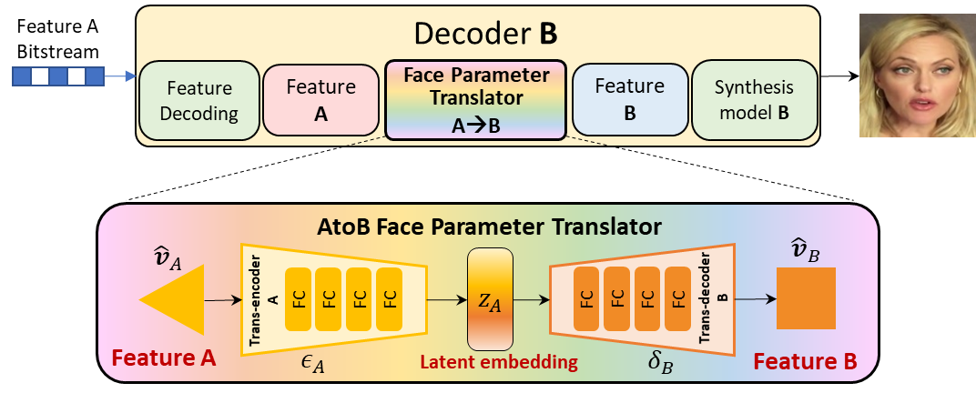
Figure 1 - Decoding with face parameter translator

Refinement for Parameter Translator with difference translation
As shown in Figure 2, in previous face parameter translator scheme, absolute translation is utilized to realize translation between feature values extracted from the same frame with different GFVC algorithms,
${\hat{v}}_{B,i}=T_{A→B}({\hat{v}}_{A,i})$ (1)
where ${\hat{v}}_{A,i}$ and ${\hat{v}}_{B,i}$ denote the decoded face features of type A and type B extracted from the i-th frame, and $T_{A→B}$ denotes AtoB translator.
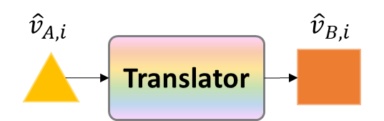
- Absolute Translation
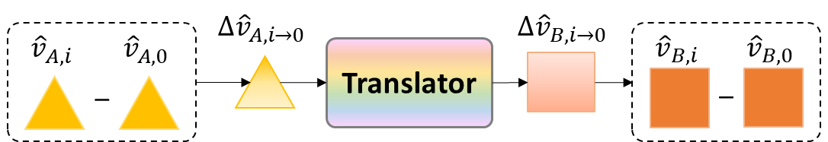
- Difference Translation
Figure 2 - Comparison of absolute and difference translation
In this contribution, we propose to realize such a translation between feature differences of the i-th frame and the key frame from different GFVC algorithms,
$({\hat{v}}_{B,i}-{\hat{v}}_{B,0})=T_{A→B}({\hat{v}}_{A,i}-{\hat{v}}_{A,0})$ (2)
then, feature of the i-th frame can be obtained by,
${\hat{v}}_{B,i}=T_{A→B}({\hat{v}}_{A,i}-{\hat{v}}_{A,0}) + {\hat{v}}_{B,0}$ (3)
The benefit of this difference translation is two-fold. First, the feature differences have more regular and narrower data distribution than their original values, as shown in Figure 3, which can improve the translation accuracy under the same training cost and translator model size. Second, the inaccuracy of absolute translation could lead to incorrect head position, while inaccurate difference translation would only lead to incorrect head movement relative to the key frame, thus mitigating the potential distortion. Figure 4 shows the reconstruction quality comparison of absolute translation and difference translation of FOMMtoCFTE. It can be seen that difference translation can achieve better quality with fewer parameters.
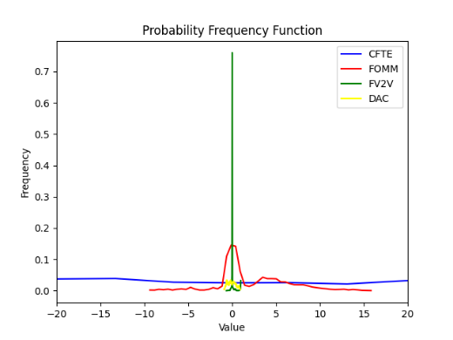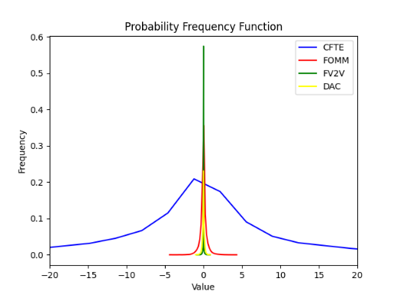
(a) Feature values (b) Feature difference
Figure 3 Data distribution of face features on GFVC testset
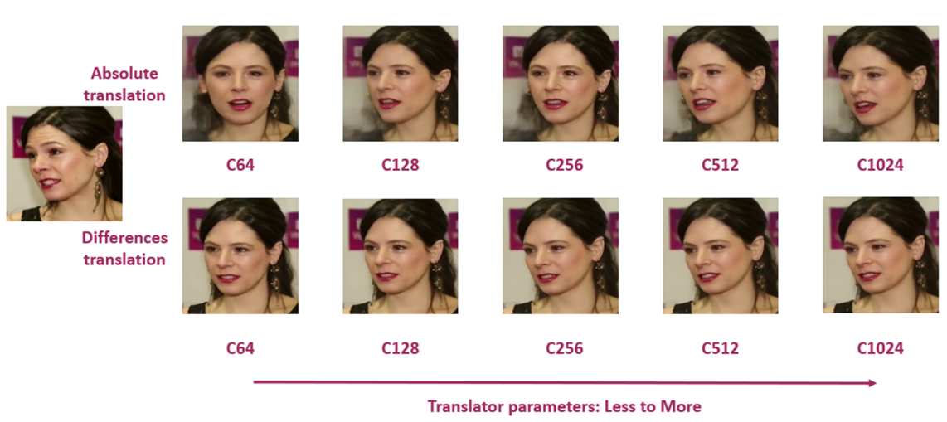
Figure 4 – Quality comparison between absolute and difference translation
The difference translator networks have a unified structure where each module consists of 4 full-connected layers with ReLU activation in between, and the embedding size is set to 256. We build 12 translators for translation between parameters from each pair of CFTE, DAC, FOMM and FV2V. Each translator is trained on face features of VoxCeleb [11] training sets for 400 epochs.

Experimental Results
We follow the GFVC test conditions in JVET-AJ2035 [10], as follows:
- For VVC, VTM 22.2 is used and the test is conducted under low-delay B (LDB) configuration with quantization parameters (QP) setting to 37, 42, 47 and 52.
- For GFVC, its base picture is compressed as an I picture using the VTM reference software 22.2, and other pictures are further represented with a series of facial parameters and compressed via a context-adaptive arithmetic coder. The QPs of the base picture are set to 22, 32, 42 and 52.

Rate-distortion Performance
We present the RD performances of generative face video coding systems with face parameter translators in a decoder-aligned manner. As shown in Figure 5 to Figure 8, the legends denote the combination of encoder models and decoder models in a ‘EncodertoDecoder’ format, such that translated GFVCs with the same decoder are presented in the same chart. For example, ‘FOMMtoCFTE’ indicates that encoder and decoder models are FOMM and CFTE, respectively. With these proposed updates to the face parameter translators, the GFVC system is able to operate on different analysis and synthesis models with acceptable performance deviation.
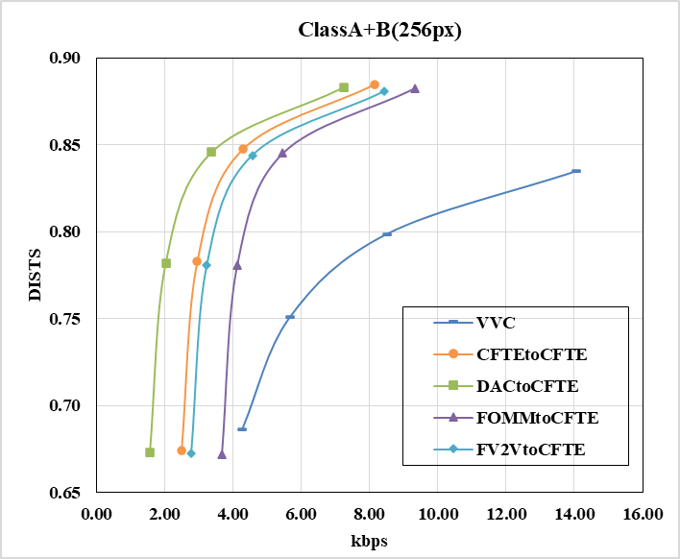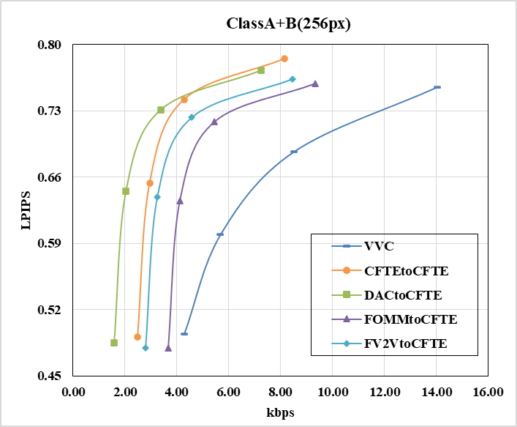
(a) Rate-DISTS for ClassA&B (b) Rate-LPIPS for ClassA&B
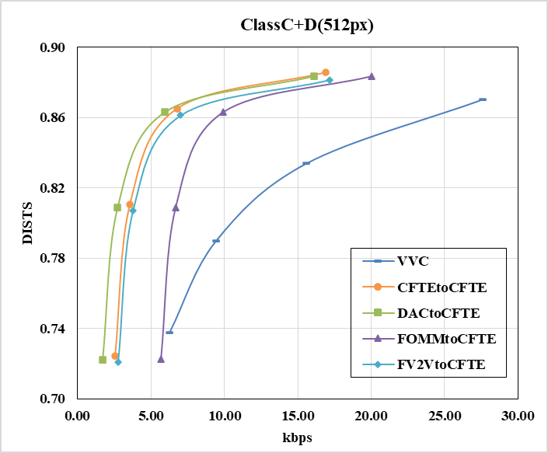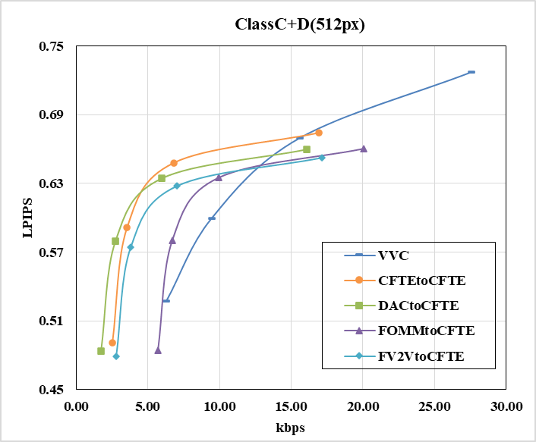
(c) Rate-DISTS for ClassC&D (d) Rate-LPIPS for ClassC&D
Figure 5 - Rate distortion performance of CFTE decoding GFVC with face parameter translators and VVC measured by two perceptual quality metrics DISTS and LPIPS in terms of overall dataset.

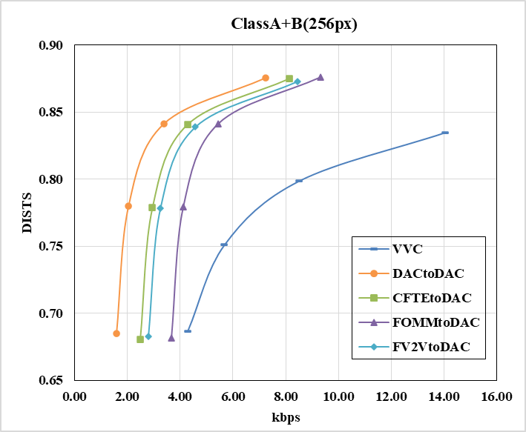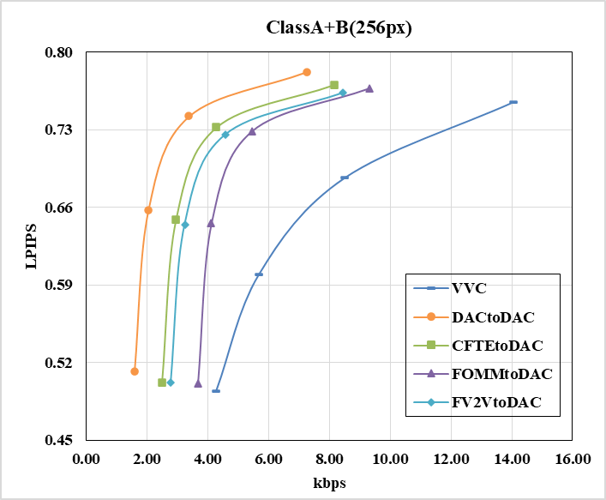
(a) Rate-DISTS for ClassA&B (b) Rate-LPIPS for ClassA&B
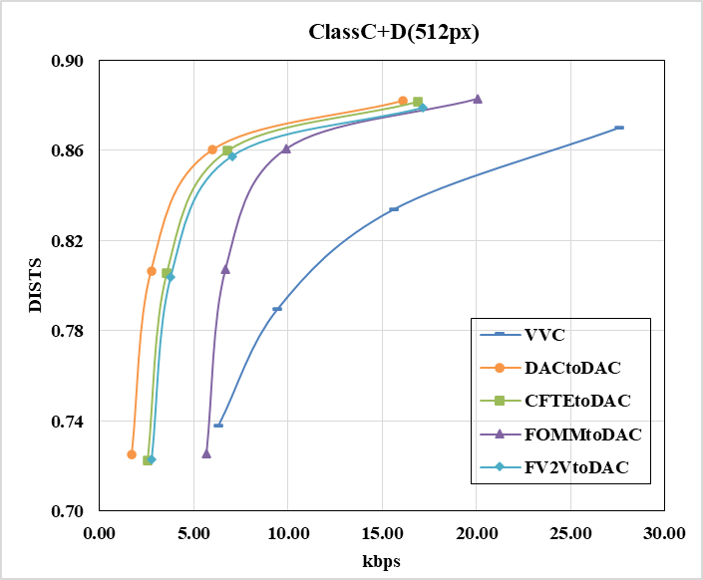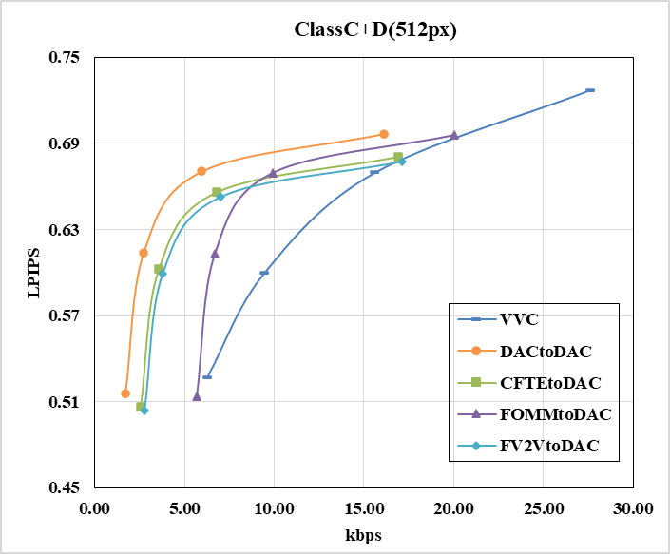
(c) Rate-DISTS for ClassC&D (d) Rate-LPIPS for ClassC&D
Figure 6 - Rate distortion performance of DAC decoding GFVC with face parameter translators and VVC measured by two perceptual quality metrics DISTS and LPIPS in terms of overall dataset.
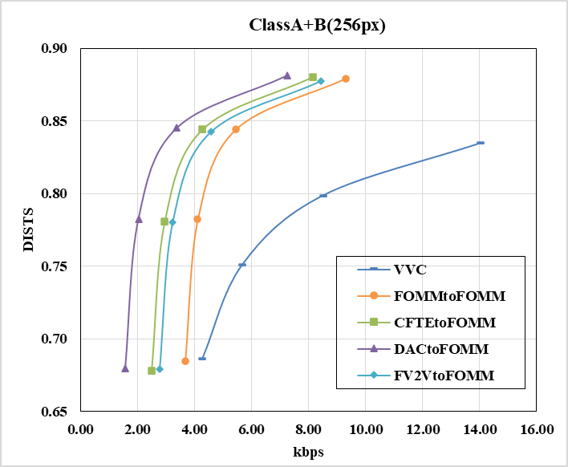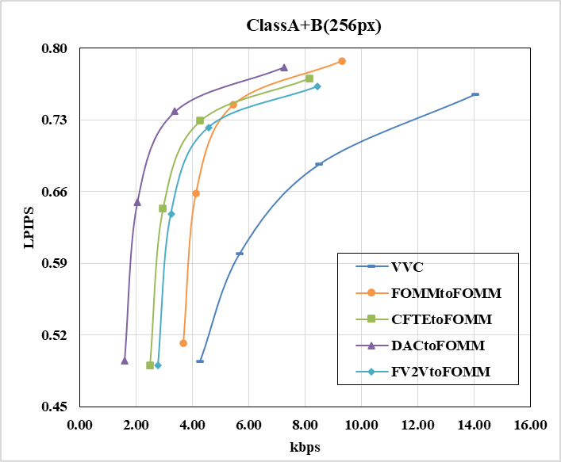
(a) Rate-DISTS for ClassA&B (b) Rate-LPIPS for ClassA&B
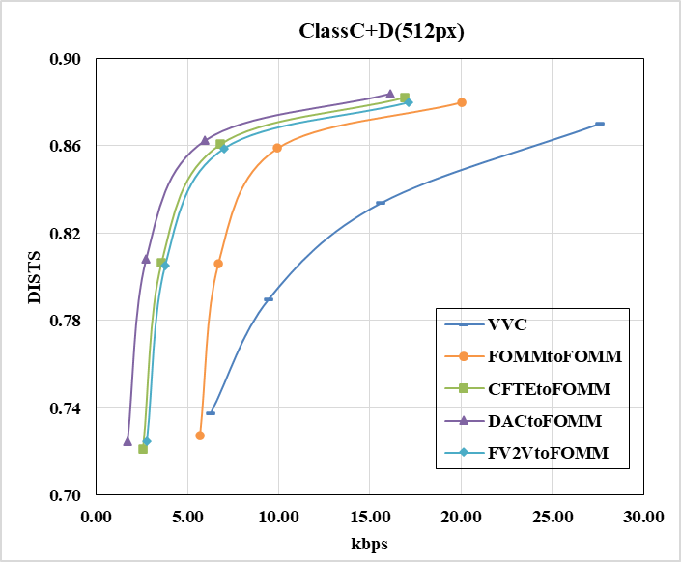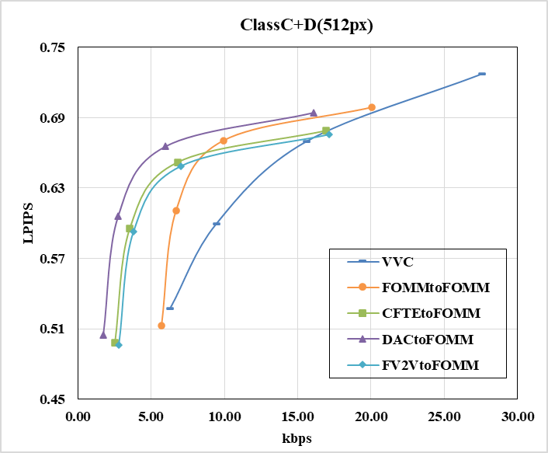
(c) Rate-DISTS for ClassC&D (d) Rate-LPIPS for ClassC&D
Figure 7 - Rate distortion performance of FOMM decoding GFVC with face parameter translators and VVC measured by two perceptual quality metrics DISTS and LPIPS in terms of overall dataset.
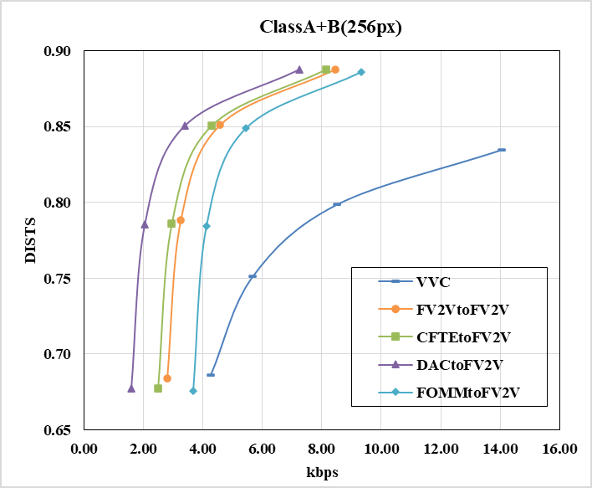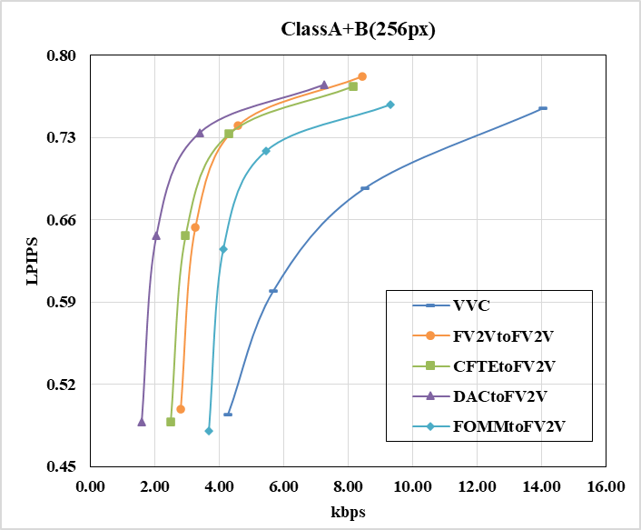
(a) Rate-DISTS for ClassA&B (b) Rate-LPIPS for ClassA&B
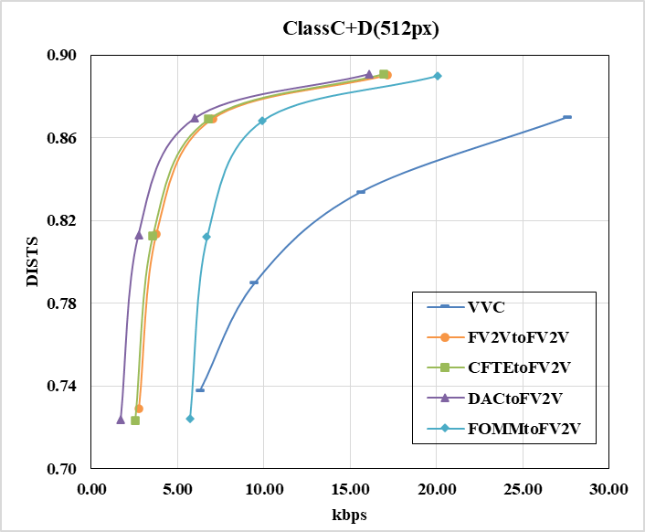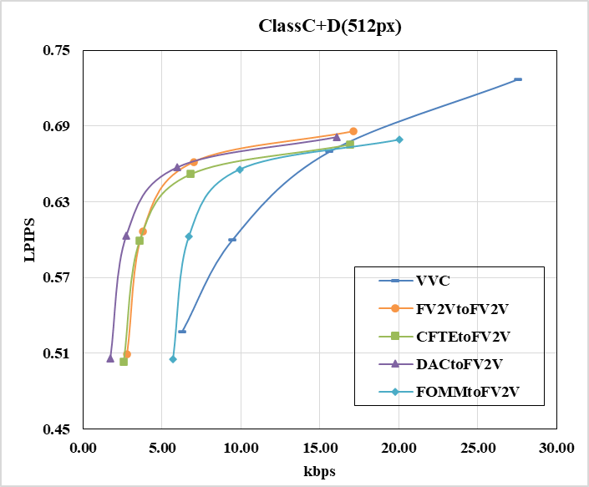
(c) Rate-DISTS for ClassC&D (d) Rate-LPIPS for ClassC&D
Figure 8 - Rate distortion performance of FV2V decoding GFVC algorithms with face parameter translators and VVC measured by two perceptual quality metrics DISTS and LPIPS in terms of overall dataset.

BD-rate Savings
From Table 1, we can see that CFTE can achieve 59.62% average bit-rate savings in terms of Rate-DISTS and 50.64% bit-rate savings in terms of Rate-LPIPS when the encoder is matched. And there are 4.49% and 24.77% less bit-rate savings in terms of Rate-DISTS when the encoder is FV2V or FOMM. Such a degradation increases to 8.15% and 39.08% in terms of Rate-LPIPS. There are 10.67% and 1.07% more bit-rate saving in terms of Rate-DISTS and Rate-LPIPS when the encoder is DAC.
Table 1 - Average bit-rate savings of 66 face video sequences for CFTE decoding compared with the traditional VVC codec in terms of Rate-DISTS and Rate-LPIPS evaluated RGB 444 domain.
Dataset | CFTEtoCFTE |  | FV2VtoCFTE |  | FOMMtoCFTE |  | DACtoCFTE
Dataset | Rate-DISTS | Rate-LPIPS | Rate-DISTS | Rate-LPIPS | Rate-DISTS | Rate-LPIPS | Rate-DISTS | Rate-LPIPS
Class A | -60.49% | -59.91% | -56.38% | -54.57% | -40.77% | -36.96% | -74.24% | -73.14%
Class B | -48.55% | -42.62% | -42.93% | -32.37% | -32.23% | -22.11% | -63.09% | -55.71%
Class C | -71.30% | -56.21% | -67.76% | -52.91% | -39.77% | -21.40% | -77.19% | -63.60%
Class D | -60.25% | -46.29% | -55.76% | -33.85% | -28.46% | -4.57% | -68.45% | -52.85%
Average | -59.62% | -50.64% | -55.13% | -42.49% | -34.85% | -20.54% | -70.29% | -60.69%
From Table 2, we can see that DAC can achieve 70.24% average bit-rate savings in terms of Rate-DISTS and 66.88% bit-rate savings in terms of Rate-LPIPS when the encoder is matched. And there are 11.56%, 35.14% and 15.64% less bit-rate savings in terms of Rate-DISTS when the encoder is CFTE, FOMM or FV2V. Such a degradation increases to 15.23%, 41.22% and 23.34% in terms of Rate-LPIPS.
Table 2- Average bit-rate savings of 66 face video sequences for DAC decoding compared with the traditional VVC codec in terms of Rate-DISTS and Rate-LPIPS evaluated RGB 444 domain.
Dataset | DACtoDAC |  | CFTEtoDAC |  | FOMMtoDAC |  | FV2VtoDAC
Dataset | Rate-DISTS | Rate-LPIPS | Rate-DISTS | Rate-LPIPS | Rate-DISTS | Rate-LPIPS | Rate-DISTS | Rate-LPIPS
Class A | -74.35% | -75.71% | -60.29% | -60.96% | -40.91% | -41.11% | -56.51% | -57.31%
Class B | -62.63% | -57.49% | -47.50% | -38.29% | -31.77% | -24.73% | -41.74% | -31.66%
Class C | -78.19% | -73.74% | -70.38% | -60.29% | -42.00% | -33.31% | -68.78% | -59.47%
Class D | -67.79% | -63.19% | -58.77% | -50.06% | -27.85% | -19.67% | -54.03% | -42.98%
Average | -70.24% | -66.88% | -58.68% | -51.65% | -35.10% | -29.02% | -54.60% | -46.90%
From Table 3, we can see that FOMM can achieve 34.94% average bit-rate savings in terms of Rate-DISTS and 29.98% bit-rate savings in terms of Rate-LPIPS when the encoder is matched. And there are 24.15%, 35.76% and 20.22% more bit-rate savings in terms of Rate-DISTS when the encoder is CFTE, DAC or FV2V. Such improvement decreases to 20.39%, 30.22% and 10.41% in terms of Rate-LPIPS.
Table 3 - Average bit-rate savings of 66 face video sequences for FOMM decoding compared with the traditional VVC codec in terms of Rate-DISTS and Rate-LPIPS evaluated RGB 444 domain.
Dataset | FOMMtoFOMM |  | CFTEtoFOMM |  | DACtoFOMM |  | FV2VtoFOMM
Dataset | Rate-DISTS | Rate-LPIPS | Rate-DISTS | Rate-LPIPS | Rate-DISTS | Rate-LPIPS | Rate-DISTS | Rate-LPIPS
Class A | -41.94% | -44.39% | -60.36% | -59.47% | -74.35% | -74.18% | -56.35% | -55.73%
Class B | -32.36% | -26.93% | -48.52% | -38.04% | -63.46% | -57.15% | -42.96% | -30.74%
Class C | -40.72% | -32.61% | -70.01% | -58.65% | -78.33% | -70.35% | -68.51% | -58.21%
Class D | -26.85% | -18.82% | -59.50% | -48.21% | -68.55% | -61.35% | -55.22% | -40.60%
Average | -34.94% | -29.98% | -59.09% | -50.37% | -70.70% | -65.16% | -55.16% | -45.35%
From Table 4, we can see that FV2V can achieve 57.50% average bit-rate savings in terms of Rate-DISTS and 49.35% bit-rate savings in terms of Rate-LPIPS when the encoder is matched. And there are 3.06%, 14.08% more bit-rate savings in terms of Rate-DISTS when the encoder is CFTE, DAC. And there are 1.63%, 7.03% and 10.41% more bit-rate savings in terms of Rate-LPIPS. On the opposite, there are 20.91% and 32.79% less bit-rate saving in terms of Rate-DISTS and Rate-LPIPS when the encoder is FOMM.
Table 4 - Average bit-rate savings of 66 face video sequences for FV2V decoding compared with the traditional VVC codec in terms of Rate-DISTS and Rate-LPIPS evaluated RGB 444 domain.
Dataset | FV2VtoFV2V |  | CFTEtoFV2V |  | DACtoFV2V |  | FOMMtoFV2V
Dataset | Rate-DISTS | Rate-LPIPS | Rate-DISTS | Rate-LPIPS | Rate-DISTS | Rate-LPIPS | Rate-DISTS | Rate-LPIPS
Class A | -57.55% | -56.73% | -60.80% | -59.19% | -74.60% | -73.31% | -41.09% | -36.69%
Class B | -44.93% | -36.97% | -49.74% | -38.74% | -63.98% | -55.46% | -33.24% | -21.44%
Class C | -71.22% | -57.78% | -72.13% | -59.54% | -79.89% | -71.78% | -43.70% | -28.80%
Class D | -58.58% | -48.56% | -61.53% | -49.26% | -69.74% | -60.25% | -30.28% | -14.58%
Average | -57.50% | -49.35% | -60.56% | -50.98% | -71.58% | -64.53% | -36.59% | -24.71%

Subjective Results
Figure 9 provides comparisons of reconstructed face results using GFVC schemes with various face parameter translator at similar bitrates. Reconstructions with same type of encoder are in the same row, while reconstructions with same type of decoder are in the same column.
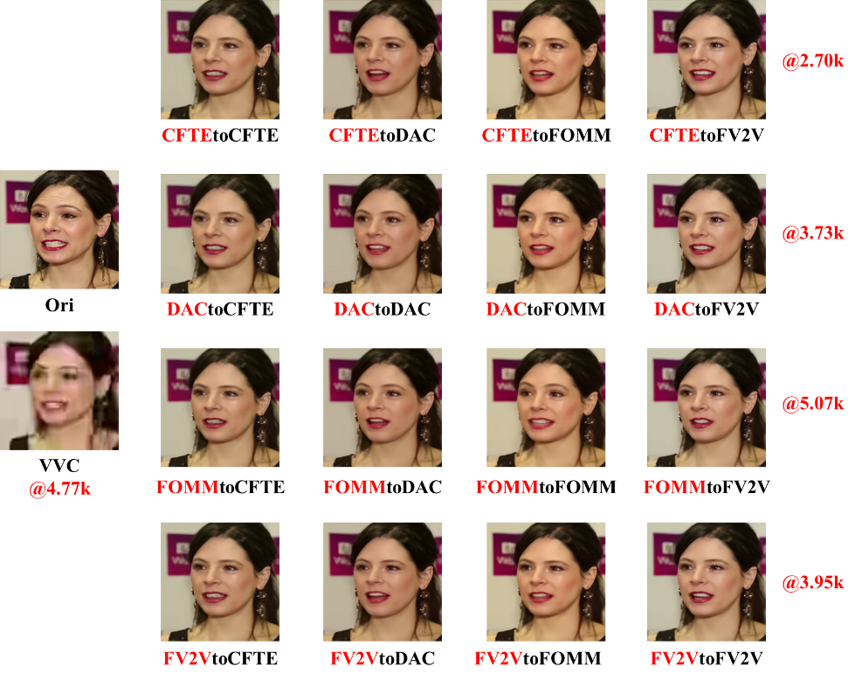
(a) ClassA Seq 001
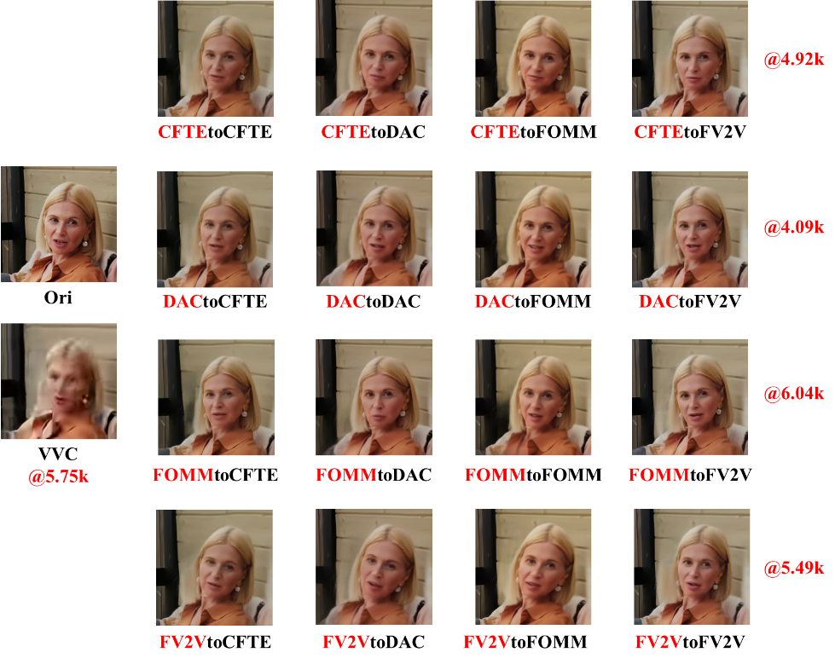
(b) ClassB Seq 001

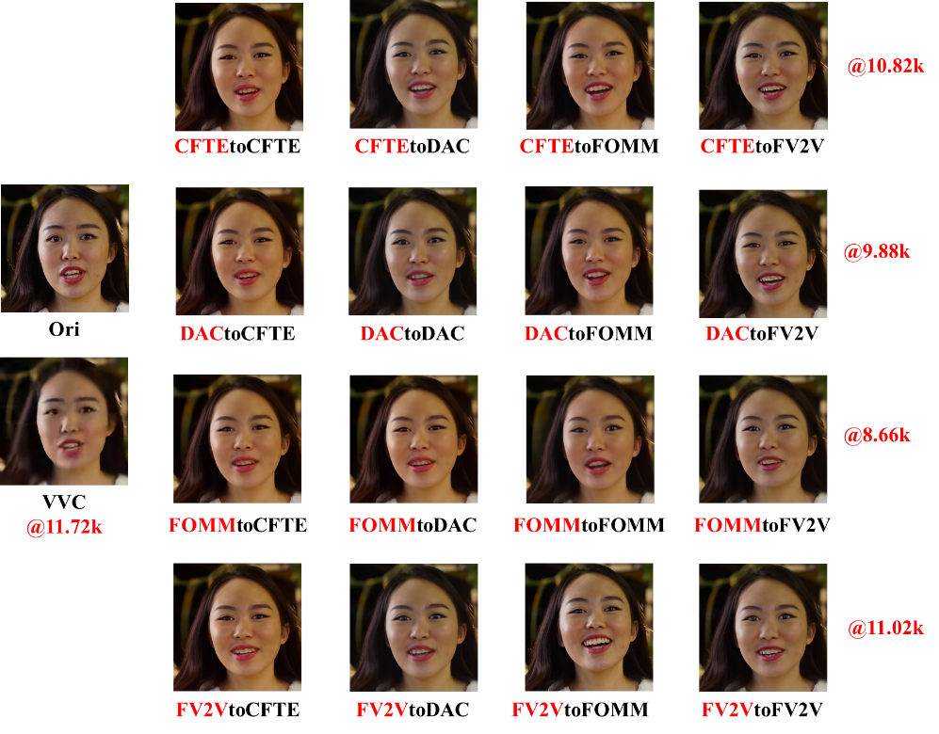
(c) ClassC Seq 001

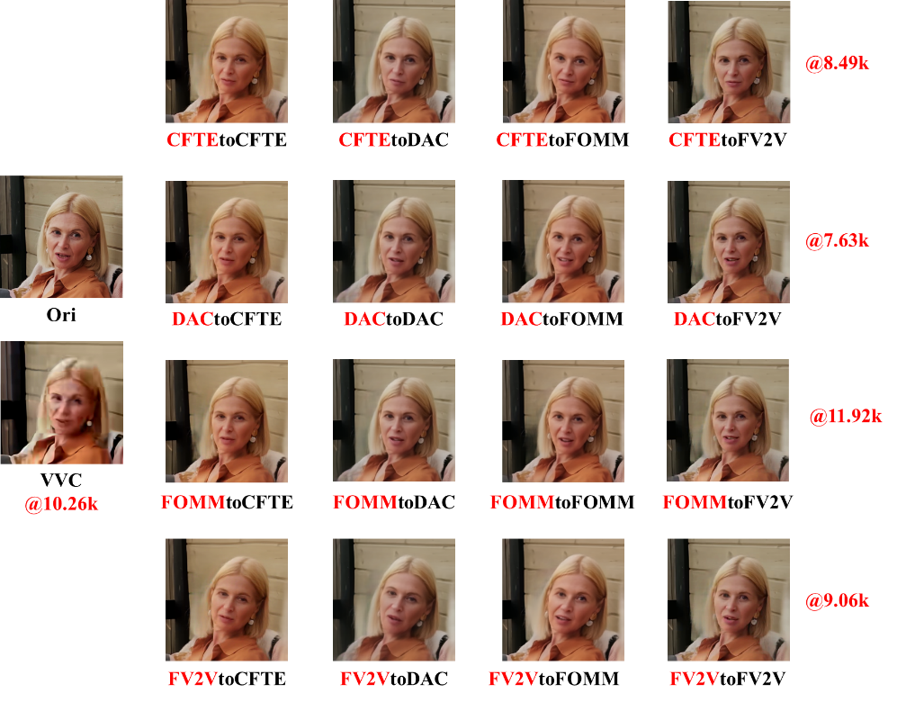
(d) ClassD Seq 001
Figure 9 - Comparison of reconstruction quality using VVC vs. GFVC methods at similar coded bitrates

Model Complexity
We measure the model complexity in terms of parameter number and MACs, as shown in Table 5. We can see that, for each face parameter translator, the number of parameters is around 410K and computation is around 6.30MAC per pixel for 256×256 resolution and 1.57MAC per pixel for 512×512 resolution.
Table 5 - Model complexity of face parameter translators.
Translators | MACs/pixel |  | Params
DACtoCFTE CFTEtoDAC | 256×256 | 6.14 | 404.24K
DACtoCFTE CFTEtoDAC | 512×512 | 1.53 | 404.24K
FOMMtoCFTE  CFTEtoFOMM | 256×256 | 6.30 | 414.52K
FOMMtoCFTE  CFTEtoFOMM | 512×512 | 1.57 | 414.52K
FV2VtoCFTE  CFTEtoFV2V | 256×256 | 6.28 | 413.75K
FV2VtoCFTE  CFTEtoFV2V | 512×512 | 1.57 | 413.75K
DACtoFV2V  FV2VtoDAC | 256×256 | 6.30 | 414.78K
DACtoFV2V  FV2VtoDAC | 512×512 | 1.57 | 414.78K
DACtoFOMM  FOMMtoDAC | 256×256 | 6.31 | 415.55K
DACtoFOMM  FOMMtoDAC | 512×512 | 1.58 | 415.55K
FOMMtoFV2V  FV2VtoFOMM | 256×256 | 6.46 | 425.02K
FOMMtoFV2V  FV2VtoFOMM | 512×512 | 1.61 | 425.02K

Conclusion
In this contribution, we propose face feature translators for four multi-resolution models in the latest AHG16 software. The interoperability of CFTE, DAC, FOMM and FV2V can be enabled on both 256×256 and 512×512 resolutions with a refined difference translation scheme. The experiment results show performance loss due to parameter translation is acceptable. It is recommended to adopt the proposed translator into AHG16 software to replace the existing translators that have become obsolete.

References
- Chen B, Yin S, Chen J, et al. “A Study on Decoder Interoperability of Generative Face Video Compression,” The Joint Video Experts Team of ITU-T SG 16 WP 3 and ISO/IEC JTC 1/SC 29, doc. no. JVET- AF0048, October 2023.
- Yin S, Chen B, Chen J, et al. “AHG16: Interoperability Study on Parameter Translator of Generative Face Video Coding,” The Joint Video Experts Team of ITU-T SG 16 WP 3 and ISO/IEC JTC 1/SC 29, doc. no. JVET- AG0048, January 2024.
- Chen B, Wang Z, Li B, et al. Beyond keypoint coding: Temporal evolution inference with compact feature representation for talking face video compression. 2022 Data Compression Conference (DCC). IEEE, 2022: 13-22.
- Siarohin A, Woodford O J, Ren J, et al. Motion representations for articulated animation. Proceedings of the IEEE/CVF Conference on Computer Vision and Pattern Recognition. 2021: 13653-13662.
- Wang T C, Mallya A, Liu M Y. One-shot free-view neural talking-head synthesis for video conferencing. Proceedings of the IEEE/CVF conference on computer vision and pattern recognition. 2021: 10039-10049.
- Chen B, Ye Y, et al. “AHG 16: Updated Common Software Tools for Generative Face Video Compression,” The Joint Video Experts Team of ITU-T SG 16 WP 3 and ISO/IEC JTC 1/SC 29, doc. no. JVET- AH0114, April 2024.
- Chen B, Ye Y, et al. “AhG16: Improving GFVC Performance with Diverse Training Data,” The Joint Video Experts Team of ITU-T SG 16 WP 3 and ISO/IEC JTC 1/SC 29, doc. no. JVET- AI0048, July 2024.
- Yin S, Chen B, et al. “AHG 16: Multi-resolution Models for Generative Face Video Compression,” The Joint Video Experts Team of ITU-T SG 16 WP 3 and ISO/IEC JTC 1/SC 29, doc. no. JVET- AJ0052, November 2024.
- Konuko G, Valenzise G, Lathuilière S. Ultra-low bitrate video conferencing using deep image animation[C]//ICASSP 2021-2021 IEEE International Conference on Acoustics, Speech and Signal Processing (ICASSP). IEEE, 2021: 4210-4214.
- McCarthy , Chen B. “Test conditions and evaluation procedures for generative face video coding,” The Joint Video Experts Team of ITU-T SG 16 WP 3 and ISO/IEC JTC 1/SC 29, doc. no. JVET- AJ2035, October 2024.
- Nagrani A, Chung J S, Zisserman A. Voxceleb: a large-scale speaker identification dataset[J]. arXiv preprint arXiv:1706.08612, 2017.

Patent rights declaration(s)
City University of Hong Kong and Alibaba Group may have current or pending patent rights relating to the technology described in this contribution and, conditioned on reciprocity, is prepared to grant licenses under reasonable and non-discriminatory terms as necessary for implementation of the resulting ITU-T Recommendation | ISO/IEC International Standard (per box 2 of the ITU-T/ITU-R/ISO/IEC patent statement and licensing declaration form).

