    Joint Video Experts Team (JVET)  of ITU-T SG 16 WP 3 and ISO/IEC JTC 1/SC 29  36th Meeting, Kemer, TR, 1–8 November 2024 | Document: JVET-AJ0374-v1

Title: | Results of expert viewing for FGC subjective test category 1
Status: | Input document to JVET
Purpose: | Information
Author(s) or  Contact(s): | M. Wien  P. de Lagrange  A. Wieckowski | Email: | wien@lfb.rwth-aachen.de  philippe.delagrange@interdigital.com  adam.wieckowski@hhi.fraunhofer.de
Source: | BoG
_____________________________

Abstract
This contribution presents dry-run results achieved from an expert viewing test for film grain conducted at the 36th JVET and 17th SC 29/AG 5 meetings in Sapporo. The test targets at determining the potential of the film grain synthesis (FGS) technology to mask encoding artifacts an improve the viewing experience, in correspondence with category 1 of JVET-AH2022 Draft plan for subjective quality testing of the FGC SEI message (update 2) [1]. A subset of 6 test sequences provided in JVET-AI0138 [2] was selected for the visual evaluation, taking into account the viewing feedback from the category 2 test from JVET-AI0337 [3]. The sequences cover film material as well as digitally captured content with different artificial grain. The setting included 4 TV (3 miniLED and 1 OLED) screens which were driven by a PC video player.
- MOS range
  - For some sequences, the lowest tested rate already exhibits a mid-range MOS – no observations for lower range of the MOS scale can be made
  - This is deemed appropriate given the set goal of the test
- Results
  - For all tested points the MOS of the FGS encoding is larger than the corresponding NonFGS version, in most cases significantly
  - For four of the tested sequences the highest FGS rate points matches the MOS the transparency point. For the other two sequences, the confidence interval overlaps the transparency points. The highest FGS points always has a significantly lower rate than the transparency point.
  - For the sequences MeridianSmoker1 and MeridianIntoCar1 the benefit of FGS is the lowest among the tested sequences. This might be attributed to the subtle grain present in the original sequences.
  - The highest gain is observed for the sequence MarketStreet1, for which the up to 10x bitrate reduction without quality degradation is measured.

Introduction
This document reports the results of an on-site expert viewing performed at the 36th JVET meeting in Kemer, TR.

Test setup

Logistics
The setup at the meeting site included a PC with a Decklink video board for HDMI connection and SSD drives capable of stable playout of the raw YUV data at the required frame rate.
Test Site | On-site
Display, size, connection  (resolution setting) | TCL 85C855, 2×TCL 75C855 (all miniLED); VESTEL 55” OLED, HDMI (3840×2160), 10bit input
Viewing distance | Viewers sitting at 1.5H (4 viewers for the 85” display, 3 viewers for the 75” displays, 2 viewers for the 55” display)
Viewing angle | ±75°, 90° (at screen center)
Total number of viewers | 25 (8 female, 17 male)
Participants confirmed visual acuity and normal colour vision.
The display settings were browsed, and any enhancement features were switched off. For the VESTEL 55” display, an internal frame rate up-conversion was switched on in the test. No disabling option was found.

Test sequences and quantizer settings
For evaluation, a subset of test sequences and quantizer settings listed in JVET-AI2022 [1] and JVET-AI0138 [2] were tested. Six UHD sequences were tested, including the test sequences DinnerScene2, MarketStreet1, MeridianIntoCar1, MeridianSmoker1, OldTownCross and TearsOfSteel-044 which have been prepared in JVET-AI0138 [2].
Two coding configurations were tested:
- NonFGS with the sequences being encoded and not enhanced with an FGS information
- and FGS with the encoded sequences being enhanced by SEI FGS information as described in JVET-AI0138 [2].
For TearsOfSteel-044, which exists in two version, clean original and original enhanced with synthetic grain, the NonFGS version is encoded from the grainy original, and the FGS version is encoded from the clean original. For all other sequences the original only exits in grainy version, which is used for both encodings.
In addition to two tests, a “transparent” QP point of the NonFGS version has been included in the tests, with the transparent QP established in the test JVET-AI0337 [3]. It represents an encoding which the viewers in the previous test established as just distinguishable from the original. The QP values evaluated in the expert viewing are shown in the table below.

Table 1 – Selected test sequences and QP settings for the viewing.
Sequence | Properties
DinnerScene2  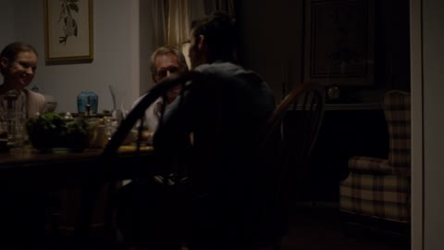 | Transparent QP | Non FGS QPs | FGS QPs
 | 16 | 22 | 22
 | Frame rate | 26 | 26
 | 60 | 30 | 30
 |  | 34 | 34
MarketStreet1  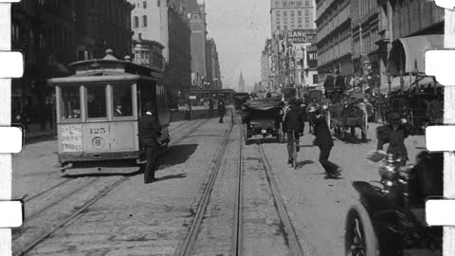 | Transparent QP | Non FGS QPs | FGS QPs
 | 26 | 30 | 30
 | Frame rate | 34 | 34
 | 16 | 38 | 38
 |  | 42 | 42
MeridianIntoCar1  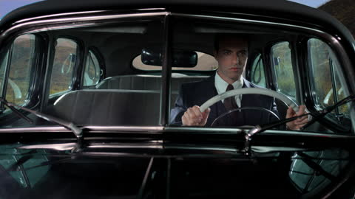 | Transparent QP | Non FGS QPs | FGS QPs
 | 18 | 24 | 24
 | Frame rate | 28 | 28
 | 60 | 32 | 32
 |  | 36 | 36
MeridianSmoker1   | Transparent QP | Non FGS QPs | FGS QPs
 | 20 | 28 | 28
 | Frame rate | 32 | 32
 | 60 | 36 | 36
 |  | 40 | 40
OldTownCross  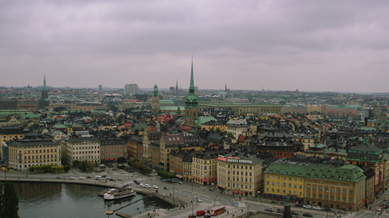 | Transparent QP | Non FGS QPs | FGS QPs
 | 20 | 29 | 29
 | Frame rate | 33 | 33
 | 50 | 37 | 37
 |  | 41 | 41
TearsOfSteel-044  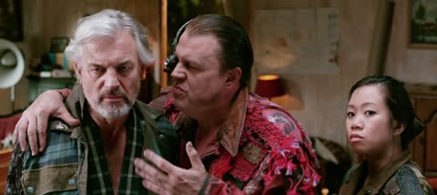 | Transparent QP | Non FGS QPs | FGS QPs
 | 18 | 24 | 24
 | Frame rate | 28 | 28
 | 24 | 32 | 32
 |  | 36 | 36

Grain parameters
For all sequences but DinnerScene2, the same grain parameters were used as described in JVET-AI0138 [2]. For DinnerScene2 an improved set of grain parameters have been used to better represent the different grain characteristics after the scene change at frame 360.
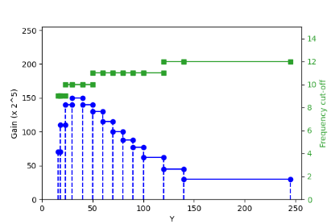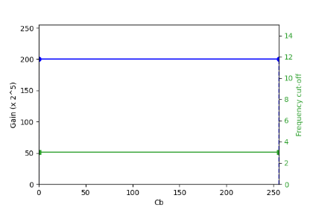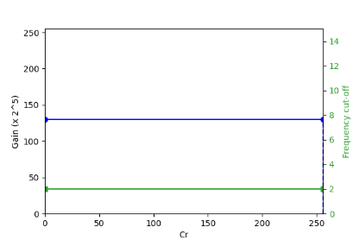
Figure 1: Y/U/V film grain parameters for DinnerScene2, first scene
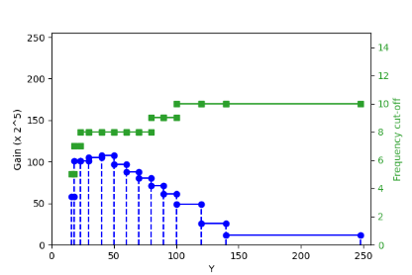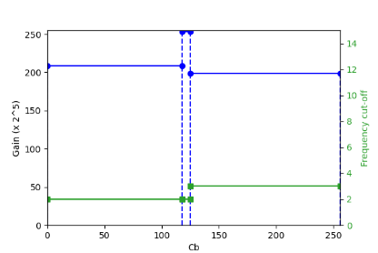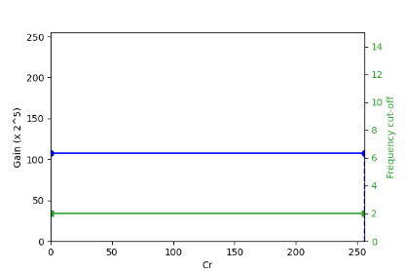
Figure 2: Y/U/V film grain parameters for DinnerScene2, second scene

Test method and test design
The assessment was performed with the reconstructed UHD output. Two DCR test session with 37 BTCs were presented to the viewers. The duration of each test session was about 19 min.

Degradation category rating

Session setup
The test sequences were evaluated using an 11-grade scale shown in Figure 3 below.
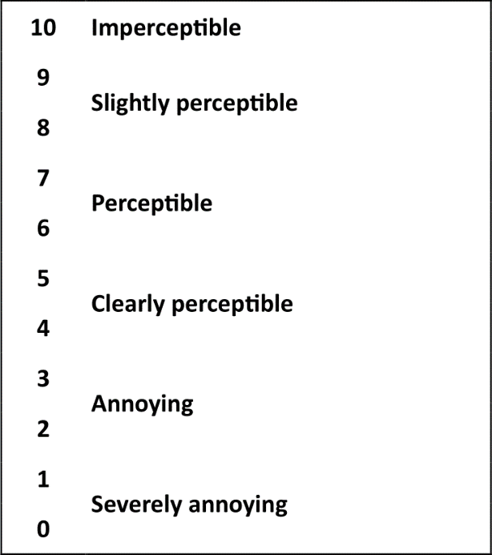
Figure 3: Meaning of the used 11 grade numerical scale
The test sessions included 37 basic test cells (BTCs) showing the original uncompressed video sequence and one processed video sequence. Each BTC was structured as followed (PVS denotes the processed video sequence under evaluation):
“Original” (1sec) – [original sequence] (10sec) – “A” (1sec) – [PVS] (10sec) – “Vote <N>” (5sec)
The session included a stabilization phase of three BTCs, trapping BTCs where original full resolution test sequences were to be scored in the PVS, as well as the uncompressed upscaled base layer resolution test sequences.

Viewer information and training
The viewers were explained the viewing task, the organization of the session and the meaning of the grading scale. The viewers were organized into two groups of 12 and 13 participants, respectively. Training, viewing of session 1 and viewing of session 2 were done in an interleaved fashion, where one group performed the viewing tasks at the four displays while the other group had a break. During the viewing sessions, scoring was done on paper sheets. The breaks were used to enter the acquired scores into the test database.
For training, the participants were shown a test session of 12 BTCs including representative examples of the impairments shown in the tests.

Subjective results and analysis

Data processing
It was noticed that the Pearson correlation coefficient of the viewers scores for session 2 was significantly higher than for session 1 (mean increasing from 80% to 88%). It was decided to only remove viewers with a Pearson correlation of below 70% relative to the MOS. Three viewers with an otherwise a high correlation entered a opinion score of 7 for the trapping sequence (original vs. original) in the first session. It was decided to keep them in the set. As a last step, the non-normalized $z$-scores ${z_{ij}=v}_{ij}-{MOS}_{i}$of the viewer scores were compared to a threshold of 2, where $v_{ij}$ is the score of viewer $j$ for PVS $i$, ${MOS}_{i}$ is the mean opinion score for that PVS for the viewers. Based on this threshold, 19.2% of the scores were removed from the dataset.

Subjective results
The measured MOS values of the reconstructed video on the 11-grade scale are plotted over the bit rate of the corresponding bitstream. The ±95% confidence intervals for the MOS values are indicated. The uncompressed original was only assessed for MeridianSmoker1 and OldTownCross. For the other sequences this data is not reported.
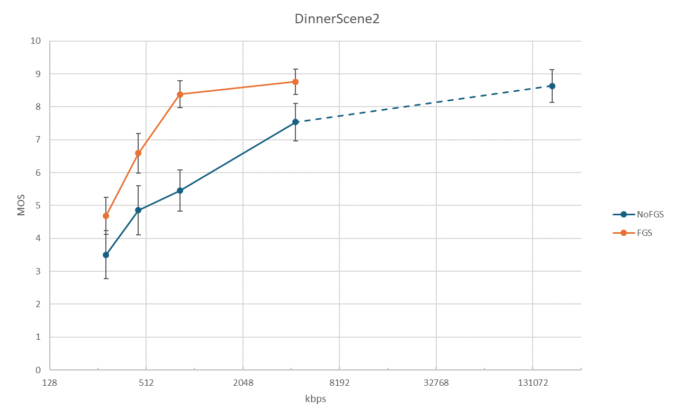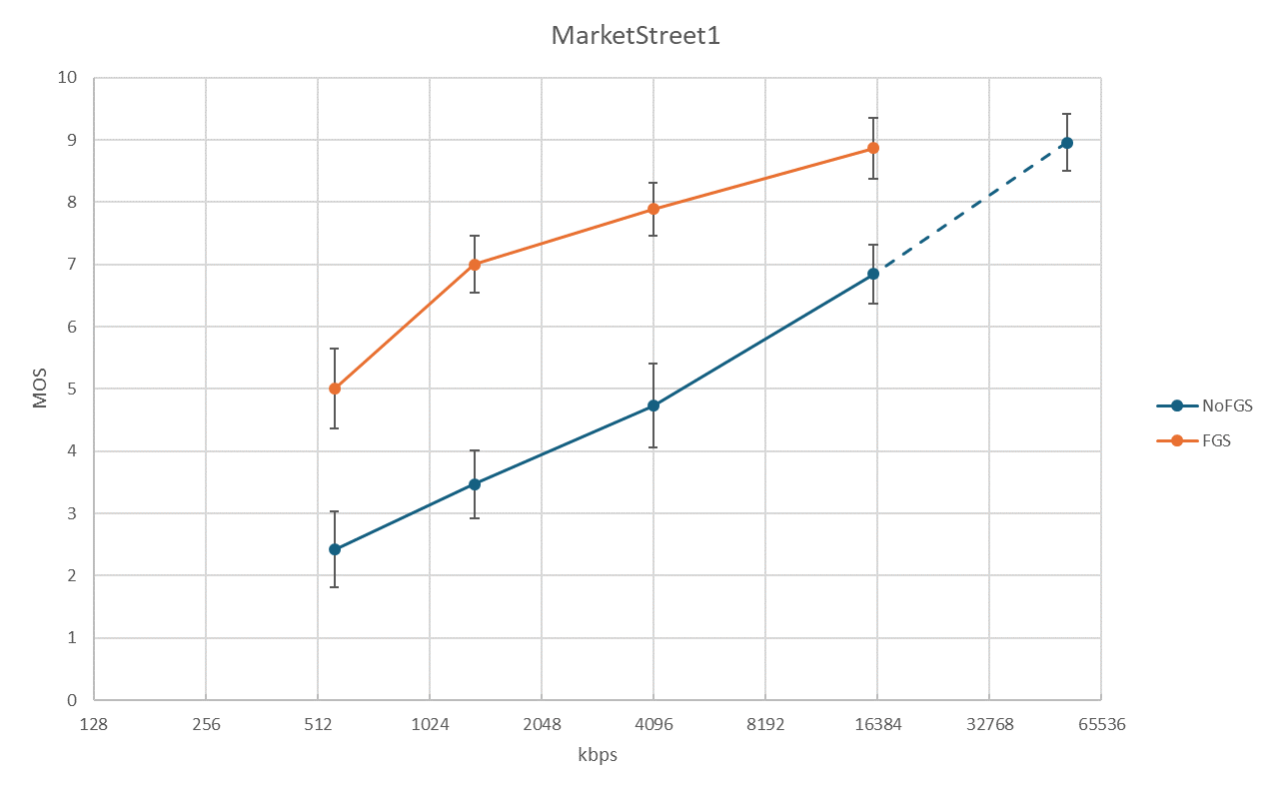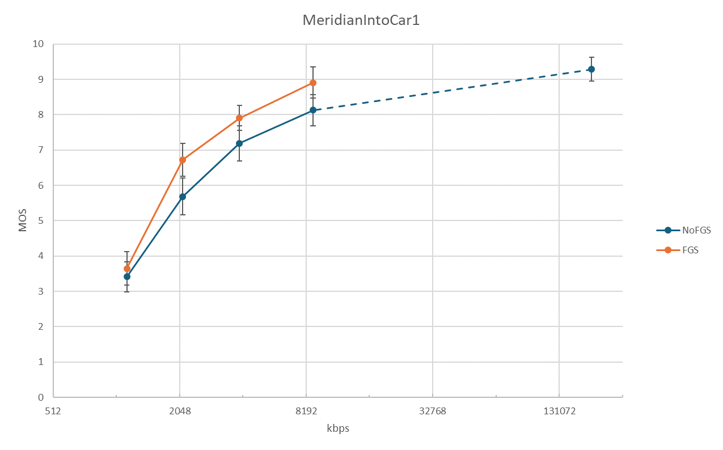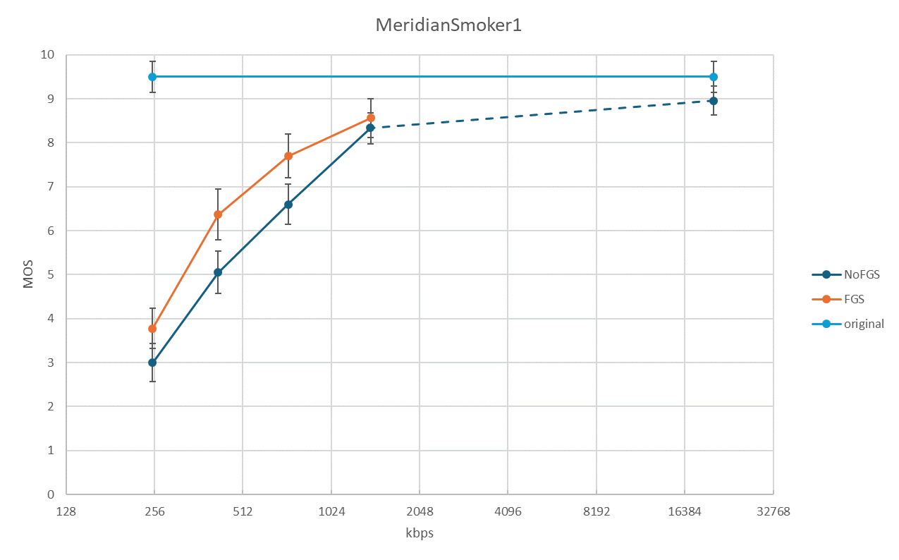
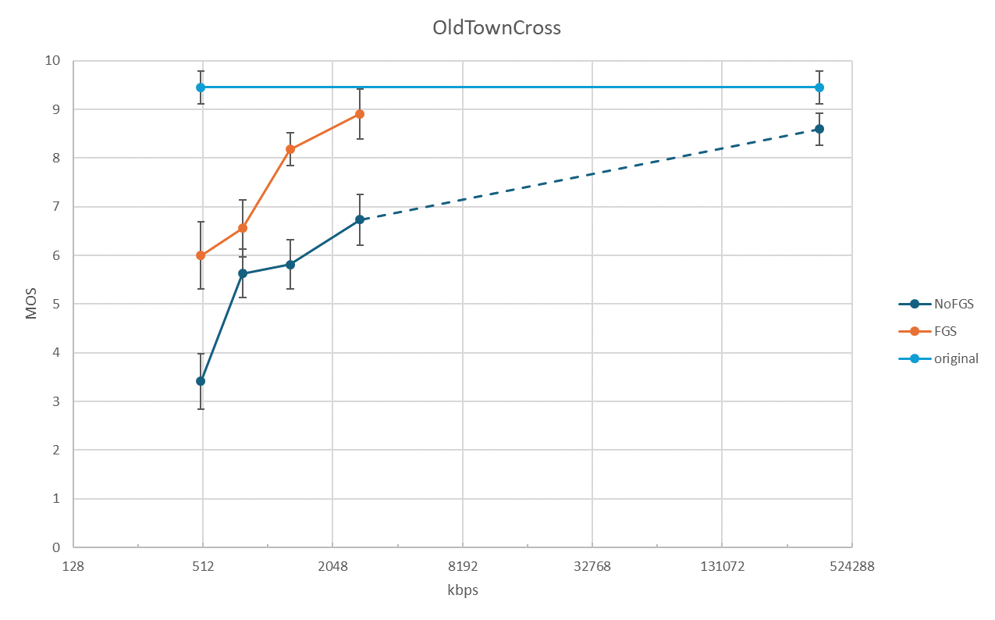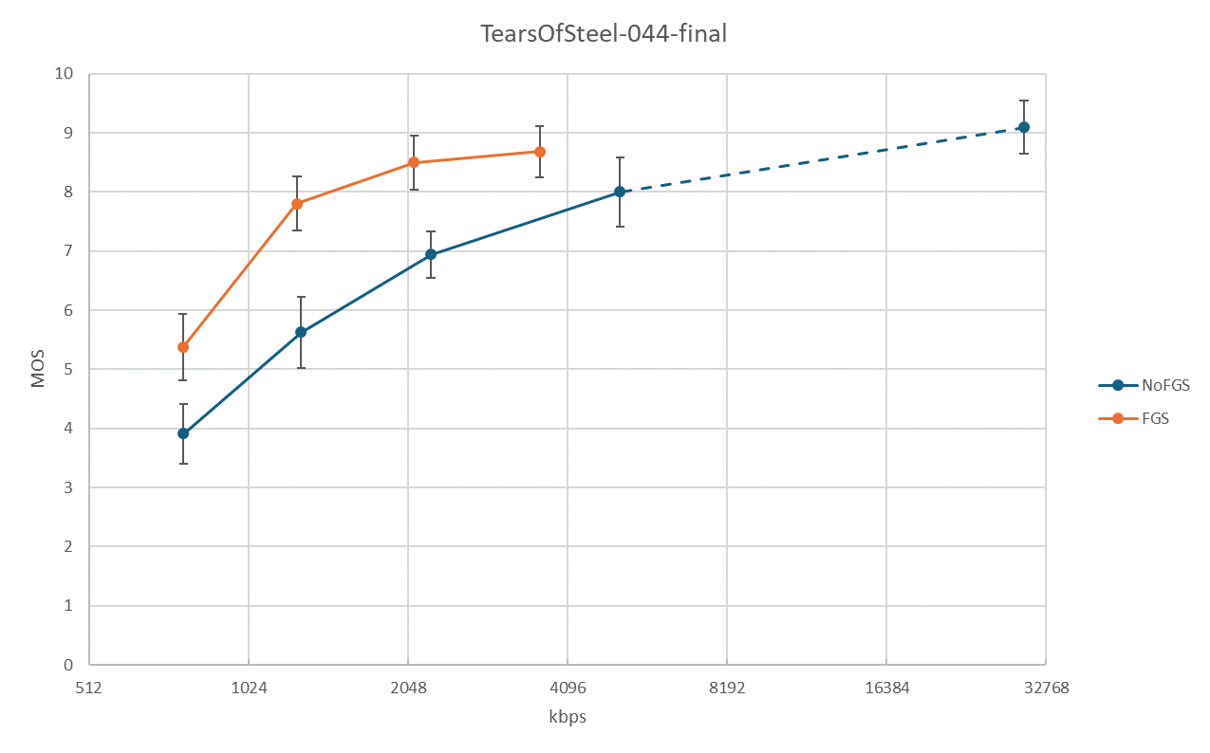
Figure 4: MOS-over-rate plots for the DCR experiment

Discussion
- MOS range
  - For some sequences, the lowest tested rate already exhibits a mid-range MOS – no observations for lower range of the MOS scale can be made
  - This is deemed appropriate given the set goal of the test
- Results
  - For all tested points the MOS of the FGS encoding is larger than the corresponding NonFGS version, in most cases significantly
  - For four of the tested sequences the highest FGS rate points matches the MOS the transparency point. For the other two sequences, the confidence interval overlaps the transparency points. The highest FGS points always has a significantly lower rate than the transparency point.
  - For the sequences MeridianSmoker1 and MeridianIntoCar1 the benefit of FGS is the lowest among the tested sequences. This might be attributed to the subtle grain present in the original sequences.
  - The highest gain is observed for the sequence MarketStreet1, for which the up to 10x bitrate reduction without quality degradation is measured.

Appreciation
TCL and VESTEL are gratefully thanked for providing the displays for viewing. Fraunhofer HHI is thanked for providing the playout PC. The participating experts are gratefully thanked for their evaluation efforts.

References
- P. de Lagrange, W. Husak, M. Wien, “Draft plan for subjective quality testing of the FGC SEI message,” Doc. JVET-AI2022, 35th Meeting, Sapporo, Jul. 2024.
- P. de Lagrange, “AHG4: preparation of test material for film grain visual testing,” Doc. JVET-AI0138, 35th meeting, Sapporo, Jul. 2024.
- M. Wien, P. de Lagrange, A. Wieckowski, “Preliminary results of expert viewing for FGC subjective test category 2,” Doc. JVET-AI0337, 35th meeting, Sapporo, Jul. 2024.

