    Joint Video Experts Team (JVET)  of ITU-T SG 16 WP 3 and ISO/IEC JTC 1/SC 29  36th Meeting, Kemer, TR, 1–8 November 2024 | Document: JVET-AJ0225-v3

Title: | AHG3/AHG10: RDO adjustments for inter-layer predictions
Status: | Input document to JVET
Purpose: | Proposal
Author(s) or  Contact(s): | Mikaël Le Pendu  Philippe de Lagrange  Fabrice Urban | Email: | mikael.lependu@interdigital.com
Source: | InterDigital
_____________________________

Abstract
This contribution proposes adjustments of the encoder selection of coding modes for dual-layer coding in order to prevent quality degradation of the enhancement layer compared to the base layer. The rate-distortion (RD) criterion is adjusted to favor the selection of inter-layer coding modes over intra-layer coding modes using a modified RD cost. Modifications are also proposed to make sure that inter-layer coding modes are included in the rate distortion optimization process.
The proposed modifications have been tested on the candidate test sequences for verification testing of scalable video coding described in JVET-AH2021.
It is asserted that visual quality is improved in areas where local degradations compared to the base layer were observed.
The BD-rate is reported to be +0,48%/+0,51%/+0,54% for Y/U/V PSNR. The BD-rate of a further combined test with JVET-AJ0067 are also reported to be -0,37%/-0,24%/-0,01% for Y/U/V PSNR.

Introduction
During the 31st JVET meeting in Geneva, CH, an expert viewing test has been performed to verify that dual-layer coding outperforms an upscaled anchor at comparable bitrate. The result has been reported in JVET-AE0288: it has been found that at least for CorsairJoy and TallBuildings test sequences, the quality of dual-layer is lower than the upscaled anchor. Although the situation was improved in JVET-AF0186 by moving the inter-layer reference first in the reference picture lists (instead of last), visual artifacts remain in some areas of the dual-layer where the quality is still lower than in the upscaled anchor. It was also analysed in JVET-AF0186 that the artifacts correlate with the selection of a reference picture from the enhancement layer (i.e., intra-layer) instead of the base layer (i.e., inter-layer) even in smooth areas where there is no need for a resolution enhancement.
A possible explanation is that the signaling cost R of an inter-layer coding mode (i.e., using the inter-layer reference picture) may be higher than that of an intra-layer coding mode in some cases. This may result in the inter-layer coding mode not being selected even if it yields the lowest distortion D, as it may have a too high rate-distortion (RD) cost C=D+lambda*R. A quality degradation compared to the upscaled base layer may thus be observed in such a case.

Proposal
In this contribution, it is proposed to adapt the encoder selection criterion for inter-layer coding modes to prevent quality degradation of the enhancement layer compared to the base layer. The following modifications are proposed:
- When an inter-layer coding mode is compared to an intra-layer coding mode, a modified RD cost C’=D+lambda’*R is computed for both modes where lambda’ is smaller than the original lambda. If the inter-layer mode has a lower modified RD cost than the intra-layer mode, the inter-layer mode is selected. Otherwise, the regular criterion based on the original RD cost C is used. A split mode (e.g., QT, BT, TT) is considered as an inter-layer mode if at least one of its split sub-blocks use an inter-layer mode.

- When selecting the best merge candidate, a fast evaluation pass pre-selects some of the candidates based on the SATD of the prediction to accelerate the search. It is proposed to force the pre-selection of at least one of the merge candidates that performs inter-layer prediction.

- A heuristic that may prevent the search of splits modes of a block is deactivated if the current best coding mode selected for the non-split block is not an inter-layer mode.
The software changes are available in VTM merge request 2778.

Experimental results

Coding conditions
The proposed modifications are implemented and tested in VTM 23.4 using the test conditions in JVET-AJ0042, where the enhancement layer is coded using the base-layer in first position in both L0 and L1 reference picture lists. The anchor is the commit 029f7b12 which supports explicit inter-layer reference picture configuration in the reference picture lists.
A new encoder configuration flag --EncInterLayerOpt is added to activate the proposed modifications (set to false by default). The flag has no effect for encoding the base layer.
The modified Lagrangian parameter lambda’ is controlled by a modifier (lambda’= lambda * modifier) where the modifier can be set with a new configuration parameter --EncInterLayerOptLambdaModifier (set to 0.1 by default). In the experiments the default value of 0.1 is used for the modifier.

Inter-layer mode selection
It is first verified in Figure 1 that the proposed modifications encourage the selection of inter-layer prediction by the encoder for the CorsairJoy2 sequence. Areas overlayed in yellow show inter-layer coding modes. Using the proposed --EncInterLayerOpt configuration flag, smooth areas below the logo (that do not need resolution enhancement) are more likely to be coded with inter-layer prediction.

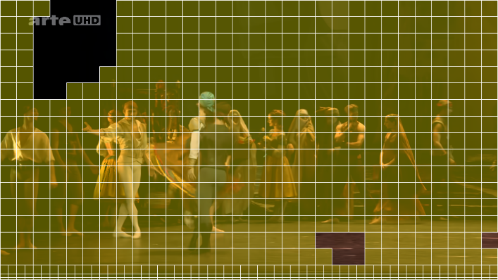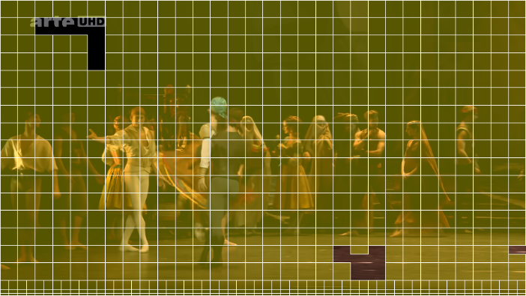
Figure 1 – Inter-layer prediction map, POC 7, base layer QP 37, enhancement layer QP 44 (left: anchor, right: with proposed modifications enabled with --EncInterLayerOpt configuration flag)

Visual results
Figure 2 illustrates the degradation between the upscaled base-layer and the enhancement layer. In the middle and bottom subfigures, dark blue areas indicate a degradation, while yellow areas indicate a quality improvement compared to the upscaled base layer. With the proposed modifications, the degradations are reduced while maintaining quality improvements in the logo.
The bitrate is also increased with the proposed modifications at equal QP. However, comparing the tested modifications at QP 44 (bottom) with bitrate=370.86 kbps and the anchor at QP 43 (middle left) with bitrate=375.19 kbps, it is observed that the proposed modifications still reduce the degradations with respect to the base layer.
The corresponding reconstructed images are also shown in Figure 3. The sharpness improvement of the logo compared to the base layer is further illustrated in Figure 4.
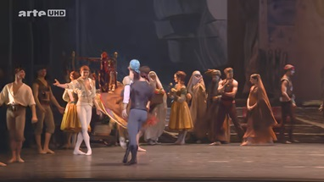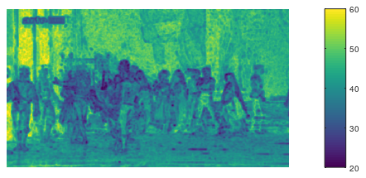
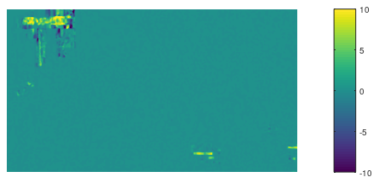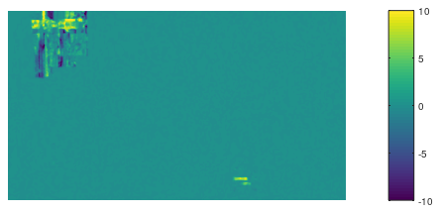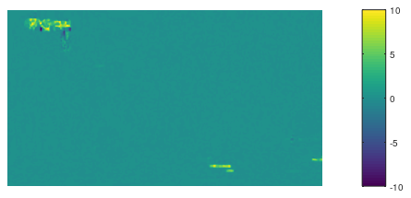
Figure 2 – Local PSNR maps of CorsairJoy2 at POC=7. Top-left: reconstructed image, Top-right: local PSNR of upscaled base layer (QP 37). Middle row: local PSNR difference of EL vs BL in anchor (left: QP 43, bitrate=375.19 kbps; right: QP 44, bitrate=370.86 kbps). Bottom: local PSNR difference of EL vs BL using proposed modifications (QP 44, bitrate=371.712 kbps).

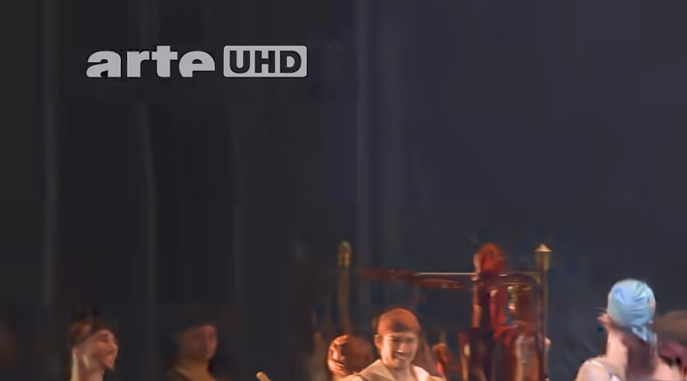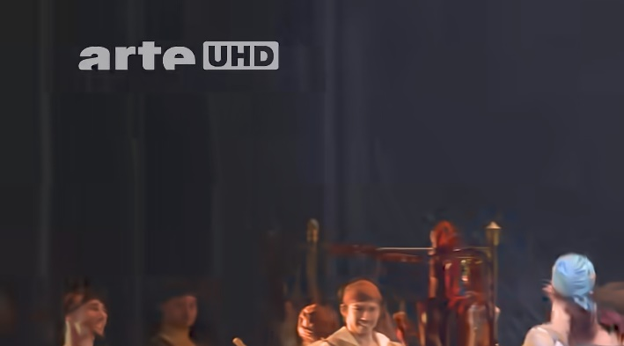
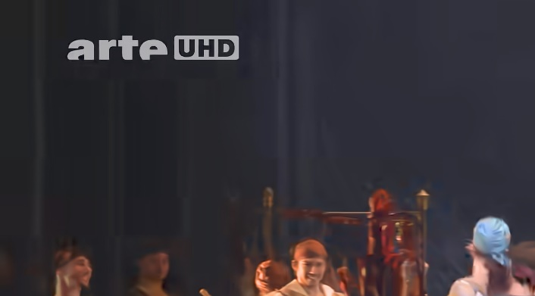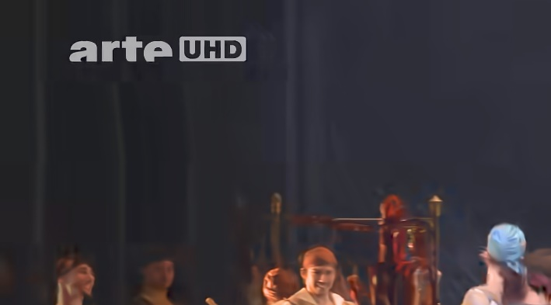
Figure 3 – Visual result of CorsairJoy2 at POC 7.
Top-left: base layer QP 37, Top-right: enhancement layer anchor QP 43,
Bottom-left: enhancement layer anchor QP 44, Bottom-right: enhancement layer with modifications QP 44.


Figure 4 – Sharpness improvement in CorsairJoy2 at POC 7 (from top to bottom: base layer QP 37, enhancement layer anchor QP 43, enhancement layer anchor QP 44, enhancement layer with modifications QP 44)

BD-rate results

BD-rate with proposed modifications
The BD-rate results are reported for the sequences and QP settings detailed in JVET-AH2021 (using a QP offset of +7 for the enhancement layer compared to base layer) for both the anchor and the test:

Sequence | Y-PSNR | U-PSNR | V-PSNR
CorsairJoy2 | 0.23% | 0.35% | 0.35%
DrivingPOV3 | 0.06% | 0.10% | 0.16%
Fortnite_Part1 | 0.42% | 0.59% | 0.48%
Marathon2 | 0.04% | 0.11% | 0.02%
MountainBay2 | 0.26% | 0.63% | 0.44%
Procession | 0.12% | 0.22% | 0.22%
TallBuildings2 | 0.97% | 1.32% | 1.00%
CatRobot1 | 0.72% | 1.18% | 1.06%
DrivingPOVLogo | 0.81% | 1.03% | 1.26%
LupoPuppet | 0.04% | 0.07% | 0.07%
BoxeLogo | 0.27% | -2.10% | 0.02%
TrafficHDLogo | 0.61% | 1.24% | 0.63%
Starcraft | 1.66% | 1.94% | 1.36%
Average | 0.48% | 0.51% | 0.54%

Combined test with JVET-AJ0067
BD-rate are also reported when combining the proposed modifications with the configuration changes presented in JVET-AJ0067 (omit the base layer reference picture from L1 in the explicit reference picture configurations, decrease the IntraQPOffset to -4 from -3 for the enhancement layer, and set the beta deblocking offsets to 0):

Sequence | Y-PSNR | U-PSNR | V-PSNR
CorsairJoy2 | 0.36% | 0.59% | 0.49%
DrivingPOV3 | 0.25% | 0.27% | 0.34%
Fortnite_Part1 | -0.28% | -1.27% | -1.89%
Marathon2 | 0.69% | -0.41% | -0.65%
MountainBay2 | 0.69% | 1.61% | 1.71%
Procession | 0.00% | 0.40% | 0.44%
TallBuildings2 | 0.14% | 5.17% | 4.81%
CatRobot1 | 0.30% | 1.44% | 1.23%
DrivingPOVLogo | -1.61% | -0.97% | -0.13%
LupoPuppet | 0.10% | 0.14% | 0.13%
BoxeLogo | -2.16% | -4.80% | -0.74%
TrafficHDLogo | -0.69% | -1.56% | -1.53%
Starcraft | -2.60% | -3.68% | -4.32%
Average | -0.37% | -0.24% | -0.01%

Conclusion
Modifications of the VTM encoder are proposed to address visual artifacts of the enhancement layer in dual-layer coding.
It is proposed to merge the changes in the VTM (from MR !2778).
In addition, it is suggested to run expert viewing tests with the proposed modifications.

Patent rights declaration(s)
InterDigital Inc. may have current or pending patent rights relating to the technology described in this contribution and, conditioned on reciprocity, is prepared to grant licenses under reasonable and non-discriminatory terms as necessary for implementation of the resulting ITU-T Recommendation | ISO/IEC International Standard (per box 2 of the ITU-T/ITU-R/ISO/IEC patent statement and licensing declaration form).

