    Joint Video Experts Team (JVET)  of ITU-T SG 16 WP 3 and ISO/IEC JTC 1/SC 29  36th Meeting, Kemer, TR, 1–8 November 2024 | Document: JVET-AJ0223-v0

Title: | Non-EE2: Bilateral Filtering for Intra Prediction
Status: | Input document to JVET
Purpose: | Proposal
Author(s) or  Contact(s): | Wenbin Yin¹, Kai Zhang², Yang Wang¹, Zhipin Deng¹, Na Zhang¹, Lei Zhao¹, Mehdi Salehifar², Li Zhang²  ¹Zijinshumayuan 4th building F9, 18 Zhongguancun Nansijie, Haidian District, 100190, Beijing, China  ²8910 University Center Lane, San Diego, CA 92122, USA | Tel:  Email: | yinwenbin.hit@bytedance.com  zhangkai.video@bytedance.com  lizhang.idm@bytedance.com
Source: | Bytedance Inc.
_____________________________

Abstract
In this contribution, bilateral filtering for intra prediction is proposed. Intra prediction samples are filtered by bilateral filtering before they are used in the later processes.
On top of ECM-14.0, simulation results of the proposed method are reported as below:
AI: %, %, %, %, %.
RA: %, %, %, %, %.

Introduction
In general, intra prediction samples may contain coding noises. Bilateral filtering (BF) is suitable to reduce coding noises of intra prediction samples since it can achieve edge-protected denoising. Similar concept has been proposed in [3].

Proposed Method
In the proposed method, the generated intra prediction samples are further filtered by BF to reduce the noise level of the prediction samples, as shown in Figure 1.
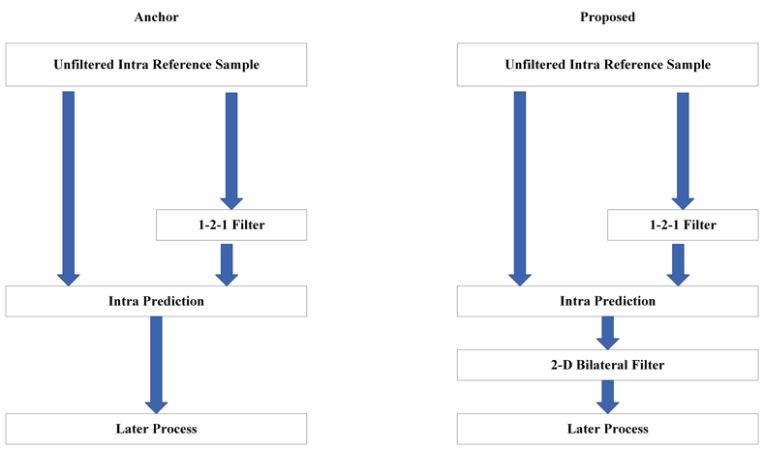
Figure 1 The Proposed Method.
BF used in the proposed method is kept the same as BF used in the loop-filtering stage. The filter length is kept as 2 and the filtering logic is unchanged. The available above and left neighbouring reconstructed samples are used in BF for the current block. Besides, the 6-tap cubic interpolation filter is always selected for the blocks with TIMD mode.

Simulation Results
The proposed method was implemented on top of the ECM-14.0 [1]. Simulations were performed following the common test conditions [2]. More detailed results could be found in the attached excel sheets.
Table 1 Performance of the Proposed Method
 | All Intra Main 10
 | Over ECM-14.0
 | Y | U | V | EncT | DecT | EncVmPeak | DecVmPeak
Class A1
Class A2
Class B | -0.09% | 0.00% | -0.07%
Class C | -0.18% | -0.24% | -0.22%
Class E | -0.14% | -0.09% | 0.04%
Overall
Class D | -0.15% | -0.08% | -0.32%
Class F
 | Random Access Main 10
 | Over ECM-14.0
 | Y | U | V | EncT | DecT | EncVmPeak | DecVmPeak
Class A1
Class A2
Class B
Class C | -0.01% | -0.23% | 0.04%
Class E
Overall
Class D | -0.02% | -0.26% | -0.13%
Class F

Conclusions
In this contribution, bilateral filtering for intra prediction is proposed. The intra prediction samples are refined by bilateral filtering for noise reduction. The proposed method can achieve promising coding performance with negligible coding time changes. It is recommended to include the proposed method into the next round of EE2.

Reference
- ECM-14.0, https://vcgit.hhi.fraunhofer.de/ecm/ECM/-/tree/ECM-14.0.
- M. Karczewicz, and Y. Ye, “Common test conditions and evaluation procedures for enhanced compression tool testing,” Document of Joint Video Experts Team, JVET-AI2017, JP, July 2024.
- W. Yin, K. Zhang, Y. Wang and L. Zhang, “Non-EE2: Bilateral Filtering for Intra Prediction,” Document of Joint Video Experts Team, JVET-AF0199, DE, October 2023.

Patent Rights Declaration(s)
Bytedance Inc. may have current or pending patent rights relating to the technology described in this contribution and, conditioned on reciprocity, is prepared to grant licenses under reasonable and non-discriminatory terms as necessary for implementation of the resulting ITU-T Recommendation | ISO/IEC International Standard (per box 2 of the ITU-T/ITU-R/ISO/IEC patent statement and licensing declaration form).

