    Joint Video Experts Team (JVET)  of ITU-T SG16 WP3 and ISO/IEC JTC1/SC29/WG11  36th Meeting, Kemer, Türkiye, 1–8 November 2024 | Document: JVET-AJ0187-v1

Title: | AHG3: Guidelines for VTM-based software development
Status: | Output Document of JVET
Purpose: | Software guidelines
Author(s) or  Contact(s): | Frank Bossen  Xiang Li  Karsten Suehring | Email: | frank@bossentech.com  xlxiangli@google.com  karsten.suehring@hhi.fraunhofer.de
Source: | AHG Chairs
_____________________________
Abstract
It is proposed to update the guidelines for VTM-based software development and add a paragraph about the use of SIMD-optimized code, which is now more common. The list of supported compilers is also updated to reflect current Gitlab CI practice.

Guidelines for VTM-based software development

The use of the following rules is mandatory for all software implementation work. Changes that don’t comply with these rules will not be accepted by the software coordinators.
The VVC reference software contains legacy code using different styles. When working on sections using old styles, that are different from the rules in this document, it is encouraged to update the related sections to the new style.

License

Copyright/License statements

Copyright disclaimers shall not be altered, except to include the current year. When adding a file, the same copyright disclaimer, as reproduced below, shall be included at the beginning of the file.
/* The copyright in this software is being made available under the BSD
* License, included below. This software may be subject to other third party
* and contributor rights, including patent rights, and no such rights are
* granted under this license.
*
* Copyright (c) 2010-2023, ITU/ISO/IEC
* All rights reserved.
*
* Redistribution and use in source and binary forms, with or without
* modification, are permitted provided that the following conditions are met:
*
* * Redistributions of source code must retain the above copyright notice,
* this list of conditions and the following disclaimer.
* * Redistributions in binary form must reproduce the above copyright notice,
* this list of conditions and the following disclaimer in the documentation
* and/or other materials provided with the distribution.
* * Neither the name of the ITU/ISO/IEC nor the names of its contributors may
* be used to endorse or promote products derived from this software without
* specific prior written permission.
*
* THIS SOFTWARE IS PROVIDED BY THE COPYRIGHT HOLDERS AND CONTRIBUTORS "AS IS"
* AND ANY EXPRESS OR IMPLIED WARRANTIES, INCLUDING, BUT NOT LIMITED TO, THE
* IMPLIED WARRANTIES OF MERCHANTABILITY AND FITNESS FOR A PARTICULAR PURPOSE
* ARE DISCLAIMED. IN NO EVENT SHALL THE COPYRIGHT HOLDER OR CONTRIBUTORS
* BE LIABLE FOR ANY DIRECT, INDIRECT, INCIDENTAL, SPECIAL, EXEMPLARY, OR
* CONSEQUENTIAL DAMAGES (INCLUDING, BUT NOT LIMITED TO, PROCUREMENT OF
* SUBSTITUTE GOODS OR SERVICES; LOSS OF USE, DATA, OR PROFITS; OR BUSINESS
* INTERRUPTION) HOWEVER CAUSED AND ON ANY THEORY OF LIABILITY, WHETHER IN
* CONTRACT, STRICT LIABILITY, OR TORT (INCLUDING NEGLIGENCE OR OTHERWISE)
* ARISING IN ANY WAY OUT OF THE USE OF THIS SOFTWARE, EVEN IF ADVISED OF
* THE POSSIBILITY OF SUCH DAMAGE.
*/

Syntax usage

Language

Use C++17.

Templates

Do not make excessive usage of templates. Use them only for simple functions like min() or max() which are easy to understand and where code duplication can be avoided.

Pre-processor macros

Do not use #define for function definitions. Use (static or static inline) functions instead. Lambda functions may also be used where a function is needed only locally. Functions are much less prone to logical errors and compilers can even better optimize them.

Do not use #define to encapsulate bug fixes. If bug fixes ever need to be removed again, they can be tracked back using the revision control system (see paragraph 7.1).

Avoid using #define for enabling or disabling a tool. Use a config file option instead unless polling the value of the option would significantly slow down the code.

Avoid using #define to define constants. Use const or constexpr global variables.

Header files multiple include safety

All header files shall include a mechanism to prevent multiple inclusion. The preferred mechanism is to use the #pragma once directive at the beginning of each header file.

private and protected class members

Make member variables and methods as private as possible. Only methods that need to be called from outside should be public. Private and protected member variables should be named including the “m_” prefix.

Storage classes (and structs) may contain simple member variables not requiring encapsulation. These may be defined as public. In such case the “m_” prefix should be omitted.

Data types

Don’t use aliases for basic data types, unless the name describes the variable of such type and not the type itself (e.g. uint64_t being redefined as Distortion) or the type is not machine-independent (e.g. long integers). Define custom types in TypeDef.h unless they are not needed globally.

Use the appropriate size for data types. Using <cstdint> types is encouraged, e.g. int16_t for 16 bit or int32_t for 32 bit.

Use the (signed) int type for integer variables unless there is a good reason not to (e.g., excessive memory usage). Avoid using unsigned types as they can be a source of bugs (e.g., when comparing signed with unsigned integers).

Do not use the long type as its width is not machine-independent (may be 32 or 64 bits wide). If a 64-bit variable is required, use type int64_t.

Use size_t and ptrdiff_t where appropriate.

Avoid using the NULL macro. Use nullptr instead.

Use of strong typing is encouraged to avoid implicit type conversions that are prone to bugs. For example, enumerated types may be defined as enum class EnumType.

Unused code

Unused code shall be removed from the source code. Commenting out (or using #defines that evaluate to false) is not allowed. Old revisions are available in the revision control system.

Code duplication

Avoid duplication of code. Define functions where appropriate and localize the scope of #defines as much as possible.

Optimizations

Do not try to do the compiler’s work by trying to optimize the code. Make the code easy to read and maintain.

Avoid usage of explicit function inlining and define functions and methods in .cpp files unless they are really short. When using explicit inlining, use the inline keyword (without leading underscores).

Whereas not encouraged, use of SIMD intrinsics is acceptable where it provides significant run time reduction. There shall be a plain (i.e., not processor-specific) fallback implementation for every function. When multiple implementations (e.g., using different SIMD extensions) of a function exist, their behaviour shall be identical, i.e., they should produce identical results.

Naming

General

Classes, methods, functions, and variables shall be given descriptive and meaningful names describing their functionality and purpose.

All type names (classes, structs, enums, unions, typedefs) shall be named using nouns and have an initial uppercase letter.

Methods and functions shall be named using verbs describing the activity and have an initial lowercase letter.

Variable names must have an initial lowercase letter.

Do not use type prefixes (like iVar, uiVar, etc.) on new variable names. These tend to be confusing if the data type changes and the variable is not renamed (e.g. if it is used differently depending on different macros).

In all cases, “Camel Case” shall be used to connect multiple words, where each subsequent word in a name starts with an uppercase letter.
Example:
class CodingTool
{
void doSomething()
{
<code here>
}

void* m_privateMember;
};

const int g_someTable[] = { 1, 2, 3, 4 };

Global variables shall be named using the prefix ‘g_’.

Notwithstanding the rules above, simple global constants may be named using uppercase letters and underscores as for example static constexpr int GLOBAL_CONSTANT = 42;.

Non-public member variables shall be named using the prefix ‘m_’.
Example:
unsigned g_globalVariable;

struct Foo
{
int memberVariable;
}

class Bar
{
int m_memberVariable;
}

Formatting

Indentation

All code blocks that are included into braces shall be indented by two (2) space characters. Tabulator (TAB) characters are never used.
Example:
void doSomething()
{
<code here>
}

Usage and placement of braces

Code following conditionals (e.g. if, else, do, while) shall always be enclosed in braces, even if it is only a single statement.

The opening brace is placed on a new line on the same indentation level as the defining keyword (e.g. void, if, for, while, etc.). The included code block starts at the following line and is indented. The closing brace is placed on the same indentation level as the opening brace.
Example:
void doSomething()
{
if (<expression>)
{
<code here>
}
}

Automated formatting

All code may be formatted using the clang-format tool using the configuration file provided in the software package.

Code comments

General

Do not use comments or other means to mark code as yours. The revision control system allows tracking who submitted which code.

Use comments to explain the intent (or implementation detail) of code sections that are not obvious. Note that obvious may have a different meaning for users who are reading this section for the first time.

Compiler warnings

Contributed code must not produce compiler warnings when compiled with the following compilers when using default CMake project generation:
- Visual Studio 2017,
- Visual Studio 2019,
- gcc-7.x
- gcc-8.x
- gcc-9.x
- gcc-10.x
- gcc-11.x
- gcc-12.x
- Xcode/clang (x86 and ARM builds).

Version control system

General

All software is managed through version control. A merge request (MR) should be submitted for every change.

MRs should be for a single logical “change”, i.e. a single feature, single bug fix, etc.

If refactoring, try to provide a refactor MR first before any changes that require the refactor. This allows the SW AHG to determine that the refactor has not broken anything.

Please notify the software coordinators at the beginning of the implementation cycle, if a MR is going to be larger than 1000 lines of code (including refactoring).

Best practices are further described on the following wiki page: <https://vcgit.hhi.fraunhofer.de/jvet/VVCSoftware_VTM/wikis/VVC-Software-Development-Workflow>

Log messages

Commit log messages must contain a good description of what the commit contains. If appropriate, they should reference related JVET documents or trac (bug tracker) tickets.

MR subject lines shall be written in a way appropriate for verbatim inclusion into a list of changes for release notes.

Some recommendations for a better coding style

Variable declaration

Variables that are not declared inside of functions (global or file local) should be declared at the beginning of the corresponding file preceding all function definitions.

Variables should be declared as near as possible to the lexical scope of their first usage.

Global variables should not be used without good reason.

Use the const and constexpr qualifiers whenever possible

Switch

The code following a case label should be terminated with a break or return statement. If it's necessary to handle multiple cases, there should be a comment explaining the reason.

Every switch statement should contain a default branch that handles unexpected cases.

Functions

Functions should be kept to a reasonable size. If a function exceeds 100 lines of code, consider splitting it into multiple smaller functions.

Data structures

Use static_vector instead of std::vector where the maximum number of elements is known in advance and is reasonably small. This avoids dynamically allocating and releasing memory.

Use EnumArray to define arrays that are indexed by an enumerated type.

Consider using a Pool for objects that may require frequent dynamic allocation and deallocation.

Configuration parameters

Encoder configuration

Configuration parameters should be provided for features that are switchable according to the VVC specification (e.g., in the Sequence or Picture Parameter Set)

Encoding parameters should not be selected based on configuration (e.g., AI, RA, LD), resolution, frame rate, or sequence. If it is necessary to have an automated selection based on such criteria, means to override the automated selection should be provided using configuration parameters.

Configuration parameters shall be documented in the software manual.

Technical hints (informative)

MS Visual Studio
The following settings for MS Visual Studio will assist you using the formatting rules. This menu can be found in
Tools->Options.
Go to Text Editor-> C/C++

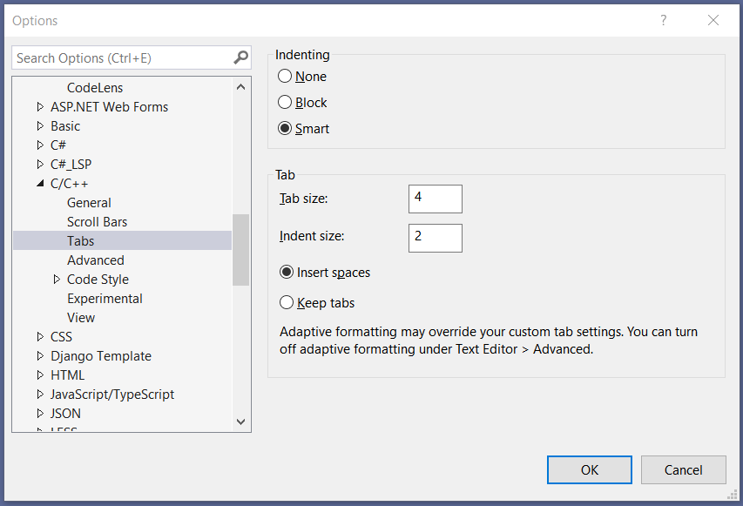
After applying these setting you can use
Edit->Advanced->Untabify Selection
to remove TAB characters and
Edit->Advanced->Format Selection
to format the selected section.
Note: There is a bug in MS Visual Studio 6.0 that leads to a wrong indentation if nested ‘for’-loops are used without braces.

Xcode
For setting up Xcode to properly format the source code, go to Preferences->Text Editing->Indentation and make the following changes:
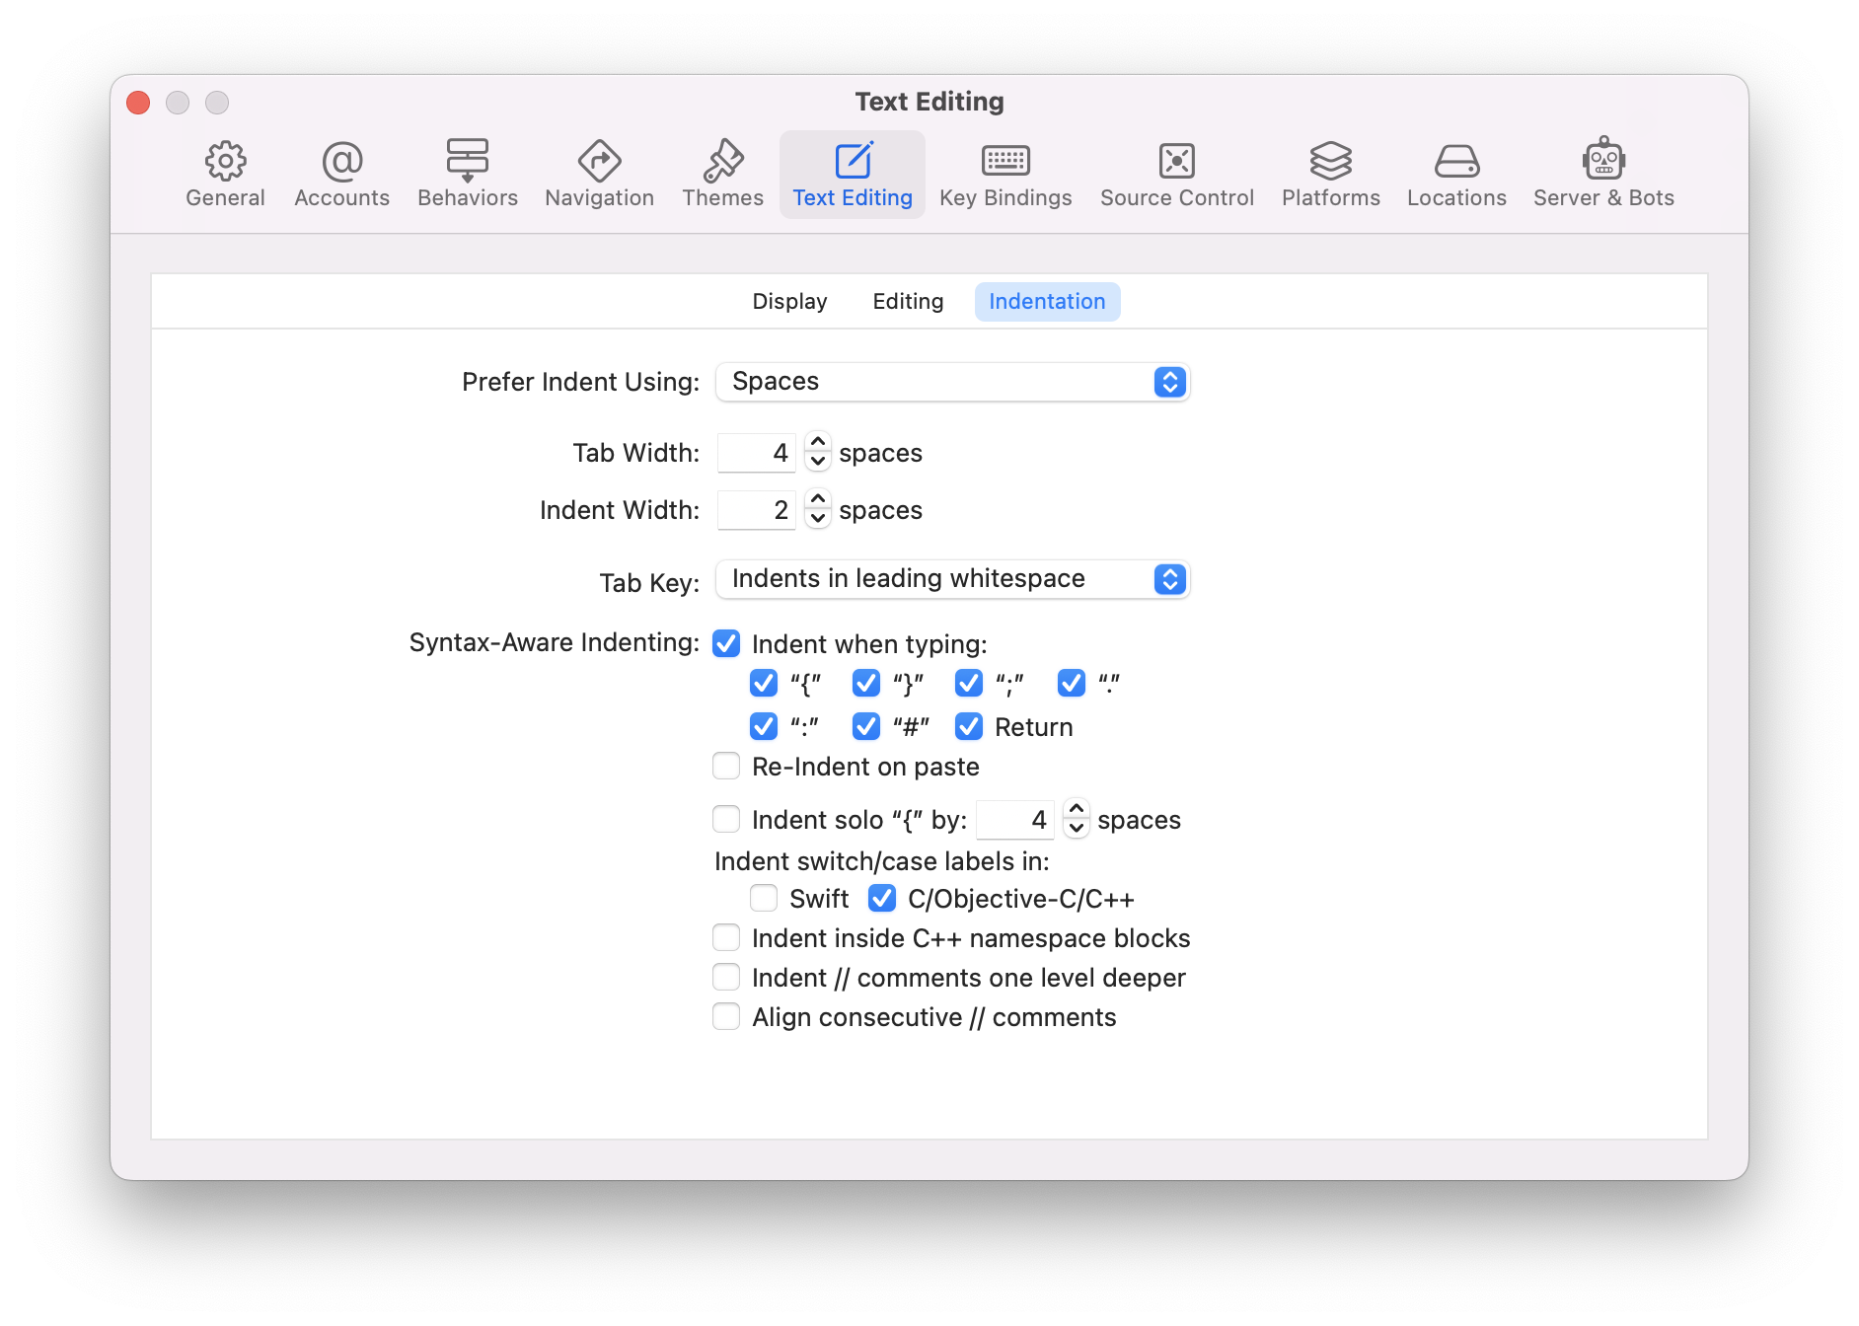

VIM
For setting up the proper indentation in VIM add the following lines to your .vimrc file
" set indentation of two tabs
set sts=2 sw=2 ts=8 et

Eclipse
For setting up the proper indentation in Eclipse go to Windows->Preferences->C++->Code Style->Edit and set the following options:
Tab Policy: Spaces only
Indentation Size: 2
Tab size: 2

