    Joint Video Experts Team (JVET)  of ITU-T SG 16 WP 3 and ISO/IEC JTC 1/SC 29  36th Meeting, Kemer, TR, 1–8 November 2024 | Document: JVET-AJ0087-v2

Title: | Non-EE2: Block vector guided DIMD
Status: | Input document to JVET
Purpose: | Proposal
Author(s) or  Contact(s): | Lai Zhang, Yue Yu, Haoping Yu, Dong Wang | Tel:  Email: | zhanglai@oppo.com
Source: | OPPO
_____________________________

Abstract
This contribution proposes a block-vector guided DIMD method (BVG-DIMD) that uses block vectors to locate reference areas, construct a histogram of gradients for the samples in the reference areas, and derive intra modes based on the histogram. In the BVG-DIMD mode, the prediction of the block is obtained by using these intra modes. The proposed method is implemented on top of ECM-14.0, and the simulation results are reported as follows:
AI: { -0.14% Y, 0.00% U, 0.05% V, 104.4% EncT, 106.0% DecT }
RA: { xx% Y, xx% U, xx% V, xx% EncT, xx% DecT }

Introduction
The DIMD process in ECM [1] derives up to five intra modes from the reconstructed neighbor samples, and those five predictors are combined with the non-directional predictor (planar or a block vector based predictor) with the weights derived from the histogram of gradients (HoG). The DIMD mode has a three-line template around the current block and applies the Sobel filter upon the template to derive the HoG, as shown in Figure 1.
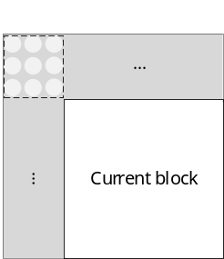
Figure 1. DIMD

Proposed method
It is proposed to use the reference samples pointed at by the block vectors, instead of the neighboring samples shown in Figure 2, to build HoG and derive intra modes. Up to 5 block vectors are obtained by a searching process like in IntraTMP. With each block vector, a reference area in the current picture is determined and its samples are used to derive the intra modes and corresponding amplitudes. All results are counted in constructing the HoG. Similar to the DIMD and OBIC modes, five intra modes with the highest amplitudes are selected and the prediction of the current block is the blending of those five predictors and a non-directional predictor. The non-directional predictor is the blending of up to 5 BV-based predictors obtained using the block vectors.
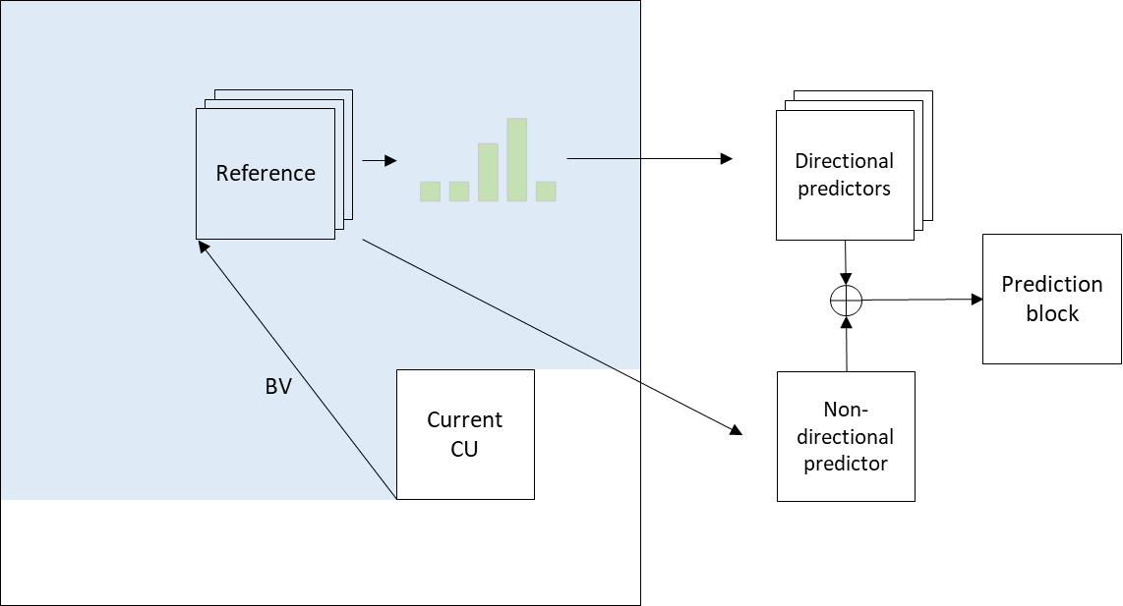
Figure 2. prediction process of the proposed BVG-DIMD method
The proposed BVG-DIMD method is explicitly signaled as a sub-mode of DIMD. The encoder will always check this mode with a full RD, like DIMD and OBIC.

Simulation results
The proposed method is implemented on top of ECM-14.0 [1] and tested based on the common test condition [2]. The test results are summarized below.
Table 1: Test result of the proposed method over ECM-14.0
 | All Intra Main 10
 | Over ECM-14.0
 | Y | U | V | EncT | DecT | EncVmPeak | DecVmPeak
Class A1 | -0.14% | 0.03% | -0.03% | 104.9% | 105.7% | 101.4% | 100.3%
Class A2 | -0.13% | -0.03% | -0.09% | 103.8% | 105.8% | 98.6% | 100.3%
Class B | -0.14% | -0.05% | 0.09% | 105.0% | 106.0% | 99.4% | 100.0%
Class C | -0.15% | -0.06% | 0.02% | 104.1% | 108.7% | 101.3% | 100.1%
Class E | -0.11% | 0.12% | 0.22% | 104.0% | 103.1% | 101.6% | 100.0%
Overall | -0.14% | 0.00% | 0.05% | 104.4% | 106.0% | 100.4% | 100.1%
Class D | -0.10% | 0.12% | 0.03% | 104.2% | 106.3% | 100.4% | 100.0%
Class F | -0.16% | -0.12% | -0.05% | 102.6% | 103.6% | 99.4% | 100.1%

 | Random Access Main 10
 | Over ECM-14.0
 | Y | U | V | EncT | DecT | EncVmPeak | DecVmPeak
Class A1
Class A2
Class B | -0.05% | 0.10% | 0.09% | 101.1% | 99.9% | 100.1% | 100.1%
Class C | -0.07% | 0.05% | 0.23% | 101.0% | 101.1% | 100.1% | 100.1%
Class E
Overall
Class D | -0.05% | -0.24% | -0.15% | 100.3% | 101.1% | 100.1% | 100.0%
Class F

Conclusions
The proposed BVG-DIMD method can bring -0.14%/0.00%/0.05% BD-rates performance for AI on top of ECM-14.0. It is suggested to further study the proposed method in the next round of EE2.

References
- ECM14.0, https://vcgit.hhi.fraunhofer.de/ecm/ECM/-/tree/ECM-14.0
- M. Karczewicz, Y. Ye, “Common Test Conditions and evaluation procedures for enhanced compression tool testing”, JVET-AI2017, July 2024.

Patent rights declaration(s)
Guangdong OPPO Mobile Telecommunications Corp., Ltd. (OPPO) may have current or pending patent rights relating to the technology described in this contribution and, conditioned on reciprocity, is prepared to grant licenses under reasonable and non-discriminatory terms as necessary for implementation of the resulting ITU-T Recommendation | ISO/IEC International Standard (per box 2 of the ITU-T/ITU-R/ISO/IEC patent statement and licensing declaration form).

