    Joint Video Experts Team (JVET)  of ITU-T SG 16 WP 3 and ISO/IEC JTC 1/SC 29  36th Meeting, Kemer, TR, 1–8 November 2024 | Document: JVET-AJ0023-v2

Title: | EE1: Summary report of exploration experiment on neural network-based video coding
Status: | Input document to JVET
Purpose: | Report
Author(s) or  Contact(s): | E. Alshina, R. Chang, F. Galpin, Y.Li, D. Rusanovskyy, M. Santamaria, J. Ström, and Z. Xie | Email: | elena.alshina@huawei.com  renjiechang@tencent.com  franck.galpin@interdigital.com  yue.li@bytedance.com  dmytror@qti.qualcomm.com  maria.santamaria_gomez@nokia.com  jacob.strom@ericsson.com  xiezhihuang@oppo.com
Source: | EE Coordinators
_____________________________

Abstract
This report summarizes the activities of the Exploration Experiment 1 (EE1) performed between the 35th and 36th JVET meetings to evaluate Neural Network-based Video Coding (NNVC) technologies, analyze their performance, evaluate their complexity aspects, and clarify training procedure. Two teleconferences have been conducted during this meeting circle.
NNVC performance is assessed for three complexity settings with in-loop (IL) filters and intra prediction enabled: High Operational Point (HOP, 471kMAC/pixel), Low Operational Point (LOP, 21.8kMAC/pixel) and Very Low Operational Point (VLOP, 10kMAC/pixel). Compared with VVC, NNVC HOP provides {14.2%, 19.5%, 19.9%}, NNVC LOP provides {7.4%, 13.6%, 11.6%} and NNVC VLOP provides {5.6%, 7.6%, 6.4%} bitrate saving for {Y, Cb, Cr} channels in the RA configuration. Observed run time increase relatively to VVC is ×2.6, ×1.2, ×1.1 ( encoding ) and ×1441, ×34, ×15 ( decoding) for HOP, LOP and VLOP configurations respectively. EE1 tests were targeting improving the performance complexity trade-off of all three operation points of neural-network based filter and super-resolution.

Introduction

It was decided [1] that the code base for the test should be NNVC-10.0. The anchor for all tests is default configuration of NNVC-10.0 (NN-Intra as adopted from JVET-AI0130 and LOP-3 filter are enabled). Anchor performance results were provided by AhG 14 [2] and have been used by all proponents.

For tests competing with technologies in NNVC-10.0 it was agreed to configure the proposed solution targeting close to existing NNVC tool complexity, but not exceeding it:
- kMAC/pxl of EE1 test ≤ kMAC/pxl NNVC (must),
- Number of Parameters EE1 test ≤ Number of Parameters NNVC (if possible).
The minor violation of this requirements is allowed for the final model, if the reason is keeping the number of channels a multiple of 16 (or at least 8), since it is very helpful for neural network algorithms implementation on wide range of platforms. Reported results should follow the constraints for evaluation purpose but the final model might violate the constraints.
NN architecture provided in this test description should not be changed, beside minor adjustment for parameters (such as channels number) in order to meet recommendation above.

Exact parameters settings were announced by proponents by 2nd AhG11/14 teleconference on October 1 [3].

The teleconferences are conducted in order to discuss the NNVC reference software integration and EE1 tests setup.
Table 1 provides performance and complexity number of several tools’ combinations in NNVC relatively to VVC anchor.

Table 1 Performance of NNVC tools combinations relatively to VVC
Test | Random Access |  |  |  |  | All Intra |  |  |  |  | Total kMAC/pxl | Total Param (Mprm)
Test | Y | U | V | Enc | Dec | Y | U | V | Enc | Dec | Total kMAC/pxl
NNIntra+LOP | -7.4% | -13.6% | -11.6% | 1.2 | 34 | -8.5% | -14.3% | -14.0% | 1.7 | 22 | 21.7 | 1.5
NNIntra+HOP | -14.2% | -19.5% | -19.9% | 2.6 | 1441 | -13.6% | -15.9% | -17.1% | 2.7 | 767 | 471 | 2.7
NNIntra+VLOP | -5.6% | -7.6% | -6.4% | 1.1 | 15 | -7.2% | -9.4% | -8.8% | 1.7 | 13 | 10.0 | 1.4
NNIntra+LOP+SR | -8.1% | -10.3% | -8.9% |  |  | -9.2% | -11.5% | -11.0% |  |  | 26.4 | 1.5

List of tests
This round of EE1 tests includes:
- EE1-1: LOP and VLOP in-loop filter
  - EE1-1.1 – Partial Convolution and Over-Parameterization
    - Report: JVET-AJ0080, cross-check: JVET-AJ0150
  - EE1-1.2 – LOP with residual groups and Attention
    - Report:JVET-AJ0165, cross-check JVET-AJ0327
  - EE1-1.3 - NN in-loop filters using early cropping
    - Report: JVET-AJ0054, cross-check: JVET-AJ0133
  - EE1-1.4 – Reduced complexity input feature extraction for LOP & VLOP
    - Report: JVET-AJ0066 cross-check: JVET-AJ0163
  - EE-1.5 - Multiscale blocks in LOP3 and VLOP2 filter
    - Report: JVET-AJ0182 cross-check: JVET-AJ0206
- EE1-2: HOP in-loop filter
  - EE1-2.1 – Attention block with transformers
    - Withdrawn
  - EE1-2.2 – Block-size invariant implementation of HOP
    - Report:JVET-AJ0166 cross-check: JVET-AJ0177
  - EE1-2.3 – Block based QP information in NN loop filters
    - Report:JVET-AJ0124 cross-check: JVET-AJ0324
- EE1-3: NN-inter prediction
  - E1-3.1 – RA/LDB Unified Reference Frame Synthesis for VVC Inter Coding
    - Report: JVET-AJ0099 cross-check: Nokia
- EE1-4: NN-based super resolution
  - EE1-4.1 – Wavelet transform for super-resolution loss function
    - Report:JVET-AJ0056, cross-check: JVET-AJ0291

Test results summary
Details of each test can be found in attached presentation.

LOP and VLOP filter modifications

In NNVC-10 LOP and VLOP filters architecture are unified. Just number of channels and back bone blocks are different to match two different level of complexity.
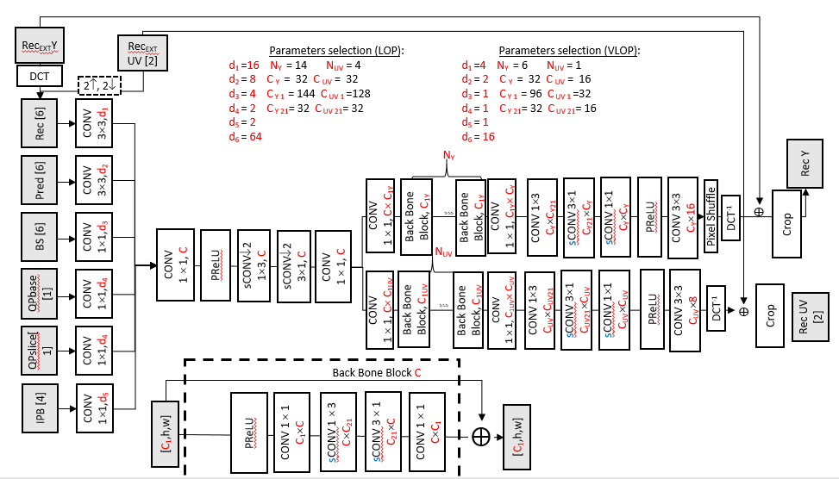
Figure 1. LOP and VLOP filters in NNVC-10
Proponents of tests EE1-1.3, EE1-1.4 and EE1-1.5 provided their solutions for both LOP and VLOP keeping filters unified. Tests EE1-1.1 and EE1-1.2 provided solution and test results only for LOP.

Table 1 Tests EE1-1: LOP in-loop filter
Test | Random Access |  |  | All Intra |  |  | kMAC/pxl |  |  | Param,M |  |  | Source
Test | Y | U | V | Y | U | V | Total | Filter | Intra | Total | Filter | Intra
NNVC-LOP | 0.0% | 0.0% | 0.0% | 0.0% | 0.0% | 0.0% | 21.7 | 16.9 | 4.8 | 1.5 | 0.21 | 1.3 | JVET-AJ0014
EE1-1.1 (int) | -0.1% | 1.2% | 1.2% | -0.1% | 1.0% | 0.9% | 21.7 | 16.9 | 4.8 | 1.5 | 0.20 | 1.3 | JVET-AJ0080
EE1-1.1 (fl) | 0.0% | 1.1% | 1.1% | -0.1% | 0.9% | 0.8% | 21.7 | 16.9 | 4.8 | 1.5 | 0.20 | 1.3 | JVET-AJ0080
EE1-1.2 | -0.4% | 0.0% | 0.3% | -0.4% | -0.1% | 0.4% | 21.7 | 16.9 | 4.8 | 1.5 | 0.49 | 1.3 | JVET-AJ0165
EE1-1.3 | -0.3% | -1.2% | -1.0% | -0.3% | -1.1% | -0.9% | 21.6 | 16.8* | 4.8 | 1.5 | 0.21 | 1.3 | JVET-AJ0054
EE1-1.4.1 | 0.0% | 0.8% | 0.4% | 0.0% | 0.6% | 0.6% | 21.7 | 16.9 | 4.8 | 1.5 | 0.21 | 1.3 | JVET-AJ0066
EE1-1.5.1 | -0.2% | -0.4% | -0.8% | -0.1% | -0.4% | -0.4% | 21.7 | 16.9 | 4.8 | 1.5 | 0.21 | 1.3 | JVET-AJ0182
EE1-1.5.2 | 0.0% | -2.5% | -3.2% | 0.0% | -2.4% | -2.8% | 21.7 | 16.8 | 4.8 | 1.5 | 0.21 | 1.3 | JVET-AJ0182
(*) w/o optimal implementation
Table 2 Tests EE1-1 VLOP in-loop filter
Test | Random Access |  |  | All Intra |  |  | kMAC/pxl |  |  | Param,M |  |  | Source
Test | Y | U | V | Y | U | V | Total | Filter | Intra | Total | Filter | Intra
NNVC-VLOP | 0.0% | 0.0% | 0.0% | 0.0% | 0.0% | 0.0% | 10.0 | 5.2 | 4.8 | 1.5 | 0.06 | 1.3 | JVET-AJ0014
EE1-1.3 | 0.0% | 0.2% | -0.1% | -0.1% | 0.0% | -0.1% | 9.9 | 5.1 | 4.8 | 1.5 | 0.06 | 1.3 | JVET-AJ0054
EE1-1.4.1 | -0.1% | 1.3% | 1.0% | -0.1% | 1.4% | 1.3% | 10.0 | 5.2 | 4.8 | 1.5 | 0.06 | 1.3 | JVET-AJ0066
EE1-1.5.3 | -0.1% | 1.9% | 1.5% | -0.2% | 1.8% | 1.4% | 10.0 | 5.2 | 4.8 | 1.5 | 0.06 | 1.3 | JVET-AJ0182
EE1-1.5.4 | 0.0% | 0.1% | 0.1% | -0.1% | 0.1% | 0.3% | 10.0 | 5.2 | 4.8 | 1.5 | 0.06 | 1.3 | JVET-AJ0182

HOP filter modifications

EE1-1.1 – Partial Convolution and Over-Parameterization.
The motivation of the test reduction of overall number of convolutions in order to reduce the latency. Run-time reduction confirms 5-7% decoder run time reduction.

EE1-1.2 – LOP with residual groups and Attention
Several modifications of LOP architecture provide 0.4% gain both in all intra and random-access test configuration. Some new operations introduced (hard sigmoid, depth-wise convolution, max-pooling, bi-linear interpolation) which not optimized in SADL. Sigmoid unlikely to be quantized w/o loss, also complexity of sigmoid cannot be reflected in kMAC/pxl. For depth wise separable convolution SIMD optimization provided. Still run time increase 7-8% relatively to NNVC anchor observed.

EE1-1.3 - NN in-loop filters using early cropping
Non-used elements are cropped out, so overall kMAC/pxl has been reduced. This complexity is utilized to increase the number of channels. So, gain of 0.3% is observed in random access and all intra configuration (for LOP). For VLOP gain is 0.1%. Decoder run time increases substantially, likely because number of channels is not multiple of 16.

EE1-1.4 - Reduced complexity input feature extraction for LOP & VLOP

A reduced complexity input features extraction is tested for LOP3 and VLOP2 filters. It is proposed to remove application of the DCT transform on the sparse input data types, such as IPB and BS (subtest 1.4.1), and further reduce input data volume by combining planes of the sparse input data types (1.4.2). Simulation results for sub-test 1.4.1 are reported. In VLOP configuration, average luma gain of 0.1% is consistently reported for AI/RA/LDB, with 0.2% luma coding gain for ClassF. Run-time decreased is reported for all configurations, around 2-4% for Encoder and 4-6% for decoder. The same method was tested in LOP configuration, with similar gain being observed for floating point SADL and no gain for SADL int16 implementation. Proponents is planning to report another set or results for quantized model during this meeting.
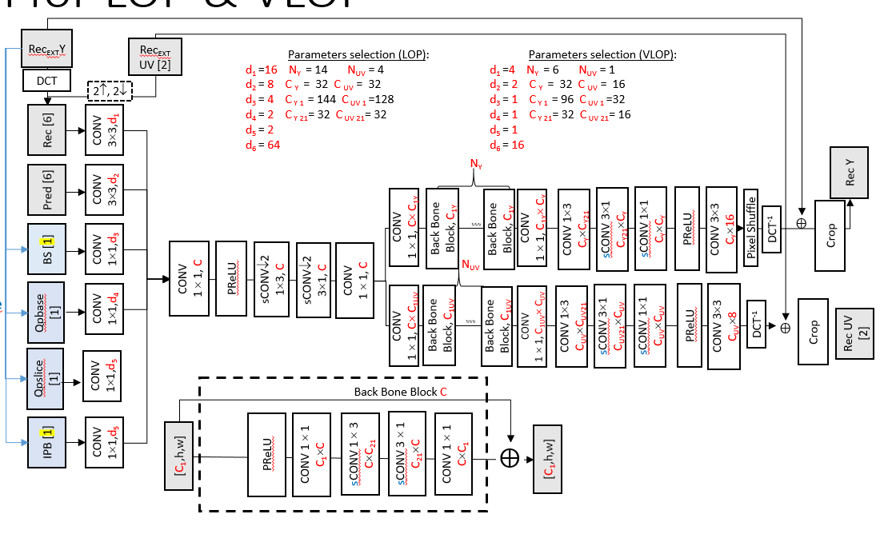
Figure 1. Changes of EE1-1.4.1 (experiments EE1-1.4.2 results were not reported)

EE1-1.5 - Multiscale blocks in LOP3 and VLOP2 filter

Two variants of multi-scale back bone block are proposed. Gain for all color components in both all-intra and random-access test is observed for EE1.1.5.1 (multi-scale BBB variant 1 with LOP). Buts similar changes for VLOP show luma gain (01..0.2%) and chroma drop (1.4-1.9%)
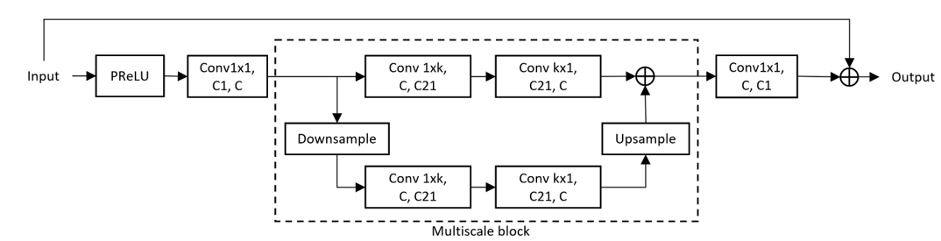
Figure 2 Multiscale Back bone block (variant 1): two branches
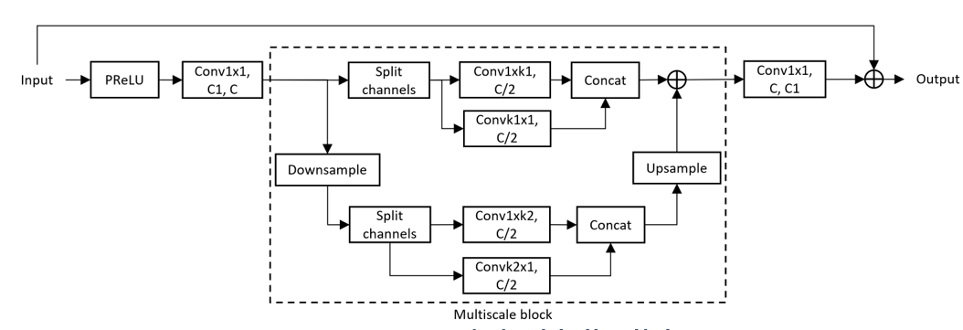
Figure 3 Multiscale Back bone block (variant 2): four branches

HOP filter modifications
HOP filter architecture is shown in Figure 4. Two out of 23 back bone blocks include attention block.

EE1-2.2 - Block-size invariant implementation of HOP

Only inference is changed. Attention map computation equation modified on a way it doesn’t depend on block size. Minor performance variation (0.0%).

EE1-2.3 - Block based QP information in NN loop filters
One of the inputs for NN-base filter in Slice QP. Under common test conditions all blocks share the same QP. If adaptive QP is enabled there are two options: replace slice QP with average QP inside patch or use block QP instead. It is shown that the second variant (block QP) with proper NN-filter retraining brings 1.6% performance improvement (Table 3). Proposed to change SliceQP to BlockQP (there will be no change at common test conditions).

Table 3 Tests EE1-2.3 results with Adaptive Qp enabled in the anchor and test

Test | Random Access |  |  | All Intra
Test | Y | U | V | Y | U | V
HOP3 (avg QP) vs HOP3 (slice) | 0.8% | 2.0% | 2.4% | 1.4% | 2.6% | 2.6%
HOP3 block QP(retrained) vs HOP3 (slice) | -0.8% | -0.9% | -1.3% | -0.9% | -1.2% | -1.3%
HOP5 (avg QP) vs HOP5 (slice) | 0.6% | 1.2% | 1.3% | 0.7% | 2.0% | 2.6%
HOP5 block QP(retrained) vs HOP5 (slice) | -1.0% | 0.5% | 0.4% | -1.6% | 0.4% | -0.3%

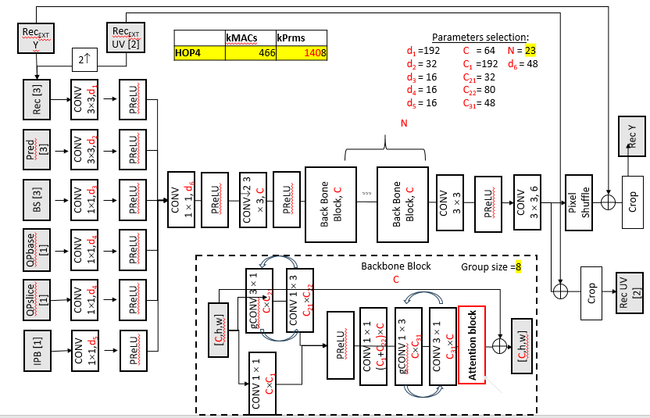

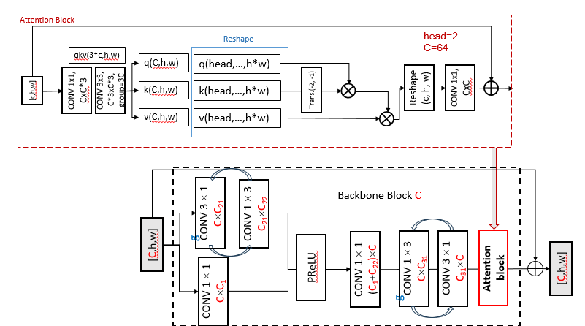
Figure 4 HOP filter architecture with attention block

Table 3 Tests EE1-2 HOP in-loop filter
Test | Random Access |  |  | All Intra |  |  |  | kMAC/pxl |  |  | Param,M |  |  | Source
Test | Y | U | V | Y |  | U | V | Total | Filter | Intra | Total | Filter | Intra
NNVC-HOP | 0.0% | 0.0% | 0.0% | 0.0% | 0.0% |  | 0.0% | 471 | 466 | 4.8 | 2.96 | 1.439 | 1.3 | JVET-AJ0014
EE1-2.2 | 0.0% | 0.0% | 0.0% | 0.0% |  | 0.0% | 0.0% | 471 | 466 | 4.8 | 2.96 | 1.439 | 1.3 | JVET-AJ0166

EE1-3.1 - RA/LDB Unified Reference Frame Synthesis for VVC Inter Coding

Table 4 Tests EE1-3: NN-based Inter prediction
Test | Random Access |  |  | Low-delay B |  |  | kMAC/pxl |  |  |  | Param (Mprm)
Test | Y | U | V | Y | U | V | Total | FL | Intra | Inter | Total | FL | Intra | Inter
NNVC-10.0-LOP | 0.0% | 0.0% | 0.0% | 0.0% | 0.0% | 0.0% | 21.7 | 16.9 | 4.8 | 0 | 1.5 | 0.21 | 1.3 | 0
EE1-3.1.2 | -3.5% | -4.4% | -4.3% | -3.6% | -3.9% | -0.3% | 748.7 | 16.9 | 4.8 | 727 | 5.3 | 0.21 | 1.3 | 3.8
The training set is still Vimeo-90K triplet. No decoder run time reported.
Gain is 3.5…3.6% (random access and low-delay B), but complexity is still very high 727 kMAC/pxl.

EE1-4.1 - Wavelet transform for super-resolution loss function
NNVC NNSR filter was retrained with and without DWT in loss function. DWT in loss function provides small chroma gain.

SW location
https://vcgit.hhi.fraunhofer.de/jvet-ai-ee1/VVCSoftware_VTM/-/tree/EE1-X.X

Reference
- E. Alshina, F. Galpin, R. Chang, Y. Li, D. Rusanovskyy, M. Santamaria, J. Ström, Z. Xie Exploration Experiments on Neural Network-based Video Coding (EE1) JVET-AI2023
- F. Galpin (chair), R. Chang, Y. Li, Y. Li, J. N. Shingala, Z. Xie (vice-chairs) JVET AHG report: NNVC software development (AHG14) JVET-AJ0014
- E. Alshina, F. Galpin [AHG11] [AHG14] Teleconference on NNVC JVET-AJ0041

