    Joint Video Experts Team (JVET)  of ITU-T SG 16 WP 3 and ISO/IEC JTC 1/SC 29  35th Meeting, Sapporo, JP, 12–19 July 2024 | Document: JVET-AI0204-v2

Title: | EE1-Related: EE1-1.5 with reduced complexity reduced complexity input feature extraction
Status: | Input document to JVET
Purpose: | Proposal
Author(s) or  Contact(s): | Dmytro Rusanovskyy,  Yun Li,  Marta Karczewicz (Qualcomm) | Email: | dmytror@qti.qualcomm.com  yli30@qti.qualcomm.com  martak@qti.qualcomm.com
Source: | Qualcomm
_____________________________

Abstract
NN filter for Very Low Operational Point (VLOP), targeting complexity of 5kMAC/pixel level, was proposed in JVET-AH0051 and adopted to NNVC. In JVET-AI0107, a new VLOP filter based on LOP3 architecture is tested. In this proposal VLOP filter of EE1-1.5 is modified with reduced complexity input feature extraction. It is proposed to remove application of the DCT transform on sparse input data and further reduce input data volume by aggregating supplementary data into fewer number of planes. As a result, volume of the input data to the NN model can be reduced by around 40% with around 2% kMAC/pixel reduction.
The performance of the model (including NNIntra) is compared to EE1-1.5 model, trained with the same hyperparameters, and it was tested with NNVC9.1 inference. Summary of proposed method results (int 16), comparing to the respective EE1-1.5 method are shown below:
RA -0.1% (Y), 0.4% (U), 0.6% (V),
AI -0.1% (Y), 0.4% (U), 0.8% (V),
It is proposed to study proposed method in EE1.

Introduction
NN filter for Very Low Operational Point (VLOP), targeting complexity of 5kMAC/pixel level, was proposed in JVET-AH0051 and adopted to NNVC. A new VLOP filter is being studied in EE1-1.5, JVET-AH0107. The filter of EE1-1.5 is based on LOP3 architecture and its backbone operates at the reduced spatial resolution, comparing to the input data. To achieve it, 2x2 DCT transform over pixels and supplementary data, such as IPB, BS, is used to exchange spatial resolution to the number channels at the headblock. Block diagram of the VLOP filter of EE1-1.5 is shown in Figure 1.
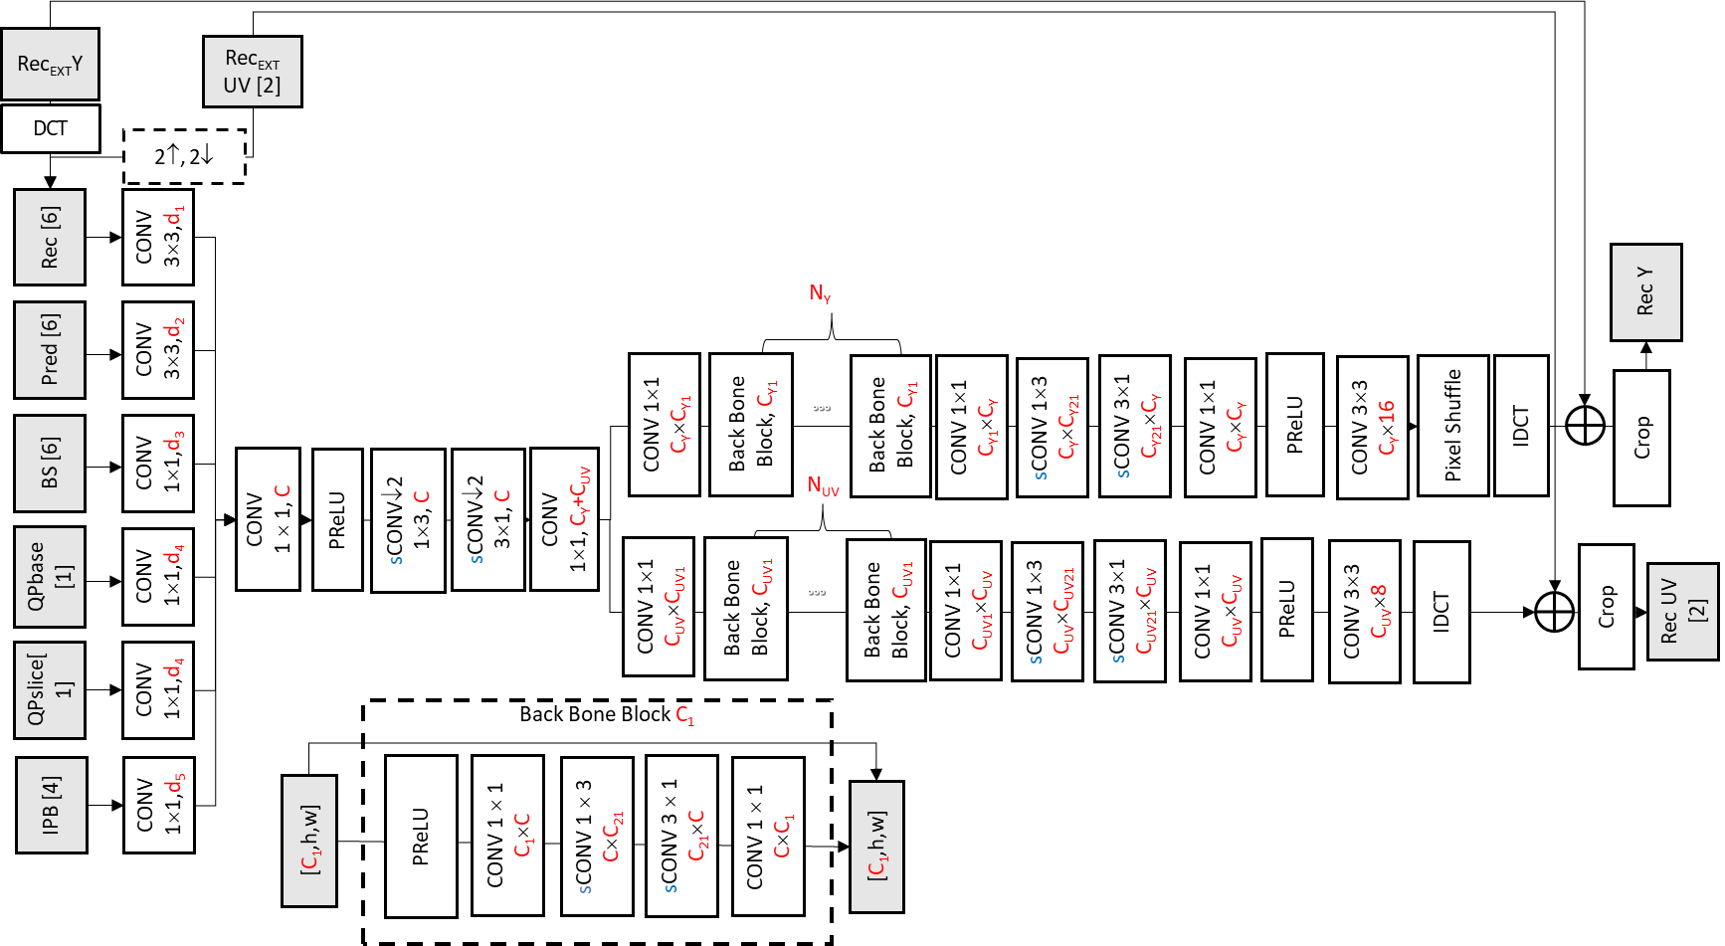
Fig. 1. The architecture of EE1-1.5 VLOP filter.

Proposed model for VLOP
In this contribution VLOP filter of EE1-1.5 is modified with reduced complexity input feature extraction. It is proposed to remove application of the DCT transform on the sparse input data types, such as IPB and BS, and further reduce input data volume. It is also proposed to reduce number of BS input planes from 6 to 1, IPB planes from 4 to 1, as well combine QP base and slice information into a single plane by means of codewords compaction. As a result, number of input planes in the proposed filter is around 40% less, comparing to the VLOP filter of EE1-1.5.
Block diagram of the proposed filter is shown in Figure 2, with blocks affected in this proposal marked in red.
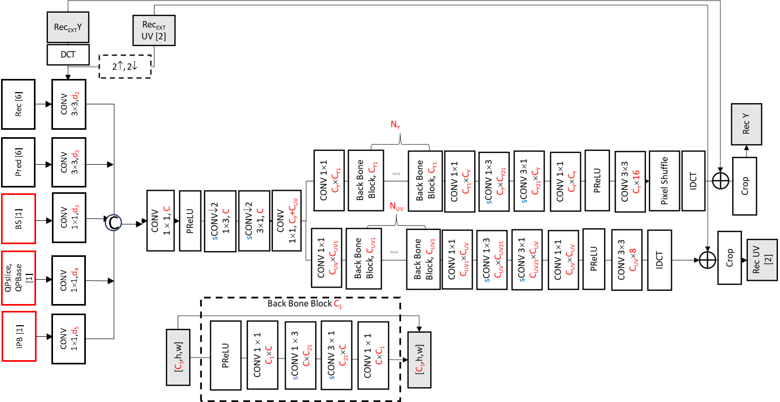
Prepr
Fig. 2. Proposed filter architecture.

Training and inference information
Training of the model is performed over LOP2 Stage 3 dataset. Training follows the LOP3 training hyperparameters: luma:chroma weighting 12:2, batch size 64, and milestones 41, 51, 55, learning rate 2e-4.
Table 1. Network Information for the model in EE1-1.5 in training.
Network Information in Training Stage
Mandatory | GPU Type | GPU: NVIDIA A100-PCIE-40GB
Mandatory | Framework: | PyTorch v2.1
Mandatory | Number of GPUs per Task | 1
Mandatory | Epoch: | Stage3: 60
Mandatory | Batch size: | Stage3: 64
Mandatory | Loss function: | L1 and MSE
Mandatory | Training time: | Stage3: 12 days
Mandatory | Training data information: | DIV2K, BVI-DVC, TVD
Mandatory | Training configurations for generating compressed training data (if different to VTM CTC): | The LOP stage 3 dataset
Optional
Optional | Number of iterations
Optional | Patch size | 144x144
Optional | Learning rate: | Stage3: 2e-4, milestones [41, 51, 55]
Optional | Optimizer: | ADAM
Optional | Preprocessing:
Optional | Mini-batch selection process:
Optional | Other information:

Table 2. Network Information for the model in inference.
Network Information in Inference Stage
Mandatory | HW environment:
Mandatory | GPU Type | N/A
Mandatory | Framework: | SADL
Mandatory | Number of GPUs per Task | 0
Mandatory | Total Parameter Number | 59625
Mandatory | Parameter Precision (Bits) | int16
Mandatory | Memory Parameter (MB) | fp32: 0.25MB, int16: 0.13MB
Mandatory | Multiplay Accumulate (MAC) | 5.0 kMAC/pixel
Optional
Optional | Total Conv. Layers
Optional | Total FC Layers
Optional | Total Memory (MB)
Optional | Batch size: | 1
Optional | Patch size | 128x128, 256x256
Optional | Changes to network configuration or weights required to generate rate points
Optional | Peak Memory Usage (Total)
Optional | Peak Memory Usage (per Model)
Optional | Border handling
Optional | Other information:

Results
The proposed method was integrated to the NNVC-9.1rc and tested under NNVC CTC in int16 configuration. The summary of results in comparison to the respective EE1-1.5 model (int16), trained with the same configurations (LR=0.0002 are shown in Table 1.
Table 1. BD-rate performance of the proposed method, comparing to EE1-1.5 model, float.
 | AI |  |  | RA
 | Y-PSNR | U-PSNR | V-PSNR | Y-PSNR | U-PSNR | V-PSNR
Class A1 | -0.14% | 0.39% | 1.17% | 0.11% | 0.41% | 1.12%
Class A2 | 0.01% | 0.88% | 0.17% | -0.01% | 0.93% | 0.12%
Class B | -0.02% | 0.30% | 0.92% | -0.09% | 0.31% | 1.02%
Class C | -0.06% | 0.21% | 0.56% | -0.16% | 0.00% | 0.20%
Class E | -0.05% | 0.11% | 0.98%
Overall | -0.05% | 0.36% | 0.77% | -0.05% | 0.37% | 0.64%
Class D | -0.07% | 0.69% | 0.76% | -0.28% | 0.50% | 0.53%

Conclusions
In this contribution VLOP filter of EE1-1.5 is modified with reduced complexity input feature extraction. It is proposed to remove application of the DCT 2x2 transform on sparse input data and further reduce input data volume. As a result, volume of the input data to NN model can be reduced by around 40% with around 2% kMAC/pixel reduction. The performance of the model (including NNIntra), compared to the respective EE1-1.5 model, trained with identical hyperparameters, was tested in NNVC9.1 for inference and summary results are shown below:
RA -0.1% (Y), 0.4% (U), 0.64% (V),
AI -0.1% (Y), 0.4% (U), 0.8% (V),
It is proposed to study the method in EE1.

References
[1] EE1-5: Study of the NN architecture at Very Low Operational Point, JVET-AH0051, D. Rusanovskyy, Y. Li, M. Karczewicz (Qualcomm), J. Li, Y. Li, C. Lin, K. Zhang, L. Zhang (Bytedance), Z. Xie, Y. Yu, H. Yu, D. Wang (OPPO), Joint Video Experts Team (JVET) of ITU-T SG 16 WP 3 and ISO/IEC JTC 1/SC 29 34th Meeting, Rennes, FR, 1417–24 April 2024.
[2] EE1-1.2: Joint LOP model with inputs transformed, JVET-AH0080, D. Liu, J. Ström, M. Damghanian, P. Wennersten, D. Rusanovskyy, Y. Li, M. Karczewicz, T. Shao, P. Yin, S. McCarthy, J. N. Shingala, A. Shyam, A. Suneja, S. P. Badya, Joint Video Experts Team (JVET) of ITU-T SG 16 WP 3 and ISO/IEC JTC 1/SC 29 34th Meeting, Rennes, FR, 17–24 April 2024.
[3] Common Test Conditions and evaluation procedures for neural network-based video coding technology, E. Alshina, R.-L. Liao, S. Liu, A. Segall, JVET-AF2016, Joint Video Experts Team (JVET) of ITU-T SG 16 WP 3 and ISO/IEC JTC 1/SC 29, 32nd Meeting, Hannover, DE, 13–20 October 2023.

Patent rights declaration(s)
Qualcomm may have current or pending patent rights relating to the technology described in this contribution and, conditioned on reciprocity, is prepared to grant licenses under reasonable and non-discriminatory terms as necessary for implementation of the resulting ITU-T Recommendation | ISO/IEC International Standard (per box 2 of the ITU-T/ITU-R/ISO/IEC patent statement and licensing declaration form).

