    Joint Video Experts Team (JVET)  of ITU-T SG 16 WP 3 and ISO/IEC JTC 1/SC 29  35th Meeting, Sapporo, JP, 12–19 July 2024 | Document: JVET-AI0196-v5

Title: | AHG8: On combined pre- and post-processing and ROI-based adaptive QP for machine vision
Status: | Input document to JVET
Purpose: | Proposal
Author(s) or  Contact(s): | Shurun Wang  Binzhe Li  Jie Chen  Yan Ye (Alibaba Group)  Shiqi Wang (City University of Hong Kong) | Tel:  Email: | {shurun.wsr, libinzhe.lbz, jiechen.cj, yan.ye}@alibaba-inc.com  shiqwang@cityu.edu.hk
Source: | Alibaba Group, City University of Hong Kong
_____________________________

Abstract
This contribution reports the performance of enabling both pre- and post-processing and ROI-based adaptive QP for machine vision. According to experimental results, it is reported that when both pre- and post-processing and ROI-based adaptive QP in AGH8 software are enabled, the combined method achieves 37.11% (RA), 34.63% (LD) and 43.34% (AI) BD-rate savings for object detection task on the SFU-HW dataset under VCM CTC, which is higher than individually enabling pre- and post-processing or ROI-based adaptive QP for machine vision.
For object tracking task on the TVD dataset under VCM CTC, the combined method achieves 62.92% (RA), 43.69% (LD) and 72.48% (AI) BD-rate savings.
The text for

Description of both pre- and post-processing and ROI-based adaptive QP enabling
In previous meetings, JVET-AB0275 [1] proposed the ROI-based adaptive QP method (ROIAQP) for encoding optimization, and JVET-AH0157 [2] proposed the pre- and post-processing method (PREPOST), which consists of the pre-processing of foreground and background [3] and the enhancement post-filtering [4]. Based on the interesting coding performance introduced by these methods, they are included in the technical report (TR) [5] on optimization of encoders and receiving systems for machine analysis of coded video content, and the software for both methods are available in AHG8 software branch. In this contribution, the experiments of combining both methods are conducted and the results are reported.
The experiment flowchart is shown in Figure 1. The original video is processed with foreground and background pre-processing first. And then the pre-processed video is encoded with ROIAQP optimized VVC encoder. After decoding, the decoded video is further processed by the enhancement post-filter. And finally, the filtered video is fed to the machine consumption model.

Figure 1 The experiment flowchart on combined pre- and post-processing and ROI-based adaptive QP

Experimental results
The experiment is conducted under the VCM CTC specified in JVET-AH2031 [6], where the VTM version is 23.3 for test and 23.0 for anchor. The overall BD rate performance for detection and tracking is shown in Table 1. Overall, better coding gain can be achieved from combined pre- and post-processing and ROI-based adaptive QP, noted as JOINT, compared with individually enabling pre- and post-processing or ROI-based adaptive QP.

Table 1 Overview of the averaged BD-rate performance in terms of mono-mAP
Task | Dataset | Methods | RA | LD | AI
Detection | SFU-HW | PREPOST | -32.75% | -33.26% | -40.29%
Detection | SFU-HW | ROIAQP | -11.21% | -4.09% | -9.03%
Detection | SFU-HW | JOINT | -37.11% | -34.63% | -43.34%
Tracking | TVD | PREPOST | -52.05% | -39.40% | -65.45%
Tracking | TVD | ROIAQP | -28.39% | -1.38% | -31.95%
Tracking | TVD | JOINT | -62.92% | -43.69% | -72.48%
The per-class performance on SFU-HW dataset for object detection is shown in Table 2 and the per-sequence performance on TVD dataset for object tracking is given in Table 3. (Please note “/” in the tables indicates the performance cannot be calculated validly, due to the nonmonotonic machine task performance or the non-overlap between rate-accuracy curves). The results show that the combined pre- and post-processing and ROI-based adaptive QP achieves significant performance improvement under CTC.

Table 2 Performance of combined pre- and post-processing and ROI-based adaptive QP on SFU-HW dataset under RA, LD and AI configurations.
 |  | End-to-End BD-rate (%)
 |  | Mono-mAP | mAP | End-to-End BD-mAP
SFU-HW | Class A | -17.75% | / | 2.54
SFU-HW | Class B | -38.03% | / | 7.85
SFU-HW | Class C | -41.44% | -42.68% | 6.17
SFU-HW | Class D | -36.70% | -37.76% | 4.14
SFU-HW | Average | -37.11% | / | 5.78
LD | Object Detection | Mono-mAP | mAP | End-to-End BD-mAP
SFU-HW | Class A | -35.94% | -35.25% | 10.23
 | Class B | -30.24% | / | 6.01
 | Class C | -37.18% | -35.06% | 5.77
 | Class D | -36.15% | -36.44% | 4.56
 | Average | -34.63% | / | 5.81
AI | Object Detection | Mono-mAP | mAP | End-to-End BD-mAP
SFU-HW | Class A | -45.67% | -45.14% | 15.04
 | Class B | -51.31% | / | 13.73
 | Class C | -46.27% | -46.63% | 9.14
 | Class D | -31.87% | -31.87% | 5.18
 | Average | -43.34% | / | 9.79

Table 3 Performance of combined pre- and post-processing and ROI-based adaptive QP on TVD dataset under RA, LD and AI configurations.
RA | Object Tracking | End-to-End BD-Rate [%]
RA | Object Tracking | Mono-MOTA | MOTA | End-to-end BD-MOTA
TVD | TVD-01-1 | -65.98% | / | 10.62
TVD | TVD-01-2 | -77.09% | -76.32% | 8.45
TVD | TVD-01-3 | -52.26% | / | 6.16
TVD | TVD-02-1 | -35.37% | -36.30% | 3.58
TVD | TVD-03-1 | -54.12% | -55.29% | 7.84
TVD | TVD-03-2 | -73.27% | / | 7.94
TVD | TVD-03-3 | -82.37% | -83.50% | 10.48
TVD | Average | -62.92% | / | 7.87
LD | Object Tracking | Mono-MOTA | MOTA | End-to-end BD-MOTA
TVD | TVD-01-1 | -53.92% | -58.05% | 8.02
 | TVD-01-2 | -63.09% | / | 6.93
 | TVD-01-3 | -39.11% | / | 4.39
 | TVD-02-1 | 26.41% | / | -1.32
 | TVD-03-1 | -34.94% | -34.72% | 5.75
 | TVD-03-2 | -69.67% | / | 7.14
 | TVD-03-3 | -71.48% | -72.55% | 7.35
 | Average | -43.69% | / | 5.46
AI | Object Tracking | Mono-MOTA | MOTA | End-to-end BD-MOTA
TVD | TVD-01-1 | -79.70% | -79.40% | 21.57
 | TVD-01-2 | -88.09% | -87.90% | 17.90
 | TVD-01-3 | -65.47% | / | 9.72
 | TVD-02-1 | -41.32% | -44.69% | 4.03
 | TVD-03-1 | -70.21% | -70.28% | 15.16
 | TVD-03-2 | -77.08% | -78.26% | 13.30
 | TVD-03-3 | -85.52% | -86.34% | 17.64
 | Average | -72.48% | / | 14.19

Proposal
In this contribution, the performance of combined pre- and post-processing and ROI-based adaptive QP is reported. Simulation results show that, jointly applying pre- and post-processing and ROI-based adaptive QP can achieve obvious coding performance improvement compared with pre- and post-processing or ROI-based adaptive QP only.
Thus, it is suggested to update the following text into section 5.1 of the next draft of technical report (TR) on optimization of encoders and receiving systems for machine analysis of coded video content, as shown in the attached TR draft file.
“It is noted that depending on specific use cases, the technologies outlined in this report can be implemented individually or in combination to optimize machine consumption performance within the constraints of the system capabilities. For example, a better performance can be achieved by applying a post-filtering being optimized towards object detection on the decoded video that was pre-processed with the method described in Annex A.2 and encoded with the ROI-based adaptive QP method described in Annex A.1. When employing multiple technologies simultaneously, it is important to consider that certain combinations can be impractical or infeasible due to inherent methodological constraints.”
Further, it is suggested to include the combined pre- and post-processing and ROI-based adaptive QP implementation into AHG8 software branch.
The text for the annex that describes post processing currently in TR is shown below:

A.3 Enhancement post-processing algorithm for machine consumption

A.3.1 Introduction
An implementation of the method described in this section can be found in the branch “JVET-AG0212” in a software repository hosted by JVET. This implementation can be found under the tag https://vcgit.hhi.fraunhofer.de/jvet-ahg-ofm/vtm-ofm/-/tags/JVET-AG0212-v1.
This implementation is conducted with a neural network model, which can enhance the reconstructed video sequence towards machine vision.

A.3.2 Post-processing network
Denote the reconstructed pictures as Ir (input to the post-processing network) and post-processed pictures as Ip (output of the post-processing network), the architecture of the post-processing network is shown in Figure A.2. In order to achieve a multi-granularity post-processing, we use the promising U-Net architecture with parallel mirrored skip connections and multi-resolution modules. In particular, the reconstructed picture Ir is fed to feature down sampling branch. After that, the intermediate feature Fd1 of 1st resolution is extracted by the convolution layer. Then, the intermediate features Fdi are processed with the base block to F'di. After that, the F'di is downsampled to Fdi+1 by the max pooling layer with kernel size 2x2. The F'di is also copied to the up branch by the skip connection. In the feature up sampling branch, the intermediate feature F'ui+1 or F'd4 is upsampled by the deconvolution layer and pixel shuffle function with the upscaling factor of 2. Then, the unsampled feature is combined with skip connected feature F'di. The convolution layer with kernel size 1x1 reduces the channel size of the combined feature and obtains the feature Fui. The base block is also facilitated to transform the Fui to F'ui. Finally, the output visual signal Ip is inferred based on the F'u1. Specifically, the base block of the visual signal restoration network is introduced to improve the visual signal enhancement performance, which could enhance the features representation with the channel attention mechanism with the adaption layer. Base block consists of convolution layers, the depth-wase convolution layer, the Gaussian error linear units (GELU), the layer normalization, channel attention and shortcuts.
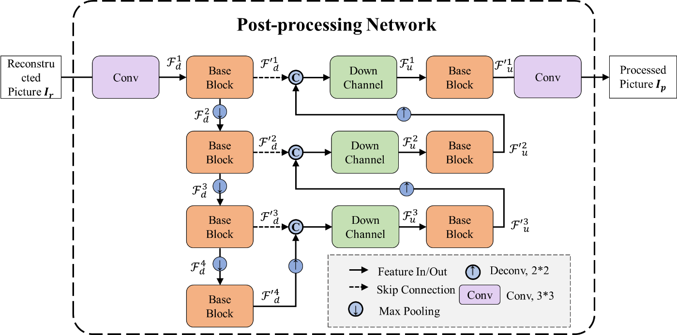
Figure A.2 — The architecture of the post-processing network.
The text for the annex which describes possible combinations of tools that are proven to provide benefit is shown below,
Examples of combinations by which a better performance can be achieved are described in Annes A.0.

A.0 Examples of combinations with better performance
A better performance can be achieved by jointly applying pre-processing, ROI-based adaptive QP and post-processing, which are described in Annex A.2, Annex A.1 and Annex A.3, respectively, compared with pre- and post-processing or ROI-based adaptive QP only.

References
- C. Hollmann, J. Ström, P. Wennersten, L. Litwic, R. Sjöberg, M. Damghanian, “Information about Ericsson’s response to the CfP for Video Coding for Machines,” Joint Video Experts Team (JVET) of ITU-T SG 16 WP 3 and ISO/IEC JTC 1/SC 29 input document JVET-AB0275, 28th Meeting, Mainz, DE, 20–28 October 2022 (available online at https://jvet-experts.org/)
- S. Wang, B. Li, J. Chen, Y. Ye, “AHG8: On combined pre-processing and post-processing for machine vision,” Joint Video Experts Team (JVET) of ITU-T SG 16 WP 3 and ISO/IEC JTC 1/SC 29 input document JVET-AH0157, 34th Meeting, Rennes, FR, 17–27 April 2024 (available online at https://jvet-experts.org/).
- B. Li, S. Wang, J. Chen, Y. Ye, S. Wang, “AHG8: A preprocessing software implementation for OFM,” Joint Video Experts Team (JVET) of ITU-T SG 16 WP 3 and ISO/IEC JTC 1/SC 29 input document JVET-AD0047, 30th Meeting, Antalya, TR, 21–28 April 2023 (available online at https://jvet-experts.org/).
- B. Li, S. Wang, J. Chen, Y. Ye, S. Wang, “AHG8: A post-processing algorithm for machine consumption,” Joint Video Experts Team (JVET) of ITU-T SG 16 WP 3 and ISO/IEC JTC 1/SC 29 input document JVET-AG0212, 33rd Meeting, Online, 17–26 January 2024 (available online at https://jvet-experts.org/).
- S. Liu, J. Chen, C. Hollmann, “Optimization of encoders and receiving systems for machine analysis of coded video content (draft 5),” Joint Video Experts Team (JVET) of ITU-T SG 16 WP 3 and ISO/IEC JTC 1/SC 29 output document JVET-AH2030, 34th Meeting, Rennes, FR, 17–27 April 2024 (available online at https://jvet-experts.org/).
- S. Liu, C. Hollmann, “Common test conditions for optimization of encoders and receiving systems for machine analysis of coded video content,” Joint Video Experts Team (JVET) of ITU-T SG 16 WP 3 and ISO/IEC JTC 1/SC 29 output document JVET-AH2031, 34th Meeting, Rennes, FR, 17–27 April 2024 (available online at https://jvet-experts.org/).

Patent rights declaration(s)
Alibaba group and City University of Hong Kong may have current or pending patent rights relating to the technology described in this contribution and, conditioned on reciprocity, is prepared to grant licenses under reasonable and non-discriminatory terms as necessary for implementation of the resulting ITU-T Recommendation | ISO/IEC International Standard (per box 2 of the ITU-T/ITU-R/ISO/IEC patent statement and licensing declaration form).

