    Joint Video Experts Team (JVET)  of ITU-T SG 16 WP 3 and ISO/IEC JTC 1/SC 29  35th Meeting, Sapporo, JP, 12–19 July 2024 | Document: JVET-AI0094-v2

Title: | EE2-3.10 Sharp motion compensation filter for bi-prediction
Status: | Input document to JVET
Purpose: | Proposal
Author(s) or  Contact(s): | Jonatan Samuelsson-Allendes | Tel:  Email: | +46721882169  samuelssonj@sharplabs.com
Source: | Sharp Labs of America, Inc.
_____________________________

Abstract
This input contribution reports the results of EE2-3.10. The test includes a new motion compensation (MC) filter for luma with sharper filter properties compared to the existing MC filter in ECM. In subtest a, the proposed filter is used for all bi-predicted blocks, while the existing MC filter is used for all uni-predicted blocks. In subtest b, the proposed filter is used for bi-predicted blocks with both width and height greater than 4, while the existing MC filter is used for all other blocks. The filters for chroma and the filters for RPR are unchanged. EE2-3.10a gives an average BD-Rate(PSNR-Y/U/V) impact of -0.06%/-0.01%/-0.05% for RA and -0.03%/0.11%/-0.18% for LDB. EE2-3.10b gives an average BD-Rate(PSNR-Y/U/V) impact of -0.07%/0.00%/0.00% for RA and -0.10%/-0.11%/-0.16% for LDB. In the first version of the proposal, 2 QP points are copied from the anchor for subtest EE2-3.10b and some test classes are from a heterogenous cluster (yielding somewhat unreliable encoding and decoding times). In the second version of the contribution, the missing results are added, and all class A-D results are updated with run times from a homogenous cluster. The reported enc/dec time for EE2-3.10a is for RA: 100.2%/100.0% and for LDB: 100.1%/99.5%. The reported enc/dec time for EE2-3.10b is for RA: 100.2%/99.8% and for LDB: 100.1%/99.6%.

Problem Statement
The background section of the this contribution is copied from the original proposal, JVET-AH0141. Motion compensation (MC) filtering in video coding standards is generally realised with fixed Finite Impulse Response (FIR) filters and in ECM, the motion compensation filter for luma is a 12-tap filter with 8-bit filter coefficients and 16 phases and looks as follows:

ecmFilter = {
{ 0, 0, 0, 0, 0, 256, 0, 0, 0, 0, 0, 0},
{ -1, 2, -3, 6, -14, 254, 16, -7, 4, -2, 1, 0},
{ -1, 3, -7, 12, -26, 249, 35, -15, 8, -4, 2, 0},
{ -2, 5, -9, 17, -36, 241, 54, -22, 12, -6, 3, -1},
{ -2, 5, -11, 21, -43, 230, 75, -29, 15, -8, 4, -1},
{ -2, 6, -13, 24, -48, 216, 97, -36, 19, -10, 4, -1},
{ -2, 7, -14, 25, -51, 200, 119, -42, 22, -12, 5, -1},
{ -2, 7, -14, 26, -51, 181, 140, -46, 24, -13, 6, -2},
{ -2, 6, -13, 25, -50, 162, 162, -50, 25, -13, 6, -2},
{ -2, 6, -13, 24, -46, 140, 181, -51, 26, -14, 7, -2},
{ -1, 5, -12, 22, -42, 119, 200, -51, 25, -14, 7, -2},
{ -1, 4, -10, 19, -36, 97, 216, -48, 24, -13, 6, -2},
{ -1, 4, -8, 15, -29, 75, 230, -43, 21, -11, 5, -2},
{ -1, 3, -6, 12, -22, 54, 241, -36, 17, -9, 5, -2},
{ 0, 2, -4, 8, -15, 35, 249, -26, 12, -7, 3, -1},
{ 0, 1, -2, 4, -7, 16, 254, -14, 6, -3, 2, -1}}

The same filter is used for both uni-prediction and bi-prediction. Other filters are used for chroma and RPR.
When a block is predicted using bi-prediction, two different reference blocks will be blended together to form the final prediction of the block. One or both of these reference blocks might be located at a non-integer position, and thereby being the result of a filtering operation. Our hypothesis has been that the blending and the filtering can result in that the predicted block is smoother than would be ideal and that a slight level of sharpening would be beneficial to improve the prediction. However, rather than introducing a separate sharpening filter stage in the prediction loop, we propose to use a different MC-filter for bi-predicted blocks compared to uni-predicted blocks.

Proposal
We propose to introduce an additional MC filter to be used for bi-predicted blocks, while the existing MC filter is still used for uni-predicted blocks. No changes are proposed to chroma filters or RPR filters.
The proposed filter is specified as follows:

proposedBiPredFilter = {
{ 0, 0, 0, 0, 0, 256, 0, 0, 0, 0, 0, 0},
{ -1, 3, -5, 8, -16, 256, 15, -6, 3, -1, 0, 0},
{ -2, 5, -9, 15, -30, 253, 32, -12, 5, -2, 1, 0},
{ -3, 7, -12, 21, -40, 244, 50, -18, 9, -4, 2, 0},
{ -3, 8, -15, 25, -48, 235, 71, -25, 12, -6, 2, 0},
{ -3, 9, -16, 28, -53, 220, 93, -32, 16, -8, 3, -1},
{ -3, 8, -16, 28, -54, 204, 116, -39, 19, -10, 4, -1},
{ -2, 8, -15, 27, -53, 183, 139, -45, 22, -12, 5, -1},
{ -2, 6, -13, 25, -50, 162, 162, -50, 25, -13, 6, -2},
{ -1, 5, -12, 22, -45, 139, 183, -53, 27, -15, 8, -2},
{ -1, 4, -10, 19, -39, 116, 204, -54, 28, -16, 8, -3},
{ -1, 3, -8, 16, -32, 93, 220, -53, 28, -16, 9, -3},
{ 0, 2, -6, 12, -25, 71, 235, -48, 25, -15, 8, -3},
{ 0, 2, -4, 9, -18, 50, 244, -40, 21, -12, 7, -3},
{ 0, 1, -2, 5, -12, 32, 253, -30, 15, -9, 5, -2},
{ 0, 0, -1, 3, -6, 15, 256, -16, 8, -5, 3, -1},

Just like the current ECM MC filters, the proposed filter is based on a cos-windowed sinc function. However, a more generalized form has been used, and unlike the current ECM MC filter, $a$ and $b$ have been selected to be slightly lower than 1 (instead of equal to 1). The formula is shown in Equation (1), where A is a scaling factor to provide the desired number of filter taps.
$f\left(x\right)=\cos^{a}\left(Ax\right)sinc\left(\frac{x}{b}\right)$ (1)
The normalized sinc function shown in Equation (2) is used.
$sinc\left(x\right)= \left\{ \begin{aligned}\frac{\sin\left(πx\right)}{π}, x≠0 \\ 1, x=0\end{aligned}\right.$ (2)
Figure 1 illustrates the effect on the sinc function of using an $a$ smaller than 1, and figure 2 illustrates the effect on the cos-window of using a $b$ smaller than 1. Figure 3 illustrates the combined impact of using $a$ and $b$ both slightly lower than 1.
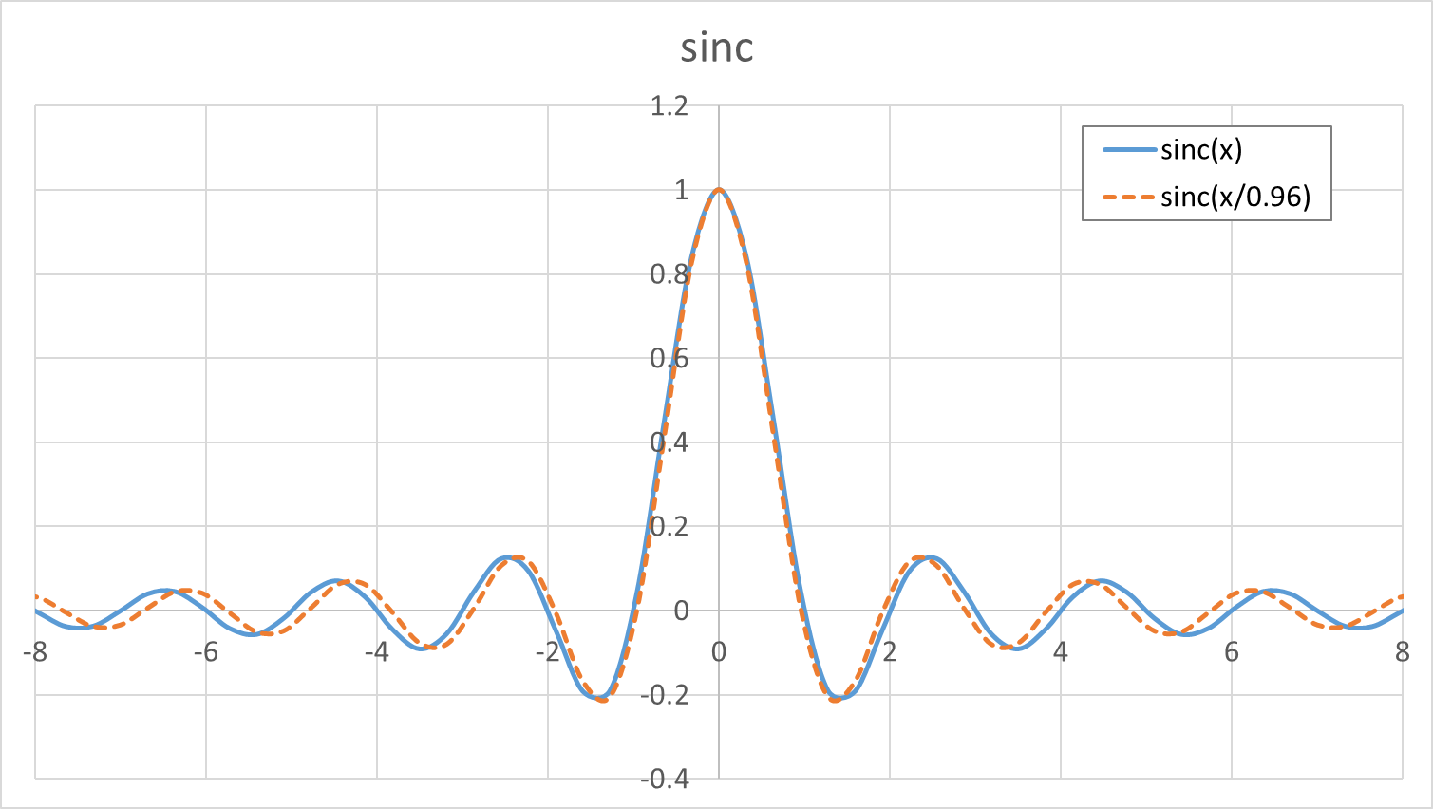
Figure 1. An illustration of the effect of a scaled sinc function as in the proposal.

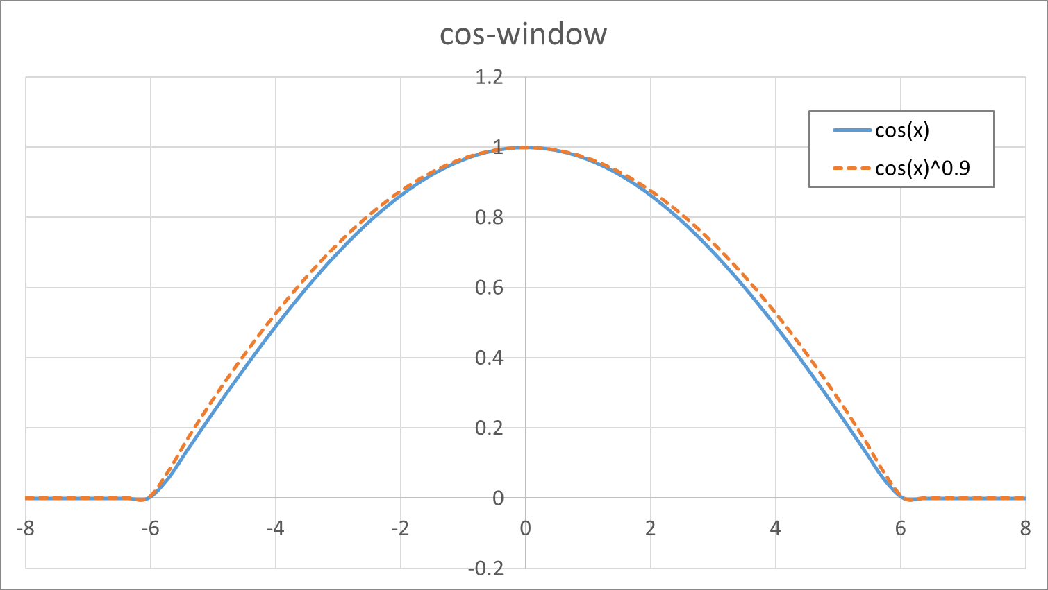
Figure 2. An illustration of the effect of a modified cos window as in the proposal.

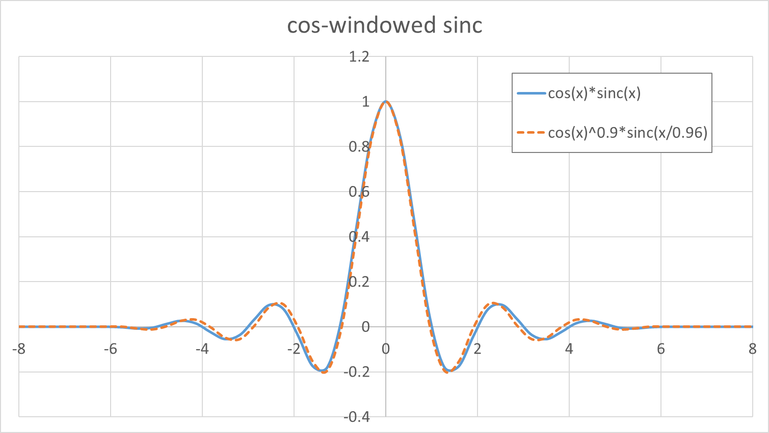
Figure 3. An illustration of the effect of a modified cos-windowed sinc function as in the proposal.

It can be noted that no filtering is introduced for the 0th phase (integer position motion vectors) and that the 8th phase (half-pel position) filter is the same as the current ECM MC filter. It can also be noted that the difference between the proposed filter and the current ECM MC filter is not larger than 5 for any coefficient, in absolute terms, as shown below:

ecmFilter - proposedBiPredFilter = {
{ 0, 0, 0, 0, 0, 0, 0, 0, 0, 0, 0, 0},
{ 0, -1, 2, -2, 2, -2, 1, -1, 1, -1, 1, 0},
{ 1, -2, 2, -3, 4, -4, 3, -3, 3, -2, 1, 0},
{ 1, -2, 3, -4, 4, -3, 4, -4, 3, -2, 1, -1},
{ 1, -3, 4, -4, 5, -5, 4, -4, 3, -2, 2, -1},
{ 1, -3, 3, -4, 5, -4, 4, -4, 3, -2, 1, 0},
{ 1, -1, 2, -3, 3, -4, 3, -3, 3, -2, 1, 0},
{ 0, -1, 1, -1, 2, -2, 1, -1, 2, -1, 1, -1},
{ 0, 0, 0, 0, 0, 0, 0, 0, 0, 0, 0, 0},
{ -1, 1, -1, 2, -1, 1, -2, 2, -1, 1, -1, 0},
{ 0, 1, -2, 3, -3, 3, -4, 3, -3, 2, -1, 1},
{ 0, 1, -2, 3, -4, 4, -4, 5, -4, 3, -3, 1},
{ -1, 2, -2, 3, -4, 4, -5, 5, -4, 4, -3, 1},
{ -1, 1, -2, 3, -4, 4, -3, 4, -4, 3, -2, 1},
{ 0, 1, -2, 3, -3, 3, -4, 4, -3, 2, -2, 1},
{ 0, 1, -1, 1, -1, 1, -2, 2, -2, 2, -1, 0},

Subtest EE2-3.10b
During integration of the code from JVET-AH0141 into ECM-13.0, a bug was identified. The proposed filter was not used for all bi-predicted blocks, due to that there is a separate SIMD function for applying MC filtering to 4x4 blocks, and it was found that there seem to be a small benefit to excluding the smallest blocks from using the proposed filter. In order to get a better understanding of this and be able to make the most informed decision, it was suggested on JVET email reflector (on June 25) to create a new subtest where the proposed filter is only applied for bi-predicted blocks where both width and height are greater than 4 (for all other blocks the existing MC filter is used). No objections were raised to the suggestion of creating such a subtest and the code for the subtest was checked in to the EE branch on June 28.

Results
The proposed filter has been tested in ECM-13.0 using the Common Test Conditions described in JVET-AF2017.

Results for EE2-3.10a
 | Random Access Main 10
 | Over ECM-13.0
 | Y | U | V | EncT | DecT | VmPeak
Class A1 | -0.01% | -0.08% | -0.12% | 100.3% | 99.9% | 100.0%
Class A2 | 0.03% | -0.05% | 0.03% | 100.3% | 100.2% | 100.6%
Class B | -0.04% | -0.05% | -0.09% | 100.2% | 100.2% | 100.0%
Class C | -0.20% | 0.10% | 0.00% | 100.1% | 99.6% | 99.6%
Class E
Overall | -0.06% | -0.02% | -0.05% | 100.2% | 100.0% | 100.0%
Class D | -0.43% | -0.11% | -0.20% | 99.3% | 100.1% | 100.0%
Class F | -0.04% | 0.08% | -0.03% | 98.5% | 99.0% | 99.6%
Class TGM | -0.08% | 0.01% | -0.05% | 99.6% | 99.2% | 99.8%
Table 1. EE2-3.10a Results for Random Access Configuration

 | Low delay B Main 10
 | Over ECM-13.0
 | Y | U | V | EncT | DecT | VmPeak
Class A1
Class A2
Class B | -0.09% | -0.14% | 0.00% | 100.1% | 100.0% | 100.0%
Class C | -0.08% | 0.15% | -0.59% | 100.1% | 99.7% | 100.0%
Class E | 0.12% | 0.46% | 0.08% | 100.2% | 98.4% | 100.5%
Overall | -0.03% | 0.11% | -0.18% | 100.1% | 99.5% | 100.1%
Class D | -0.05% | -0.09% | -0.25% | 99.9% | 100.6% | 100.1%
Class F | -0.09% | 0.30% | -0.09% | 100.4% | 101.3% | 98.1%
Class TGM | -0.10% | 0.08% | 0.07% | 101.5% | 100.5% | 100.5%
Table 2. EE2-3.10a Results for Low Delay B Configuration

Results for EE2-3.10b
 | Random Access Main 10
 | Over ECM-13.0
 | Y | U | V | EncT | DecT | VmPeak
Class A1 | -0.03% | 0.00% | 0.05% | 100.1% | 99.6% | 100.0%
Class A2 | 0.00% | -0.03% | 0.03% | 100.3% | 100.2% | 100.6%
Class B | -0.04% | 0.10% | -0.12% | 100.4% | 100.1% | 100.0%
Class C | -0.17% | -0.11% | 0.07% | 100.0% | 99.4% | 99.6%
Class E
Overall | -0.07% | 0.00% | -0.01% | 100.2% | 99.8% | 100.0%
Class D | -0.38% | -0.18% | -0.04% | 99.5% | 99.5% | 100.1%
Class F | -0.03% | 0.04% | -0.04% | 99.6% | 99.6% | 100.1%
Class TGM | -0.08% | -0.07% | -0.05% | 99.5% | 99.1% | 99.9%
Table 3. EE2-3.10b Results for Random Access Configuration
 | Low delay B Main 10
 | Over ECM-13.0
 | Y | U | V | EncT | DecT | VmPeak
Class A1
Class A2
Class B | -0.10% | -0.19% | -0.27% | 100.3% | 99.8% | 100.0%
Class C | -0.09% | -0.05% | -0.19% | 99.7% | 99.8% | 100.0%
Class E | -0.12% | -0.08% | 0.06% | 100.2% | 99.0% | 101.5%
Overall | -0.10% | -0.11% | -0.16% | 100.1% | 99.6% | 100.4%
Class D | -0.06% | -0.36% | 0.26% | 99.5% | 99.3% | 99.8%
Class F | 0.11% | -0.01% | -0.49% | 95.3% | 99.5% | 99.0%
Class TGM | -0.15% | -0.07% | -0.08% | 99.0% | 100.2% | 100.2%
Table 4. EE2-3.10b Results for Low Delay B Configuration

Patent rights declaration(s)
Sharp Labs of America, Inc., may have current or pending patent rights relating to the technology described in this contribution and, conditioned on reciprocity, is prepared to grant licenses under reasonable and non-discriminatory terms as necessary for implementation of the resulting ITU-T Recommendation | ISO/IEC International Standard (per box 2 of the ITU-T/ITU-R/ISO/IEC patent statement and licensing declaration form).

Acknowledgement
These research results were obtained from the commissioned research (No.05101) by National Institute of Information and Communications Technology (NICT), Japan.

Annex A. Filter response.

The filter response for the proposed filter is shown below.

