    Joint Video Experts Team (JVET)  of ITU-T SG 16 WP 3 and ISO/IEC JTC 1/SC 29  35th Meeting, Sapporo, JP, 12–19 July 2024 | Document: JVET-AI0044-v1

Title: | AHG15: Improved versions of gaming content sequences by Huawei
Status: | Input document to JVET
Purpose: | Proposal
Author(s) or  Contact(s): | Weilan Chen  Zehui Lin  Yuxin Zhao  Kangying Cai  Elena Alshina  Johannes Sauer  Zhao Yin | Tel:  Email: | caikangying@huawei.com
Source: | Huawei Technologies
_____________________________

Abstract
Huawei contritubed the following sequences (part of class G1 of “Draft Common Test Conditions (CTC) for gaming applications”) for the study of gaming content compression:

Sequence name | Frame count | Low delay frame count | Frame rate | Bit depth | Intra | Random access | Low-delay
ARPG | 600 | 300 | 60 | 8 | M | M | M
DesertTown2 | 600 | 300 | 60 | 8 | M | M | M
SunTemple1 | 600 | 300 | 60 | 8 | M | M | M

In this contribution we propose improved version of these sequences, in order to address the following:
- In expert viewing it was found that the camera movement in the sequences is unsmooth (stuttering). The source of this was a bottleneck in the data capturing process which has been solved.
- Another improvement to the capturing process is that has been made reproducible, i.e. the same sequence can be rendered again. This can be used for further improvements if issues are found.
A further improvement is that the improved versions are made available as 10bit HDR content.
It should be noted that the new sequences have the same setting/scene as the previous ones, but the view path of the player is different (reproducibility issue mentioned above).

Proposed sequences
3 sequences were created using the Unreal game engine to load and play three games. We captured the frame buffers into FloatRGBA 16-bits Unsigned Float images by custom post-processing codes and shaders in the default render pipeline. The frame buffers are then converted to YUV420 10bits sequences by using ffmpeg. The color information of the YUV sequences is listed below:
- Color Primaries: BT.2020
- Transfer Characteristics: ACES 1000-nit ST-2084 (Dolby PQ)
- Matrix Coefficients: BT.2020 non constant
- Color Range: limited
Furthermore, the auxiliary information, including Depth, Motion Vector and Camera Information, are provided along with the sequences. Copyright information is attached to the end.
The sequences have been uploaded to the jvet ftp server. They are available at:
- ftp://jvet-ul1@ftp.ient.rwth-aachen.de/JVET-AI0044

Examples
Examples:
“ARPG2”  Rendered view | 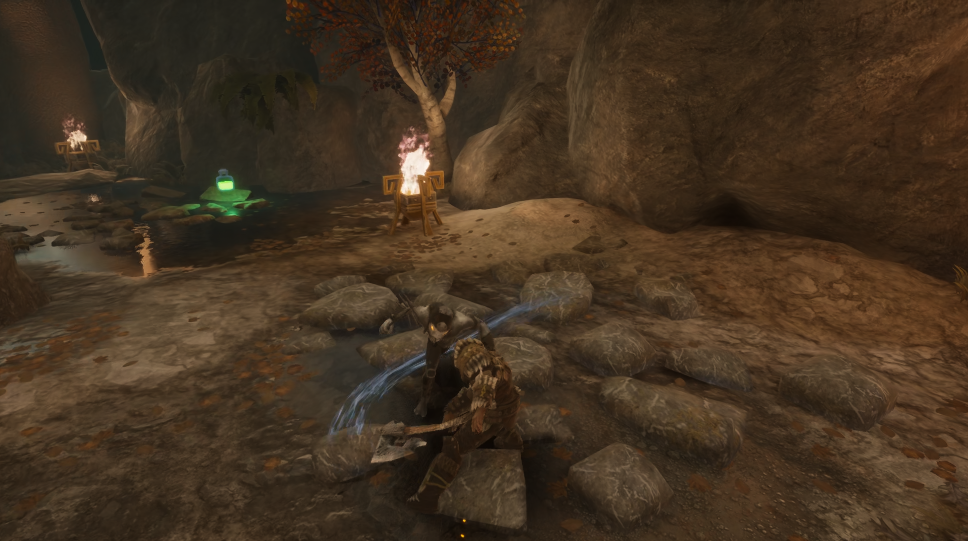
“DesertTown3”  Rendered view | 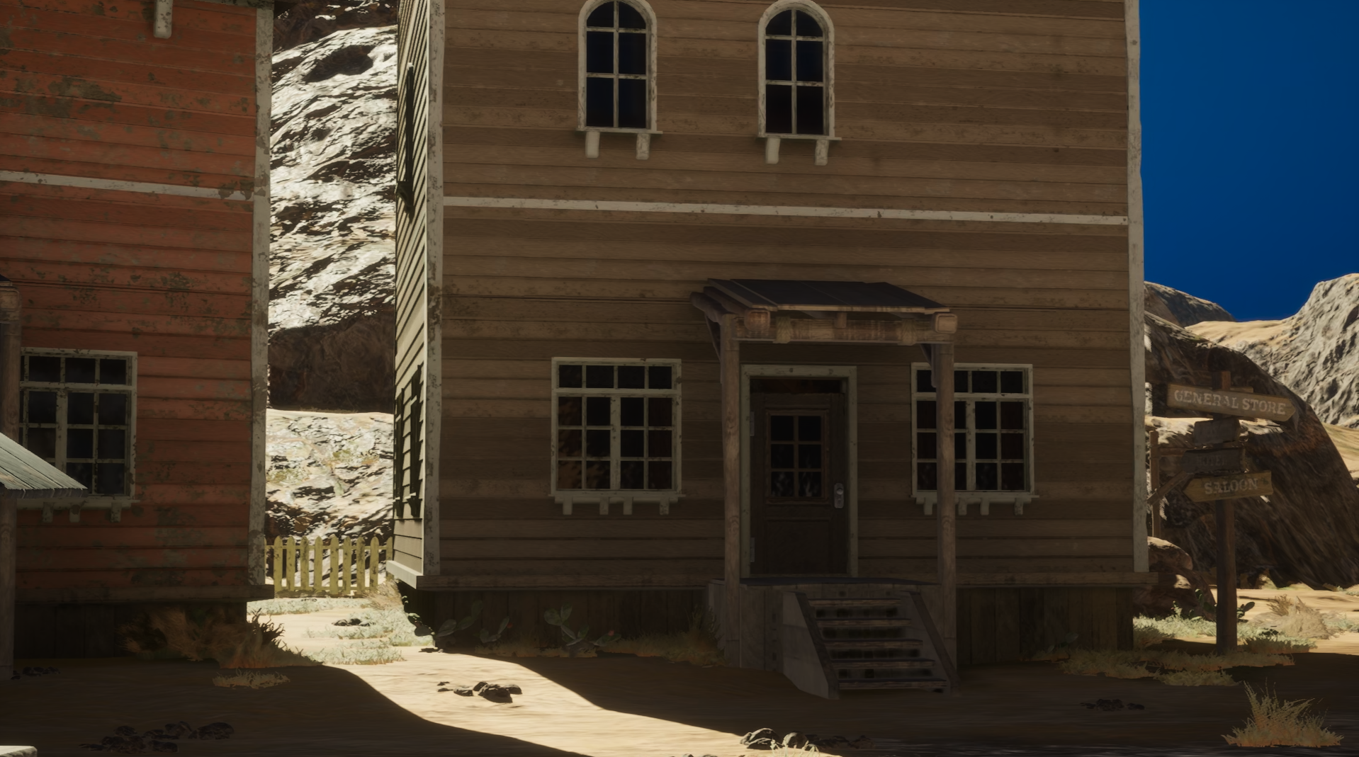
“SunTemple3”  Rendered view | 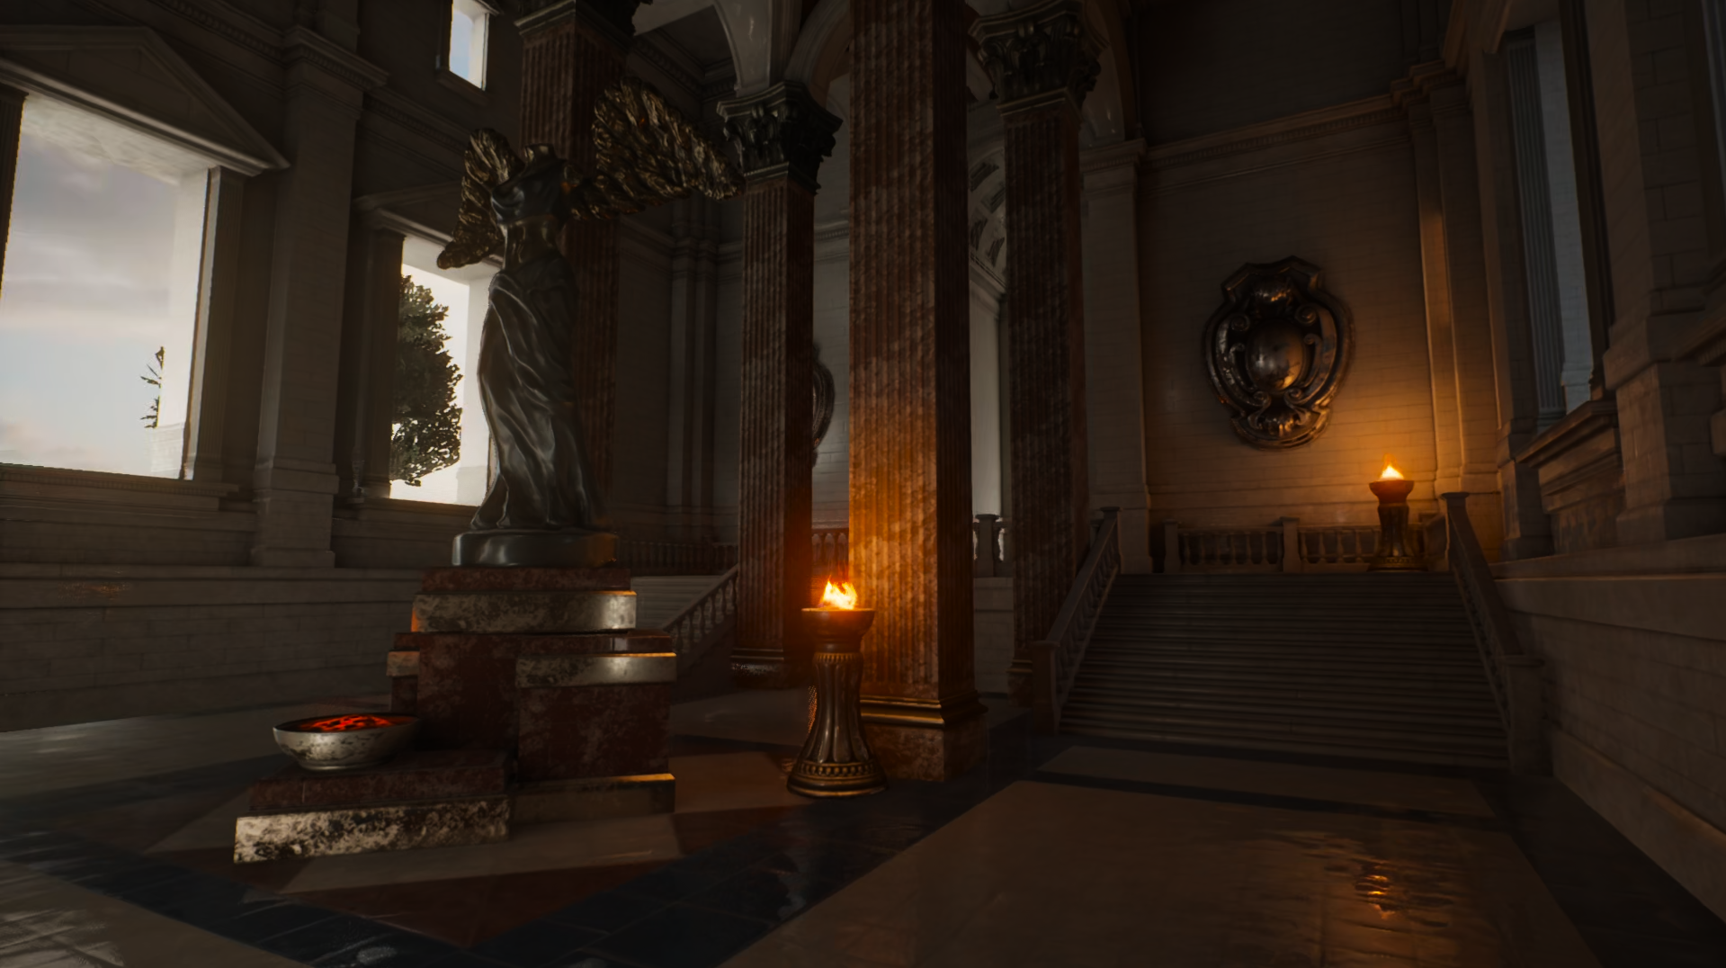

Sequence metadata
Sequence name | Resolution | Frame count | Frame rate | Bit depth | md5sum
ARPG2 | 1920x1080 | 600 | 60 | 10 | 6eabdb7f0827afa5b0ecb95208b069c1
DesertTown3 | 1920x1080 | 600 | 60 | 10 | 8b91f2c5630b592d8bc0e30c6e33b758
SunTemple3 | 1920x1080 | 600 | 60 | 10 | e9766660f098c63a5874605a89bf6ccf

Coding results

Results following draft CTC conditions (JVET-AH2027)

 | All Intra Main 10
 | Over VTM-11.0ecm12.0
 | Y | U | V
ARPG2 | -7.31% | -21.86% | -23.68%
DesertTown3 | -11.57% | -28.83% | -27.92%
SunTemple3 | -13.30% | -32.00% | -32.12%

 | Random Access Main 10
 | Over VTM-11.0ecm12.0
 | Y | U | V
ARPG2 | -27.82% | -38.67% | -38.48%
DesertTown3 | -25.49% | -42.41% | -37.57%
SunTemple3 | -32.22% | -43.67% | -42.86%

 | Low delay B Main 10
 | Over VTM-11.0ecm12.0
 | Y | U | V
ARPG2 | -16.91% | -44.48% | -39.82%
DesertTown3 | -18.52% | -54.74% | -45.97%
SunTemple3 | -21.80% | -54.47% | -51.37%

 | Low delay P Main 10
 | Over VTM-11.0ecm12.0
 | Y | U | V
ARPG2 | -16.67% | -43.01% | -39.81%
DesertTown3 | -18.28% | -55.55% | -47.61%
SunTemple3 | -21.53% | -54.39% | -51.84%

Comparison to previous versions

ARPG2

DesertTown3

SunTemple3

Copyright
This video sequences and auxiliary data (collectively "Data") may only be used for the purpose of developing, testing and promulgating technology standards developed by ISO/IEC JTC 1/SC 29 WG 5 or ITU-T SG 16 VCEG standardization groups (Purpose), under Huawei Technologies owned or controlled copyrights, by individual(s) or organization (s) that participates, contributes or is part of such standardization group (User(s)).

• The DesertTown3 sequence and auxiliary data are rendered using the "Western Desert Town" Unreal Engine assets created by KK Design available at https://www.unrealengine.com/marketplace/en-US/product/western-desert-town .
• The SunTemple3 sequence and auxiliary data are rendered using the “Sun Temple” Unreal Engine assets created by Epic Games available at https://www.unrealengine.com/marketplace/en-US/product/sun-temple .
• The ARPG2 sequence and auxiliary data are rendered using the “Action RPG” Unreal Engine assets created by Epic Games available at https://www.unrealengine.com/marketplace/en-US/product/action-rpg-01 .
All these assets are licensed by their respective owners and it is the User’s responsibility to comply with the license terms that are provided by such owner. Huawei Technologies claims no ownership nor liability on these assets.

RESTRICTIONS: No license whatsoever is implied except from this expressed limited personal, non-sublicensable, non-transferrable authorization. In particular no right under any patent of Huawei Technologies or its affiliates is granted.
Any other use is strictly prohibited. This Data cannot be distributed or otherwise disposed of or made available (via internet or otherwise), broadcasted, disclosed to third parties (except to other User(s) who agreed with the present terms and conditions), used for providing any services to third parties or for any commercial use, nor copied (except as technically necessary for the Purpose), modified, adapted, translated, exchanged, publicly performed (even for demonstration or educational purposes), integrated, without limitation. This Data and all intellectual property rights, titles and interests therein, are and remain the exclusive property of Huawei Technologies or its affiliates.

NO WARRANTY: This Data is supplied "as is" and without any warranty of any kind, expressed or implied, including but not limited to any warranty for accuracy or performance, fitness for a general or particular purposes, or any warranty arising by statute or by law, or non-infringement of any third parties rights. In no event will Huawei Technologies be liable for damages of any kind, including without limitation, any special, indirect, incidental, or consequential damages even if Huawei Technologies has been advised of the possibility of such damages.
Huawei Technologies may terminate this license at any time for any reason upon notice to User(s). In such situation, the relevant User(s) shall inform any Secondary User of such termination and make sure that such Secondary User shall cease to use the video.
This authorization is governed by the laws of China without regard to conflict of laws. It shall be exclusively submitted to the competent people's court in Longgang District, Shenzhen City in the event of a dispute not settled amicably.
BY USING THIS DATA USER(S) AGREES AND ACCEPTS THE ABOVE MENTIONED TERMS AND CONDITIONS. IF USER(S) DOES NOT AGREE TO THESE TERMS AND CONDITIONS, IT SHALL NOT ACCESS OR OTHERWISE USE THIS DATA. DO NOT REMOVE OR MODIFY HUAWEI TECHNOLOGIES OR ITS AFFILIATES NAMES, SIGNS, LOGOS, NOTICES OF/IN THE DATA.

Patent rights declaration(s)
Huawei does not have any current or pending patent rights relating to the technology described in this contribution.

