    Joint Video Experts Team (JVET)  of ITU-T SG 16 WP 3 and ISO/IEC JTC 1/SC 29  35th Meeting, Sapporo, JP, 12–19 July 2024 | Document: JVET-AI0024-v1

Title: | EE2: Summary Report on Enhanced Compression beyond VVC capability
Status: | Input document to JVET
Purpose: | Report
Author(s) or  Contact(s): | Vadim Seregin  Jie Chen  Roman Chernyak  Karam Naser  Jacob Ström  Fan Wang  Martin Winken  Xiaoyu Xiu  Kai Zhang | Email: | vseregin@qti.qualcomm.com  jiechen.cj@alibaba-inc.com  chernyak@tencent.com  Karam.Naser@InterDigital.com  jacob.strom@ericsson.com  wangfan6@oppo.com  martin.winken@hhi.fraunhofer.de  xiaoyuxiu@kwai.com  zhangkai.video@bytedance.com
Source: | EE coordinators
_____________________________

Abstract
This document provides a summary report of Exploration Experiment on Enhanced Compression beyond VVC capability. The tests are categorized as intra prediction, inter prediction, transform and coefficient coding, in-loop filtering, and entropy coding.
The software basis for this EE is ECM-13.0, released at https://vcgit.hhi.fraunhofer.de/ecm/ECM/-/tags/ECM-13.0. ECM-13.0 is used as an anchor in the tests.
Software for EE tests is released in the corresponding branches at https://vcgit.hhi.fraunhofer.de/ecm/jvet-ah-ee2/ECM/-/branches.
Test results can be found in input JVET contributions, cross-check results are uploaded to https://vcgit.hhi.fraunhofer.de/ecm/jvet-ah-ee2/simulation-results if cross-check reports are not submitted as they are optional for EE tests.

List of tests
 | Tests | Tester | Cross-checker
1 Partitioning
1.1 | Adaptive dual tree coding in inter slices | F. Le Léannec (InterDigital) | P. Andrivon (Ofinno)  JVET-AI0265
1.1a | Adaptive dual tree coding in inter slices (trade-off 1) | F. Le Léannec (InterDigital) | P. Andrivon (Ofinno)  JVET-AI0265
1.1b | Adaptive dual tree coding in inter slices (trade-off 2) | F. Le Léannec (InterDigital) | P. Andrivon (Ofinno)  JVET-AI0265
1.1c | Adaptive dual tree coding in inter slices (trade-off 3) | F. Le Léannec (InterDigital) | P. Andrivon (Ofinno)  JVET-AI0265
1.2a | Restricting BT CUs to apply QT-like partitioning structure | W. Ahmad (Ericsson) | A.Tissier (Xiaomi)  JVET-AI0263
1.2b | Restricting BT CUs to apply QT-like partitioning structure (also at smaller block sizes) | W. Ahmad (Ericsson) | T. Dumas  (InterDigital)  JVET-AI0272
1.2c | Restricting BT CUs to apply QT-like partitioning structure (non-normative solution) | W. Ahmad (Ericsson) | A. Sidiya  (Sharp)
2 Intra prediction
2.1 | TIMD merge | M. Abdoli (Xiaomi) | M. Salehifar  (ByteDance)
2.2 | TIMD with enhanced block vectors deployment | K. Naser  (InterDigital)  J. Fu  (Peking Univ.) | M. Blestel (Ofinno)
2.3 | Test 2.1 + Test 2.2 | M. Abdoli (Xiaomi)  K. Naser  (InterDigital)  J. Fu  (Peking Univ.) | M. Blestel (Ofinno)
2.4a | Additional TIMD mode with different cost metric | D. Bugdayci Sansli (Nokia) | J. Konieczny (TCL)
2.4b | Additional TIMD mode with different cost metric (no template size change) | D. Bugdayci Sansli (Nokia) | J. Konieczny (TCL)
2.4c | Test 2.2 + Test 2.4a | D. Bugdayci Sansli (Nokia) | D. Ruiz Coll  (Ofinno)  X. Zhihuang (OPPO)
2.4d | Test 2.1 + Test 2.2 + Test 2.4a | D. Bugdayci Sansli (Nokia) | W. Ahmad (Ericsson)  JVET-AI0310
2.5a | Intra merge mode | Y.-J. Chang (Qualcomm) | M. Blestel (Ofinno)
2.5b | Intra merge mode without TIMD candidate | Y.-J. Chang (Qualcomm) | M. Blestel (Ofinno)
2.5c | Intra merge mode with adjacent and non-adjacent neighbours used in current ECM intra tools | Y.-J. Chang (Qualcomm) | Y. Kidani (KDDI)
2.5d | Intra merge mode with larger candidate list | Y.-J. Chang (Qualcomm) | J. Fu (PKU)
2.6a | IntraTMP merge candidates clustering based on refinement window | D. Ruiz Coll  (Ofinno) | T.M. Bae  (Sharp)
2.6b | IntraTMP search arIntraTMP search area shifting and plus-shape refinement for LIC candidates | K. Naser  (InterDigital) | W. Ahmad(Ericsson)  JVET-AI0215
2.6c | Test 2.6a + Test 2.6b | D. Ruiz Coll  (Ofinno)  K. Naser  (InterDigital) | Z. Deng  (Bytedance)
2.7a | Regularized EIP | H. Qin  (TCL) | R. Ishimoto  (Sharp)
2.7b | Regularized CCCM | H. Qin  (TCL) | R. Ishimoto  (Sharp)
2.7c | Test 2.7a + Test 2.7b | H. Qin  (TCL) | R. Ishimoto  (Sharp)
2.8a | MIP with mode and block shape dependent matrices. | H. Wang (Qualcomm) | J. Konieczny (TCL)  Y. Wang (Bytedance) JVET-AI0260
2.8b | MIP with downsampling/upsampling in the process. | H. Wang (Qualcomm) | Y. Wang (Bytedance) JVET-AI0260
2.9a | Derived modes with fusion | Z. Xie  (OPPO) | C. Zhou  (vivo)  JVET-AI0284  T. Dumas  (InterDigital)  JVET-AI0271
2.9b | MIP-LFNST transform set derivation by upsampled prediction | Z. Xie  (OPPO) | C. Zhou  (vivo)  JVET-AI0284  T. Dumas  (InterDigital)  JVET-AI0271
2.9c | Test 2.9a + Test 2.9b | Z. Xie  (OPPO) | C. Zhou  (vivo)  JVET-AI0284  T. Dumas  (InterDigital)  JVET-AI0271
3 Inter prediction
3.1a | High accuracy sample based BDOF | M. Salehifar  (Bytedance) | X. Xiu  (Kwai)
3.1b | High accuracy sample based BDOF with no weight | M. Salehifar  (Bytedance)
3.2 | Temporal BV for IBC merge list construction | L. Xu  (OPPO)  N. Zhang  (Bytedance) | X. Li  (Alibaba)
3.3a | GPM with inter prediction and IBC | Y. Wang  (Bytedance) | L. Xu  (OPPO)  JVET-AI0295
3.3b | Test 3.2 + Test 3.3a | Y. Wang  (Bytedance)  L. Xu  (OPPO) | C. Ma  (Kwai)  JVET-AI0291
3.4a | Merge candidates with alternative reference indices | Z. Zhang  (Qualcomm) | C. Ma,  X. Xiu(Kwai)  JVET-AI0292
3.4b | Additional TMVP and SbTMVP candidates | Z. Zhang  (Qualcomm) | C. Ma, X. Xiu  (Kwai)  JVET-AI0292
3.4c | Additional bi-TMVP candidates | Z. Zhang  (Qualcomm) | C. Ma, X. Xiu  (Kwai)  JVET-AI0292
3.4d | Test 3.4a + Test 3.4b + Test 3.4c | Z. Zhang  (Qualcomm) | C. Ma, X. Xiu  (Kwai)  JVET-AI0292
3.4e | Test 3.4b + Test 3.4c | Z. Zhang  (Qualcomm) | C. Ma, X. Xiu  (Kwai)  JVET-AI0292
3.5a | Additional CMVP candidates introduced in the pairwise merge candidate list. | N. Zhang  (Bytedance) | Y.Kidani (KDDI)  JVET-AI0302
3.5b | Additional CMVP candidates introduced in the initial merge candidate list. | N. Zhang  (Bytedance) | Y.Kidani (KDDI)  JVET-AI0302
3.6 | Adaptive cost function selection in merge mode | K. Cui  (Qualcomm) | N. Zhang  (Bytedance)  JVET-AI0249
3.7 | TMVP for chained motion vector prediction | P.-H. Lin  (Qualcomm) | Y.Kidani (KDDI)  JVET-  AI0305
3.8a | GPM-affine with MMVD | Y. Wang  (Bytedance) | H. Wang  (Qualcomm)  JVET-AI0293
3.8b | GPM-affine with TM | Y. Wang  (Bytedance) | H. Wang  (Qualcomm)  JVET-AI0293
3.8c | Test 3.8a + Test 3.8b | Y. Wang  (Bytedance) | H. Wang  (Qualcomm)  JVET-AI0293
3.9 | Affine candidates derived from temporal collocated pictures | C. Ma  (Kwai) | N. Zhang  (ByteDance)  JVET-AI0250
3.10a | Sharp motion compensation filter for bi-prediction | J. Samuelsson-Allendes  (Sharp) | L. Chen  (Tencent)
3.10b | Test 3.10a applied to blocks 8x8 and larger | J. Samuelsson-Allendes  (Sharp) | L. Chen  (Tencent)
4 Transform and coefficients coding
4.1a | Multiple kernel set selection for inter LFNST/NSPT | L. Zhao  (Bytedance) | F. Wang  (OPPO)  JVET-AI0267
4.1b | LFNST/NSPT for SBT-coded blocks | L. Zhao  (Bytedance) | F. Wang  (OPPO)  JVET-AI0267
4.1c | Test 4.1a + Test 4.1b | L. Zhao  (Bytedance) | F. Wang  (OPPO)  JVET-AI0267
4.2a | Shifting quantization center for transform skip coefficient | Y. Yu  (OPPO) | M. Balcilar  (InterDigital)  JVET-AI0274  H.-J. Jhu  (Kwai)  JVEG-AI0277
4.2b | Shifting quantization amount derived from quantization level of individual quantizer | Y. Yu  (OPPO) | M. Balcilar  (InterDigital)  JVET-AI0274  H.-J. Jhu  (Kwai)  JVEG-AI0277
4.2c | Test 4.2a + Test 4.2b | Y. Yu  (OPPO) | M. Balcilar  (InterDigital)  JVET-AI0274  H.-J. Jhu  (Kwai)  JVEG-AI0277
4.3 | 16 States TCQ | M. Balcilar  (InterDigital)
4.4a | Multiple transform set selection for intra LFNST/NSPT without complexity reduction | F. Wang  (OPPO)  L. Zhao  (Bytedance)  M. Coban  (Qualcomm) | M. Koo  (LGE)  JVET-AI0269  X. Li  (Google)  JVET-AI0228
4.4b | Test 4.4a with CU size restriction | F. Wang  (OPPO) | M. Koo  (LGE)  JVET-AI0269  X. Li  (Google)  JVET-AI0228
4.4c | Test 4.4a with implicit kernel derivation | C. Bonnineau (InterDigital) | S. Blasi  (Nokia) JVET-AI0275  JVET-AI0275  F. Wang  (OPPO)  JVET-AI0297
4.4d | Test 4.4c with CU size restriction | C. Bonnineau (InterDigital) | S. Blasi  (Nokia) JVET-AI0275  F. Wang  (OPPO)  JVET-AI0297
4.4e | Test 4.4a with reduced number of transform candidates | M. Coban  (Qualcomm) | M. Koo  (LGE)  JVET-AI0269
4.4f | Test 4.1c from the previous EE | F. Wang  (OPPO) | M. Koo  (LGE)  JVET-AI0269
4.4g | Test 4.4c (for blocks area >= 128 && area < 256) + Test 4.4a (for blocks area >= 256) | C. Bonnineau (InterDigital) | J.-K. Lee  (Ofinno)  JVET-AI0251
4.5a | Multiple transform set selection for intra MTS | C. Bonnineau (InterDigital) | D. Ruiz Coll  (Ofinno)  JVET-AI0133
4.5b | Test 4.4a + Test 4.5a | C. Bonnineau (InterDigital) | D. Ruiz Coll  (Ofinno)  JVET-AI0133
5 In-loop filtering
5.1a | Modification of ALF RDO criterion | G. Boisson  (InterDigital) | C.-W. Kuo  (Kwai)  JVET-AI0244
5.1b | Modification of ALF APS syntax | G. Boisson  (InterDigital) | C.-W. Kuo  (Kwai)  JVET-AI0244
5.1c | Modification of CTU-level ALF syntax | G. Boisson  (InterDigital) | C.-W. Kuo  (Kwai)  JVET-AI0244
5.1d | Test 5.1b + Test 5.1c | G. Boisson  (InterDigital) | V. Shchukin  (Ericsson)  JVET-AI0112
5.1e | Test 5.1a + Test 5.1d | G. Boisson  (InterDigital) | V. Shchukin  (Ericsson)  JVET-AI0112
5.2 | ALF residuals scaling | P.Bordes  (InterDigital) | Z. Dai  (OPPO)  JVET-AI0240
5.3a | CCALF with chroma SAO outputs | Z.Dai, N. Song  (OPPO) | P.Bordes (InterDigital)  JVET-  AI0170  C. Ma  (Kwai)  JVET-AI0290
5.3b | CCALF with chroma fixed filter outputs | Z.Dai, N. Song (OPPO) | C. Ma  (Kwai)  JVET-AI0290
5.3c | CCALF with chroma ALF outputs | N. Hu  (Qualcomm) | W. Yin  (Bytedance)  JVET-AI0288
5.3d | Test 5.3a + Test 5.3b + Test 5.3c | N. Hu  (Qualcomm)  Z.Dai, N. Song (OPPO) | P.Bordes (InterDigital)  JVET-  AI0170
5.3e | Test 5.3a + Test 5.3c | N. Hu  (Qualcomm)  Z.Dai, N. Song (OPPO) | W. Yin  (Bytedance)  JVET-AI0288
6 Entropy coding
6.1a | Retrained CABAC contexts | F. Galpin (InterDigital) | X. Li  (Google)  JVET-AI0227
6.1b | Test 6.1a + some EP bins converted to NEP | F. Galpin (InterDigital) | X. Li  (Google)  JVET-AI0227
6.1c | Test 6.1b + some EP bins converted to context or NEP coded | F. Galpin (InterDigital) | X. Li  (Google)  JVET-AI0227
6.2a | Context offset for gtX | P.Nikitin  (Qualcomm) | K. Naser  (InterDigital)
6.2b | Test 6.1a + Test 6.2a | P.Nikitin  (Qualcomm) | K. Naser  (InterDigital)

Description of tests

Partitioning

Test 1.1: Adaptive dual tree coding in inter slices (JVET-AI0136)
In this method, adaptive dual tree selection is introduced to intra regions in B- and P-slices. A single tree is used in the beginning, and at a certain block size and if CU is intra coded, a flag is signalled indicating whether the tree continues to be in a single or in dual mode.
If the dual tree mode is indicated then luma and chroma are separately partitioned, and all block in that region are intra coded as shown in the next figure.
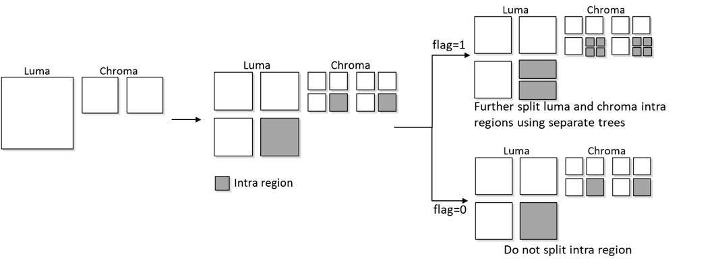
Three trade-offs are evaluated.
Test 1.1a: Adaptive dual tree coding in inter slices (trade-off 1)
Test 1.1b: Adaptive dual tree coding in inter slices (trade-off 2)
Test 1.1c: Adaptive dual tree coding in inter slices (trade-off 3)

Test 1.2: Restricting BT CUs to apply QT-like partitioning structure (JVET-AI0087)
In ECM, a BT partitioned block may be further partitioned by BT in the orthogonal direction producing a QT-like partitioned block.
In the test, such BT splits are disallowed shown in the next figure in red.
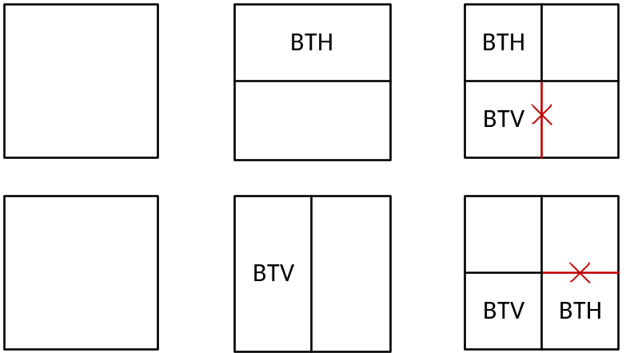
In particular, when the BTH split is applied on a CU and its first subblock selects the BTV split then for the second subblock BTV split is disallowed. Similarly, when the BTV split is applied on a CU and its first subblock selects the BTH split then for the second subblock BTH split is disallowed. The restriction is only applied to a square CUs for which QT split is allowed.
A new CABAC context is added to signal split_cu_flag. The context is used when the binary split is applied on a luma channel CU, and the first subblock selects a different binary split compared to the binary split selected by its parent CU.
When the dual tree is enabled for I-slices, the restriction is only applied to the luma channel.
The QT early termination is avoided for CU sizes where the restriction is applied.
Three tests are performed.
Test 1.2a: Restricting BT CUs to apply QT-like partitioning structure. The restriction is applied to 128x128, 64x64 and 32x32 CU sizes.
Test 1.2b: Restricting BT CUs to apply QT-like partitioning structure (also at smaller block sizes). The restriction is applied to 128x128, 64x64, 32x32, and 16x16 CU sizes.
Test 1.2c: Restricting BT CUs to apply QT-like partitioning structure (non-normative solution). The restriction is applied to 128x128, 64x64 and 32x32 CU sizes at encoder.

Intra prediction

Test 2.1: TIMD merge mode (JVET-AI0110)
In ECM, TIMD prediction is derived by a fusion of up to 3 intra modes with the smallest SATD cost with the weights corresponding to the template cost.
In the test, TIMD merge list of size 5 is constructed by adding TIMD information (prediction modes, fusion flag, fusion weights and wide-angle conditions of TIMD modes, MTS transform types) from adjacent and non-adjacent neighbouring blocks shown in the next figure.
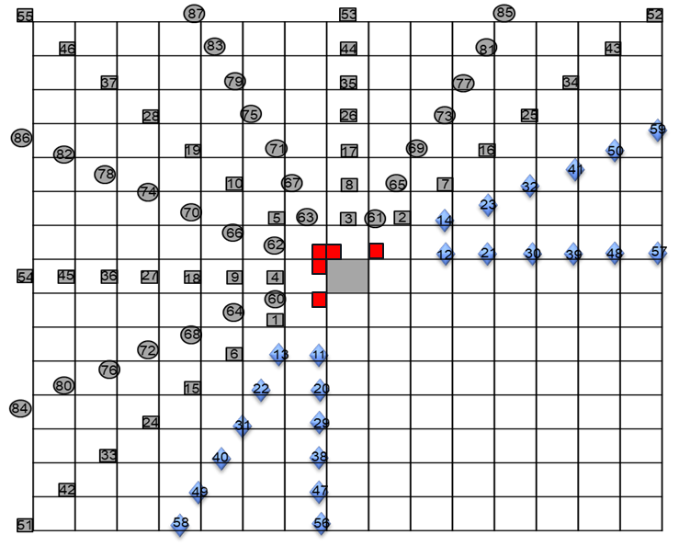
TIMD candidates are sorted in the list based on SAD template cost.
The TIMD merge mode is applied to only luma blocks and is disabled for 4x4 block sizes. A flag is signalled in TIMD branch to indicate the mode usage and if more than one candidate is used, a syntax element is signalled to indicate the selected candidate.

Test 2.2: TIMD with enhanced block vectors deployment (JVET-AI0104)
In ECM, in addition to IBC and IntraTMP modes, the block-vector-based prediction in ECM is further used in combination with directional prediction of SGPM and DIMD, where the merge candidates (adjacent and non-adjacent) are evaluated with the template cost to select the best block vector predictor to be combined with the directional modes.
In the test, BV combination with TIMD is evaluated. Any of the three fusion modes of TIMD can be replaced by a block-vector-based prediction from the merge candidates based on the template cost. Auto-relocated block vector candidates of IntraTMP are combined with DIMD and TIMD modes.
- Allow TIMD with block vectors: When deriving the intra modes of TIMD (2 angular and 1 non-angular), the block vectors of the merge candidates of IntraTMP mode are also checked. If the template cost is smaller than any of the other modes, the mode is replaced by the block vector.
- Use ARBVP merge list in DIMD and TIMD: The additional block vector candidates generated by ARBVP process are included in the merge list of DIMD and TIMD, in the same manner as in IntraTMP.

Test 2.3: Combination of TIMD related tests (JVET-AI0171)
It is a combination test of TIMD merge mode Test 2.1/2.5 and BV prediction combinations Test 2.2.

Test 2.4: Additional TIMD mode with different cost metric (JVET-AI0113)
In this test, an additional TIMD based intra mode is introduced, where the cost metric is changed from SATD to MR SAD, the number of template lines/columns around the current block are doubled to 4/8, and the list of TIMD candidate modes is modified to avoid redundancy with respect to the conventional TIMD mode.
The new TIMD based intra mode is signalled as a sub mode of TIMD with a context coded flag, the method is disabled for a block with the minimum size (either width or height) is equal to 4. Also, the candidate list is derived based on the sorted modes determined by the conventional TIMD process. An additional refinement to the candidate list is used based on the DIMD modes.
Two tests are performed.
Test 2.4a: Additional TIMD mode with different cost metric
Test 2.4b: Test 2.4a without template size change
The following combined tests are performed.
Test 2.4c: Test 2.2 + Test 2.4a (JVET-AI0141)
Test 2.4d: Test 2.1 + Test 2.2 + Test 2.4a (JVET-AI0143)

Test 2.5: Intra-merge mode (JVET-AI0110)
In the test, a list of intra mode candidates is constructed using the intra modes from the neighbour blocks. It is similar to inter merge mode, but instead of motion vector the neighbour intra modes are added to the list. In this test, the merged neighbouring blocks are those coded by DIMD and TIMD modes.
A flag is signalled to indicate whether to enable the intra merge mode. If the flag is true, the intra merge list is constructed with 5 candidates at most. Then the best candidate is selected among these 5 candidates by comparing the template costs. Adjacent and non-adjacent blocks considered for the intra merge list construction are the same as in Test 2.1.
Four tests are performed.
Test 2.5a: Intra merge mode
Test 2.5b: Test 2.5a without TIMD candidate
Test 2.5c: Test 2.5a with neighbour blocks pattern as in ECM intra tools
Test 2.5d: Test 2.5a with larger candidate list (3 candidates).

Test 2.6: IntraTMP candidates with overlapping refinement window enhanced (JVET-AI0129)
In ECM, IntraTMP has sparse, merge (adjacent, non-adjacent), and auto-relocated BV candidates. The 30 BVP candidates with the lowest template cost are further refined. The refinement window around each BVP candidate varies based on the candidate type: merge candidates use an 11x11 window size, and ARBVP and sparse candidates use a 3x3 window size. The distance between the merge, ARBVP, and sparse candidates is not constrained, so the refinement windows may overlap.
In Test 2.6a, a check is performed for merge, ARBVP, and sparse candidate refinement windows overlapping. If two refinement windows overlap, the BV candidate with the lower template cost is selected and ranked in the sparse list for further refinement. Subsequently, a new refinement window that comprises both individual refinement windows is determined for the best candidate.
- The ARBVP list is enlarged by 5 additional ARBVP candidates, using the sparse candidates instead of the merge candidates as the guiding vector.
- For block sizes 8x8 or smaller, a search region fully overlapped by a BVP candidate refinement window is skipped during the sparse searching.
- In each sparse region, the searching pattern is shifted by one sample per row to increase the candidate diversity.
It was observed that overlap may occur between the IntraTMP BVs in LIC and non-LIC modes. Although the two use different cost metric: SAD for non-LIC mode and MR-SAD for LIC mode, the overlap may occur in the sparse search as the same starting point is used.
In Test 2.6b, LIC search region is shifted by half of the subsampling factor, as shown in the next figure, where the non-LIC positions are marked with “x”, while “o” denotes the positions using MR-SAD metric for LIC.
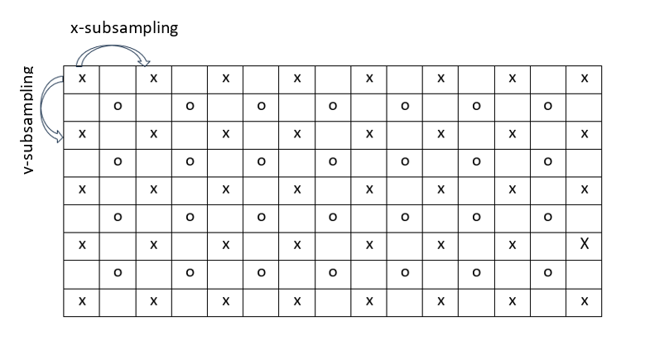
Test 2.6c: Test 2.6a + Test 2.6b.

Test 2.7: Regularized EIP/CCCM (JVET-AI0066)
Regularization term is added in solving a system of linear equations.
$$\hat{β}={\left(A^{⊤}A+λI\right)}^{-1}A^{⊤}y$$
In Test 2.7a, regularization is applied to EIP mode as follows:
- $λ=M⋅p_{EIP}$, where $p_{EIP}=15$ is the number of filter taps in EIP.
  - $M=192$ when the number of input samples $nSamples≤2024$, and thus $λ=2880$.
  - $M=128$ otherwise, and thus $λ=1920$.
- The bias term of EIP is unregularized: the bottom-right entry of the diagonal matrix is set to zero.
In Test 2.7b, regularization is applied to EIP mode as follows:
- $λ=32⋅p_{CCCM}$, where $p_{CCCM}$ is the number of filter taps of the respective CCCM model.
- The first luma and bias terma of CCCM are unregularized: the top-left and bottom-right entries of the diagonal matrix is set to zero.
Test 2.7c: Test 2.7a + Test 2.7b.

Test 2.8: Modifications to matrix-based intra prediction (JVET-AI0208)
In this test, matrix sizes of the MIP modes are increased for the blocks with sizes up to 32x32, excluding of 4x32, 32x4, 8x32 and 32x8. The proposed matrices use the L-shaped causal template as input to generate the WxH prediction block.
The prediction of a sample P(x,y) can be derived as:
P(x,y) = ∑_{k} F(x,y,k)*r(k),
Where r(k) is the kth item in the L-shaped template, and F(x,y) is the matrix weights corresponding to the position (x,y).

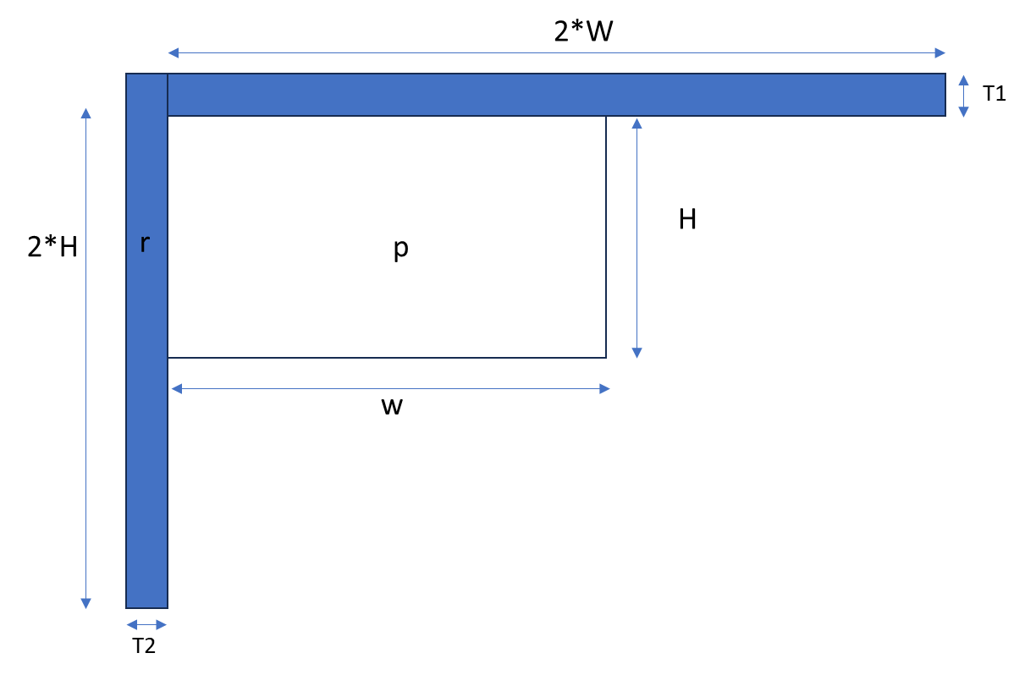
In Test 2.8a, the size of the prediction block generated by matrix multiplication equals to the current block size.
In Test 2.8b, for blocks sizes of 32x16, 16x32 and 32x32, a prediction block of 16x16 is generated by matrix multiplication and then upsampled to the size of the current block.
The memory usage of matrix coefficients is summarized in the following table.

 | Test 2.8a | Test 2.8b
Memory usage | 3.68MB | 1.92MB
The filters are trained with ~105K images of the Open Images Dataset.

Test 2.9: Derived MIP modes with fusion (JVET-AI0159)
In Test 2.9a, a fusion mode of two MIP modes is introduced. Similar to other template tools, the top and left neighbouring areas are used as templates to derive the MIP modes and the transposed flags for the current block, where the size of templates is width$×$2 and 2$×$height, respectively. Two best candidates {MIP modes, transposed flag} with the smallest template SATD cost are fused with the weights dependent on the cost.
This fusion process is applied only when the SATD cost of the best candidate is larger than half of the cost of the second-best candidate, otherwise the prediction is derived using only the best candidate without fusion.
In Test 2.9b, the DIMD process in MIP-LFNST transform set derivation is applied to the upsampled prediction samples for non-square blocks with either width or height equal to 4, which is shown in figure (b). For other blocks, the DIMD process is applied directly to the prediction samples as shown in (a).
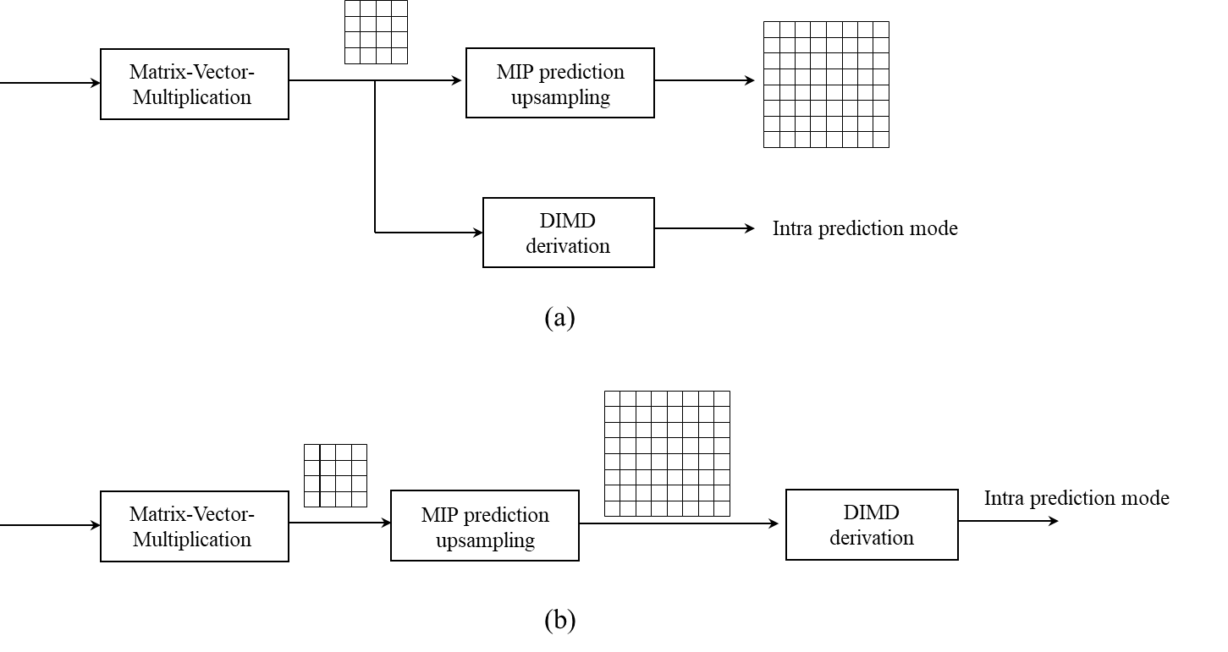
Test 2.9a: MIP modes with fusion
Test 2.9b: MIP-LFNST transform set derivation by upsampled prediction
Test 2.9c: Test 2.9a + Test 2.9b

Inter prediction

Test 3.1: High precision sample based BDOF (JVET-AI0046)
In this test, he high precision formula used for BDOF DMVR is applied to sample based BDOF as follwos.
(∑Gx.Gx+R1) * vx + ∑Gx.Gy * vy = ∑dI . Gx - dM . ∑Gx
∑Gx.Gy * vx + (∑Gy.Gy+R1) * vy = ∑dI . Gy - dM . ∑Gy
where Gx/Gy are the summation of the two horizontal/vertical gradients derived for each reference block.
Summations (Σ) are weighted sums in test a, and not weighted sum in test b.
Test 3.1a: High accuracy sample based BDOF.
Test 3.1b: High accuracy sample based BDOF with no weights.

Test 3.2: Temporal BV for IBC merge/AMVP list construction (JVET-AI0161)
In ECM, the IBC merge/AMVP list is constructed from adjacent spatial candidates, non-adjacent spatial candidates, HBVP candidates, ARBVP candidates, pairwise average candidates, and some predefined BV candidates. However, temporal BV candidates are not utilized.
In the test, temporal BV candidates are added to the IBC merge/AMVP list after the non-adjacent BV candidates. The temporal BVs are derived from collocated positions (corners and center of the block) and shifted collocated positions (five neighbouring positions) in the collocated pictures.
Two collocated pictures are utilized which are the two reference pictures with the first two least POC distances relative to the current picture, same as for TMVP in ECM.

Test 3.3: GPM with inter prediction and IBC (JVET-AI0082)
In Test 3.3a, the two geometric sub-partitions are predicted using inter prediction and IBC, individually. To generate the prediction signal of IBC, an IBC candidate list is constructed, and the index of the selected block vector is signalled. The prediction signal of IBC for one sub-partition can be blended with regular GPM, GPM-MMVD, and GPM-affine for the other sub-partition.
Test 3.3b: Test 3.2 and Test 3.3a.

Test 3.4: MVP extension (JVET-AI0183)
In the test, scaled merge candidates, TMVP candidates with alternative reference indices, and TMVP candidates based on motion trajectory crossing the current block are introduced.
Scaled merge candidates are added before the default zero MV candidates with the reference index 1 when the existing candidates already included in the merge list has reference index 0, otherwise it adds a candidate with the reference index 0. MV is scaled accordingly.
In ECM, for TMVP and SbTMVP candidates derivation, a reference picture is determined and the MV is then scaled accordingly. In the test, an additional candidate is added where instead of the determined reference picture a reference index corresponding to the collocated block’s reference picture is used and the collocated MV is scaled accordingly. If the picture is not in the reference picture list of the current block, it selects a reference picture between the collocated picture and the collocatd reference picture with the largest POC distance to the current picture.
Finally, it adds a bi-TMVP candidate (MV0, MV1 shown in the next figure) after HMVP if a motion trajectory between a block in a reference picture and its reference block crosses the current block. For a given MV shown in red, which is a reference block MV, a pair of MV0 and MV1 is constructed and if it crosses the current block then those MVs are used as bi-TMVP.
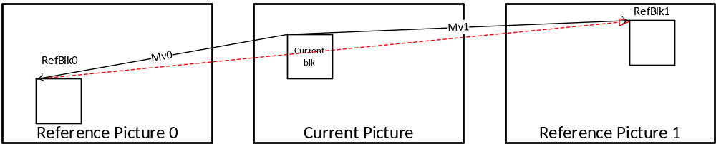
The tested aspects are applied to random access pictures when the low delay condition is false.
All elements are tested individually and all combined.
Test 3.4a: Scaled merge candidates
Test 3.4b: Additional TMVP and SbTMVP candidates
Test 3.4c: Additional bi-TMVP candidates
Test 3.4d: Test 3.4a + Test 3.4b + Test 3.4c
Test 3.4e: Test 3.4b + Test 3.4c

Test 3.5: Additional chained motion vector prediction candidates (JVET-AI0103)
In Test 3.5a, additional CMVP candidates are added in the pairwise merge candidate list.
The maximum size of the pairwise merge candidate list is increased by 6 and 2 for low delay and non-low delay pictures, respectively. The maximum number of pairwise candidates is kept unchanged.
In Test 3.5b, additional CMVP candidates are introduced before the zero padding candidates in the initial merge candidate list.
The maximum size of the initial merge candidate list is increased by 4. The maximum number of the candidates before the original CMVP candidates is kept unchanged.
In both Test 3.5a and Test 3.5b, when deriving the additional CMVP candidates, only the center position of the current block is checked to find traced MVs or BVs.

Test 3.6: Adaptive cost function selection in merge mode (JVET-AI0185)
In the test, two cost functions are alternately selected for every other candidate in a merge list to refine the corresponding merge candidate. If the merge index is an even number, the first cost function is selected for the refinement process, otherwise the second cost function is selected. It is applied to regular merge mode, template matching merge mode, bilateral matching merge mode, and affine merge mode.
For bilateral matching merge and affine merge, the two cost functions are set to SATD and SAD. For template matching merge, the two cost functions are set to weighted SAD and SAD.

Test 3.7: TMVP for chained motion vector prediction (JVET-AI0187)
In the test, TMVP candidates with MV scaled to reference picture with index 0 are added if the existed TMVP candidates has non-zero reference index. The additional TMVP candidates are used to derive CMVP candidates. After TMVP and the related CMVP candidates are derived, ARMC reordering is performed. CMVP candidates are derived in BM merge mode as well.

Test 3.8: GPM-affine with MMVD and TM (JVET-AI0083)
In ECM, GPM partition can be predicted using affine MC and the second partition can be a regular GPM, GPM affine, or GPM-intra. However, the second partition cannot be predicted by GPM-MMVD.
In Test 3.8a (GPM-affine with GPM-MMVD), an MV offset, which is signalled, is added to all CPMVs of an affine candidate and the modified CPMVs are used for predicting a GPM sub-partition.
In Test 3.8b (GPM-affine with GPM-TM), an affine candidate is refined by template matching using the same method as in affine mode. A GPM sub-partition can be predicted by GPM-affine with GPM-TM or GPM-TM.
Test 3.8c: Test 3.8a + Test 3.8b.

Test 3.9: Affine candidates derived from temporal collocated pictures (JVET-AI0197)
In the test, affine candidates derived from temporal collocated pictures are added to the affine merge candidate list. The same sampling pattern from the regular inter merge mode is reused to scan the predefined positions in the collocated pictures to derive the temporal affine candidates.
If the scanned position belongs to an affine coded CU, a new affine candidate is derived by scaling its CPMVs to the current CU based on its position and block-size in the collocated picture and the derived new affine candidates are inserted into the existing affine merge list and reordered together with the other affine merge candidates by ARMC process.

Test 3.10: Sharp motion compensation filter for bi-prediction (JVET-AI0094)
In Test 3.10a, an additional MC filter used for bi-predicted blocks is introduced, while the existed MC filter is applied to uni-predicted blocks. Like in ECM, the new filter is based on a cos-windowed sinc function. However, a more generalized form has been used, and unlike the current ECM MC filter, $a$ and $b$ have been selected to be slightly lower than 1 (instead of equal to 1).
$f\left(x\right)=\cos^{a}\left(Ax\right)sinc\left(\frac{x}{b}\right)$,
where A is a scaling factor to provide the desired number of filter taps.
In Test 3.10b, the new filter is applied to bi-predicted blocks, where both width and height are greater than 4 (for all other blocks the existing MC filter is used).

Transform and coefficient coding

Test 4.1 Improvements on Inter LFNST/NSPT (JVET-AI0050)
In the test, two aspects are investigated for inter LFNST/NSPT, which are tested separately and in a combination.
In Test-4.1a, multiple LFNST/NSPT kernel set for GPM mode is investigated. For a GPM-coded block, an alternative IPM is derived for inter LFNST/NSPT. In addition to the 1st DIMD IPM, a second DIMD IPM corresponding to the 2nd highest HOG amplitude is used as an additional IPM candidate. A chosen IPM index is signalled.
In Test 4.1b, LFNST/NSPT is enabled for SBT-coded blocks. A CU-level LFNST/NSPT index is signalled for an SBT-coded block to indicate the usage of LFNST/NSPT. When LFNST/NSPT is applied to an SBT-coded CU, the TU with non-zero residual will perform LFNST/NSPT, and the prediction signal within the TU region is used to derive the IPM for transform.
Test 4.1c: Test 4.1a + Test 4.1b.

Test 4.2 Shifting quantization center (JVET-AI0162)
In ECM, quantization center is shifter for DQ and the shifting amount is inversely proportional to the quantization indices.
In the test, a quantization center shift is introduced for the transform skip mode and additionally the quantization level from Q0 and Q1 instead of the quantization indices of DQ is used to derive the shifting amount. Those two aspects are tested separately and in a combination.
Test 4.2a: Shifting quantization center for transform skip coefficients.
Test 4.2b: Shifting quantization amount derived from quantization level of individual quantizer.
Test 4.2c: Test 4.2a + 4.2b.

Test 4.3 16 states TCQ with state exchange (JVET-AI0065 )
TCQ maps transform coefficients to reconstruction points to two predefined scalar quantizers while taking RD cost into account. The selection of the scalar quantizer used for current transform coefficient depends on the current state. Currently 8 states TCQ is used.
In the test, 16 states are used and following state to state transition table where default scalar quantizers are $Q_{0},Q_{1}$. The transition depends on the current state and the parity of the quantization index to be either even or odd shown by $p_{n}=0$ or $p_{n}=1$ respectively.

state $s_{n}$ | quantizer used | next state $s_{n+1}$
state $s_{n}$ | quantizer used | $$p_{n}=0$$ | $$p_{n}=1$$
0 | $$Q_{0}$$ | 0 | 2
1 | $$Q_{1}$$ | 5 | 7
2 | $$Q_{0}$$ | 1 | 3
3 | $$Q_{1}$$ | 6 | 4
4 | $$Q_{0}$$ | 10 | 8
5 | $$Q_{1}$$ | 12 | 14
6 | $$Q_{0}$$ | 11 | 9
7 | $$Q_{1}$$ | 15 | 13
8 | $$Q_{0}$$ | 8 | 10
9 | $$Q_{1}$$ | 13 | 15
10 | $$Q_{0}$$ | 9 | 11
11 | $$Q_{1}$$ | 14 | 12
12 | $$Q_{0}$$ | 2 | 0
13 | $$Q_{1}$$ | 4 | 6
14 | $$Q_{0}$$ | 3 | 1
15 | $$Q_{1}$$ | 7 | 5
It is an encoder only method, and encoder can select between 8 and 16 states, encoder selects 16 states for the last 50 coefficients in each transform unit in the signalled order. To reduce the encoder complexity further, one single state out of 8 extra states is updated. The updated state is the one with the smallest RD cost among extra states.

Test 4.4 Multiple transform set selection for intra LFNST/NSPT
In Test 4.4a, a multiple transform set selection for intra blocks coded with LFNST/NSPT is introduced, where CUs coded with DIMD/TIMD/SGPM/MIP/EIP/ITMP can select one LFNST/NSPT transform set out of 2 candidate sets. When the current block is coded with DIMD/TIMD/SGPM/MIP/EIP/ITMP in combination with LFNST/NSPT, one more bin is signalled to indicate whether the 1st or the 2nd candidate transform set is selected.
The derivation methods for transform sets are summarized below:
 | IPM to derive the 1st transform set | IPM to derive the 2nd transform set
DIMD, OBIC, TIMD | The 1st IPM used in current mode | The 2nd IPM used in current mode
SGPM, MIP, EIP, ITMP | The 1st IPM derived by HoG of prediction | The 2nd IPM derived by HoG of prediction
In Test 4.4b, where the method of Test 4.4a is applied to CUs with number of samples equal or larger than 256.
In Test 4.4c, LFNST/NSPT kernel in the alternative transform set is implicitly derived based on the intra mode as follows:

Intra mode | Transform set index (trIdx)
MIP | MIP index
EIP | EIP index
DIMD | DIMD derived intra mode
TIMD | TIMD derived intra mode
SGPM | SGPM index
IntraTMP | IntraTMP index

A lookup-table is used to derive the final LFNST/NSPT index in the alternative transform set. The coefficients of the LUT are the following:
LUT = {0, 1, 0, 1, 0, 2}
The final LFNST/NSPT index is computed as follows:
lfnstIdx = LUT[ trIdx % 6 ]
In Test 4.4d, the method of Test 4.4c is applied to CUs with number of samples equal or larger than 128.
In Test 4.4g, the method of Test 4.4c is applied to CUs with number of sample equal or larger than 128 and lower than 256, and the method of Test 4.4a is applied to CUs with number of samples equal or larger than 256.
In Test 4.4e, the method of Test 4.4a, where the number of transform kernels in the second set is set to 1 at encoder for AI configuration, and there is no change in RA, and LB settings.
In Test 4.4f, the method of transform selection from the previous EE is tested. In that method, which is applied to CUs with number of samples equal or larger than 256, the 1st candidate transform set remains the same as the current ECM. To derive the 2nd candidate:
- For TIMD, DIMD, OBIC, if fusion is applied, the 2nd TIMD IPM is first considered;
- For SGPM, the 2 IPMs that SGPM uses are first considered;
- For MIP and EIP, PLANAR is first considered

The following tests are performed:
Test 4.4a: Multiple transform set selection for intra LFNST/NSPT (JVET-AI0163)
Test 4.4b: Test 4.4a with CU size restriction (area >= 256) (JVET-AI0164)
Test 4.4b*: Test 4.4a with CU size restriction (area >= 128 ) (JVET-AI0220)
Test 4.4c: Test 4.4a with implicit kernel derivation (JVET-AI0213)
Test 4.4d: Test 4.4c with CU size restriction (area >= 128) (JVET-AI0213)
Test 4.4g: Test 4.4c (for blocks area >= 128 && area < 256) + Test 4.4a (for blocks area >= 256) (JVET-AI0213)
Test 4.4e: Test 4.4a with reduced number of transform candidates (JVET-AI0219)
Test 4.4f: Multiple transform set selection for intra LFNST/NSPT from the previous EE (JVET-AI0165)

Test 4.5 Multiple transform set selection for intra MTS (JVET-AI0064)
In this test, an alternative transform set is used for the explicit intra MTS for DIMD, TIMD, IntraTMP, MIP and EIP modes. In the method, 6 primary transform pair candidates are used in the alternative transform set for each of those modes. A flag is signalled in addition to the MTS transform index to indicate the best transform set.
The MIP transform set is used as alternative transform set for the EIP mode, while the planar mdoe transform set is used as alternative transform set for the other modes.
As some transform pairs are redundant, the transform sets associated with the adjacent TU are used as the alternative transform set.
Test 4.5a: Multiple transform set selection for intra MTS.
Test 4.5b: Test 4.4a + Test 4.5a.

In-loop filtering

Test 5.1: Modifications in ALF syntax (JVET-AI0058)
This test investigates the impact of modifying ALF syntax at APS and CTU levels, and the impact of modifying ALF RDO criterion.
In Test 5.1a, ALF RDO criterion (D+λR) is relaxed using a decreased lambda value for luma component. That modification is limited to frames with temporal ID higher than zero, so the test has no impact to all intra and low-delay configurations.
In Test 5.1b, ALF APS syntax is modified for the coding of filter coefficients and luma filter indices. The two signalled exp-Golomb orders are replaced by the index of a look-up table that specifies an exp-Golomb order for each coefficient. Exp-Golomb order LUTs depend on the filter coefficients precision. For the luma filter indices, a filter index predictor is introduced that consists of the value of the previous filter index in the mapping list. The predictor for the first index in the list is set equal to zero.
In Test 5.1c, ALF CTU-level syntax is modified as follows: APS indices and filter indices are signalled from a list of indices from the neighbouring CTUs.
Test 5.1d: Test 5.1b + Test 5.1c.
Test 5.1e: Test 5.1a + Test 5.1b + Test 5.1c.

Test 5.2: ALF residuals scaling (JVET-AI0084)
In the test, a scaling factor is signalled in slice header, the scaling factors is applied to the difference between the ALF input and ALF output, and the scaled residual is added to the ALF input (it produces a scaled ALF filtering). A similar scaling process is applied to NN filtering in NNVC.
Different luma scaling factors may be associated with different group of class indexes, and the ALF output is derived as follows:
rec’(s) = rec(s) + ( corr(s) * tab[ sfi[ class(s) ] ] + 4 ) >> 3,
where ALF residual correction ‘corr(s)’ is scaled using the scaling factor associated to the class index of the sample, ‘tab’ is the predefined LUT for mapping scaling index ‘sfi’ to scaling factor.

Test 5.3: CCALF with Chroma inputs (JVET-AI0166)
In ECM, an online-trained CCALF filter is constructed with 23 luma spatial reconstruction taps and 5 luma residual taps, as illustrated in next figure.
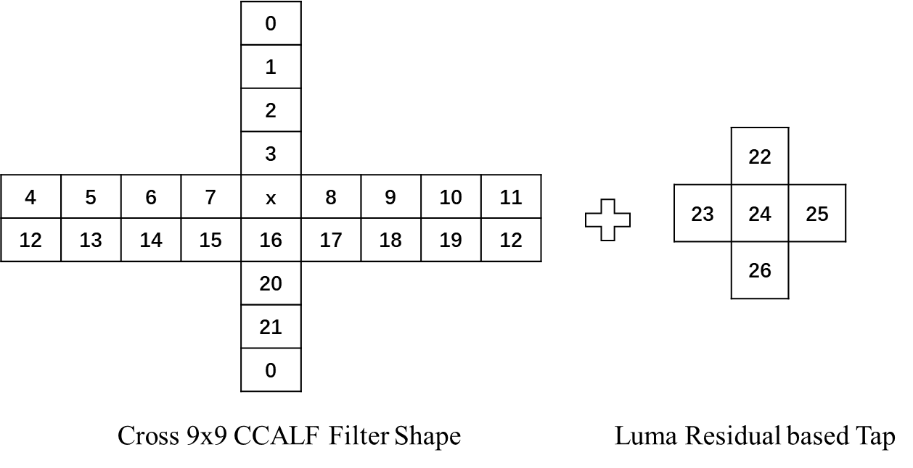
This test investigates the effect of using chroma signals at different stages of the chroma in-loop filtering process as additional inputs to CCALF, as illustrated in figure below.
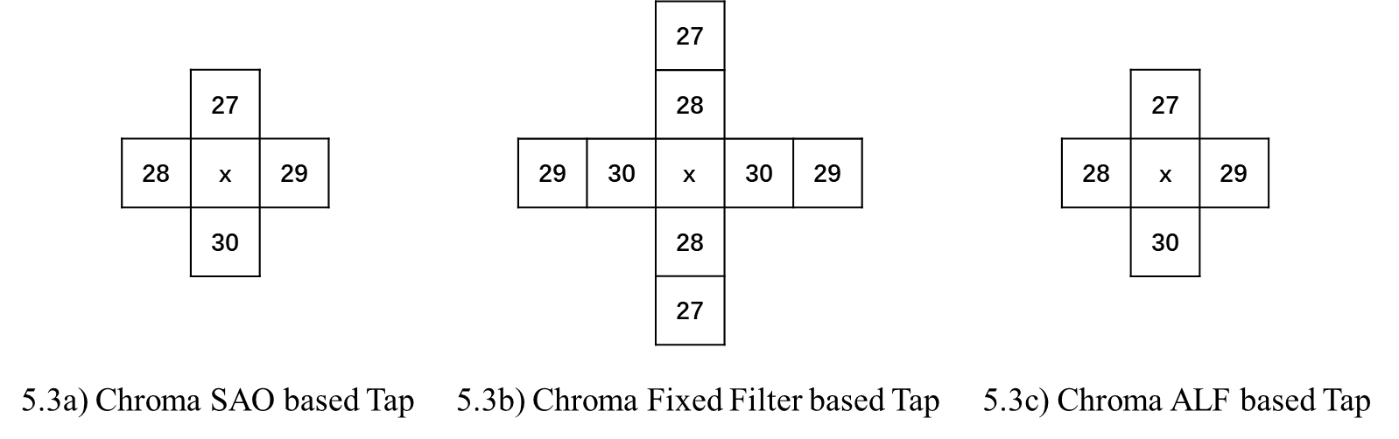
In Test 5.3a, chroma SAO output samples applied to 4 taps in a 3x3 asymmetric cross shape are added for CCALF.
In Test 5.3b, chroma fixed filter output samples applied to 8 taps in a 5x5 symmetrical cross shape are added for CCALF.
In Test 5.3c, chroma ALF output samples applied to 4 taps in a 3x3 asymmetric cross shape are added for CCALF.
Test 5.3d: Test 5.3a + Test 5.3b + Test 5.3c.
Test 5.3e: Test 5.3a + Test 5.3c

Entropy coding

Test 6.1: Entropy coding extension (JVET-AI0056)
In current ECM, slice data can be coded either using CABAC context or in bypass (equal probability) mode.
In the test, a mode is added where the probability depends on the syntax element to encode (non-equal probable), but there is no context update in the CABAC engine.
Training on CTC bitstreams were performed to identify the bypass coded bins to be placed into the new non-equal probable mode.
Test 6.1a: Retrained CABAC contexts.
Test 6.1b: Test 6.1a + some EP bins converted to non-equal probable.
Test 6.1c: Test 6.1b + some EP bins converted to context or non-equal probable coded.
The models are distributed as follow:

 | Contexts | Non-equal probable
Test 6.1a | 6396 | 0
Test 6.1b | 6264 | 1222
Test 6.1c | 6918 | 703

Test 6.2: Context offset for gtX flags for transform coefficients (JVET-AI0209)
In ECM, when the binarization of the coefficient level for the residual coding was introduced, the modification of the offset calculation for the context modelling was overlooked. The context modelling for abs_gtX_flags is done as follows:
ctxIdGtx = offset + (d == 0 ? (Luma ? 21 : 7) : Luma ? d < 3 ? 14 : (d < 10 ? 7 : 0) : 0)
offset = min( sumAbs – numSig, 6 ).
In the test, the calculation of the offset used for context modelling for coding gtX flags is fixed as follows:
offset = (sumAbs > 16) ? 6 : (sumAbs > 8) ? 5 : (sumAbs > 4) ? 4 : sumAbs.
Test 6.2a: Context offset for gtX flags.
Test 6.2b: Test 6.1a + Test 6.2a

Test results
See the accompanied Excel table.
Asterisk (*) with cursive font is used to indicate estimated results, where typically incomplete rate points are replaced with anchor.

