    Joint Video Experts Team (JVET)  of ITU-T SG 16 WP 3 and ISO/IEC JTC 1/SC 29  34th Meeting, Rennes,FR, 17–24 April 2024 | Document: JVET-AH0299-v1

Title: | AHG4/AHG13: review of test material from JVET-AF0262
Status: | Input document to JVET
Purpose: | Information
Author(s) or  Contact(s): | P. de Lagrange | Email: | philippe.delagrange@interdigital.com
Source: | InterDigital
_____________________________

Abstract
This contribution is a subjective review of the part of the material described in JVET-AF0262 that is derived from the open movie “Tears of Steel”; in JVET-AF0262, several scenes are selected, denoised, and grainy versions are derived from the denoised scenes using different variants of grain.
The intent of this contribution is to evaluate which scenes and grain variants would be relevant for subjective quality testing of the FGC SEI message, or related activities. Sequences and grain variants are listed and commented. Several issues are identified, and a selection of a few sequences and grain variants are suggested for further examination.

General description
From JVET-AF0262, only the material derived from “Tears of steel” in JVET-AF0262 has been reviewed, not the newly captured content. The video material was downloaded from Aachen ftp site (jvet@ftp.ient.rwth-aachen.de), under the /ahg/viewingtests/filmgrain/JVET-AF0262 folder.
Eleven denoised video scenes extracted from the “Tears of steel” open movie are provided. Denoising process is not described. The video was originally in TIFF format and was converted to YUV.
On top of each denoised scene, 26 different grain variants are applied, some derived from grain patterns, others from grain synthesis plugins.
The following sections lists the video scenes, the grain patterns, indicate estimated relevance for visual testing and for film grain, and which grain patterns are preferred by the author for specific scenes.
The goal is to potentially select a few candidate test sequences for film grain visual testing activities, and potentially other related activities.

List of video scenes
All scenes are 3840x1741 pixels (1:2.24 aspect ratio), YUV 4:2:0 10-bit 24 fps videos.
Table 1 – List of scenes (mostly taken from the table 2 of AF0262)
Scene | Frames | Length (s) | Thumbnail | Description
004 | 366 | 15.25 | 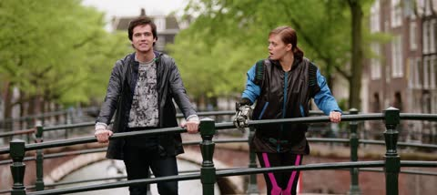 | Wide shot dialogue scene of Young Thom and Celia on a bridge, no camera motion but decent movement from characters with some movement in background
021 | 343 | 14.29 | 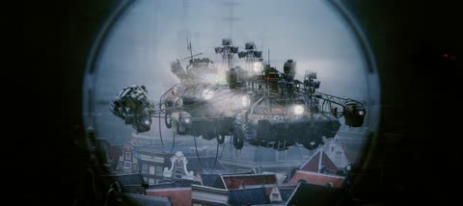 | Camera zoom from rifle scope viewpoint of airship getting attacked by wildcat-like robots jumping onto it ripping pieces away and bringing the ship down in smoke, good camera motion and movement from robots and ship with smoke particles beginning to fill screen toward end of shot
023 | 361 | 15.04 | 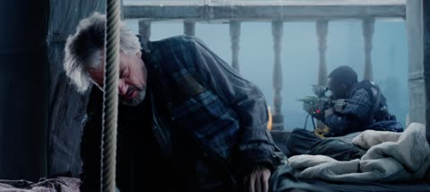 | Wide shot as Thom gets up and responds with slight camera slide/tilt following him revealing Barley in background, good steady camera motion
029 | 330 | 13.75 | 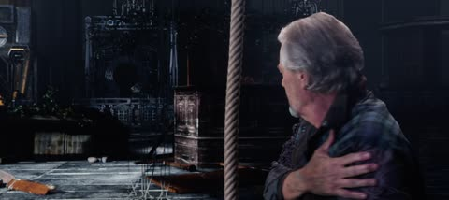 | Camera tilts up from ground as Thom lands, then walks toward lab as camera slides to right tracking him, steady camera motion
030 | 263 | 10.96 | 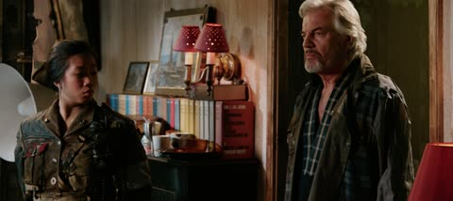 | Medium shot panning left as Thom enters Captain’s room and passes guard by doorway, pan ends after Thom stops and makes eye contact with guard and stays static as he continues walking
044 | 354 | 14.75 | 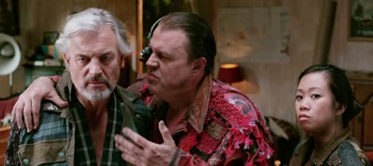 | Medium front again dialogue continues and Thom begins to step into simulation, not much camera motion but decent movement from characters
046 | 759 | 31.63 | 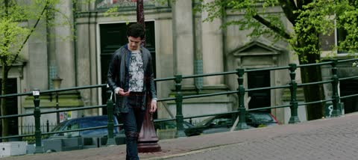 | Tracking shot inside simulation of Thom walking toward robot and being transformed into his younger self from beginning dialogue scene, steady camera motion with a pan and good movement from Thom with robot movement towards end
062 | 207 | 8.63 | 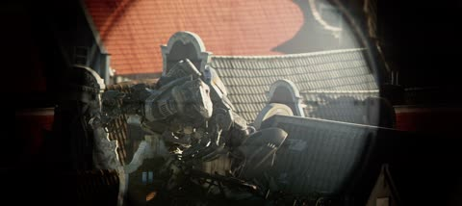 | Camera pan and zoom from rifle scope POV as robot spots Barley, good camera motion and movement from robot climbing on roof of building
101 | 406 | 16.92 | 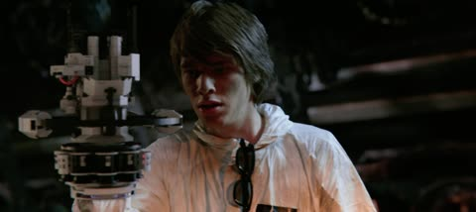 | Steady tracking shot of a technician as he gears up and gets into defensive position with other technicians, steady camera motion and decent slow motion movement from characters
135 | 252 | 10.50 | 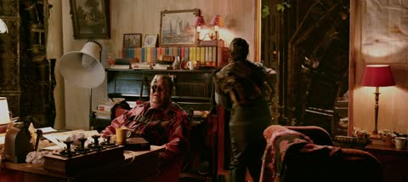 | Camera pulls away from Brain Man and guard and guard pulls out sword to attack approaching robots then camera quickly tilts up as robots jump over the room, steady to quick camera motion and decent character movement from guard and lots of movement from robots
136 | 317 | 13.21 | 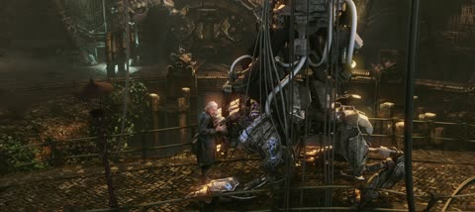 | Camera pulls away from Thom and caressed robot as more robots close in, steady camera motion and lots of movement from robots

List of grain variants
Previews are based on scene 004 (crop shown in Figure 1), showing the difference between grainy version and clean version, multiplied by 4.

Figure 1 – Crop of scene 004 used to extract grain previews

Table 2 – List of grain variants
Variant | Type | Color | Description | Preview
00 | pattern | no | 16mm grayscale | 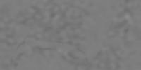
01 | pattern | no | 35mm grayscale | 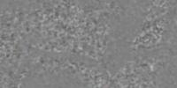
02 | pattern | no | 35mm digital grayscale | 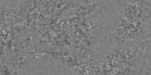
03 | pattern | no | 35mm real grayscale | 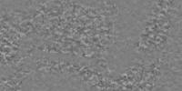
04 | pattern | no | 35mm real texture grayscale | 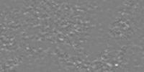
05 | pattern | no | 35mm soft grayscale | 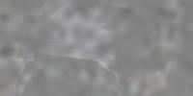
06 | pattern | no | 8mm grayscale | 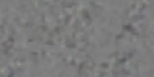
07 | pattern | no | fine grayscale | 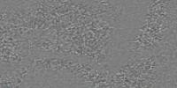
08 | pattern | no | fine texture grayscale | 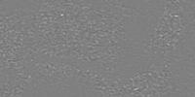
09 | pattern | no | organic grayscale | 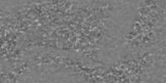
10 | pattern | yes | 16mm color | 
11 | pattern | yes | 35mm color | 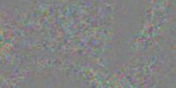
12 | pattern | yes | 35mm digital color | 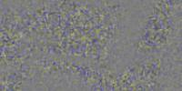
13 | pattern | yes | 35mm real color | 
14 | pattern | yes | 35mm real texture color | 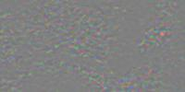
15 | pattern | yes | 35mm soft color | 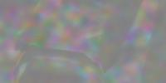
16 | pattern | yes | 8mm color | 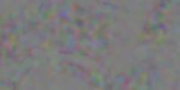
17 | pattern | yes | fine color | 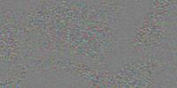
18 | pattern | yes | fine texture color | 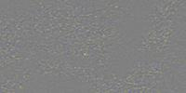
19 | pattern | yes | organic color | 
20 | plugin | no | Native: amount 0.3, style 1 | 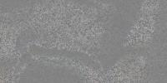
21 | plugin | no | Native: amout 0.6, style 1 | 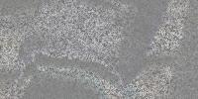
22 | plugin | no | Granularity: strength 64,  size 64, blend 4 | 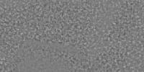
23 | plugin | no | Granularity: strength 128,  size 128, blend 4 | 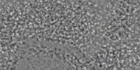
24 | plugin | no | Granularity: strength 64,  size 64 | 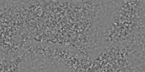
25 | plugin | no | Granularity: strength 128,  size 128 | 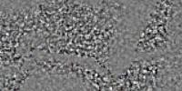

Clean scenes review, suitability for visual testing and/or grain addition
Some general comments applicable to most scenes:
- Some aliasing is often visible and sometimes distracting.
- Denoising appears effective but not perfect, with sometimes significant remaining grain or local discrepancies (e.g. white lamp ? on scene 030), or artificial looking contours (e.g. rope on scene 029, character on scene 134).
Table 3 (and others) reflects notes taken by the author when attempting to identify candidate sequences for visual testing. They only reflect the opinion of the author for this goal and by no means is a judgement of value of any kind.
Table 3 – Notes on content properties
Scene | General notes | Visual testing suitability | Grain appeal | Overall score
004 | Denoising ok but strange warping on middle-right (check original) | + Calm with some detail | = Could add drama | +
021 | Denoising problem on the roofs. | + Detail and slow motion (but sudden zoom) | + Also consider original (looks rather coarse and strong) | =
023 | Imperfect denoising (lot of it remains) | = Not much to break & see defects on | + Also consider original (looks fine & moderate) | =
029 | Denoising issues (rope edges) | - Dark, things everywhere, camera moving (but slow) | + Darkness, blurryness | -
030 | Very strange denoising issue (lamp on the left) | = Pretty static | + Drama mood | -
044 | Denoising ~ok | + Fine texture, low motion | + Drama mood | +
046 | Denoising ok, except on synthetic part. Check original | + for the beginning (natural/synthetic, etc). Too much camera move on middle/end. | = | =
062 | Denoising ok | - Too short, but otherwise ok | = | -
101 | Denoising ok | = close-up | + | +
135 | Missing grainy versions (file distribution issue) | -- very fast moves everywhere after a few seconds | + | --
136 | Denoising mostly ok but disturbing contouring issue. Check original. | = some detail, moderate motion | + | -

Grain review / preferred variants
For a given grain variant, aspect and behaviour are similar for all scenes. Grain strength is modulated depending on light amount, but it is otherwise unchanged (no size/shape modulation, even for plugins).
Grain strength modulation curve is very similar for all grain variants based on patterns. It is merely a bell shape curve: stronger in the mid-tones and lighter at both ends (light and dark). Curve is slightly different for the “Native” plugin, but still has a bell shape. The “Granularity” plugin has a similar curve for the “blend” variant, and more pronounced modulation otherwise.
Grayscale grain sometimes bleeds into UV planes, which may be due to different color primaries/matrix between grain synthesis and YUV conversion. A DC bias is often observed between clean and grainy version, which varies with light & color, and complicates grain analysis; the bias is more or less pronounced depending on the grain variant.
Comments in Table 4 are a review of grain patterns applied to scene 004, and are likely applicable to other scenes too. Table 5 indicates preferred grain (with comments) for each scene: variants 07, 02, 21, 01 are often preferred (listed in order of grain size).
Table 4 – Review of grain variants for scene 004
Identifier | Description | Comment
00 | 16mm grayscale | Way too coarse. Bias.
01 | 35mm grayscale | Still too coarse but could make it. Bias.
02 | 35mm digital grayscale | A bit finer, and stronger. Not too bad. Not too much bias.
03 | 35mm real grayscale | Strange (horizontal structures), otherwise comparable to 02, maybe a bit finer. Not too much bias.
04 | 35mm real texture grayscale | Coarser, but could still work, strange dots, lighter. Bias.
05 | 35mm soft grayscale | Way way too coarse. Big bias.
06 | 8mm grayscale | Way too coarse. Not too much bias.
07 | fine grayscale | Very fine and regular (maybe 2x finer than 02, like a gaussian noise). Works. Not too much bias.
08 | fine texture grayscale | Very fine and regular, too light. Strange dots. Bias.
09 | organic grayscale | Average grain with some dots. Still kind of works. Not too much bias.
10 | 16mm color | Very light and too coarse. Bias.
11 | 35mm color | Similar to 01, a bit lighter on luma, with bias. Almost as strong on U and V (with bias too). Works less than 01: too gentle and strange balance between colors.
12 | 35mm digital color | Same comment as 11 vs 01 but could make it (as it is stronger overall)
13 | 35mm real color | Same comment, could make it (but too gentle)
14 | 35mm real texture color | Same comment. Generally color versions even out / regularize grain, which looses some of its identity
15 | 35mm soft color | Horrible
16 | 8mm color | Too coarse, does not work. Even worse than 06.
17 | fine color | Same comment as 11-14. Looks finer than 07 and too light
18 | fine texture color | Same comment
19 | organic color | Amplitude ok, but the dots in color ruin the whole thing
20 | Native: amount 0.3, style 1 | Very fine. Bias.
21 | Native: amout 0.6, style 1 | Same as 20, just stronger.
22 | Granularity: strength 64,  size 64, blend 4 | Rather fine (like 01 ?). Bias.
23 | Granularity: strength 128,  size 128, blend 4 | 2x coarser, and stronger (too strong). Even stronger bias.
24 | Granularity: strength 64,  size 64 | Size comparable to 22, stronger modulation vs ligtht (peak stronger and almost nothing in the blacks). No bias ?
25 | Granularity: strength 128,  size 128 | Same comparison as 24 vs 22.
Table 5 – Grain preferences for some scenes
Scene | Comment | Preferred variants
004 | Scene has very neat and well-balanced picture with some fine detail. | 02, 07 (21, 01 04)
021 | Scene with lots of fine contrasted details (metallic structures). 01 does work any more (too coarse) except when things get blurry because of motion. We need 07 “fine” (08 is still too light) or 22. 20 and 21 not too bad. 24 does not work (too strong and regular), 22 maybe (but 21 much better). Lighter grain can work on that scene (because of low contrast / fog ?) compared to 004. | 21, 02, 07
023 | 02 and 21 work well. 07 too light / regular. | 02, 21
029 | Scene more blurry. We can go stronger and coarser. | 24, 01, 02
030 | Scene also slow, with some more fine details. Coarse grain not ok. | 21, 07, 02
044 | Scene similar to 030 but more drama and less background detail. Grain works very well. | 02, 01
046 | Detailed scene with some synthetic parts, if adding grain it should be fine and low | 07
062 | Different sorts of grain work | 02, 21, 07, 01
101 | Different grains work too here, but more on the larger/strong side | 02, 01, 21
136 | Difficult to choose. Needs some strength but coarse would not work on zoomed-out part | 21, 07, 02

Conclusion
The video scenes considered here seem to be representative of movie content, which fits the use case of grain synthesis, and most may be good candidates for quality assessment (to be confirmed by experiments).
Unfortunately, the quality of the denoised version is often problematic, with artefacts also found on all grainy derivatives. Another problem worth noting is that on most grain variants some significant bias is observed when compared to the clean baseline, which prevents cross-PSNR studies, that could be useful to measure denoisers efficiency, or to compare encoder performance on clean or noisy versions, or to compare encoded grainy sequence with grain synthesis on top of encoded clean sequence.
On some cases, the same clips of the original “Tears of steel” movie, that could already contain grain may be worth considering, even without a clean reference.
Most grain variants look too coarse or too light, but variants 02 (average size), 07 and 21 (fine) are found to work well on most scenes. Other variants like 01 (coarser) may work on some scenes. Variant 24 (very strong) may work on one scene.
A short list for visual testing could start with scenes 004 (with grain 02) and 044 (with grain 02 or 01), and could continue with scenes where either finer or coarser grain is preferred.
Grain strength is a function of light intensity, as expected, however grain shape/size is not, thus such content would not test this feature of FGC SEI message. Other test content would be needed to test the dependence of grain shape/size over light intensity, for example real film scans. It is also noted that post-production plugins do exist that have this property (InterDigital has developed such a plugin for Technicolor production services in the past).

