    Joint Video Experts Team (JVET)  of ITU-T SG 16 WP 3 and ISO/IEC JTC 1/SC 29  34th Meeting, Rennes,FR, 17–24 April 2024 | Document: JVET-AH0195-v4

Title: | EE1-related: Complexity reduction of NN in-loop filters through early cropping
Status: | Input document to JVET
Purpose: | Proposal
Author(s) or  Contact(s): | Jacob Ström, Mitra Damghanian, Du Liu and Per Wennersten | Email: | {jacob.strom, mitra.damghanian, du.liu, per.wennersten}@ericsson.com
Source: | Ericsson
_____________________________

Abstract
This contribution proposes to gradually reduce the patch size in the last convolutional layers in the neural network-based in-loop filters to avoid unnecessary computation. This way, the output patch from the network can have the desired size, and subsequent cropping is not needed. It is alleged that the proposed method can reuse existing models without the need of retraining. Using the EE1-1.3 as an example, the complexity can reportedly be reduced by -0.8% to 16.76 kMAC/pixel, compared to the 16.90 kMAC/pixel of EE1-1.3. The results are claimed to be bit-exact identical to those of EE1-1.3 (no BDR impact). The reported results over EE1-1.3 are hence
RA-BDR 0.00% (Y) 0.00% (U) 0.00% (V) DecT 99%
AI-BDR 0.00% (Y) 0.00% (U) 0.00% (V) DecT 100%
Results over NNVC-8.0 are reported to be identical to those of EE1-1.3, hence
RA-BDR -0.71% (Y) -0.96% (U) -0.09% (V)
AI-BDR -0.44% (Y) -1.71% (U) -1.16% (V)
The method has also been tried on the LOP.2 model. The complexity is stated to be 16.86 kMAC/pixel, a reduction of 1.1% over the 17.05 kMAC/pixel of LOP.2. The results are again reported to be identical to those of LOP.2, hence the results oer NNVC-8.0 are
RA-BDR 0.00% (Y) 0.00% (U) 0.00% (V) DecT 95%
LDB-BDR 0.00% (Y) 0.00% (U) 0.00% (V) DecT 94%
AI-BDR 0.00% (Y) 0.00% (U) 0.00% (V) DecT 97%
It is proposed to adopt the method into the next version of NNVC.

Introduction
The current neural network-based in-loop filters operate as illustrated in Figure 1. To improve a 128x128 patch of the picture, a larger patch of 144x144 samples (8 samples on each side) is inputted to the network.
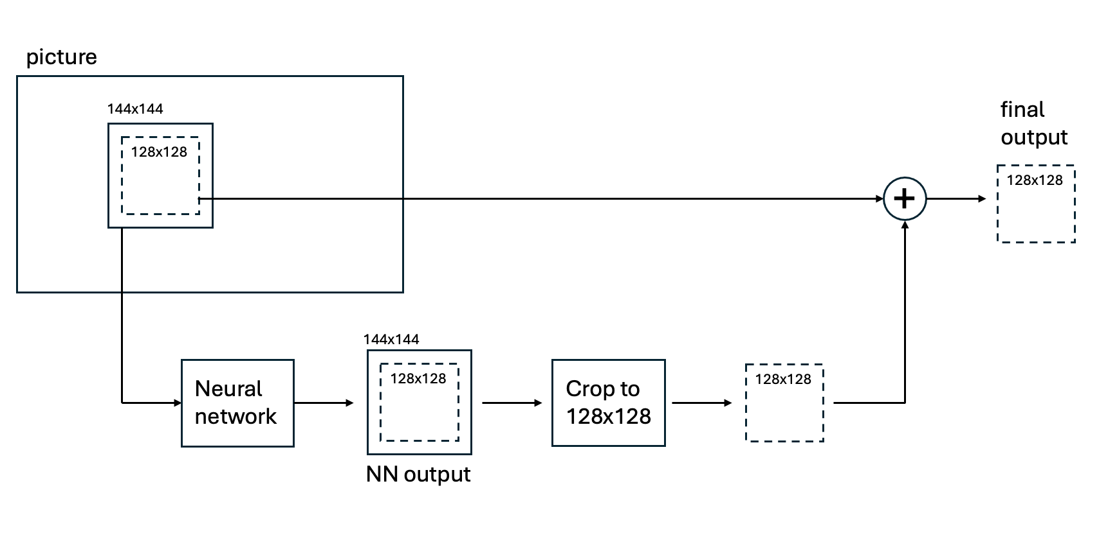
Figure 1. Current operation of the neural network-based in-loop filters in JVET. A patch of 144x144 samples is processed and results in an NN output of 144x144 samples, which is then cropped before adding with the input to produce the final output.

This process is wasteful since the neural network calculates a lot of values that are not used: Only values in the middle 128x128 area (marked with the dashed rectangle) of the NN are used for final output, the ones outside are simply discarded in the subsequent cropping step.

Proposed method
In this contribution we instead propose the functionality according to Figure 2: The neural network still takes a patch with margins as input, e.g., 144x144 samples, but outputs only the relevant 128x128 samples that are further processed.
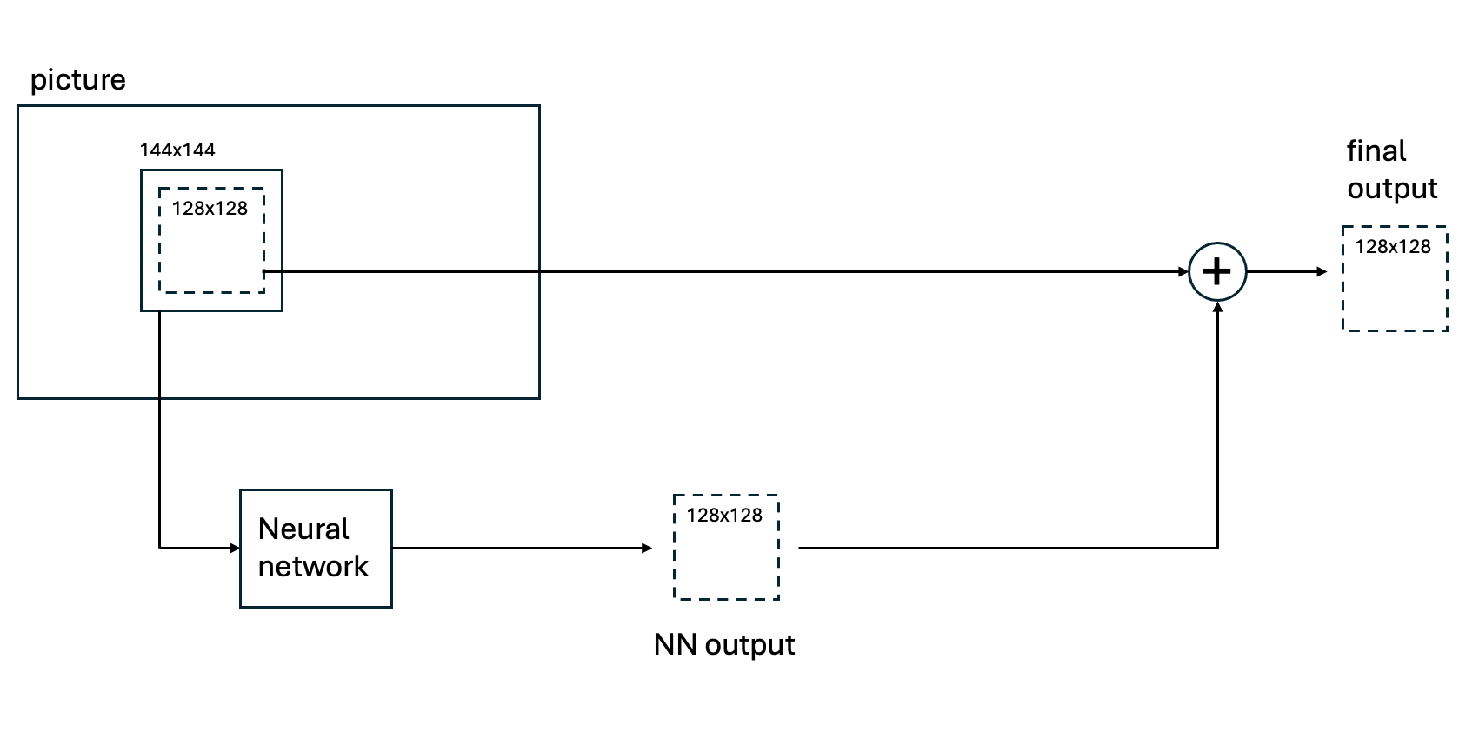Figure 2. In the proposed way of operation, the neural network again gets a 144x144 sample patch as input, but the NN output is already 128x128 samples and does not need to be cropped. This way, no unnecessary calculations are performed.

The proposed method reduces the size of the output patch from the NN in-loop filter, so a further cropping step is not required any more. We use the in-loop filter from EE1-1.3 as an example to test the proposed method. Applying the proposed method to other in-loop filter architectures (HOP, LOP, etc.) is be similar. The architecture of EE1-1.3 is shown in Figure 3.
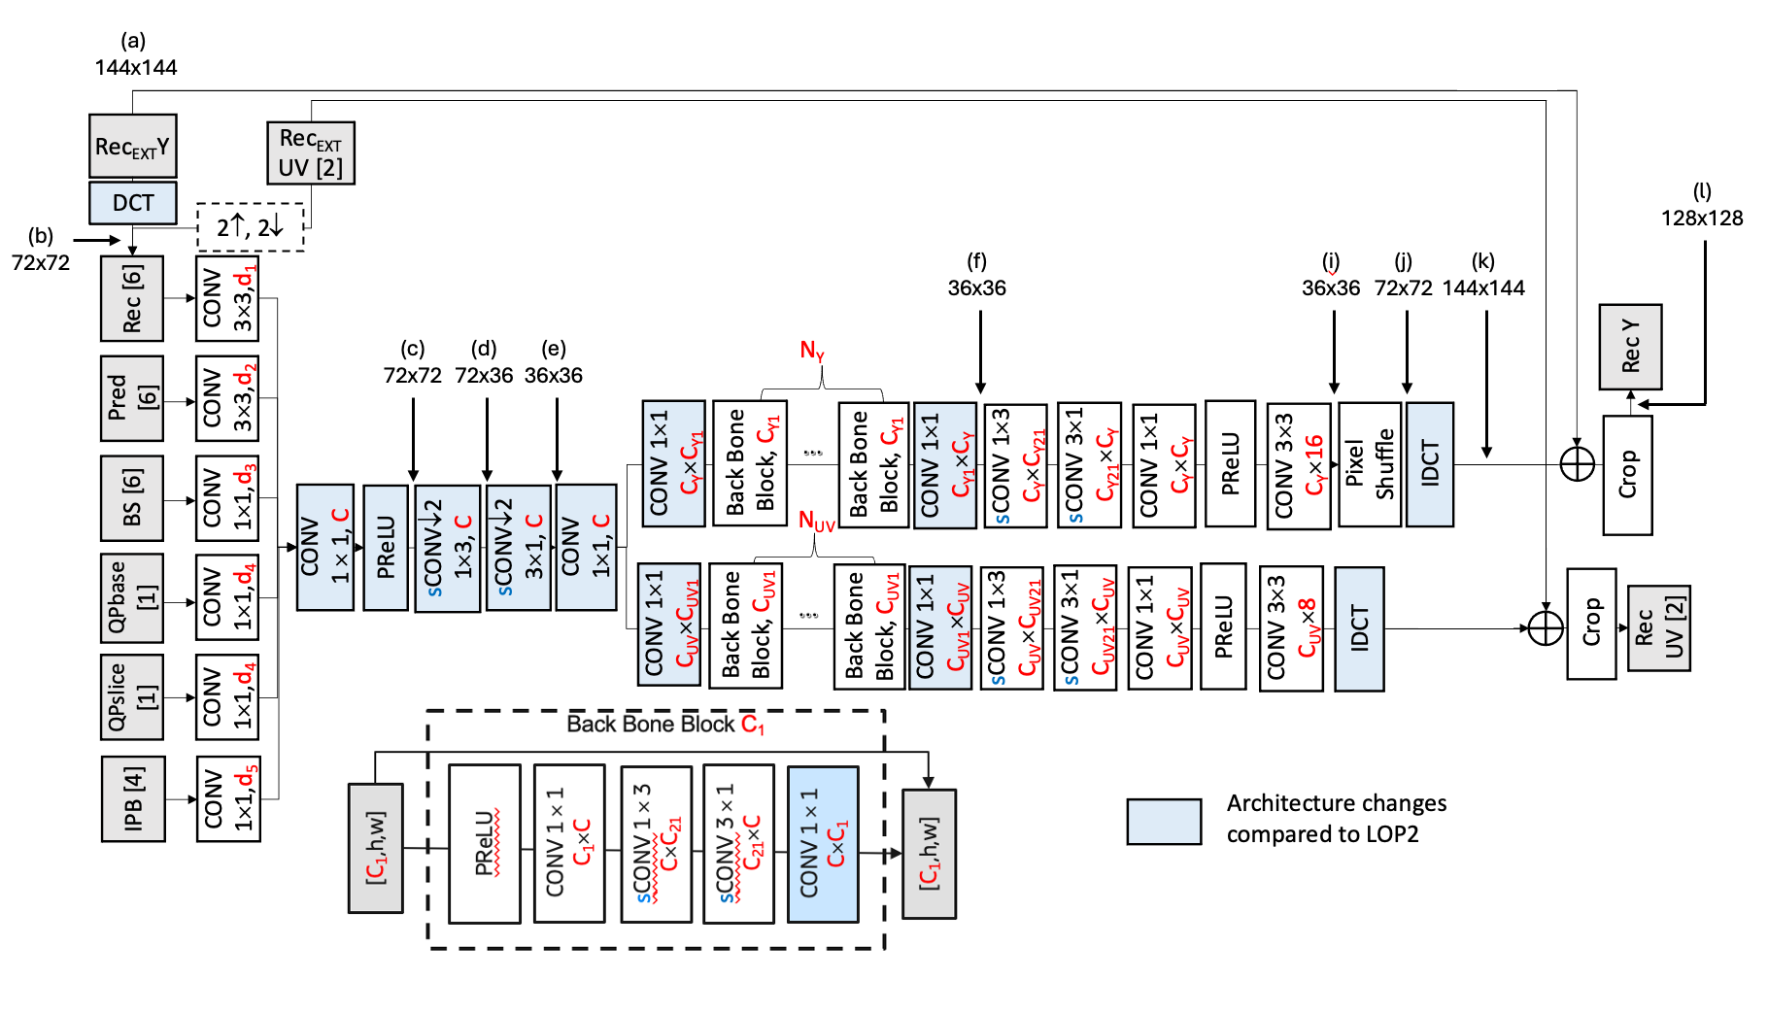
Figure 3. The architecture of EE1-1.3 and the x- and y- size when processing a 144x144 sample patch. The resolution sometimes changes by a factor of two, such as between a) and b) and between d) and e), but it is never cropped.

Here, it can be seen that a luma input patch size of 144x144 sometimes undergoes a resolution change: As an example, after DCT, the size is 72x72 ((b) in the figure), and another example is the convolution with stride 2 which gives a resolution of 36x36 at point (e). At the end, the resolution is back at 144x144 (k) and is then cropped to 128x128 (l).
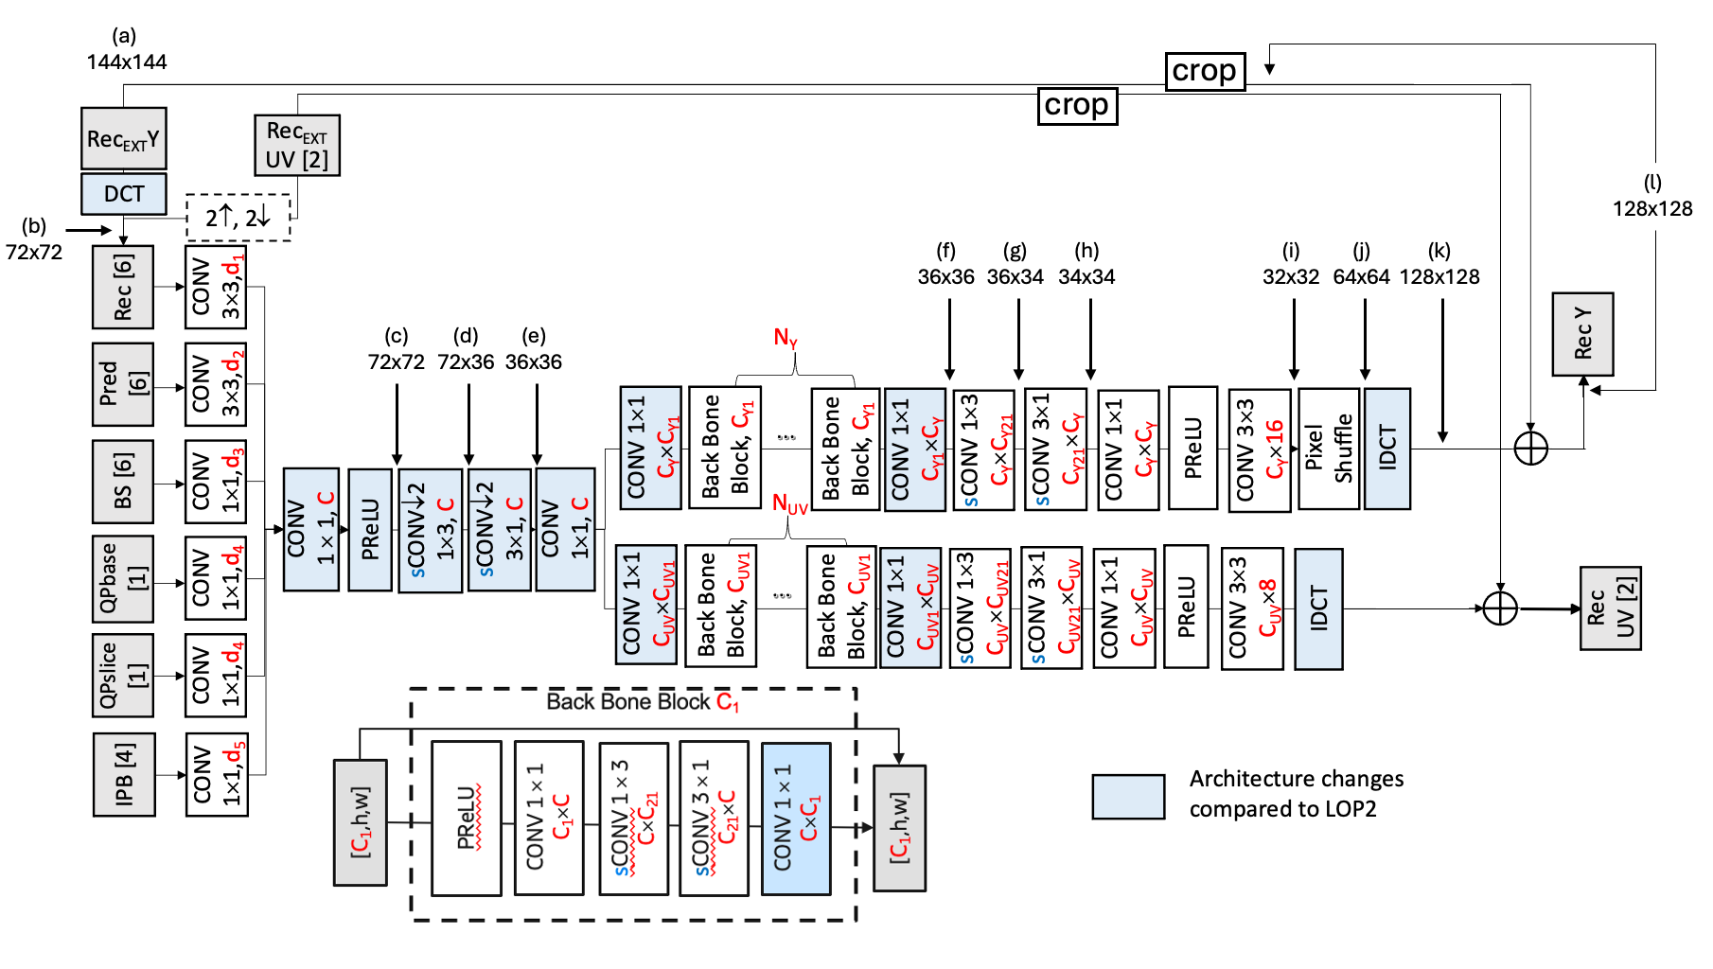
Figure 4. The proposed solution reduces the patch size by using convolutions without padding (padding=(0,0)) which results in an output size at (k) of 128x128, which means that no cropping of (k) is needed.

Figure 4 shows the proposed solution. Up to point (f), everything is the same. Then, the 1x3 convolution between (f) and (g) uses padding=(0,0) (i.e., no padding), which means that the patch size at (g) becomes 36x34. The next convolution also uses padding=(0,0) so that the patch size at (h) is 34x34. Finally, the 3x3 convolution before (i) uses padding=(0,0), bringing the patch size down to 32x32. After pixelshuffle and IDCT, the size becomes 128x128 at (k). Therefore, the input Rec_{EXT}Y has to be cropped from 144x144 to 128x128 (by taking the middle portion) so that it can be added with the output of the IDCT.
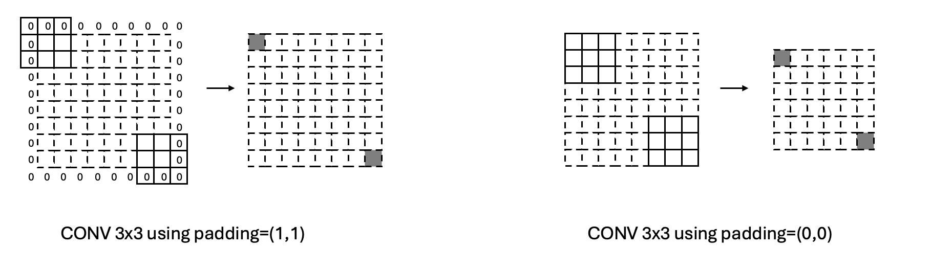
Figure 5. Left: When padding a CONV 3x3 with one pixel everywhere (padding=(1,1)), the output patch size stays the same as the input patch size. Right: Without padding (padding=(0,0)), the patch size is reduced one pixel in top, bottom, left and right giving an output patch size of (N-2)x(N-2) for an NxN input.
A detailed view of the convolution before point (i) can be seen in Figure 5. The left-hand diagram shows the situation in EE1-1.3, where the patch size stays the same using padding=(1,1). The right-hand diagram shows the proposed method, where the size is reduced by two pixels both in the x- and y-dimension. Note that if the same weights and biases are used, the result to the right will be identical to the middle part of the left-hand output.

LOP.2 version
The method has also been tested on LOP.2. Here, the approach is similar; the patch size is gradually reduced until the output is 128x128 rather than 144x144 (for a 144x144-sized input patch). Since the patch-size in the LOP.2 model is twice that of EE1-1.3 (since the former lacks the DCT-step), two backbone-blocks are also using padding=(0,0) in their 3x1 and 1x3 convolution layers.

Training and inference
No retraining is needed; a previous training checkpoint is reused to create a new cropped SADL model that gives identical results to the non-cropped version. This way, weights and bias values from previous trainings are loaded into the new network architecture. For inference, the NNVC code is changed so that no cropping is done on the output of the NN filter. Furthermore, SADL is modified so that it can handle padding=(0,0) for kernels of size 3x3, 1x3 and 3x1.

Results
For the EE1-1.3-based version, the complexity in terms of kMAC/pixel was calculated according to the attached excel file to 16.76 kMAC/pixel. This has also been verified by estimation using the thop library v0.1.1. This is a reduction of -0.8% compared to the 16.90 kMAC/pixel of EE1-1.3. The number of parameters is unchanged at 205108. For the LOP.2-based version, the complexity in terms of kMAC/pixel was calculated according to the attached excel file to 16.86 kMAC/pixel. Again, this was verified using the thop library. This is a reduction of -1.1% compared to the 17.05 kMAC/pixel of LOP.2.

Results for EE1-1.3-based version over NNVC-8.0
These have equivalent BD-rate results to those of EE1-1.3.
 | Random access
 | Over NNVC-8.0 int16 (NNIntra+LOP)
 | Y-PSNR | U-PSNR | V-PSNR
Class A1 | -1.21% | -2.82% | -2.72%
Class A2 | -1.06% | -0.65% | 0.90%
Class B | -0.59% | -0.97% | -0.24%
Class C | -0.22% | 0.20% | 1.33%
Class E
Overall | -0.71% | -0.96% | -0.09%
Class D | 0.23% | 0.60% | 2.41%
Class F | -0.09% | 2.45% | 3.09%

 | All Intra
 | Over NNVC-8.0 int16 (NNIntra+LOP)
 | Y-PSNR | U-PSNR | V-PSNR
Class A1 | -1.05% | -2.47% | -3.25%
Class A2 | -0.45% | -1.85% | 0.06%
Class B | -0.39% | -1.70% | -1.51%
Class C | -0.01% | -0.09% | 0.78%
Class E | -0.47% | -3.02% | -2.31%
Overall | -0.44% | -1.71% | -1.16%
Class D | 0.30% | 0.54% | 2.58%
Class F | 0.21% | 2.19% | 2.01%

Results for EE1-1.3-based version over EE1-1.3
These are bit-exact identical to those of EE1-1.3.

 | Random access
 | Over EE1-1.3 int16
 | Y-PSNR | U-PSNR | V-PSNR
Class A1 | 0.00% | 0.00% | 0.00%
Class A2 | 0.00% | 0.00% | 0.00%
Class B | 0.00% | 0.00% | 0.00%
Class C | 0.00% | 0.00% | 0.00%
Class E
Overall | 0.00% | 0.00% | 0.00%
Class D | 0.00% | 0.00% | 0.00%
Class F | 0.00% | 0.00% | 0.00%

 | All Intra
 | Over EE1-1.3 int16
 | Y-PSNR | U-PSNR | V-PSNR
Class A1 | 0.00% | 0.00% | 0.00%
Class A2 | 0.00% | 0.00% | 0.00%
Class B | 0.00% | 0.00% | 0.00%
Class C | 0.00% | 0.00% | 0.00%
Class E | 0.00% | 0.00% | 0.00%
Overall | 0.00% | 0.00% | 0.00%
Class D | 0.00% | 0.00% | 0.00%
Class F | 0.00% | 0.00% | 0.00%

Results for LOP.2-based version over NNVC8.0
These are bit-exact identical to those of NNVC8.0.

 | Random access
 | Over NNVC-8.0
 | Y-PSNR | U-PSNR | V-PSNR
Class A1 | 0.00% | 0.00% | 0.00%
Class A2 | 0.00% | 0.00% | 0.00%
Class B | 0.00% | 0.00% | 0.00%
Class C | 0.00% | 0.00% | 0.00%
Class E
Overall | 0.00% | 0.00% | 0.00%
Class D | 0.00% | 0.00% | 0.00%
Class F | 0.00% | 0.00% | 0.00%

 | Low delay B
 | Over NNVC-8.0
 | Y-PSNR | U-PSNR | V-PSNR
Class A1
Class A2
Class B | 0.00% | 0.00% | 0.00%
Class C | 0.00% | 0.00% | 0.00%
Class E | 0.00% | 0.00% | 0.00%
Overall | 0.00% | 0.00% | 0.00%
Class D | 0.00% | 0.00% | 0.00%
Class F | 0.00% | 0.00% | 0.00%

 | All Intra
 | Over EE1-1.3 int16
 | Y-PSNR | U-PSNR | V-PSNR
Class A1 | 0.00% | 0.00% | 0.00%
Class A2 | 0.00% | 0.00% | 0.00%
Class B | 0.00% | 0.00% | 0.00%
Class C | 0.00% | 0.00% | 0.00%
Class E | 0.00% | 0.00% | 0.00%
Overall | 0.00% | 0.00% | 0.00%
Class D | 0.00% | 0.00% | 0.00%
Class F | 0.00% | 0.00% | 0.00%

Conclusions
This contribution describes a method to avoid unnecessary computation in neural network-based in-loop filters. The method works by using padding=(0,0) for some of the convolutions that have a kernel sizes larger than 1x1, which has the effect of reducing the size of the output patch. This reduces the complexity in terms of kMAC/pixel by 0.8% for the EE1-1.3 architecture with identical (bit-exact) results. It is proposed to adopt this method into the next version of NNVC.

References
[1] https://pypi.org/project/thop/
[2] Common Test Conditions and evaluation procedures for neural network-based video coding technology, E. Alshina, R.-L. Liao, S. Liu, A. Segall, JVET-AF2016, Joint Video Experts Team (JVET) of ITU-T SG 16 WP 3 and ISO/IEC JTC 1/SC 29, 32nd Meeting, Hannover, DE, 13–20 October 2023.
[3] EE1-1.3: Training from scratch for the joint LOP model with inputs transformed, D. Liu, J. Ström, M. Damghanian, P. Wennersten (Ericsson), D. Rusanovskyy, Y. Li, M. Karczewicz (Qualcomm), T. Shao, P. Yin, S. McCarthy (Dolby), J. N. Shingala, A. Shyam, A. Suneja, S. P. Badya (Ittiam), JVET-AH0081, Joint Video Experts Team (JVET) of ITU-T SG 16 WP 3 and ISO/IEC JTC 1/SC 29, 34th Meeting, Rennes, FR, 17–24 April 2024.

Patent rights declaration(s)
Ericsson may have current or pending patent rights relating to the technology described in this contribution and, conditioned on reciprocity, is prepared to grant licenses under reasonable and non-discriminatory terms as necessary for implementation of the resulting ITU-T Recommendation | ISO/IEC International Standard (per box 2 of the ITU-T/ITU-R/ISO/IEC patent statement and licensing declaration form).

