    Joint Video Experts Team (JVET)  of ITU-T SG 16 WP 3 and ISO/IEC JTC 1/SC 29  34th Meeting, Rennes, FR, 17–24 April 2024 | Document: JVET-AH0180-v2

Title: | AHG12: Modified CTC for encoding time reduction under low-delay configuration
Status: | Input document to JVET
Purpose: | Proposal
Author(s) or  Contact(s): | R. Utida  S. Puri  I. Marzuki  C. Bonnineau | Tel:  Email: | Renan.Utida@interdigital.com
Source: | InterDigital
_____________________________

Abstract
In JVET-AE0163, a modification to the CTC for low delay configuration was proposed to significantly reduce the worst-case encoding runtime for LDB/LDP. The modification proposed and accepted by JVET was to modify encoder configuration by decreasing the maximum MTT hierarchy depth from 3 to 2 for slices with temporal depth higher or equal to 2, for QP 22 of Class B sequences.
This contribution proposes new changes for maximum MTT hierarchy depth for QP 22 of Class B sequences. The first is to set the maximum depth from 3 to 2 for temporal depth higher or equal to 1 (Test 1). The second is to, on top of the first change, also set the maximum depth from 2 to 1 for temporal depth higher or equal to 3 (Test 2).
Additional results for Tests 1 and 2 combined with setting the maximum depth from 3 to 2 for temporal depth higher or equal to 3 for QP 27 (Tests 3 and 4, respectively) are also provided.
The results are summarized below:
LDB (Test 1):
97.2% average encoding time relative to ECM-12.0 Class B, with 0.01% luma coding loss.
89% encoding time relative to ECM-12.0 for the worst case (BQTerrace QP 22)
LDB (Test 2):
93.3% average encoding time relative to ECM-12.0 ClassB, with 0.14% luma coding loss.
73% encoding time relative to ECM-12.0 for the worst case (BQTerrace QP 22)
LDB (Test 3):
93.8% average encoding time relative to ECM-12.0 Class B, with 0.15% luma coding loss.
84% encoding time relative to ECM-12.0 for the worst case for QP27 (BasketballDrive)
LDB (Test 4):
90.0% average encoding time relative to ECM-12.0 ClassB, with 0.28% luma coding loss.
84% encoding time relative to ECM-12.0 for the worst case for QP27 (BasketballDrive)
Similar encoder time savings are observed in LDP configuration in ECM-12.0. It is proposed to adopt this CTC change for the LDB and LDP configurations.

Introduction
The encoder runtime in ECM-12.0 has increased by 19.0% and 21.4% respectively for LDB and LDP configurations compared to the ECM-11.0. This time increase has become a problem for investigating new coding tools under low delay configurations. In particular, the worst-case encoding time for low-delay B class B sequences makes it very long to wait for complete results.
Depending on the processing performance and configuration used, the encoding time for the worst-case (case of BQTerrace QP 22) has increased in 2 days from ECM-11.0 to ECM-12.0 (13 to 15 days in one example).
The JVET-AE0163 [1] addressed this by proposing a configuration to reduce the worst-case encoder run time. One of the solutions, which was adopted, was the change in the maximum MTT Hierarchy Depth for QP 22 of Class B sequences, i.e.:
- MaxMTTHierarchyDepthByTidOverrideByQP: 22 332222
With above low delay configuration, it was noticed that frames with temporal depth of 1 and 2 are encoded with the same QP. Since there is no valid justification for them to be set with different values of maximum MTT hierarchy depth, it is proposed to reduce the maximum MTT depth to 2 for frames with temporal Id higher or equal to 1. Besides that, it was also observed that a large amount of encoding time is spent on frames with temporal depth of 3, which are half of all the encoded frames. To tackle this, another test is proposed where the maximum MTT depth is reduced from 2 to 1 for frames with temporal Id of 3 or higher.
In order to prevent QP27 runtime from becoming the worst-case runtime, the maximum MTT hierarchy depth for QP27 is reduced from 3 to 2 for frames with temporal depth larger or equal to 3. The results of this change are presented in the next section under Test 3 and Test 4.

Encoding parameters change for QP22
The contribution provides the results for the following two individual tests with the variations applied only to QP22.
Test 1:
Per-QP encoding parameter used for class B:
- MaxMTTHierarchyDepthByTidOverrideByQP: 22 322222
Test 2:
Per-QP encoding parameter used for class B:
- MaxMTTHierarchyDepthByTidOverrideByQP: 22 322111

Tables 1 and 2 show the obtained results for Test 1, in LDB. Table 1 shows the individual encoding time reduction per sequence, with their respective BD-rate, while Table 2, the average impact of the contribution.

Table 1: Test 1 performance results of proposed LDB encoder settings, per sequence
 | Reference |  | Tested |  |  |  | BD-rate (piecewise cubic)
 | Enc T [h] | Enc T [d] | Enc T [h] | Enc T [d] | ΔEnc T [d] | EncR | Y
MarketPlace | 310.92 | 12.96 | 276.73 | 11.53 | -1.42 | 0.89 | 0.02%
RitualDance | 196.37 | 8.18 | 177.18 | 7.38 | -0.80 | 0.90 | 0.00%
Cactus | 218.55 | 9.11 | 195.94 | 8.16 | -0.94 | 0.90 | 0.00%
BasketballDrive | 295.31 | 12.30 | 263.58 | 10.98 | -1.32 | 0.89 | 0.03%
BQTerrace | 373.17 | 15.55 | 332.34 | 13.85 | -1.70 | 0.89 | 0.02%
Average |  |  |  |  |  | 0.894

Table 2: Test 1 performance results of proposed LDB encoder settings
 | Low delay B Main 10
 | Over ECM-12.0
 | Y | U | V | EncT | DecT | VmPeak
Class B | 0.01% | 0.07% | -0.04% | 97.2% | 100.2% | #DIV/0!
Tables 3 and 4 show the obtained results for Test 2, in LDB. Table 3 shows the individual encoding time reduction per sequence, with their respective BD-rate, while Table 4, the average impact of the contribution.

Table 3: Test 2 performance results of proposed LDB encoder settings, per sequence
 | Reference |  | Tested |  |  |  | BD-rate (piecewise cubic)
 | Enc T [h] | Enc T [d] | Enc T [h] | Enc T [d] | ΔEnc T [d] | EncR | Y
MarketPlace | 310.92 | 12.96 | 242.90 | 10.12 | -2.83 | 0.78 | 0.11%
RitualDance | 196.37 | 8.18 | 151.13 | 6.30 | -1.88 | 0.77 | 0.15%
Cactus | 218.55 | 9.11 | 165.87 | 6.91 | -2.19 | 0.76 | 0.10%
BasketballDrive | 295.31 | 12.30 | 222.55 | 9.27 | -3.03 | 0.75 | 0.18%
BQTerrace | 373.17 | 15.55 | 271.94 | 11.33 | -4.22 | 0.73 | 0.18%
Average |  |  |  |  |  | 0.758

Table 4: Test 2 performance results of proposed LDB encoder settings
 | Low delay B Main 10
 | Over ECM-12.0
 | Y | U | V | EncT | DecT | VmPeak
Class B | 0.14% | 0.25% | 0.15% | 93.3% | 99.3% | #DIV/0!

Similar results can be found in Test 1 under LDP. On Test 2, the time reduction is similar, but LDP has an average BD-rate loss of 0.22%, while LDB is 0.14%.
Figure 1 below shows an example for the worst-case scenario, for sequence BQTerrace. Please note that in both figures, the graph legends are identified by the maximum depth of only the first four temporal depths, since the reminder are not used.
Figure 1(a) shows the encoding times per frame within three GOPs. It is very clear that in the anchor configuration, the encoding times for frames for temporal depth of 1 is more than double then their counterparts encoded with the same QP (frames with temporal depth of 2). It is also possible to note the large time reduction for frames with temporal depth of 3 (Test 2).
Figure 1(b) shows the accumulated encoding time (in days) according to the temporal depth, for each of the configurations. Note that for both Tests, the encoding time of frames with temporal depth of 1 is reduced by almost half. A similar reduction is observed for encoding time of frames with temporal depth of 3, in Test 2.
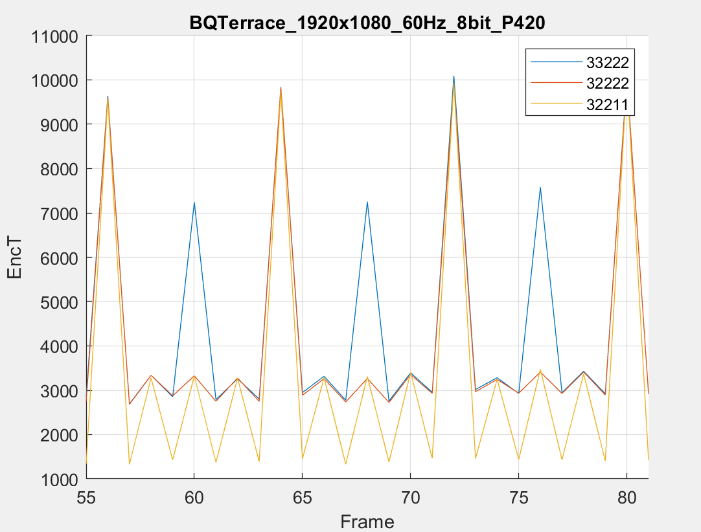  (a) | 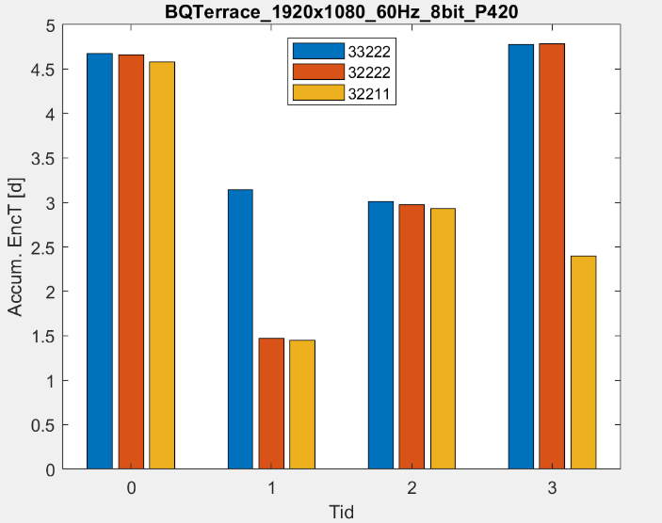  (b)
Figure 1: Example of encoding time for sequence BQTerrace, QP22: (a) per frame for three GOPs, (b) accumulated per temporal depth for the entire sequence.

Encoding parameters change for QP22 and QP27
The contribution provides the results for the following two individual tests with the variations applied to both QP22 and QP27.
Test 3:
Per-QP encoding parameter used for class B:
MaxMTTHierarchyDepthByTidOverrideByQP: 22 322222
MaxMTTHierarchyDepthByTidOverrideByQP: 27 333222
Test 4:
Per-QP encoding parameter used for class B:
MaxMTTHierarchyDepthByTidOverrideByQP: 22 322111
MaxMTTHierarchyDepthByTidOverrideByQP: 27 333222

Tables 5 and 6 show the obtained results for Test 3, in LDB. Table 5 shows the individual encoding time reduction per sequence for both QPs 22 and 27, with their respective BD-rate, while Table 6, the average impact of the contribution.

Table 5: Test 3 performance results of proposed LDB encoder settings, per sequence
 | Reference |  | Tested |  |  |  | BD-rate (piecewise cubic)
 | Enc T [h] | Enc T [d] | Enc T [h] | Enc T [d] | ΔEnc T [d] | EncR | Y
MarketPlace | 310.92 | 12.96 | 276.73 | 11.53 | -1.42 | 0.89 | 0.07%
 | 183.10 | 7.63 | 167.43 | 6.98 | -0.65 | 0.91
RitualDance | 196.37 | 8.18 | 177.18 | 7.38 | -0.80 | 0.90 | 0.22%
 | 185.16 | 7.72 | 150.89 | 6.29 | -1.43 | 0.81
Cactus | 218.55 | 9.11 | 195.94 | 8.16 | -0.94 | 0.90 | 0.10%
 | 171.02 | 7.13 | 144.80 | 6.03 | -1.09 | 0.85
BasketballDrive | 295.31 | 12.30 | 263.58 | 10.98 | -1.32 | 0.89 | 0.21%
 | 222.74 | 9.28 | 186.93 | 7.79 | -1.49 | 0.84
BQTerrace | 373.17 | 15.55 | 332.34 | 13.85 | -1.70 | 0.89 | 0.17%
 | 163.43 | 6.81 | 149.90 | 6.25 | -0.56 | 0.92

Table 6: Test 3 performance results of proposed LDB encoder settings
 | Low delay B Main 10
 | Over ECM-12.0
 | Y | U | V | EncT | DecT
Class B | 0.15% | 0.29% | 0.44% | 93.8% | 98.9%

Tables 7 and 8 show the obtained results for Test 4, in LDB. Table 7 shows the individual encoding time reduction per sequence for both QPs 22 and 27, with their respective BD-rate, while Table 8, show the average impact of the contribution.

Table 7: Test 4 performance results of proposed LDB encoder settings, per sequence
 | Reference |  | Tested |  |  |  | BD-rate (piecewise cubic)
 | Enc T [h] | Enc T [d] | Enc T [h] | Enc T [d] | ΔEnc T [d] | EncR | Y
MarketPlace | 310.92 | 12.96 | 242.90 | 10.12 | -2.83 | 0.78 | 0.16%
 | 183.10 | 7.63 | 167.43 | 6.98 | -0.65 | 0.91
RitualDance | 196.37 | 8.18 | 151.13 | 6.30 | -1.88 | 0.77 | 0.36%
 | 185.16 | 7.72 | 150.89 | 6.29 | -1.43 | 0.81
Cactus | 218.55 | 9.11 | 165.87 | 6.91 | -2.19 | 0.76 | 0.20%
 | 171.02 | 7.13 | 144.80 | 6.03 | -1.09 | 0.85
BasketballDrive | 295.31 | 12.30 | 222.55 | 9.27 | -3.03 | 0.75 | 0.36%
 | 222.74 | 9.28 | 186.93 | 7.79 | -1.49 | 0.84
BQTerrace | 373.17 | 15.55 | 271.94 | 11.33 | -4.22 | 0.73 | 0.33%
 | 163.43 | 6.81 | 149.90 | 6.25 | -0.56 | 0.92

Table 8: Test 4 performance results of proposed LDB encoder settings
 | Low delay B Main 10
 | Over ECM-12.0
 | Y | U | V | EncT | DecT
Class B | 0.28% | 0.46% | 0.62% | 90.0% | 98.0%

Comparison between results
For a better comparison of the test results, they are listed and plotted below. The encoding time variation and BD-Rate for ECM-11.0 compared to ECM-12.0 is also provided, as reference.

Table 9: Comparison of all tests
Low delay B Main 10
Over ECM-12.0
Class B | Y | U | V | EncT | DecT
Test1 | 0.01% | 0.07% | -0.04% | 97.2% | 100.2%
Test2 | 0.14% | 0.25% | 0.15% | 93.3% | 99.3%
Test3 | 0.15% | 0.29% | 0.44% | 93.8% | 98.9%
Test4 | 0.28% | 0.46% | 0.62% | 90.0% | 98.0%
ECM-11.0 | 1.13% | 0.66% | 1.60% | 85.4% | 101.6%

Figure 2: Comparative results of encoding time reduction and Y BD-Rate vs ECM-12.0.

Conclusion
A modification to the EE2 CTCs is proposed to significantly reduce the worst-case encoding time of ECM in low delay configurations. Results from four individual tests are provided.
The first test shows close to 10% average encoding time decrease for each sequence, with very little encoding loss.
The second test shows close to 24% average encoding time decrease for each sequence, with a slightly higher encoding loss, compared to Test 1.
Tests 3 and 4 show an additional overall time reduction by speeding the encoding of frames with QP27 at cost of increased encoding loss compared to the previous tests.
Furthermore, some visual checks were performed, which confirmed no visual quality decrease nor flickering or pumping were noticed with the proposal.
It is proposed to adopt Test 2 for CTC modification for the next JVET meetings.

References
- JVET-AE0163, “Ahg 12: modified CTC proposal for low-delay configurations”, S. Puri, C. Bonnineu, F. Le Leannec, T. Poirier, InterDigital, July 2023
- JVET-Y2017, “Common Test Conditions and evaluation procedures for enhanced compression tool testing”, M. Karczewicz, Y. Ye, January 2022

Patent rights declaration(s)
InterDigital may have current or pending patent rights relating to the technology described in this contribution and, conditioned on reciprocity, is prepared to grant licenses under reasonable and non-discriminatory terms as necessary for implementation of the resulting ITU-T Recommendation | ISO/IEC International Standard (per box 2 of the ITU-T/ITU-R/ISO/IEC patent statement and licensing declaration form).

