    Joint Video Experts Team (JVET)  of ITU-T SG 16 WP 3 and ISO/IEC JTC 1/SC 29  34th Meeting, Rennes, FR, 17–24 April 2024 | Document: JVET-AH0062-v2

Title: | Non-EE2: CCALF with Chroma Fixed Filter Input
Status: | Input document to JVET
Purpose: | Proposal
Author(s) or  Contact(s): | Nan Song, Zhenyu Dai, Yue Yu,  Haoping Yu, Dong Wang | Tel:  Email: | songnan@oppo.com
Source: | OPPO
_____________________________

Abstract
In ECM-12.0, the Laplacian and variance classifier-based fixed filters are applied to both luma and chroma components in the adaptive loop filter (ALF) process. This contribution proposes to add additional filter taps in CCALF and use the chroma ALF fixed filter’s output as the input for these new taps. The proposed method is implemented on top of ECM-12.0, and the coding performance is reported as follows:
AI: { 0.02 % Y, -0.66 % U, -0.76 % V, 100% EncT, 101.5% DecT }
RA: { x.xx % Y, x.xx % U, x.xx % V, x% EncT, x% DecT }

Introduction
For the chroma ALF fixed filter in ECM-12.0, the Laplacian value and variance are first calculated for each 2x2 chroma block. Then a class index is determined based on the values of activity, directionality, and scaled variance, where the activity value is a scaled value of the sum of the horizontal and vertical Laplacian values. The derived class index is used to select a filter from a fixed filter set. Then the selected filter would be used for filtering process.
For CCALF in ECM-12.0, an online-trained filter is constructed by 23 luma spatial reconstruction taps and 5 luma residual taps, which is illustrated in Figure 1.
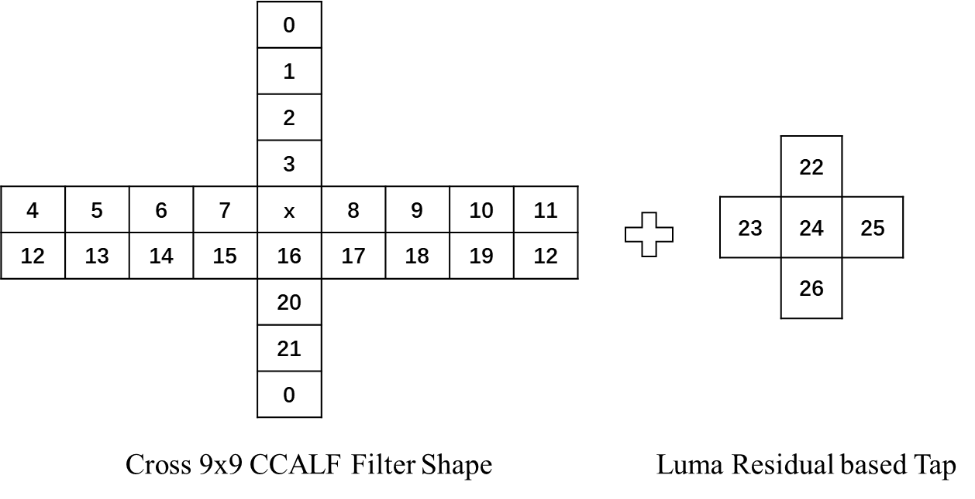
Fig. 1: The currently used filter shape of CCALF

Proposed method
This contribution proposes to add additional filter taps in CCALF and use the chroma ALF fixed filter’s output as the input for these new taps to further improve the performance of CCALF. More specifically, as shown in Fig. 2, two extra taps in a 3x3 symmetric cross shape are added to the CCALF. The input for these extended taps is the co-located and neighbouring samples from the output of the chroma ALF fixed filters. All the current luma spatial reconstruction taps and luma residual taps in CCALF are kept unchanged.
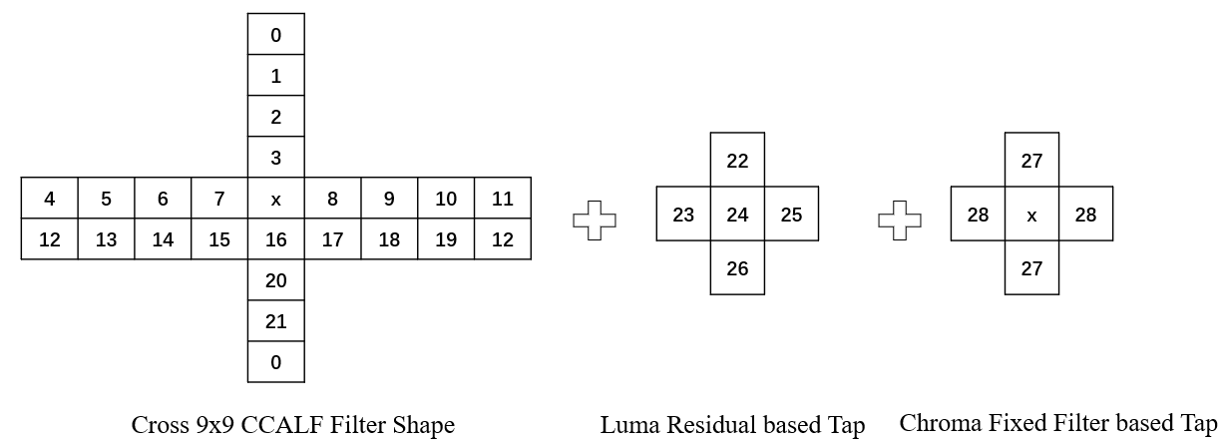
Fig. 2: The proposed filter shape for CCALF

Simulation results
The proposed method is implemented on top of ECM-12.0 [1]. The simulations were carried out by following the ECM common test conditions [2].
Table 1. The proposed method on top of ECM-11.0
 | All Intra Main 10
 | Over ECM-12.0
 | Y | U | V | EncT | DecT | EncVmPeak | DecVmPeak
Class A1 | 0.02% | -0.52% | -0.66% | 99.5% | 101.6% | 100.0% | 100.0%
Class A2 | 0.02% | -0.84% | -1.15% | 99.8% | 101.6% | 100.0% | 100.0%
Class B | 0.02% | -1.21% | -1.16% | 100.0% | 101.4% | 100.0% | 100.0%
Class C | 0.01% | -0.19% | -0.16% | 100.5% | 101.4% | 100.0% | 100.0%
Class E | 0.02% | -0.35% | -0.59% | 100.2% | 101.7% | 100.0% | 100.0%
Overall | 0.02% | -0.66% | -0.76% | 100.0% | 101.5% | 100.0% | 100.0%
Class D | 0.01% | -0.19% | -0.13% | 100.6% | 101.6% | 100.0% | 100.0%
Class F | 0.03% | -0.36% | -0.32% | 100.0% | 100.7% | 100.0% | 100.0%
Class TGM
 | Random Access Main 10
 | Over ECM-12.0
 | Y | U | V | EncT | DecT | EncVmPeak | DecVmPeak
Class A1
Class A2
Class B | 0.02% | -0.87% | -0.64% | 100.0% | 99.9% | 100.3% | 99.8%
Class C | 0.03% | -0.09% | -0.06% | 99.7% | 99.5% | 100.2% | 100.0%
Class E
Overall
Class D | 0.01% | -0.19% | -0.17% | 99.8% | 100.4% | 100.1% | 100.0%
Class F
Class TGM

Conclusion
This contribution proposes to add additional taps in CCALF and use the chroma ALF fixed filter’s output as the input for these new taps to further improve CCALF. The simulation results show that the proposed method can improve the coding efficiency of ECM. It is suggested to further study this method in EE2.

References
- ECM12.0, https://vcgit.hhi.fraunhofer.de/ecm/ECM/-/tree/ECM-12.0
- M. Karczewicz, Y. Ye, “Common test conditions and evaluation procedures for enhanced compression tool testing”, JVET-AF2017, October, 2023.

Patent rights declaration(s)
Guangdong OPPO Mobile Telecommunications Corp., Ltd. (OPPO) may have current or pending patent rights relating to the technology described in this contribution and, conditioned on reciprocity, is prepared to grant licenses under reasonable and non-discriminatory terms as necessary for implementation of the resulting ITU-T Recommendation | ISO/IEC International Standard (per box 2 of the ITU-T/ITU-R/ISO/IEC patent statement and licensing declaration form).

