    Joint Video Experts Team (JVET)  of ITU-T SG 16 WP 3 and ISO/IEC JTC 1/SC 29  34th Meeting, Rennes, FR, 17–24 April 2024 | Document: JVET-AH0060-v1

Title: | Non-EE2: On residual adjustments for adaptive loop filters
Status: | Input document to JVET
Purpose: | Proposal
Author(s) or  Contact(s): | Zhenyu Dai  Nan Song  Yue Yu  Haoping Yu  Dong Wang | Tel:  Email: | daizhenyu@oppo.com
Source: | OPPO
_____________________________

Abstract
This contribution proposes applying residual adjustments to the adaptive loop filter’s output in ECM. The proposed method is implemented on top of ECM-12.0, and the coding performance is reported as follows:
RA: { -0.01 % Y, -0.12 % U, -0.16 % V, 100.2% EncT, 100.8% DecT }
LDB: { -0.03 % Y, -0.38 % U, -0.22 % V, 99.8% EncT, 100.8% DecT }

Introduction
In the current ECM-12.0 design, the adaptive loop filters (including ALF and CCALF) are used in the in-loop filtering module to improve the coding performance. The in-loop filtering module is shown in Fig. 1. The SAO’s output will be further filtered by the ALF and CCALF.
Fig. 1: The process of the in-loop filtering module
In EE1, when a NN filter is being applied to reconstructed pictures, a residual offset value is selected and signaled for each color component in the slice header. The offset value candidates are {1, 2}. The residual of NNLF’s output is adjusted by reducing the magnitude of the residual at each pixel by this small offset value before being added to input samples^{[1]}.

Proposed method
This contribution proposes that a frame level offset can be applied to the output of the adaptive loop filters to reduce the output residual magnitude. The process of the proposed method is shown in Fig. 2. The residual image is simply extracted by subtracting the adaptive loop filters’ input from its output. Three frame level flags are signaled to indicate whether the residual adjustment method is enabled for Y, U and V components, respectively.
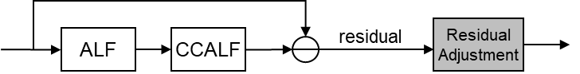
Fig. 2: The process of the proposed method
More specifically, the residual is adjusted by reducing the magnitude of the residual with a pixel-wise small offset whose absolute value is larger than 1. In this contribution, the offset value is set as 1, which means that all the positive residual values larger than 1 are decremented by 1, while all the negative residual values smaller than -1 are incremented by 1. An example of the residual adjustment is shown in Fig. 3.
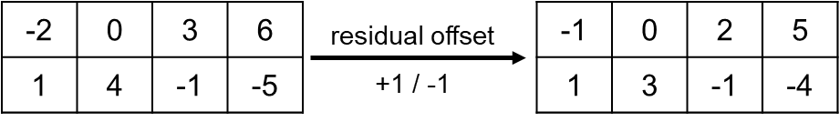
Fig. 3: An example of the proposed residual offset adjustment (left: before adjustment, right: after adjustment)

Experiment results
The proposed method is implemented on top of ECM-12.0^{[2]}. The simulation results were tested by following the ECM common test conditions^{[3]}. Since the method is proposed only for B-Slice, only Random Access and Low Delay B configurations are tested.
Table 1. The proposed method on top of ECM-12.0 (RA)
 | Random Access Main10
 | Over ECM-12.0
 | Y | U | V | EncT | DecT
Class A1 | -0.01% | -0.01% | -0.10% | 100.3% | 100.8%
Class A2 | 0.02% | -0.03% | -0.03% | 100.4% | 100.9%
Class B | -0.01% | -0.11% | -0.13% | 100.1% | 100.8%
Class C | -0.05% | -0.27% | -0.34% | 100.0% | 100.8%
Class E
Overall | -0.01% | -0.12% | -0.16% | 100.2% | 100.8%
Class D | -0.09% | -0.15% | -0.22% | 100.2% | 100.6%
Class F | -0.02% | -0.05% | -0.13% | 100.1% | 102.6%
Table 2. The proposed method on top of ECM-12.0 (LDB)
 | Low Delay B Main10
 | Over ECM-12.0
 | Y | U | V | EncT | DecT
Class A1
Class A2
Class B | -0.03% | -0.38% | -0.20% | 99.9% | 101.1%
Class C | -0.07% | -0.42% | -0.15% | 99.7% | 100.9%
Class E | 0.03% | -0.32% | -0.37% | 99.6% | 100.2%
Overall | -0.03% | -0.38% | -0.22% | 99.8% | 100.8%
Class D | -0.29% | -0.08% | -1.16% | 99.8% | 101.0%
Class F | -0.10% | -0.14% | -0.66% | 100.1% | 101.7%

Conclusions
This contribution proposes a residual offset adjustment method for adaptive loop filters. Simulation results show that the proposed method can improve the coding efficiency of ECM with minor complexity increases. It is suggested to further study this method in the next round of EE2.

References
- EE1-1.2.1: On residual adjustments for NNLF, JVET-AF0085, Z. Dai, Y. Yu, H. Yu, D. Wang (OPPO).
- ECM12.0, https://vcgit.hhi.fraunhofer.de/ecm/ECM/-/tree/ECM-12.0.
- M. Karczewicz, Y. Ye, “Common test conditions and evaluation procedures for enhanced compression tool testing”, JVET-AF2017, October, 2023.

Patent rights declaration(s)
Guangdong OPPO Mobile Telecommunications Corp., Ltd. (OPPO) may have current or pending patent rights relating to the technology described in this contribution and, conditioned on reciprocity, is prepared to grant licenses under reasonable and non-discriminatory terms as necessary for implementation of the resulting ITU-T Recommendation | ISO/IEC International Standard (per box 2 of the ITU-T/ITU-R/ISO/IEC patent statement and licensing declaration form).

