    Joint Video Experts Team (JVET)  of ITU-T SG 16 WP 3 and ISO/IEC JTC 1/SC 29  33rd Meeting, by teleconference, 17–26 January 2024 | Document: JVET-AG0058-v2

Title: | EE2-1.14: An extrapolation filter-based intra prediction mode
Status: | Input document to JVET
Purpose: | Proposal
Author(s) or  Contact(s): | Luhang Xu, Yue Yu, Haoping Yu,  Jonathan Gan, Dong Wang (OPPO) | Tel:  Email: | xuluhang@oppo.com
Source: | OPPO
_____________________________

Abstract
This contribution reports the EE2-1.14 test results for the extrapolation filter-based intra prediction mode (EIP). In the EIP mode, the extrapolation filters are derived from the neighboring reconstructed pixels or inherited from the previous decoded blocks. The extrapolation filter generates the prediction signals for the current block from the top-left position to the bottom-right position in a parallel manner. The tests are conducted on the ECM-11.0 reference software with AI and RA configurations. The test-a is the EIP with fast encoding method, and the test-b is the EIP and EIP merge mode with fast encoding method. The tests results are shown as follows,
EE2-TEST-1.14a
Config | Y | U | V | EncT | DecT
AI | -0.12% | -0.09% | -0.07% | 101.6% | 100.9%
RA
EE2-TEST-1.14b
Config | Y | U | V | EncT | DecT
AI | -0.20% | -0.14% | -0.18% | 102.1% | 101.3%
RA

Proposed method
The proposed extrapolation filter-based intra prediction is processed in three steps. First, the extrapolation filter coefficients are derived from a neighboring reconstructed area of the current block or inherited from a previous EIP block. Second, the extrapolation process generates predicted signals from the top-left to bottom-right corner within the current block. Third, an intra prediction angle is derived by analyzing the gradient of the predicted block, and then the corresponding intra-mode is used to select the MTS, NSPT and LFNST kernel for transformation.
The application of EIP is restricted to blocks with sizes not greater than 32x32 and the luma component only.

Obtaining the EIP filter
The following three EIP filter shapes are proposed in this method.
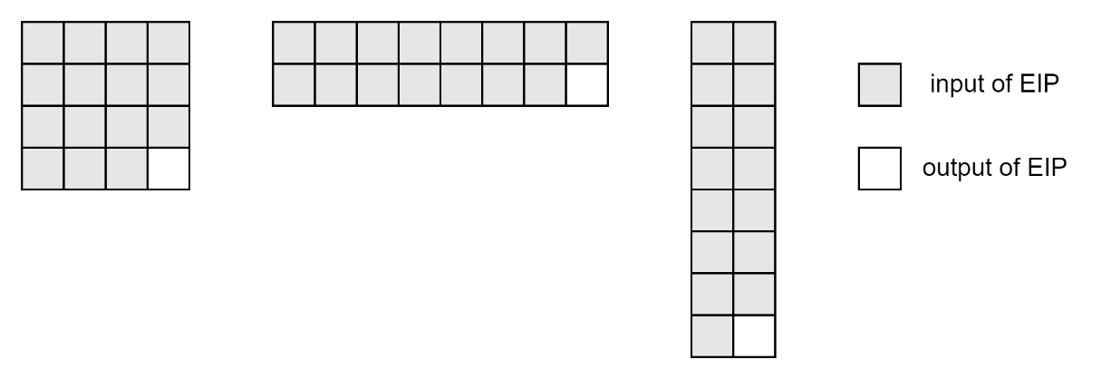
Figure-1. The defined three filter shapes with fifteen inputs and one output.
There are two ways to obtain the filter coefficients for the current CU in this proposal. First, the coefficients can be derived from the neighboring reconstructed pixels, and second, they can also be inherited from the previously decoded blocks.

Derivation of EIP coefficients
The decoder decodes the relevant syntax elements to determine the selected type of reconstructed area and the filter shape for the current block. The selected filter moves in the selected reconstructed area either horizontally or vertically with a one-pixel step to construct the auto-correlation matrix and the cross-correlation vector. The calculation of coefficients from the auto-correlation matrix and the cross-correlation vector is the same as that in CCCM.
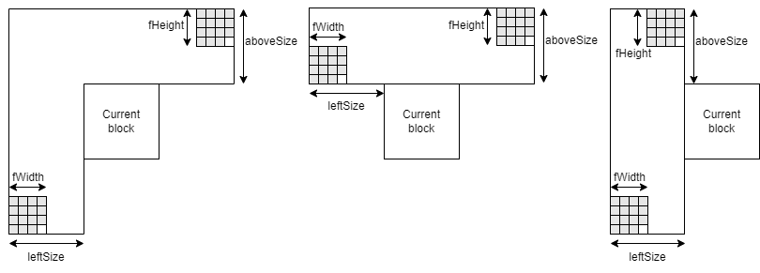
Figure-2. The defined three types of the reconstructed area. The size of the reconstructed area depends on the min(blockWidth, blockHeight) and the selected filter shape. For example, when the current block is an 8x16 block and the selected filter shape is 4x4. The aboveSize of the reconstructed area is equal to min(8, 16) + 4 – 1 = 11, and the leftSize of the reconstructed area is equal to min(8, 16) + 4 – 1 = 11.

Inheritance of the EIP filters
The EIP merge mode is also proposed and tested in this contribution. The filter shape and the filter coefficients can be inherited from the previous decoded blocks with EIP or EIP merge mode. The decoder decodes an EIP merge flag to decide whether the proposed merge mode is used when the current block uses the EIP mode. A merge index is further decoded when the EIP merge flag is true. The EIP merge list includes spatial adjacent and non-adjacent candidates, temporal candidates, and history candidates. The constructed EIP merge list can include up to 12 candidates and the list will be reduced to up to 6 candidates by the reordering process based on the SAD cost measured on a 1 column and 1 row template. In the SAD calculation, predictions of the template area by EIP filters are generated only from reconstructed (neighbouring and template) samples, allowing the EIP filters to be applied in parallel rather than sequentially.
Spatial adjacent, temporal, non-adjacent, shifted temporal candidates and history candidates
The positions and inclusion order of the spatial adjacent, temporal, non-adjacent, shifted temporal and history candidates are the same as those defined in ECM-10.0 for the CCP merge prediction candidates.

Prediction of the current block
The EIP mode generates prediction values for the current block from the top-left position to the bottom-right position by a diagonal prediction order, as shown in Figure-3.
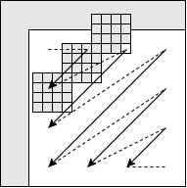
Figure-3. Example of generating predictions for different positions in the current block by a diagonal order
The calculation for the prediction values in this contribution is shown as follows,
$${pred}_{\left(x,y\right)}=\sum_{i=0}^{14}{(c_{i}×t_{\left(x-{offsetX}_{i}, y-{offsetY}_{i}\right)})}$$
where ${pred}_{\left(x,y\right)}$ is the predicted value at (x, y) in the current block, $c_{i}$ is the $i^{th}$ coefficient of the selected EIP filter, the index of the coefficients is from 0 to 14, $t_{\left(x-{offsetX}_{i}, y-{offsetY}_{i}\right)}$is a reconstructed or a predicted value used for the current position’s prediction.${offsetX}_{i}$ and ${offsetY}_{i}$ are the position offsets to the current position.

Mapping to the LFNST/NSPT/MTS set
The proposed method uses the DIMD process to derive an intra prediction mode of the current block based on the EIP predicted samples. Specifically, a horizontal gradient and a vertical gradient are calculated for each predicted sample to build a histogram of gradient (HoG). Then the intra prediction mode corresponding to the largest histogram count is used to determine the LFNST, NSPT or MTS transform set.

Fast encoder algorithm
First, the EIP and EIP merge mode do not increase the number of full RDO in intra search. The encoder compares the SATD cost among EIP, EIP merge and non-EIP modes to update the full RDO list.
Second, the encoder will conditionally reduce one mode with the worst SATD cost in the full RDO cost when EIP or EIP merge’s SATD cost is in the current full RDO list.

Simulation results
The proposed EIP mode with fast encoder algorithm (EE2-TEST-1.14a) is implemented on top of the ECM-11.0 software [1], and tested based on the common test condition [2]. The test results are summarized in Table 1 and 2.
Table 1. Test-a over ECM-11.0 (AI configuration)
 | All Intra Main 10
 | Over anchor
 | Y | U | V | EncT | DecT | EncVmPeak | DecVmPeak
Class A1 | -0.12% | -0.06% | -0.07% | 102.3% | 101.5% | 100.8% | 100.5%
Class A2 | -0.11% | 0.02% | -0.06% | 100.8% | 100.3% | 100.5% | 100.6%
Class B | -0.10% | -0.09% | -0.03% | 101.6% | 100.9% | 99.5% | 100.4%
Class C | -0.10% | -0.12% | -0.14% | 101.2% | 101.1% | 100.3% | 100.2%
Class E | -0.19% | -0.17% | -0.07% | 102.1% | 100.9% | 100.3% | 100.2%
Overall | -0.12% | -0.09% | -0.07% | 101.6% | 100.9% | 100.2% | 100.4%
Class D | -0.06% | -0.11% | -0.05% | 101.3% | 99.7% | 100.3% | 100.1%
Class F | -0.01% | -0.08% | 0.04% | 102.2% | 100.1% | 100.3% | 100.3%
Class TGM | #VALUE! | #VALUE! | #VALUE! | #DIV/0! | #DIV/0! | #DIV/0! | #DIV/0!
Table 2. Test-a over ECM-11.0 (RA configuration)
 | Random Access Main 10
 | Over anchor
 | Y | U | V | EncT | DecT | EncVmPeak | DecVmPeak
Class A1 | -0.05% | -0.27% | -0.14% | 100.6% | 99.8% | 100.7% | 101.2%
Class A2 | #VALUE! | #VALUE! | #VALUE! | #DIV/0! | #DIV/0! | #DIV/0! | #DIV/0!
Class B | -0.08% | 0.08% | -0.11% | 100.8% | 100.1% | 100.6% | 100.7%
Class C | -0.04% | -0.15% | -0.11% | 101.0% | 100.6% | 99.9% | 100.3%
Class E
Overall | #VALUE! | #VALUE! | #VALUE! | #DIV/0! | #DIV/0! | #DIV/0! | #DIV/0!
Class D | -0.06% | -0.03% | -0.18% | 100.8% | 99.2% | 100.2% | 100.1%
Class F | -0.06% | 0.11% | -0.13% | 100.8% | 100.2% | 100.1% | 100.4%
Class TGM | #VALUE! | #VALUE! | #VALUE! | #DIV/0! | #DIV/0! | #DIV/0! | #DIV/0!

The proposed EIP and EIP merge mode with fast encoder algorithm (EE2-TEST-1.14b) is implemented on top of the ECM-11.0 software [1], and tested based on the common test condition [2]. The test results are summarized in Table 3 and 4.
Table 3. Test-b over ECM-11.0 (AI configuration)
 | All Intra Main 10
 | Over anchor
 | Y | U | V | EncT | DecT | EncVmPeak | DecVmPeak
Class A1 | -0.20% | -0.11% | -0.11% | 102.7% | 101.9% | 100.5% | 100.5%
Class A2 | -0.22% | -0.11% | -0.09% | 102.5% | 101.8% | 101.1% | 100.8%
Class B | -0.18% | -0.16% | -0.24% | 102.2% | 101.2% | 101.1% | 100.5%
Class C | -0.16% | -0.20% | -0.15% | 101.0% | 101.1% | 100.7% | 100.3%
Class E | -0.27% | -0.09% | -0.27% | 102.4% | 100.8% | 100.3% | 100.3%
Overall | -0.20% | -0.14% | -0.18% | 102.1% | 101.3% | 100.8% | 100.4%
Class D | -0.02% | -0.21% | -0.07% | 101.7% | 100.5% | 100.1% | 100.1%
Class F | -0.07% | -0.22% | 0.02% | 102.1% | 100.2% | 100.3% | 100.3%
Class TGM | #VALUE! | #VALUE! | #VALUE! | #DIV/0! | #DIV/0! | #DIV/0! | #DIV/0!
Table 4. Test-b over ECM-11.0 (RA configuration)
 | Random Access Main 10
 | Over anchor
 | Y | U | V | EncT | DecT | EncVmPeak | DecVmPeak
Class A1 | -0.10% | -0.24% | -0.12% | 101.0% | 100.1% | 100.8% | 101.2%
Class A2 | #VALUE! | #VALUE! | #VALUE! | #DIV/0! | #DIV/0! | #DIV/0! | #DIV/0!
Class B | -0.11% | -0.05% | -0.11% | 100.9% | 100.2% | 99.4% | 100.5%
Class C | -0.10% | -0.23% | -0.28% | 101.1% | 100.8% | 99.8% | 100.3%
Class E
Overall | #VALUE! | #VALUE! | #VALUE! | #DIV/0! | #DIV/0! | #DIV/0! | #DIV/0!
Class D | -0.01% | -0.17% | -0.17% | 100.9% | 100.1% | 100.2% | 100.1%
Class F | -0.12% | 0.06% | -0.03% | 100.8% | 101.1% | 100.1% | 100.4%
Class TGM | #VALUE! | #VALUE! | #VALUE! | #DIV/0! | #DIV/0! | #DIV/0! | #DIV/0!

The proposed EIP and EIP merge mode without fast encoder algorithm are also tested for comparison purposes. The results of EIP mode without fast encoder algorithm and EIP, EIP merge mode without fast encoder algorithm are summarized in Table 5 and 6.
Table 5. Test-a without fast algorithm over ECM-11.0 (AI configuration)
 | All Intra Main 10
 | Over anchor
 | Y | U | V | EncT | DecT | EncVmPeak | DecVmPeak
Class A1 | -0.14% | -0.08% | 0.02% | 102.6% | 101.3% | 100.4% | 100.5%
Class A2 | -0.13% | -0.04% | -0.04% | 102.1% | 101.2% | 100.5% | 100.7%
Class B | -0.12% | -0.01% | -0.10% | 102.0% | 100.8% | 100.3% | 100.4%
Class C | -0.12% | -0.05% | -0.03% | 101.7% | 100.1% | 100.0% | 100.2%
Class E | -0.21% | -0.18% | -0.17% | 102.3% | 100.9% | 100.3% | 100.2%
Overall | -0.14% | -0.06% | -0.07% | 102.1% | 100.8% | 100.3% | 100.4%
Class D | -0.06% | -0.19% | 0.02% | 101.9% | 101.7% | 100.3% | 100.1%
Class F | -0.02% | -0.02% | 0.20% | 102.7% | 101.4% | 99.4% | 100.2%
Class TGM | #VALUE! | #VALUE! | #VALUE! | #DIV/0! | #DIV/0! | #DIV/0! | #DIV/0!
Table 6. Test-b without fast algorithm over ECM-11.0 (AI configuration)
 | All Intra Main 10
 | Over anchor
 | Y | U | V | EncT | DecT | EncVmPeak | DecVmPeak
Class A1 | -0.21% | -0.18% | -0.11% | 104.0% | 102.0% | 100.5% | 100.6%
Class A2 | -0.24% | -0.08% | -0.10% | 103.4% | 101.4% | 100.5% | 100.8%
Class B | -0.21% | -0.16% | -0.14% | 103.7% | 101.8% | 100.3% | 100.5%
Class C | -0.19% | -0.31% | -0.23% | 103.0% | 101.2% | 100.0% | 100.3%
Class E | -0.31% | -0.32% | -0.24% | 103.6% | 100.5% | 100.3% | 100.2%
Overall | -0.23% | -0.21% | -0.17% | 103.5% | 101.4% | 100.3% | 100.4%
Class D | -0.06% | -0.11% | -0.04% | 103.0% | 99.6% | 100.3% | 100.1%
Class F | -0.08% | -0.19% | 0.03% | 102.9% | 101.0% | 99.4% | 100.2%
Class TGM | #VALUE! | #VALUE! | #VALUE! | #DIV/0! | #DIV/0! | #DIV/0! | #DIV/0!

Conclusions
This contribution reports the results of EE2-TEST-1.14. The proposed method brings 0.12% coding gain for AI, 0.xx% coding gain for RA in test-a, and 0.20% coding gain for AI, 0.xx% coding gain for RA in test-b with reasonable encoding and decoding time changes over the ECM-11.0 reference software. It is suggested to adopt the proposed method test-b in the next version of ECM reference software.

References
- ECM-11.0, https://vcgit.hhi.fraunhofer.de/ecm/ECM/-/tree/ECM-11.0
- M. Karczewicz, Y. Ye, “Common Test Conditions and evaluation procedures for enhanced compression tool testing”, JVET-AD2017, April, 2023.

Patent rights declaration(s)
Guangdong OPPO Mobile Telecommunications Corp., Ltd. (OPPO) may have current or pending patent rights relating to the technology described in this contribution and, conditioned on reciprocity, is prepared to grant licenses under reasonable and non-discriminatory terms as necessary for implementation of the resulting ITU-T Recommendation | ISO/IEC International Standard (per box 2 of the ITU-T/ITU-R/ISO/IEC patent statement and licensing declaration form).

