    Joint Video Experts Team (JVET)  of ITU-T SG 16 WP 3 and ISO/IEC JTC 1/SC 29  33rd Meeting, by teleconference, 17–26 January 2024 | Document: JVET-AG0057-v2

Title: | [AHG11] Study on lower-complexity NNLF
Status: | Input document to JVET
Purpose: | Proposal
Author(s) or  Contact(s): | Zhihuang Xie  Yue Yu  Haoping Yu  Dong Wang | Tel:  Email: | xiezhihuang@oppo.com
Source: | OPPO
_____________________________

Abstract
This contribution reports the experimental results of a lower-complexity NNLF, with computational complexity about 5.0 KMAC/pixel. The training and inference processes are identical to the NNVC-7.1 LOP.2. Compared with VTM anchor, the simulation results of the proposed lower-complexity NNLF are summarized as follows:
Compared with VTM-anchor:
AI: -3.32% (Y) , -4.19% (U), -3.42% (V), 81% (EncT), 1631% (DecT)
RA: -2.89% (Y), -3.83% (U), -2.29% (V), 104% (EncT), 3473% (DecT)

Introduction
In the current NNVC-7.1 software, two unified neural-network loop filters are working as additional in-loop filters to improve the coding performance. One is the high operation point (HOP) filter, as shown in Fig.1, which provides over 12% luma coding gain over VTM for RA with 477 KMAC/pixel computational complexity. The other one is the low operation point (LOP) filter, as shown in Fig.2, which can achieve over 5% luma coding gain over VTM for RA with only 17.0 KMAC/pixel computational complexity.
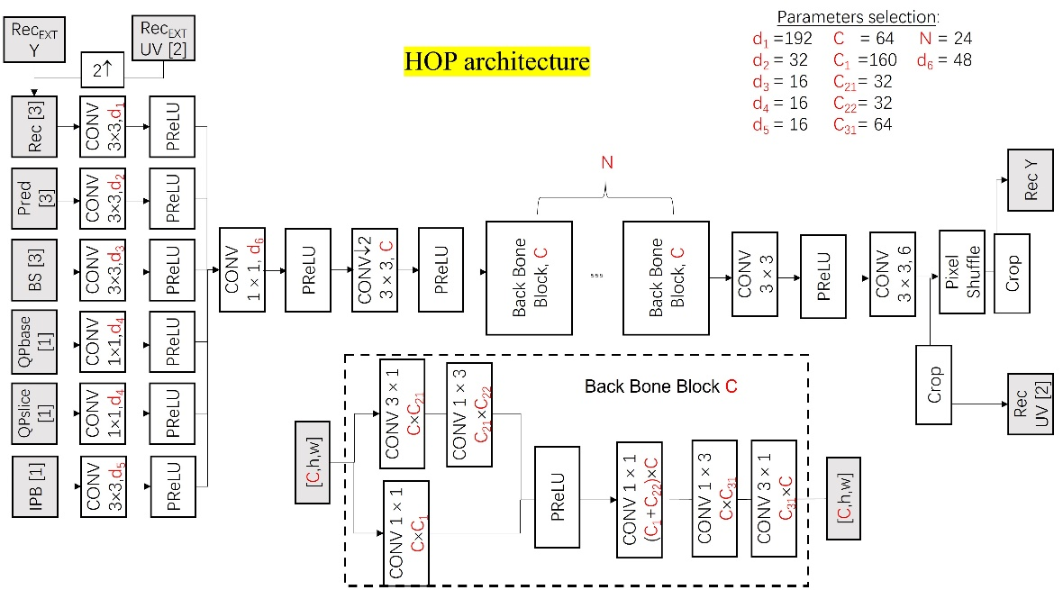
Fig. 1 Network architecture of HOP filter
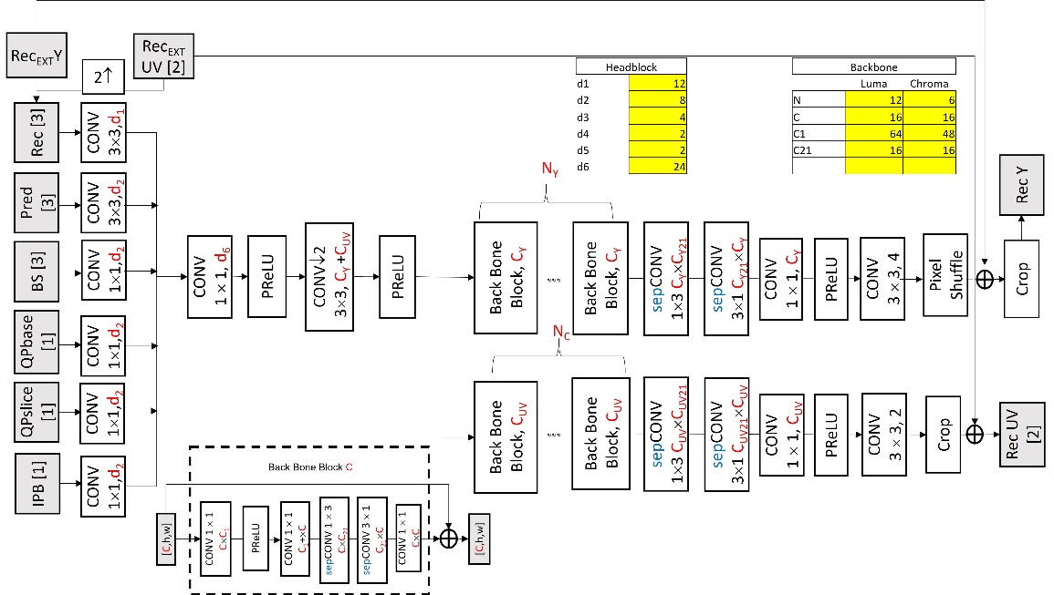
Fig. 2 Network architecture of LOP filter

Proposed method

Lower-complexity NNLF
In previous JVET meetings, further complexity reductions on LOP^{[1][2]} were proposed. Those contributions provided several designs of NNLF with different computational complexity. Both of them achieved good coding performance with super-low complexity (around 5.0 KMAC/pixel).
In this contribution, a NNLF with super-low complexity is designed and studied based on LOP in the current NNVC-7.1 software. To achieve such kind of super-low complexity (5.0 KMAC/pixel), the number of feature maps and backbone blocks of LOP are reduced. The designed NNLF is shown in Fig. 3.
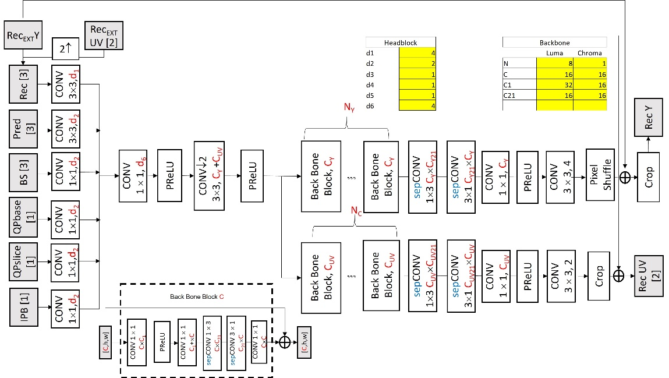
Fig. 3 The proposed lower complexity NNLF

Inference Stage
The inference information is shown in the table below.

Network Information in Inference Stage
Mandatory | HW environment:
Mandatory | GPU Type | CPU only
Mandatory | Framework: | SADL
Mandatory | Number of GPUs per Task | 0
Mandatory | Number of Parameters (Each Model) | 0.03M
Mandatory | Total Number of Parameters (All Models) | 0.03M
Mandatory | Parameter Precision (Bits) | 16
Mandatory | Memory Parameter (MB) | 0.05
Mandatory | Multiply Accumulate (kMAC/pixel) | 5.0
Mandatory | Calculation Method | block basis
Mandatory | Total Conv. Layers | 61
Mandatory | Total FC Layers | 0
Mandatory | Total Memory (MB)
Mandatory | Batch size: | 1
Mandatory | Patch size | 128x128, 256x256
Mandatory | Changes to network configuration or weights required to generate rate points
Mandatory | Peak Memory Usage (Total)
Mandatory | Peak Memory Usage (per Model)
Mandatory | Border handling
Mandatory | Other information:

Experimental results
The proposed NNLF is trained by LOP.2 scripts and HOP stage3 dataset. The unified loop filter in NNVC-7.1 is used to do the inference tests. All tests are conducted under the common test condition^{[3]}.

Proposed vs. VTM anchor
 | All Intra Main10
 | BD-rate Over VTM-anchor
 | Y-PSNR | U-PSNR | V-PSNR | EncT | DecT CPU
Class A1 | -2.90% | -2.81% | -2.58% | 79% | 1895%
Class A2 | -3.24% | -4.10% | -2.65% | 75% | 1540%
Class B | -3.13% | -4.70% | -3.81% | 80% | 1549%
Class C | -3.16% | -5.31% | -4.03% | 83% | 1362%
Class E | -4.38% | -3.35% | -3.55% | 90% | 2062%
Overall | -3.32% | -4.19% | -3.42% | 81% | 1631%
Class D | -3.46% | -4.88% | -3.47% | 86% | 980%
Class F | -2.20% | -4.32% | -3.30% | 77% | 1179%
 | Random access Main10
 | BD-rate Over VTM-anchor
 | Y-PSNR | U-PSNR | V-PSNR | EncT | DecT CPU
Class A1 | -2.90% | -2.46% | -2.08% | 106% | 3671%
Class A2 | -3.03% | -3.18% | -1.45% | 103% | 3306%
Class B | -2.68% | -4.53% | -2.52% | 103% | 3436%
Class C | -3.04% | -4.45% | -2.81% | 103% | 3504%
Class E
Overall | -2.89% | -3.83% | -2.29% | 104% | 3473%
Class D | -3.27% | -4.46% | -2.86% | 103% | 3492%
Class F | -1.68% | -3.05% | -2.26% | 107% | 1449%
*Please note that running time is not reliable.

Proposed(with NnIntra Enable) vs. VTM anchor
 | All Intra Main10
 | BD-rate Over VTM-anchor
 | Y-PSNR | U-PSNR | V-PSNR | EncT | DecT CPU
Class A1 | -7.07% | -6.47% | -6.51% | 154% | 2302%
Class A2 | -5.99% | -6.47% | -5.38% | 157% | 2121%
Class B | -6.21% | -7.45% | -6.81% | 154% | 2041%
Class C | -6.15% | -8.08% | -6.99% | 149% | 1844%
Class E | -8.88% | -7.98% | -7.06% | 151% | 2235%
Overall | -6.75% | -7.35% | -6.60% | 153% | 2080%
Class D | -6.22% | -7.54% | -6.35% | 141% | 1885%
Class F
 | Random access Main10
 | BD-rate Over VTM-anchor
 | Y-PSNR | U-PSNR | V-PSNR | EncT | DecT CPU
Class A1 | -5.10% | -3.30% | -3.64% | 95% | 2860%
Class A2 | -4.37% | -3.25% | -2.18% | 92% | 2629%
Class B | -4.35% | -5.06% | -3.18% | 108% | 3093%
Class C | -4.55% | -5.52% | -3.95% | 109% | 3192%
Class E
Overall | -4.56% | -4.47% | -3.28% | 102% | 2972%
Class D | -4.53% | -5.48% | -3.90% | 107% | 3130%
Class F | -2.71% | -3.70% | -2.89% | 109% | 1332%
*Please note that running time is not reliable.

Reference
[1] T. Shao, A. Arora, P. Yin, F. Pu, T. Lu, S. McCarthy, J. Shingala, A. Shyam, A. Suneja, S. Badya. EE1-related: Neural-network loop filters in EE1-1.1.2 with further complexity reduction. 30th Meeting, Antalya, TR, 21–28 April 2023.
[2] J. Li, Y. Li, C. Lin, K. Zhang, L. Zhang. AHG11: Complexity reduction of NN-based loop-filters. 32nd Meeting, Hannover, DE, 13–20 October 2023.
[3] E. Alshina, R.-L. Liao, S. Liu, A. Segall. JVET common test conditions and evaluation procedures for neural network-based video coding technology. JVET-AF2016, 32nd Meeting, Hannover, DE, 13–20 October 2023.

Patent rights declaration(s)
Guangdong OPPO Mobile Telecommunications Corp., Ltd. (OPPO) may have current or pending patent rights relating to the technology described in this contribution and, conditioned on reciprocity, is prepared to grant licenses under reasonable and non-discriminatory terms as necessary for implementation of the resulting ITU-T Recommendation | ISO/IEC International Standard (per box 2 of the ITU-T/ITU-R/ISO/IEC patent statement and licensing declaration form).

