    Joint Video Experts Team (JVET)  of ITU-T SG 16 WP 3 and ISO/IEC JTC 1/SC 29  31st Meeting, Geneva, CH, 11–19 July 2023 | Document: JVET-AE2021-v1

Title: | Verification test plan for VVC multilayer coding
Status: | Output document to JVET
Purpose: | Test plan document
Author(s) or  Contact(s): | S. Iwamura  P. de Lagrange  M. Wien | Tel:  Email: | iwamura.s-gc@nhk.or.jp  philippe.delagrange@interdigital.com  wien@lfb.rwth-aachen.de
Source: | AHG
_____________________________

Abstract
This document contains a plan for the video verification test to be conducted to verify the coding performance of the VVC Multilayer Main 10 profile in several configurations: spatial scalability with optimized coding performance, quality ladder involving both spatial and quality scalability, content layering, and stereo coding. The three configurations involve output layer sets with maximum two layers.

Introduction
Multilayer coding capability is supported in VVC Multilayer Main 10 profile. Multilayer coding enables efficient transmission/storage of contents with different resolutions/qualities in broadcasting and streaming applications as well as additional functional features where the viewer/user can select different content according to their preference. In the verification test, several use cases relevant for multilayer coding are categorized: spatial scalability, quality ladder, content layering, and dual view (stereo). In broadcasting applications, the same contents are occasionally broadcasted simultaneously for both home TV sets and mobile terminals with different resolution. In streaming applications, the same video content is stored in the server at different qualities and resolutions; in such use case, multilayer coding can save storage space compared to coding and storing them separately. Meanwhile, personalized service in video distribution has become more important recently; multi language and sign language support are typical use cases of personalized service. Content layering makes those personalized services possible at video coding level whereas previously this functionality was only implemented at a higher system level.
To verify the abovementioned effectiveness of multi-layer coding, a formal subjective evaluation is planned, for the relevant categories, comparing the VVC Multilayer Main 10 profile to VVC single layer and simulcast using the VVC Main 10 profile.
The tests include four categories, covering different aspects of multilayer coding:
- Spatial scalability coding efficiency, using UHD enhancement layer on top of 1.5x or 2x downscaled base layer with a QP offset that optimizes coding efficiency. This addresses use cases where spatial scalability feature itself (= multiple resolutions) is of interest, with quality comparable to or better than single layer. In this category, enhancement layer quality is compared to single layer.
- Quality ladder, using a range of resolutions and bit rates. This exercises both spatial and quality scalability, with resolution ranges from 960x540 to UHD with bitrates from 1 to 10x, and quality points grouped in pairs of layers which can have 1.33x, 1.5x or 2x resolution ratios. The use case addressed is local cache storage space for streaming applications. In this category, each quality point (which can be either base or enhancement layer) is compared with single layer.
- Content layering, where main content (UHD) is coded as base layer and sub-content (overlay with the size of 10-20% of main content) is coded as enhancement layer. This functionality enables the viewers to turn on/off the sub-contents at the decoder side. In this category, UHD base layer with overlayed sub-content enhancement layer is compared to single-layer UHD coding with sub-content superimposed.
- Dual view (stereo). The anchor is simulcast.

Verification test coordination
The proposed coordinators of the verification tests are the chairs of AHG4/AG5.

Test sites
Test sites should be capable of conducting formal subjective assessments of UHD video content in accordance with ITU-R BT.500-14 [2], following the DCR test method [3] with 11 quality levels.

Test categories, coding conditions, and test sequences

Spatial scalability
In this category, the UHD enhancement layer of dual-layer coding is compared to single-layer UHD coding. As a second anchor, a comparison to upscaled single-layer bitstreams is considered, with the single-layer bitstreams encoding the sequence at base layer resolution and using the upscaling methods provided with the VTM to reach UHD resolution. Thereby the benefit of an enhancement layer compared to adaptive resolution is assessed.

Coding conditions
The following test conditions are used for the verification test.
- Number of sequences, video resolutions and frame rates:
  - Five sequences at UHD resolution (3840×2160), downscaled to 2560×1440 and 1920×1080 using the TAppDownConvertStatic tool from the SHM repository. The following example command lines are used for 1920×1080, and similarly, for 2560×1440:
    - For UHD BT.709-color content (chroma location 0):
TAppDownConvertStatic 3840 2160 <input_UHD.yuv> 1920 1080 <output_HD.yuv> 10 10
    - For UHD BT.2020-color content (chroma location 2):
TAppDownConvertStatic 3840 2160 <input_UHD.yuv> 1920 1080 <output_HD.yuv> 10 10 0 0 0 600 -phase 0 0 0 0
  - SDR dynamic range. HDR is to be discussed.
  - Both 25/30fps and 50/60fps, to vary the number of frames per intra period
- Bitstreams
  - Anchors: encoded using VTM-21.0, single layer, coded at UHD resolution, and at reduced resolution which is then upscaled to UHD using the VVC RPR upsampling filters.
  - Test: encoded using VTM-21.0 in multilayer configuration:
    - UHD as enhancement layer and 2560×1440 (1.5x) downscale as a base layer.
    - UHD as enhancement layer and 1920×1080 (2x) downscale as a base layer.
- Encoding parameters
  - Fixed QP.
    - Four bitrate points per sequences covering the whole MOS range as much as possible with QP values for each encoder configuration. The QPs are to be selected such that the subjectively assessed quality is comparable between test and anchor.
    - The QP relation between single layer, as well as base and enhancement layer is t.b.d.
  - Bit depth of 10 bits
  - Coding structure
    - Random access, RA
      - Intra refresh at approximately 1 second intervals.
      - GOP size 32
      - Picture reordering allowed.
      - For dual-layer coding, inter-layer and intra-layer prediction is allowed. Enhancement layer uses the same coding structure as base layer + same POC of base layer as additional reference.
  - Other settings as in the configuration files, with the Picture Hash SEI deactivated for the measurement of bit rate:
    - VTM: cfg/encoder_randomaccess_vtm.cfg
    - Encoder control of DMVR: set DMVREncMvSelect=1

Test sequences and QP settings
Candidates for test sequences might be taken from previous verification tests, including previous scalability tests. E.g., the test sequence “Procession” is of interest since it has already been used for SHVC verification tests and could offer a comparison point.
The selection of sequences and QP settings under consideration are reported in the Table 1 below.
Table 1 – Candidate test sequences and QP settings for “spatial scalability” category
Test sequence & format | 1440+UHD  dual- layer QPs | HD+UHD  dual- layer QPs | UHD anchor QPs | Thumbnail
CorsaireJoy  3840×2160, 25fps, 250 frames | 30+33  34+38  37+41  40+44 | 27+34  31+38  34+41  37+44 | 33  37  40  43 | 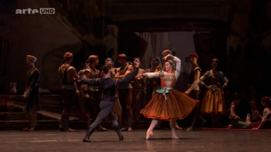
DrivingPOV3  3840×2160, 60fps, 600 frames | 31+35  35+39  39+43  43+47 | 27+34  33+40  37+44  40+47 | 32  38  42  46 | 
ElFuente-12000 (Procession)  3840×2160, 60fps, 600 frames | 32+36  37+41  41+45  44+48 | 29+36  34+41  38+45  41+48 | 35  40  44  47 | 
Marathon2  3840×2160, 30fps, 300 frames | 29+33  33+37  38+42  43+47 | 26+33  30+37  35+42  40+47 | 32  36  41  46 | 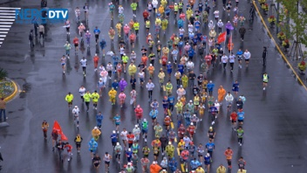
MountainBay2  3840×2160, 30fps, 300 frames | 27+31  31+35  35+39  39+43 | 24+31  28+35  32+39  36+43 | 30  34  38  42 | 
TallBuildings2  3840×2160, 30fps, 300 frames | 31+35  35+39  39+43  43+47 | 28+35  32+39  36+43  40+47 | 34  38  42  46 | 
Fortnite  3840×2160, 60fps, 600 frames | 37+41  40+44  43+47  46+50 | 34+41  37+44  40+47  43+50 | 40  43  46  49 | 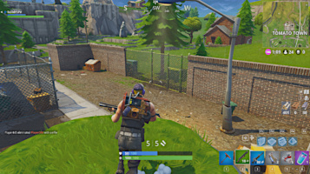
CatRobot1  3840×2160, 60fps, 600 frames | 25+29  30+34  35+39  40+44 | 22+29  27+34  32+39  37+44 | 28  33  38  43 | 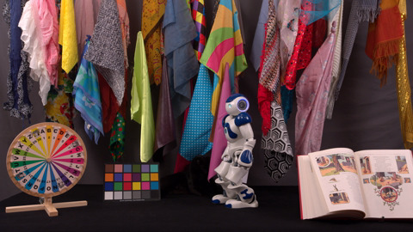
LupoPuppet  3840×2160, 50fps, 500 frames | 28+32  32+36  36+40  40+44 | 25+32  29+36  33+40  37+44 | 31  35  39  43 | 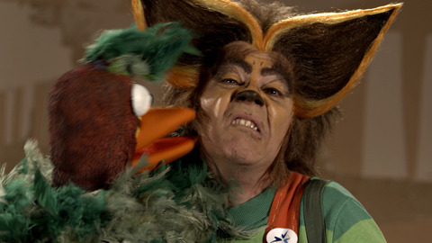
DrivingPOVLogo  3840×2160, 60fps, 600 frames | 29+33  34+38  39+43  43+47 | 26+33  31+38  36+43  40+47 | 32  37  42  46 | 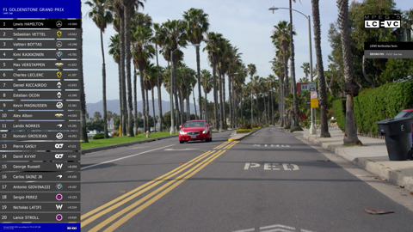
BoxeLogo  3840×2160, 60fps, 596 frames | 27+31  32+36  37+41  42+46 | 24+31  30+37  32+39  37+44 | 30  34  38  42 | 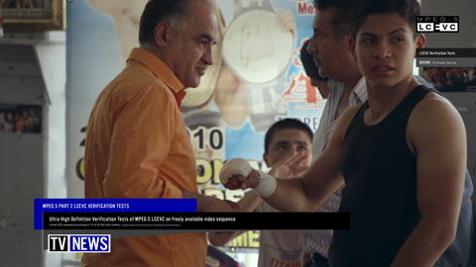
TrafficHDLogo  1920x1080, 60fps, 600 frames | 23+27  27+31  31+35  35+39 | 20+27  24+31  28+35  32+39 | 26  30  34  38 | 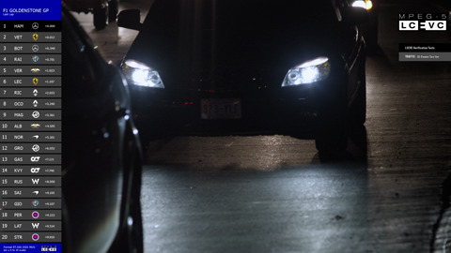
StarCraft  1920x1080, 60fps, 600 frames | 23+27  27+31  31+35  35+39 | 20+27  24+31  28+35  32+39 | 36  30  34  38 | 

Timeline and methodology for test conditions refinement
- Report on activity by input document to the 34nd JVET meeting:
  - Assessment of suitable parameters for encoder control.
  - Assessment of suitability of rate points and sequences.
- Final report at 35th JVET meeting

Quality ladder
In this category, the resolution and rate of interest from multilayer coding (either base layer or enhancement layer) is compared to single layer coding at the same resolution. Preferably, both are viewed after being upscaled to UHD using RPR filters; another option to be discussed is to view lower resolutions on a different screen, noting that perception may be very different on a TV and on a phone, and normalized viewing distances depend on resolution.

Use case description
In streaming applications, the quality of the video distributed to the end user is typically adapted to network conditions and device capabilities. The same video content is then encoded at several resolutions, bitrates (and potentially different codecs), which is called a quality ladder here. The quality ladder is typically stored in what is called “edge storage” here, used as a cache to adaptively distribute content to several local users: the relevant item is selected and distributed to each end user.
Since the same video content is encoded several times, at different qualities (rate and resolution), multi-layer coding can potentially help reduce storage requirements by combining several quality points, while coding performance of these arrangements would impact the end user.
It is suggested to focus on dual-layer coding, so that the end user device has to decode at most one base layer and one dependent layer. Note that several independent pairs can reuse the same base layer.

Proposed quality ladder for VVC
For the purpose of this test, an example quality ladder is used to derive test points for visual testing. The HLS authoring specification [3] contains a recommended quality ladder for AVC, HEVC SDR and HEVC HDR, that define 12 quality levels (resolution and bitrate). The bitrates are said to be initial encoding targets for typical streaming content, and it is recommended that they are evaluated against actual encoded content and encoding workflow, then adjusted accordingly.
This recommendation could be extended to VVC with the proposed bitrates in Table 2.
Table 2 – Proposed quality ladder for VVC (bitrates in kbit/s)
Resolution | HEVC (HDR) | VVC | % of HEVC  HDR | % of previous  step | % of total
416×234 | 160 | 130 | 81 | - | 0.4
480×270 | 360 | 260 | 72 | 200 | 0.7
640×360 | 730 | 530 | 73 | 204 | 1.5
768×432 | 1090 | 790 | 72 | 149 | 2.2
960×540 | 1930 | 1300 | 67 | 165 | 3.6
1280×720 | 2900 | 1800 | 62 | 138 | 4.9
1280×720 | 4080 | 2400 | 59 | 133 | 6.6
1920×1080 | 5400 | 3100 | 57 | 129 | 8.5
1920×1080 | 7000 | 4000 | 57 | 129 | 11
2560×1440 | 9700 | 5200 | 54 | 130 | 14.2
3840×2160 | 13900 | 7000 | 50 | 135 | 19.2
3840×2160 | 20000 | 10000 | 50 | 143 | 27.4

Figure 1 – Bitrate distribution within proposed quality ladder for VVC
For the purpose of visual evaluation, a partial ladder suitable for UHD playout is considered.

Coding conditions
The following test conditions are suggested to be used for the verification test.
- Number of sequences, video resolutions and frame rates:
  - Five sequences at UHD resolution (3840×2160), downscaled to 2560×1440 and 1920×1080 using the TAppDownConvertStatic tool from the SHM repository, then downscaled again from 1920×1080 to 1280×720 and 960×540 resolutions using the same tool. Then potentially downscaled again from 960×540 to 640×360. The following example command lines are used:
    - For UHD BT.709-color content (chroma location 0):
TAppDownConvertStatic 3840 2160 <input_UHD.yuv> 1920 1080 <output_HD.yuv> 10 10
    - For UHD BT.2020-color content (chroma location 2):
TAppDownConvertStatic 3840 2160 <input_UHD.yuv> 1920 1080 <output_HD.yuv> 10 10 0 0 0 600 -phase 0 0 0 0
  - SDR dynamic range. HDR to be discussed.
  - Both 25/30fps and 50/60fps, to vary the number of frames per intra period
- Bitstreams
  - Anchor: encoded using VTM-19.2, single layer, for each resolution
  - Test: encoded using VTM-19.2 in multilayer configuration (to be discussed and narrowed down; experiments may be needed):
    - (960×540) + (1280×720) (1.33x)
    - (1280×720) + HD (1.5x)
    - HD + HD (different rates)
    - HD (higher rate) + (2560×1440) (1.33x)
    - (2560×1440) + UHD (lower rate) (1.5x)
    - HD (higher rate) + UHD (lower rate) (2x)
    - UHD + UHD (different rates)
- Encoding parameters
  - Fixed QP
    - Five resolutions + bitrate points per sequence covering the MOS range as much as possible with QP values for each encoder configuration, but keeping a fixed QP offset ladder for all sequences. The QPs are to be selected such that the subjectively assessed quality is comparable between test and anchor.
    - QP ladder to be discussed (experiments needed)
  - Bit depth of 10 bits for all video resolutions
  - Coding structure
    - Random access
      - Intra refresh at approximately 1 second intervals.
      - GOP size 32
      - Picture reordering allowed.
      - Interlayer and intra-layer prediction allowed. Dependent layer uses the same coding structure + same POC of base layer as additional ref.
  - Other settings as in the configuration files, with the Picture Hash SEI deactivated for the measurement of bit rate
    - VTM: cfg/encoder_randomaccess_vtm.cfg

Test sequences and QP settings
It is suggested to use sequences relevant for the streaming use cases, e.g. movie or documentary content. Potential candidates can be some sequences of e.g., SVT FairyTale, NetFlix ElFuente, Chimera and Meridian, Technicolor Zombie, etc.
Dry-run experiments are needed for the selection of sequences and QP settings.
Table 3 – Candidate test sequences for “quality ladder” category
Test sequence & format | Anchor QPs | Thumbnail
CorsaireJoy  3840×2160, 25fps, 250 frames | UHD: 32, 36  1440: 36  HD: 26, 30, 33  720: 32, 36  540: 33
DrivingPOV3  3840×2160, 60fps, 600 frames | UHD: 30, 36  1440: 28, 32, 36  HD: 26, 30, 34, 36  720: 30, 32, (33,) 36  540: (30,) 33
ElFuente-12000 (Procession)  3840×2160, 60fps, 600 frames | UHD: 33, 37, 41, 44  1440: 29, 33, 37, 40  HD: 27, 31, 35, 38  720: 31, 34  540: 31
Marathon2  3840×2160, 30fps, 300 frames | UHD: 29, 32, 36  1440: 26, 28, 32, 36  HD: 26, 30, 33  720: 26, 29  540: 27
MountainBay2  3840×2160, 30fps, 300 frames | UHD: 30, 34, 38, 42  1440: 26, 31, 35, 39  HD: 28, 32, 36  720: 28, 32  540: 29
TallBuildings2  3840×2160, 30fps, 300 frames | UHD: 34, 38, 42, 46  1440: 29, 34, 38, 42  HD: 26, 31, 35, 39  720: 30, 34  540: 30
Fortnite
3840×2160, 60fps, 600 frames

Timeline and tasks for test conditions refinement
- Report on activity by input document to the 34th JVET meeting: experiments using more sequences, possibly grouping tests with spatial scalability category.
- Determination of ladder points to be tested and finalization of plan for this category at 32nd meeting.
- Tentative final report at 35nd JVET meeting.

Stereo coding (to be discussed)

Test setup
To be discussed: either a head-mounted display, a 3DTV with passive glasses, or regular TV with either time multiplexing and shuttered glasses, or anaglyph conversion and colored glasses.
Note: 3DTV may be hard to find since most recent models are from 2016.

Coding conditions
To be discussed: either 2xHD, 2xUHD, or 2x-horizontal or vertical downscales of UHD similar to side-by-side carriage or stereo sequences.
Mostly random-access, though LD can make sense (we could imagine video conf. with 2 cams).

Test sequences and QP settings
Candidate sequences should be native stereo ones, preferably captured rather than synthetic.
Dry-run experiments are needed for the selection of sequences and QP settings.

Potential extra categories / use cases
TBD

References
- Recommendation ITU-R BT.500-14 (2019), Methodologies for the subjective assessment of the quality of television images.
- Recommendation ITU-T P.910 (2008), Subjective video quality assessment methods for multimedia applications.
- https://developer.apple.com/documentation/http_live_streaming/http_live_streaming_hls_authoring_specification_for_apple_devices, HTTP Live Streaming (HLS) Authoring Specification for Apple Devices.

