    Joint Video Experts Team (JVET)  of ITU-T SG 16 WP 3 and ISO/IEC JTC 1/SC 29  32nd Meeting, Hannover, DE, 13–20 October 2023 | Document: JVET-AF0307-v2

Title: | BoG on assessment of HOP proposals
Status: | Input document to JVET
Purpose: | Report
Author(s) or  Contact(s): | E. Alshina, F. Galpin | Tel:  Email: | elena.alshina@huawei.com  franck.galpin@interdigital.com
Source: | BoG
_____________________________

Abstract
This report summarizes the discussion during BoG on assessment of HOP proposals established during JVET-AF meeting.
First session of BoG conducted on Oct. 16, 13:00-16:00.
First session of BoG conducted on Oct. 17, 08:30-11:00.

Mandates
Status of EE proposals:
- Suggest potential adoptions for HOP in NNVC7 (likely only EE1-1.2.4)
- Identify promising approaches for which a training crosscheck should be performed in the next EE
- Identify promising new proposals on HOP for next EE. Prepare a unified design to be proposed as next candidate for HOP.
- Discuss aspects of luma/chroma balance, and aspects of single filter vs. separate luma/chroma filters.

Categories

Following categories of proposals have been discussed:
- Filter usage aspects (section 1);
- Training aspects (section 2);
- Design elements of HOP for future NNVC (section 3).

Filter usage aspects
Performance test results for filter usage aspects studied in EE1 are listed in Table 1
Table 1 Filter usage aspects from EE1.
Test | Doc# | #Par M | kMAC /pxl | Random Access cfg. |  |  |  |  | Low Delay-B cfg.
 |  |  |  | Y | U | V | Enc. | Dec. | Y | U | V | Enc. | Dec.
NNVC-6-HOP | JVET-AF0014 | 1.45 | 477 | 0.0% | 0.0% | 0.0% | 100% | 100% | 0.0% | 0.0% | 0.0% | 100% | 100%
EE1-1.2.1 | JVET-AF0085 | 1.45 | 477 | 0.0% | -0.2% | -0.5% | 100% | 101% | -0.3% | -1.8% | -4.9% | 100% | 105%
EE1-1.2.3 | JVET-AF0154 | 1.45 | 477 | -0.1% | -0.6% | -0.8% | 97% | 99% | -0.4% | -2.6% | -2.2% | 98% | 100%
EE1-1.2.4 | JVET-AF0205 | 1.45 | 477 | 0.0% | -0.1% | -0.1% | 100% | 99%
EE1-1.2.6 | JVET-AF0086 | 1.45 | 477 | -0.1% | -0.5% | -0.7% | 98% | 99% | -0.4% | -2.1% | -1.4% | 98% | 101%

Filter usage aspects from EE1

EE1-1.2.4 awaiting cross-check (candidate for adoption).
EE1-1.2.1 (off-set) was under study for multiple rounds of EE1, demonstrated stable gain, recommended for adoption (supported by cross-checker).
Decision: adopt EE1-1.2.1.
EE1-1.2.3 (rotation) and EE1-1.2.6 (flipping) and recommended to be tested together in next EE1 round.

JVET-AF0085 EE1-1.2.1: On residual adjustments for NNLF [Z. Dai, Y. Yu, H. Yu, D. Wang (OPPO)]

JVET-AF0254 Cross-check of JVET-AF0085 (EE1-1.2.1: on residual adjustments of NNLF) [T. Dumas (Interdigital)] [late]

JVET-AF0086 EE1-1.2.6: On flipping of input and output of model in NNVC HOP filter [Z. Xie, Y. Yu, H. Yu, D. Wang (OPPO)]

JVET-AF0272 Crosscheck of JVET-AF0086 (EE1-1.2.6: On flipping of input and output of model in NNVC HOP filter) [R. Chang (Tencent)] [late] [miss]
Cross-checker reported perfect match for small resolution classes. Cross-check is not yet finished.

JVET-AF0154 EE1-1.2.3: Input and output rotation of model for NNVC in-loop filter [R. Chang, L. Wang, X. Xu, S. Liu (Tencent)]

JVET-AF0257 Crosscheck of JVET-AF0154 (EE1-1.2.3: Input and output rotation of model for NNVC in-loop filter) [D. Liu (Ericsson)] [late] [miss]

Cross-checker reported perfect match of test results.

New filter usage aspects (beyond EE1)

JVET-AF0172 AHG14: Cleanup on scale flag signalling for HOP [Y. Li, K. Zhang, L. Zhang (Bytedance)]
This contribution proposes a cleanup on signalling the scale flag in the high operation point (HOP) in-loop filter. The proposed method removes redundancy and leads to BD-rate gain. BD-rate changes on top of NNNC-6.0 anchor (NN intra + LOP) and NNVC-5.0 HOP anchor (NN intra + HOP) are reportedly summarized as below:
Compared with NNVC-6.0 anchor: RA: -5.39%, -19.16%, -19.92%, LD: -6.01%, -14.37%, -8.89%, AI: -3.31%, -14.72%, -15.81%
Compared with NNVC-6.0 HOP anchor: RA: -0.01%, -0.01%, -0.01%, LD: -0.02%, -0.02%, -0.01%, AI: 0.00%, 0.00%, 0.00%
The patch indicating the code changes on top of NNVC-6.0 has been attached.
Presented. Removes 2 bits per picture. Fixing SW bug. Recommended to use bug tracker next time.
Decision: adopt JVET-AF0172.

JVET-AF0259 Crosscheck of JVET-AF0172 (AHG14: Cleanup on scale flag signalling for HOP) [F. Galpin (InterDigital)] [late] [miss]

JVET-AF0193 AHG11: Decoder complexity optimization for NNVC in-loop filter [R. Chang, L. Wang, X. Xu, S. Liu (Tencent)]
In this contribution, an encoder-only coding tool is proposed to optimize the decoder complexity of NNVC in-loop filter. In the proposed method, the filter gain of each CTU is first calculated if the block-level NNLF on/off is enabled. Then, NNLF will be disabled for the CTUs with small filter gains.
Gain of filter for each CTU computed using difference to original before and after filter. Encoder performs sorting and decide in which CTU to disable NNFL.
Decoding run time reduction 10-15% (both HOP and LOP).
Questions:
- what is the portion of CTUs with NNFL disabled?
  - Not checked, should be proportional to dec. time change
- how much method is dependent on content?
Performance is consistent for HOP/LOP different classes.
Decision: Adopt JVET-AF0193 to NNVC SW (keep disabled by default in NNVC CTC).

JVET-AF0256 Crosscheck of JVET-AF0193 (AHG11: Decoder complexity optimization for NNVC in-loop filter) [D. Liu (Ericsson)] [late] [miss]
Cross-check successful.

JVET-AF0278 Cross-check of JVET-AF0193 (AHG11: Decoder complexity optimization for NNVC in-loop filter) [M. Santamaria (Nokia)] [late] [miss]

Training aspects

JVET-AF0150 AhG11: on HOP batch size [F. Galpin, T. Dumas, P. Bordes (InterDigital)]
A Unified Filter Architecture for the High-performance Operation Point (HOP) was defined at JVET-AD0380. It includes filter architecture, training process and training test set. Training strategy and full results were presented in JVET-AF0041. This contribution gives additional results on the impact of the batch size on the training results. It is reported that smaller batch size improves the results and also allows reducing the requirements on the GPU memory size. Results for a smaller batch size of 32 compared to original HOP in VTM mode are {-0.07% 0.42% 0.57%} and {-0.21% 0.45% 0.79%} for AI and RA configurations respectively.
Batch size has effect on memory usage. Batch size increment 64128 helped LOP-2 training. Same change for HOP doesn’t bring performance improvement, but 64 32 give Luma gain, Chroma drop. So benefit of proposal is mostly memory saving.
Support to add into EE1 and change learning rate at the same time, square root of learning rate suggested as starting point.

JVET-AF0155 AhG11: on HOP luma/chroma balance [F. Galpin, T. Dumas, P. Bordes (InterDigital)]
A Unified Filter Architecture for the High-performance Operation Point (HOP) was defined at JVET-AD0380. It includes filter architecture, training process and training test set. Training strategy and full results were presented in JVET-AF0041. This contribution reports additional results on the impact of the luma/chroma balance. Both dataset adaptation and training adaptation are studied. Changing the luma/chroma balance during the training brings gains in both loss and performance gains, even when considering the original luma/chroma balance weighting (6:1:1) to evaluate the results.
If Chroma offset is applied, then 10:1 gain transfer from Chroma to Luma.
During training 12:1:1 also transfers gain from Chroma to Luma (compared to 6:1:1), similar 10:1 ratio, but gain change has fine granularity.
Support for adoption Chroma QP offset +1 (~1% Luma gain expected, no retraining is needed).
Also support for change loss to 12:1:1 during training.
Decision: adopt following aspects of JVET-AF0155: 1) change Chroma QP +1 for HOP 2) 12:1:1 for HOP training.

JVET-AF0180 AHG11: HOP training adjustment to improve luma/chroma coding gain balance [D. Rusanovskyy, Y. Li, M. Karczewicz (Qualcomm)]
A Unified Filter Architecture for the High-performance Operation Point (HOP) was defined at JVET-AD0380. Test results for stage 3 of HOP reported in JVET-AF00141 indicated a noticeable disbalance in coding gain for luma and chroma components. HOP bd-rate gain over the NNVC anchor is {-5.4%, -19.2%, -19.9%} in RA and {-3.3, -14.7, -15.8} in AI. Since HOP utilizes a single model for Luma and Chroma, the balance can be improved by adjusting the training strategy. It is proposed to increase training loss weight for the luma component from 6 to 12, similarly to the method utilized in EE1-0 LOP2 training. HOP with luma weight equal to 12 reportedly provides {-5.8%, -16.1%, -16.9%} and {-3.5%, -12.1%, -13.3%} bd-rate gain over the NNVC anchor in RA and AI configurations, respectively. Additional test was conducted with a weight for the luma component being equal to 24. Achieved results does not demonstrate favourable luma/chroma trade off. It is proposed to modify HOP training strategy by increasing luma training loss weight to 12.
Similar trend as JVET-AF0155, recommendation is the same 12:1:1 for HOP training.
Decision: adopt following aspect of JVET-AF0180: 12:1:1 for HOP training (same as JVET-AF0155).

JVET-AF0296 AhG11: on HOP learning rate [F. Galpin, T. Dumas, P. Bordes (InterDigital)] [late]
A Unified Filter Architecture for the High-performance Operation Point (HOP) was defined at JVET-AD0380. It includes filter architecture, training process and training test set. Training strategy and full results were presented in JVET-AF0041. This contribution gives additional results on the impact of the learning rate on the training results. It is reported that a larger learning rate improves the results. Results compared to original HOP in VTM mode are {} and {} for AI and RA configurations respectively.
See notes for JVET-AF0150. Qualcomm is willing to help.

Design elements of HOP for future NNVC
NNVC has two NN-filters, so can be configures for Low Operation Point (LOP) and High Operation Point (HOP), in both NN-Intra is enabled. Performance of those two configurations relatively to VTM is summarized in Table 1.

Table 2 Two configuration of NNVC tested vs VTM, NN-Intra enabled in both.
Test | Doc# | # Par M | kMAC /pxl | Random Access cfg. |  |  |  |  | All Intra cfg.
 |  |  |  | Y | U | V | Enc | Dec | Y | U | V | Enc | Dec
LOP | JVET-AE0014 | 0.2+1.3 | 17+8 | -6.6% | -7.7% | -7.3% | 1.3 | 76 | -7.8% | -8.6% | -8.9% | 2.0 | 45
HOP | JVET-AE0014 | 1.5+1.3 | 477+8 | -11.6% | -25.7% | -26.0% | 1.8 | 476 | -10.8% | -22.2% | -23.4% | 2.1 | 269
Completed EE1 tests are focusing on improvement of High Operation Point (HOP) complexity-performance trade-off. The natural anchor for those tests is NNVC-6.0 with HOP and NN-Intra enabled. Test results relatively to this anchor are summarized in Table 3.

Table 3 Proposals tested against NNVC- high configuration (HOP and NN-Intra are enabled)
Test | Doc# | #Par M | kMAC /pxl | Random Access cfg. |  |  |  |  | All Intra cfg.
 |  |  |  | Y | U | V | Enc. | Dec. | Y | U | V | Enc. | Dec.
NNVC-6-HOP | JVET-AF0014 | 1.45 | 477 | 0.0% | 0.0% | 0.0% | 100% | 100% | 0.0% | 0.0% | 0.0% | 100% | 100%
Group convolutions in BBB (Back Bone Block)
EE1-1.1.1-t1 | JVET-AF0153 | 1.28 | 422 | 0.3% | 2.0% | 1.5% |  |  | 0.1% | 1.1% | 1.0%
EE1-1.1.4b1 | JVET-AF0182 | 1.23 | 406 | 0.3% | 2.7% | 1.0% | 120% | 155% | 0.1% | 0.7% | 0.7% | 111% | 157%
EE1-1.1.4b2 | JVET-AF0182 | 1.27 | 419 | 0.3% | 1.1% | 1.2% | 124% | 172% | 0.2% | 0.9% | 0.9% | 112% | 175%
EE1-1.1.4b3 | JVET-AF0182 | 1.05 | 349 | 0.6% | 2.6% | 2.4% | 135% | 204% | 0.3% | 1.3% | 1.1% | 118% | 210%
Number of channels reduction in BBB (Back Bone Block)
EE1-1.1.2b | JVET-AF0102 | 1.3 | 426 | 0.1% | 1.0% | 0.4% | 82% | 71% | 0.1% | 0.2% | 0.4% | 83% | 66%
EE1-1.1.1-t2 | JVET-AF0153 | 1.35 | 442 | 0.3% | 1.3% | 0.9% |  |  | 0.2% | 0.8% | 1.1%
EE1-1.1.5 | JVET-AF0192 | 1.2 | 392 | 0.4% | 1.7% | 1.2% | 72% | 56% | 0.2% | 1.0% | 0.8% | 77% | 53%
“head” block simplifications
EE1-1.1.4a | JVET-AF0181 | 1.45 | 457 | 0.2% | 0.9% | 0.5% | 95% | 86% | 0.1% | 0.2% | 0.4% | 98% | 89%
EE1-1.1.3 | JVET-AF0103 | 1.45 | 472 | 0.0% | 1.0% | 0.3% | 98% | 96% | 0.1% | 0.3% | 0.3% | 95% | 92%
Separation of NN-filters for Luma and Chroma
EE1-1.1.4c | JVET-AF0183 | 1.42 | 473 | -0.3% | 1.5% | 1.9% | 129% | 202% | -0.4% | 0.3% | 0.5% | 112% | 206%
EE1-1.1.4d | JVET-AF0183 | 1.23 | 390 | 0.0% | 1.8% | 2.0% | 137% | 221% | -0.2% | -0.1% | 0.2% | 116% | 232%
Some plots helping complexity-performance trade-off understanding
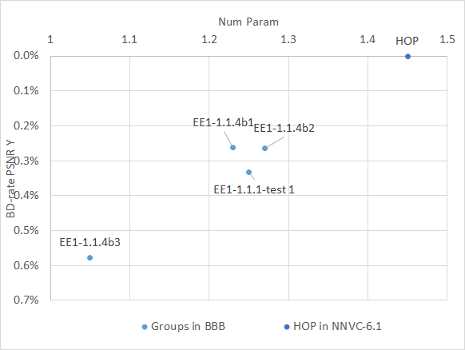 | 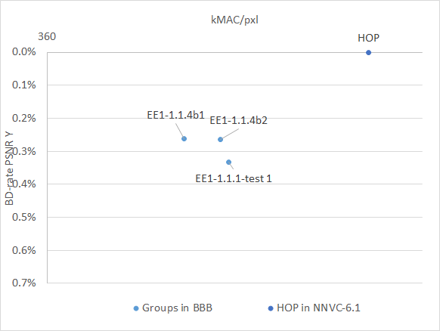
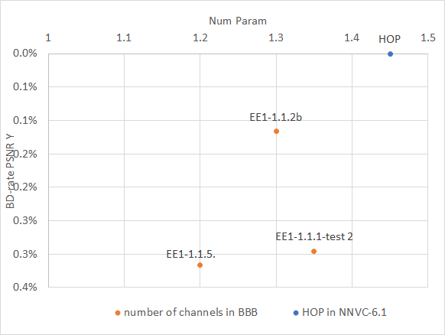 | 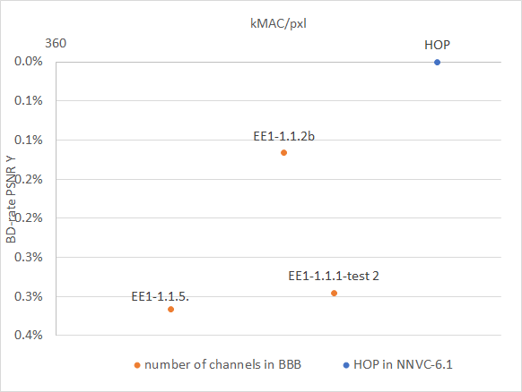
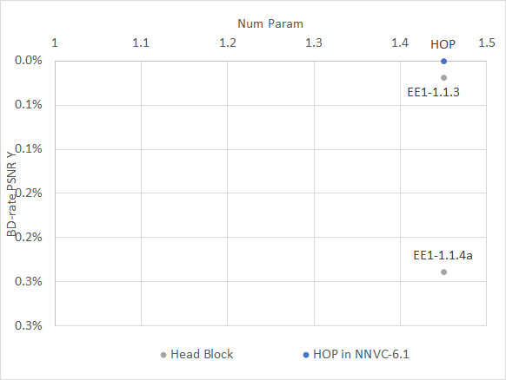 | 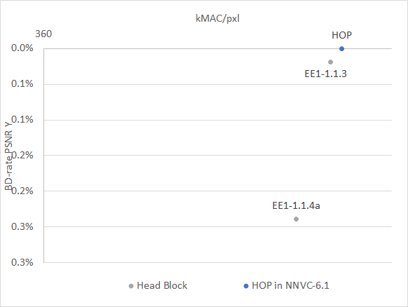
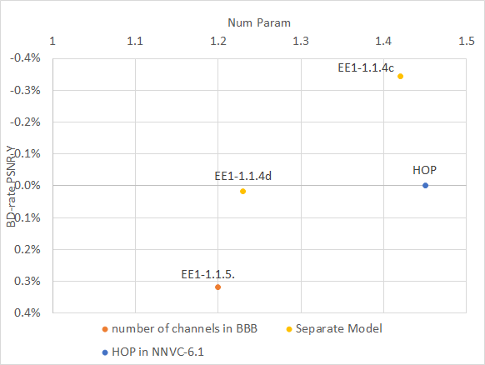 | 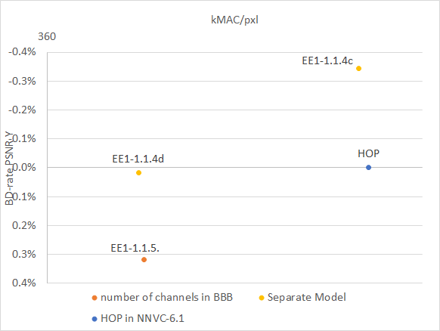

JVET-AF0102 EE1-1.1.2 Complexity-performance tradeoff of decomposition [D. Rusanovskyy, Y. Li, M. Karczewicz (Qualcomm)]
- Alternation of 3x1 and 1x3 CONVs agreed
- C31 6448 agreed.

JVET-AF0285 Crosscheck of JVET-AF0102 (EE1-1.1.2 Complexity-performance trade off of decomposition) [Y. Li (Bytedance)] [late] [miss]

JVET-AF0103 EE1-1.1.3 Study on input feature set optimization [D. Rusanovskyy, Y. Li, M. Karczewicz (Qualcomm)]
- Head block 3x3 1x1 (IPB and BS) agreed.

JVET-AF0258 Crosscheck of JVET-AF0103 (EE1-1.1.3 Study on input feature set optimization) [F. Galpin (InterDigital)] [late] [miss]

JVET-AF0153 EE1-1.1.1: Optimization for complexity-performance trade-off of HOP network [R. Chang, L. Wang, X. Xu, S. Liu (Tencent)]
- C1 = 160128 (no action)
- Group size = 4 (in some conv) as one of the group convolution position variant

JVET-AF0266 Crosscheck of JVET-AF0153 (EE1-1.1.1: Optimization for complexity-performance trade-off of HOP network) test1 [Z. Xie (OPPO)] [late] [miss]

JVET-AF0181 EE1-1.1.4.a: Simplified feature extraction for HOP [Y. Li, K. Zhang, L. Zhang (Bytedance)]
- Earlier down-sampling in Head block (no action)

JVET-AF0282 Crosscheck of JVET-AF0181 (EE1-1.1.4.a: Simplified feature extraction for HOP) [D. Rusanovskyy (Qualcomm)] [late] [miss]

JVET-AF0182 EE1-1.1.4.b: Group convolution for HOP [Y. Li, K. Zhang, L. Zhang (Bytedance)]
- Allow proponent to choose their preferred variant for group convolution place and size (best trade off in current HOP).

JVET-AF0283 Crosscheck of JVET-AF0182 (EE1-1.1.4.b: Group convolution for HOP) [D. Rusanovskyy (Qualcomm)] [late] [miss]

JVET-AF0183 EE1-1.1.4.c/d: Separate models for HOP [Y. Li, K. Zhang, L. Zhang (Bytedance)]

JVET-AF0260 Crosscheck of JVET-AF0183 (EE1-1.1.4.c/d: Separate models for HOP) [F. Galpin (InterDigital)] [late] [miss]

JVET-AF0192 EE1-1.1.5: Combination test of EE1-1.1.1 and EE1-1.1.2 [R. Chang, L. Wang, X. Xu, S. Liu (Tencent), D. Rusanovskyy, Y. Li, M. Karczewicz (Qualcomm)]

JVET-AF0267 Crosscheck of JVET-AF0192 (EE1-1.1.5: Combination test of EE1-1.1.1 and EE1-1.1.2) [Z. Xie (OPPO)] [late] [miss]

JVET-AF0208 EE1-2.1: Deep Reference Frame Generation for Inter Prediction Enhancement W. Bao, X. Chen, J. Jia, Y. Zhang, Z. Chen (Wuhan Univ.), Z. Liu, X. Xu, S. Liu (Tencent) [late]
Was discussed during EE1 summary report, recommended to be tested on top of NNVC-HOP and undergo training cross-check in new EE1.

JVET-AF0268 Crosscheck of JVET-AF0208 (EE1-2.1: Deep Reference Frame Generation for Inter Prediction Enhancement) [Z. Xie (OPPO)] [late] [miss]

Suggestions:
- EE1-0 take HOP architecture un-changed and adopted inference, re-train (only stage III) with “adopted” training hints NNVC-7.0 HOP.
  - If better than current HOP becomes new HOP
2 weeks after NNVC-7 release
- Design EE1-1 targets to kMAC/pxl 477 and performs better than HOP (changes are limited to architecture) comparison point EE1-0.
If better than current EE1-0 becomes new HOP.
  - EE1-1.1 (1.1.2b (alternation C31 6448) + EE1-1.1.4b + EE1-1.1.3) , #BBB < 477kMAC/pxl, training as in EE1-0 (exact parameters setting to match 477 by end of EE1 editing period)
  - EE1-1.2 (1.1.2b (alternation C31 6448) + group conv by Tencent + EE1-1.1.3) , #BBB < 477kMAC/pxl, training as in EE1-0 (exact parameters setting to match 477 by end of EE1 editing period)

Timeline:
- Nov. 3rd: NNVC 7.0 (2w)
- Nov 17th, (4w):
  - EE1-0 training is over
- Nov. 20th (4.5w):
  - Telco
  - decision on training strategy and discussion 2 variants on group convolution location & size
Requirements:
- have kMAC/pxl <=477, adjustment to be done by #BBB , if more parameters are used MUST be the same parameters to adjust in all tests
- New default SIMD level will be AVX2 in order to have more stable comparison.

Single vs separate models discussion.
Single model requires just on GPU for training and allows to check more ideas.
Double model shows increase of decoder run time, proponent was asked to explain phenomenon. Some proponent reported that similar phenomenon was observed for another proposal which uses number of channels 48 and possible reason is absence of SIMD for this number of channels in SADL. Another proponent commented that problem can be solved by using proper compiler option.
Explanation:
- Using AVX2, layers is processed by group of 16. Going from 64 to 48 makes the number of cycles going from 4 to 3 (runtime reduction)
- Using QVX512: layers are processed by group of 32. Going from 64 to 48 makes number of cycles going from 2 (64/32) to 3 (48/16): runtime increase
Double model allows decoder not to perform Chroma operations if filter disabled for Chroma.

It was commented that there is a bias toward HOP performance because it is the result of the best model among a set of 5 trainings. The bias is expected to be around 0.1%. It was commented that comparison of performance with HOP should take into account this gap.
It was commented that combination of some simplifications and 1.1.4 might end up with similar performance to HOP, for example separated model and other BBB simplifications.
Some analysis was shown to demonstrate that EE1-1.1.4 c/d contains separate model and also usage aspects changes, so it is not directly comparable with HOP.
Interface Diff
HOP anchor | EE1-114 c/d
Single on/off for luma and chroma | Separate on/off for luma and chroma
Single qpOffset selection for luma and chroma | Separate qpOffset selection for luma and chroma
Single scaling factor selection for luma and chroma | Separate scaling factor selection for luma and chroma

It was commented that current HOP usage is not as flexible as separate models on some aspects: separate on/off of luma/chroma, separate QP offset for luma/chroma, separate scaling factor for luma/chroma. However, such flexibility can be also be studied in HOP. On the contrary, fixing these decisions for the separate models in order to compare to HOP is also possible.
It was commended majority of EE1 test with simplifications were conducted based on single model, performance for separate models is not clear. Several experts commented but performance of simplification expected to be very similar.
Impact of NN filtering on 4:0:0 video was presented. Synthetic and natural videos were tested. Synthetic video was commented to be not conclusive since the PSNR was very high in reconstructed sequences. It was also shown that VTM was able to perfectly reconstruct some image of the synthetic sequence, as SAO was able to perfectly recover the original image.
It was commented that natural contents in 4:0:0 format are more relevant to test the issue.
For both unified and separate model, the gains of the HOP was still high, showing the NN filter is still efficient on luma only video sequence. However, in case of separate model, only the luma model needs to be run. Gap between HOP model and 1.1.4c was the almost the same as for CTC sequences (about 0.3% gains for separate model).Test results demonstrated showing that preserving perfectly reconstructed by codec Chroma by separate model. Perfectly reconstructed by codec Luma corrupted by both HOP and EE1-1.1.4c., a bit less corruption by HOP.
Separate control for Luma and Chroma filters is needed.
Separate model can skip Chroma operations.

Partial results of separate model inference using same usage as HOP (same conditions for luma and chroma) on top of 1.1.4c was presented. It shows similar results vs 1.1.4c on a reduced test (class C and D). Document is attached.

Proposition of EE tests were presented (slides are attached) by Tencent. Option to reduce complexity (option 1) and same complexity (option 2) for several variants of combination were discussed.

Agreement in a BoG is that right now we don’t have full information which allows us to justify change from single to separate model.
Decision: stay with single model.

What can help to compare single vs separate model:
- Clean decoder run time measurement w/o AVX512;
- Memory consumption;
- Alignment of filter usage aspect can be done toward both single or double model.
One expert suggested establishing EE1 test to answer those questions.
Participants: Bytedance, Qualcomm, InterDigital and Tencent.
Models to use: NNVC-6.1-HOP, EE1-1.1.4.c (JVET-AF0183) w/o re-training.
Decision: additional EE tests to compare with aligned conditions.

Recommendations
- Adoption to NNVC-7.0
  - JVET-AF0085 (EE1-1.2.1), enable by default for LOP and HOP;
  - JVET-AF0172 (redundant signalling removal);
  - JVET-AF0193 (disable by default);
  - JVET-AF0180 and JVET-AF0155 (12:1:1 distortion weight in HOP training)
  - JVET-AF0155 (Chroma QP offset +1 for HOP inference)
- Next EE1:
  - Agreement: stay with single models for HOP
  - EE1-0: HOP re-train with 12:1:1 loss (in inference Chroma QP offset +1 and JVET-AF0085);
    - JVET-AF0150 and JVET-AF0296 (batch size 32 for HOP training and new learning rate)
    - Training must be completed by Nov. 17
  - EE1-1,2:
    - Training as EE1-0
      - NN design:
      - NNVC-6 HOP with following changes:
        - EE1-1.1.2b (alternation of 3x1 and 1x3 CONV, C₃₁=48)
        - EE1-1.1.3 (1x1 CONV in Head Block for IPB and BS)
        - One of the 2 variants:
          - (1) Group convolution in BBB, location and size as in EE1-1.1.4b
          - (2) Group convolution in BBB, location size as in EE1-1.1.1-t1
    - Complexity:
      - kMAC/pxl <=477
      - adjustment of number of BBBs, if mode parameters modified must be same form in (1) and (2)
    - Final training starts after Nov. 20
  - EE1-3:
    - Only inference test for HOP-6 (single model) and EE1-1.1.4c (two models), no retraining, memory usage, accurate time measurement w/o AVX512, same inference/usage
  - EE1-4: Study joint design of JVET-AF0154 (rotation) and JVET-AF0086 (flipping)
EE1-5: Deep Reference Frame Generation for Inter Prediction Enhancement, training is crosschecked.

  - + EE tests discussed during JVET plenary

