    Joint Video Experts Team (JVET)  of ITU-T SG 16 WP 3 and ISO/IEC JTC 1/SC 29  32nd Meeting, Hannover, DE, 13–20 October 2023 | Document: JVET-AF0275-v2

Title: | AHG12: Intra TMP extension to DIMD, LIC and SGPM
Status: | Input document to JVET
Purpose: | Proposal
Author(s) or  Contact(s): | F. Le Léannec, K. Naser, G. Bihari Rath, T. Dumas, P. Bordes, Y. Chen | Email: | fabrice.leannec@interdigital.com,  karam.naser@interdigital.com,
Source: | InterDigital
_____________________________

Abstract
This contribution proposes 3 extensions to the intra TMP prediction mode in ECM.
First extension concerns DIMD. It is proposed to adaptively select between planar or block-vector based prediction obtained from IntraTMP or IBC mode of neighboring blocks for the blending with an angular intra prediction.
Second extension consists in allowing Local Illumination Compensation in blocks coded in IntraTMP mode. LIC is already allowed for IBC blocks. Thus, extending it to IntraTMP harmonizes IntraTMP and IBC with regards to LIC usage.
Last, block-vector-based prediction obtained from IntraTMP or IBC modes of the neighboring blocks are included in the candidate list of SGPM, as proposed in contribution JVET-AF0226.

The following results are obtained for AI and RA configurations.
AI: -0,09% (Y) -0,01% (U) -0,12% (V) 100,8% (EncT) 100,6% (DecT)
RA:
For screen contents in AI configuration:
Class F: -0,40% -0,36% -0,29% 101,7% (EncT) 100,5% (DecT)
Class TGM: -0,78% -0,79% -0,78% 99,9% (EncT) 100,3% (DecT)

Introduction

In DIMD mode, up to five intra modes are derived from the reconstructed neighbor samples. The final prediction is generated by blending up to five predictors and the planar mode predictor with the weights derived from the histogram of gradients as described in JVET-O0449.
In ECM-10.0, it is observed that the block vector-based prediction, obtained from IBC and IntraTMP modes, is highly used in intra-coded CU’s. This type of prediction is like planar mode, in the sense that it is non-directional one. First aspect of this contribution therefore studies replacing planar mode in DIMD with block-vector based prediction.

Second aspect of this contribution is based on the observation that LIC (Local Illumination Compensation) is supported in combination with IBC prediction mode, while it is not allowed with IntraTMP. On the other hand, convolutional template-based filtering is allowed for both IBC and IntraTMP modes. It is thus proposed to allow LIC with IntraTMP, which aligns IntraTMP and IBC in terms of possible prediction enhancements.

Thirdly, while IBC-GPM mode is allowed in ECM-10.0, no combination of IntraTMP with a geometric-partition-based prediction is supported in ECM, which makes IntraTMP potentially under-exploited in comparison to IBC mode. SGPM is an intra mode similar to the inter GPM mode, where 2 regular intra predictors are used instead of inter predictors. In this mode, a candidate list is built with each entry containing one partition split and two intra prediction modes as shown in Figure 1.

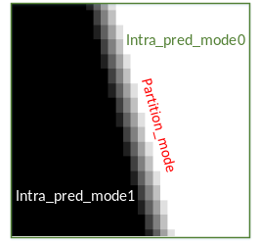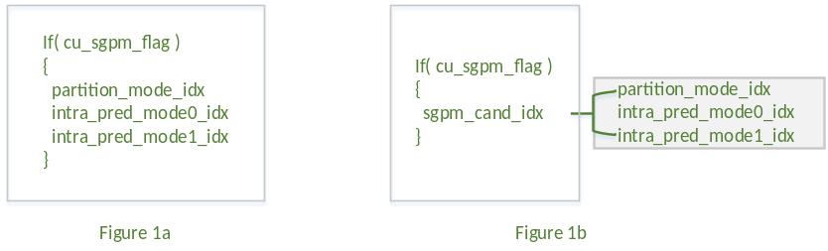
Figure 1 Spatial GPM candidates.
The list is template-based reordered using where SAD between the prediction and reconstruction of the template is used for ordering. The template size is fixed to 1.

Detailed proposal

Firstly, this contribution proposes adaptively replacing planar mode with block-vector based prediction.
Specifically:
- The block vectors of all merge candidates are collected.
- The template cost (SATD) is used to select between block-vector based prediction and planar prediction.
- The same blending of DIMD is used.

Secondly, is is proposed to allow the application of LIC to blocks in IntraTMP mode. Specifically:
- The LIC usage for an IntraTMP mode is signaled through a CU-level flag
- Usages of LIC and FLM (CCCM-like filtering) are mutually exclusive for a given CU.
- Usages of LIC and fusion in intra TMP qare mutually exclusive, similarly to FLM.

Thirdly, it is proposed to extend geometric prediction by combining block-vector-based prediction and regular intra prediction from IBC-GPM to SGPM. That is, SGPM mode tests block vectors of neighboring CU’s in addition to regular prediction modes. Specifically:
- Obtain block vectors of all merge candidates
- Select the best block vector according to SATD template cost
- Test the best block vector (if available) inside SGPM candidate list construction.

The difference with ECM-10 SGPM design is depicted in the Figure 2 below. It is about generalizing the two intra predictors from regular to regular or block-vector base.
Identifiers intra_pred_0 and intra_pred_1 correspond to be regular prediction or block-vector based obtained from neighboring IntraTMP/IBC information.

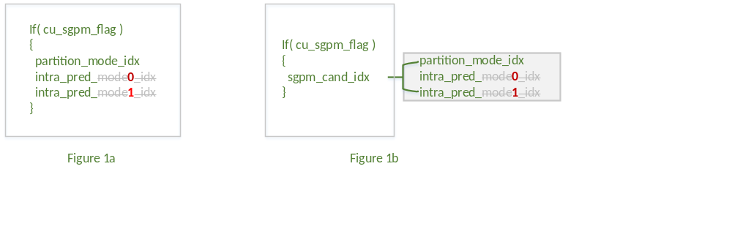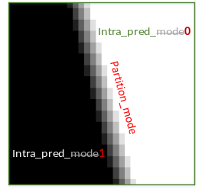

Figure 2: modified SGPM process

Experimental results
The proposal was implemented in ECM-10.0 and tested with CTC-AI and RA conditions. The following results are obtained:

Table 1: performances of proposed Intra TMP extension over ECM-10.0
 | All Intra Main 10
 | Over ECM-10.0
 | Y | U | V | EncT | DecT | VmPeak
Class A1 | -0,04% | 0,00% | -0,11% | 100,5% | 100,4% | 93,5%
Class A2 | -0,12% | -0,04% | -0,14% | 100,4% | 100,3% | 93,8%
Class B | -0,09% | -0,08% | -0,13% | 100,6% | 100,1% | 99,4%
Class C | -0,08% | -0,01% | -0,02% | 101,3% | 100,9% | 99,7%
Class E | -0,12% | 0,12% | -0,22% | 101,5% | 101,1% | 100,0%
Overall | -0,09% | -0,01% | -0,12% | 100,8% | 100,6% | 97,6%
Class D | -0,07% | 0,08% | -0,02% | 100,8% | 101,0% | 99,9%
Class F | -0,40% | -0,36% | -0,29% | 101,7% | 100,5% | 99,4%
Class TGM | -0,78% | -0,79% | -0,78% | 99,9% | 100,3% | 92,8%

Additional Data
This section demonstrates the addictiveness of coding gains achieved by this contribution and the gains obtained in contribution JVET-AF0137, which proposes extending the IntraTMP candidate list with all the merge candidates block vectors.
The following Table 2 shows the performances obtained with this combination. Note that runtimes are not reliable at all, since tests were performed on different cluster from the anchor.

Table 2: performances obtained over ECM-10.0 when combining all aspect of this contribution with Intra TMP merge mechanism of JVET-AF0137
 | All Intra Main 10
 | Over ECM-10.0
 | Y | U | V | EncT | DecT | VmPeak
Class A1 | -0,04% | -0,07% | -0,10% | 100,7% | 101,4% | 93,5%
Class A2 | -0,15% | -0,09% | -0,13% | 100,8% | 101,2% | 93,8%
Class B | -0,13% | -0,11% | -0,09% | 101,0% | 101,2% | 99,5%
Class C | -0,10% | 0,01% | 0,05% | 101,6% | 102,2% | 99,7%
Class E | -0,24% | -0,10% | -0,13% | 102,2% | 103,4% | 100,0%
Overall | -0,13% | -0,07% | -0,07% | 101,3% | 101,8% | 97,6%
Class D | -0,06% | -0,01% | -0,05% | 101,2% | 102,3% | 99,9%
Class F | #VALUE! | #VALUE! | #VALUE! | #NUM! | #NUM! | #NUM!
Class TGM | #VALUE! | #VALUE! | #VALUE! | #NUM! | #NUM! | #NUM!

Conclusion
This contribution proposes 3 aspects to extend IBC/IntraTMP in ECM and better align their design.
- In DIMD, adaptive selection between planar and IntraTMP/IBC as the mode to be blended with an angular mode.
- Allowing LIC usage in IntraTMP mode, as is already the case for IBC.
- In SGPM, allow block-vector-based prediction modes in addition to angular intra prediction modes.

It is proposed to further study the proposed extension of block-vector based prediction modes in next round of EE2.

Patent rights declaration(s)
InterDigital may have current or pending patent rights relating to the technology described in this contribution and, conditioned on reciprocity, is prepared to grant licenses under reasonable and non-discriminatory terms as necessary for implementation of the resulting ITU-T Recommendation | ISO/IEC International Standard (per box 2 of the ITU-T/ITU-R/ISO/IEC patent statement and licensing declaration form).

