    Joint Video Experts Team (JVET)  of ITU-T SG 16 WP 3 and ISO/IEC JTC 1/SC 29  32nd Meeting, Hannover, DE, 13–20 October 2023 | Document: JVET-AF0274-v1

Title: | AHG13/AHG3: film grain tuning tool
Status: | Input document to JVET
Purpose: | Information
Author(s) or  Contact(s): | P. de Lagrange | Email: | philippe.delagrange@interdigital.com
Source: | InterDigital
_____________________________

Abstract
This contribution describes a new tool to graphically display and edit an FGC SEI configuration file, available in the JVET gitlab (in “JVET AHG Film Grain Technologies” group).

Introduction
As announced during the 30th JVET meeting, a group called “JVET AHG Film Grain Technologies” has been created on gitlab (https://vcgit.hhi.fraunhofer.de/jvet-ahg-fgt). This group contains software developments related to film grain that are either independent or not yet merged into reference software.
A recent addition is “FGC SEI designer”, a graphical interactive tool to edit an FCG SEI config file, that can be useful when automatic estimation is either not practical or needs to be refined. It can also be used to export a graphical representation of film grain parameters, for use e.g. in a document.
As it is implemented as a single python script, and supposed to be connected to a film grain synthesizer, it was just added to the “VFGS” software repository (https://vcgit.hhi.fraunhofer.de/jvet-ahg-fgt/vfgs), rather than creating a new repository. External dependencies are matplotlib and numpy.
The tool is also available from InterDigital github (https://github.com/InterDigitalInc/VersatileFilmGrain), which is in fact its primary source.

Description of the tool

Graphical display and edit
Figure 1 reproduces the main window of the tool, with arbitrary default film grain parameters when no configuration file is loaded yet.
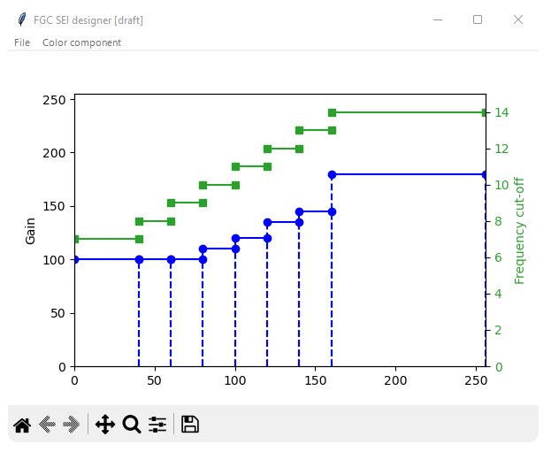
Figure 1 – Main tool window
An FGC SEI configuration file can be loaded and saved through the “File” menu. Currently, only frequency-filtering mode is supported. The syntax used in the configuration file is the same as the VTM.
Color component is selected with the “color component” menu.
Intensity interval boundaries, gain levels, and frequency cutoffs can be click-dragged. An interval is removed when it is reduced to zero-length, and is split by a double-click.

Examples
Figure 2 is an example film grain parameter representation exported with the FGC SEI designer tool, using the CrowRun.cfg file that was used for expert viewing experiment reported in JVET-AD0382. The graphical export is provided by the “save as” feature of matplotlib (the floppy disk icon of the toolbar in Figure 1).

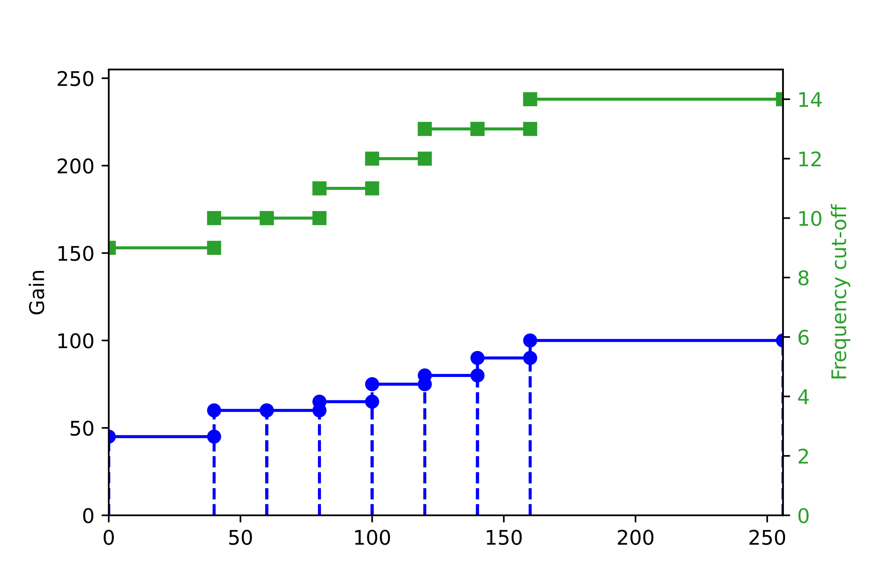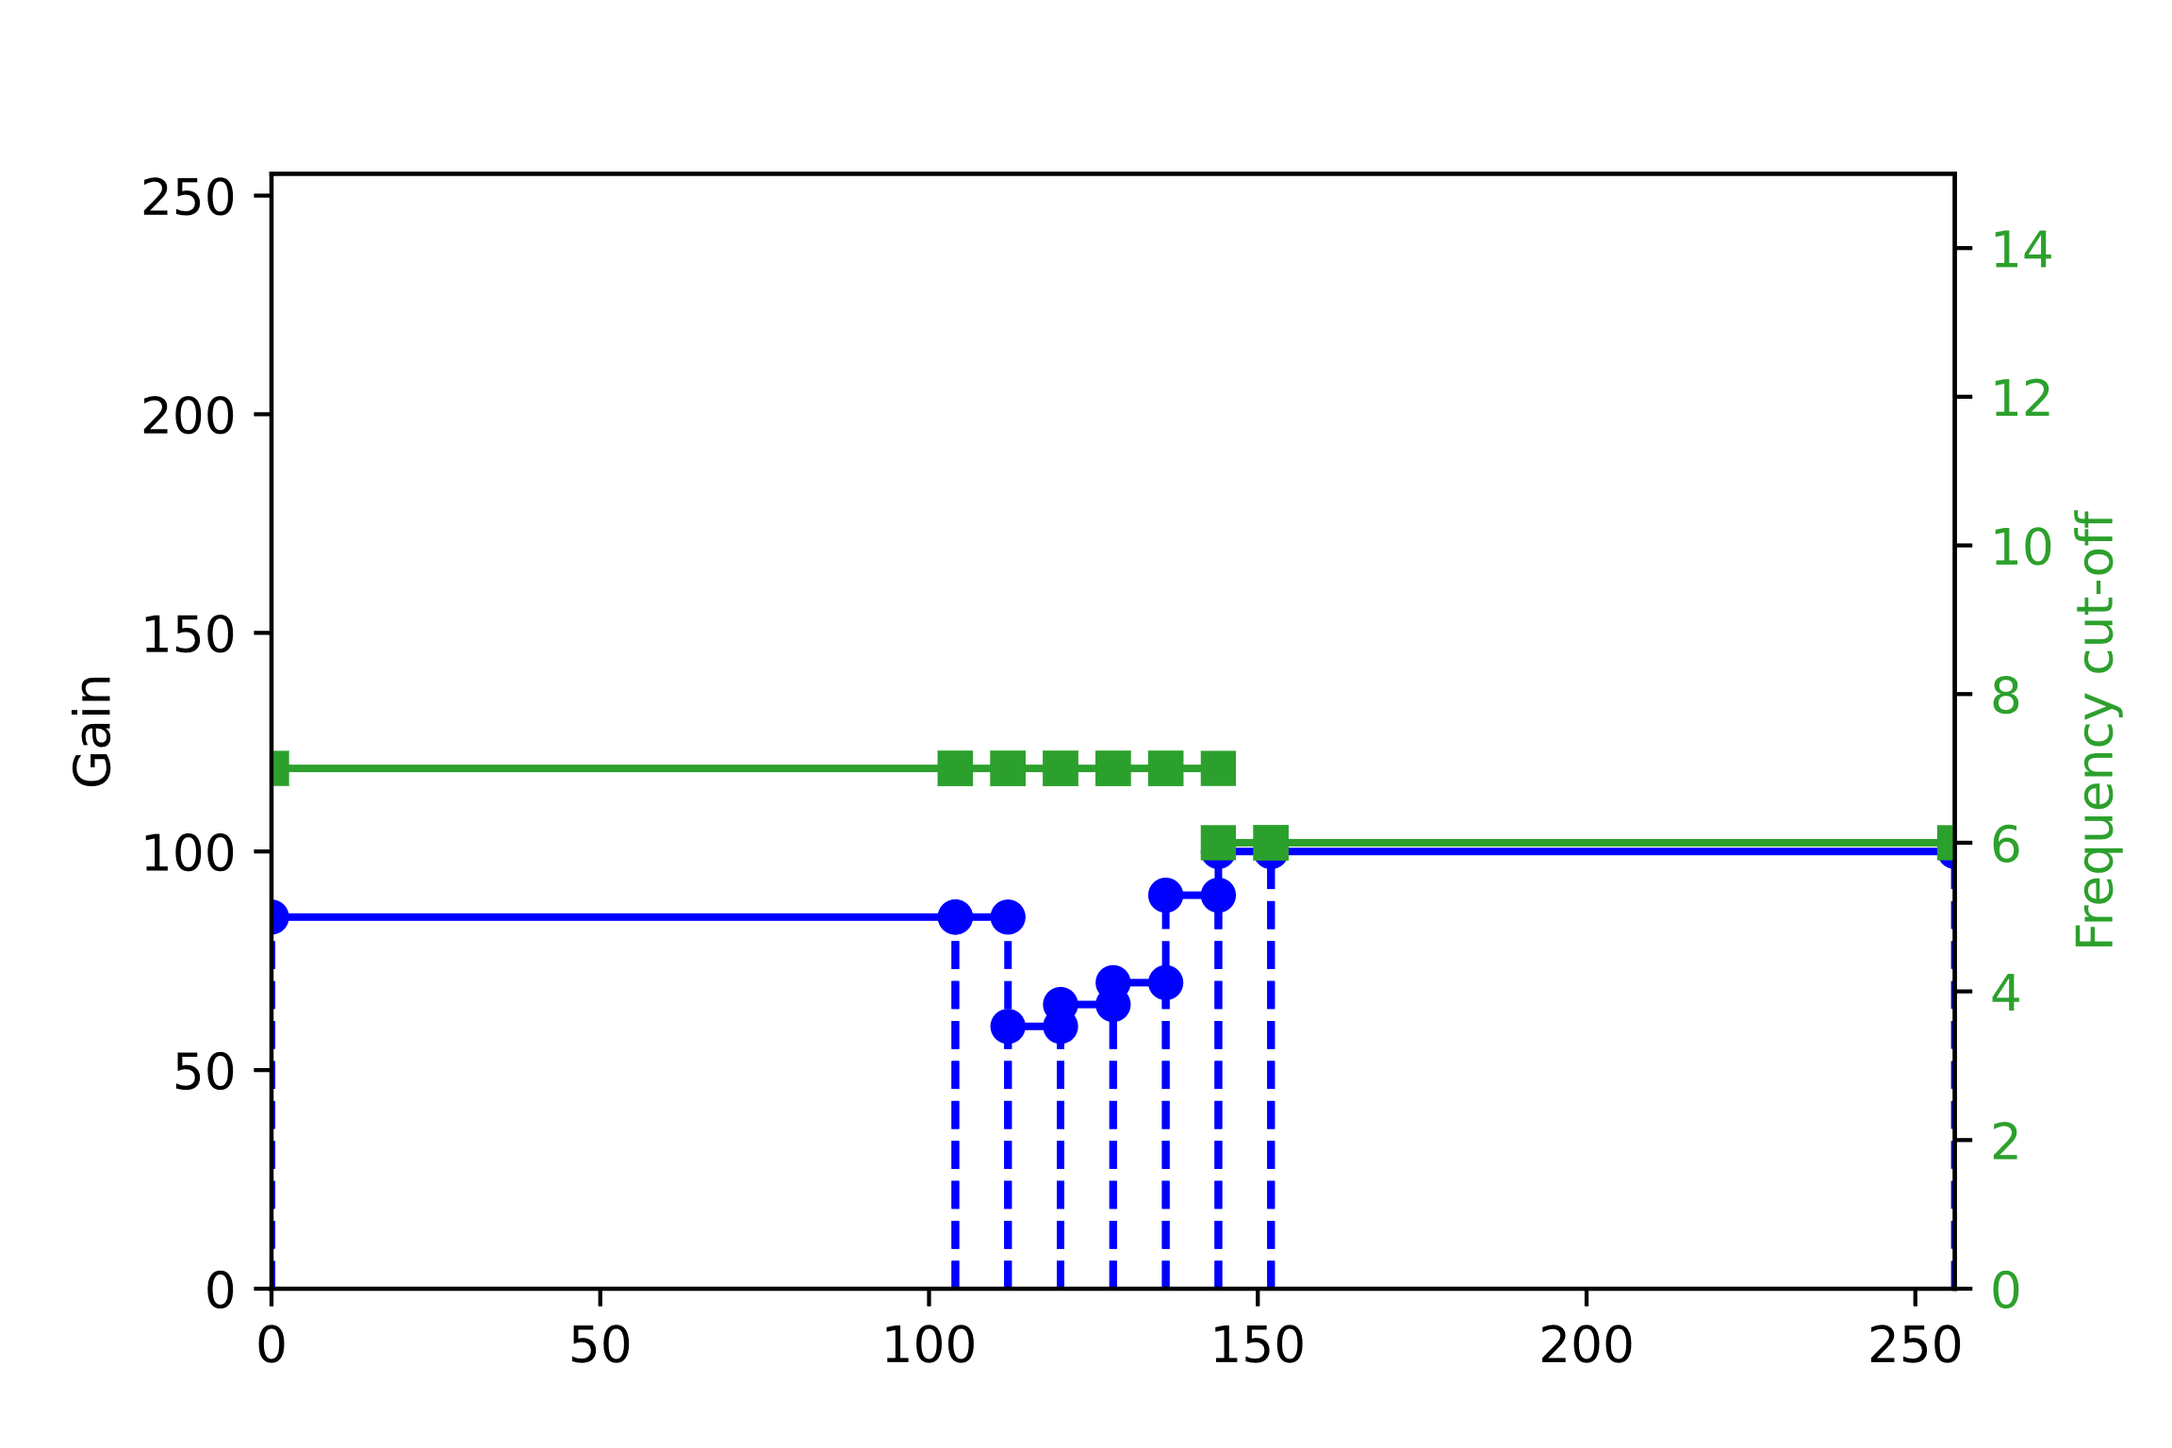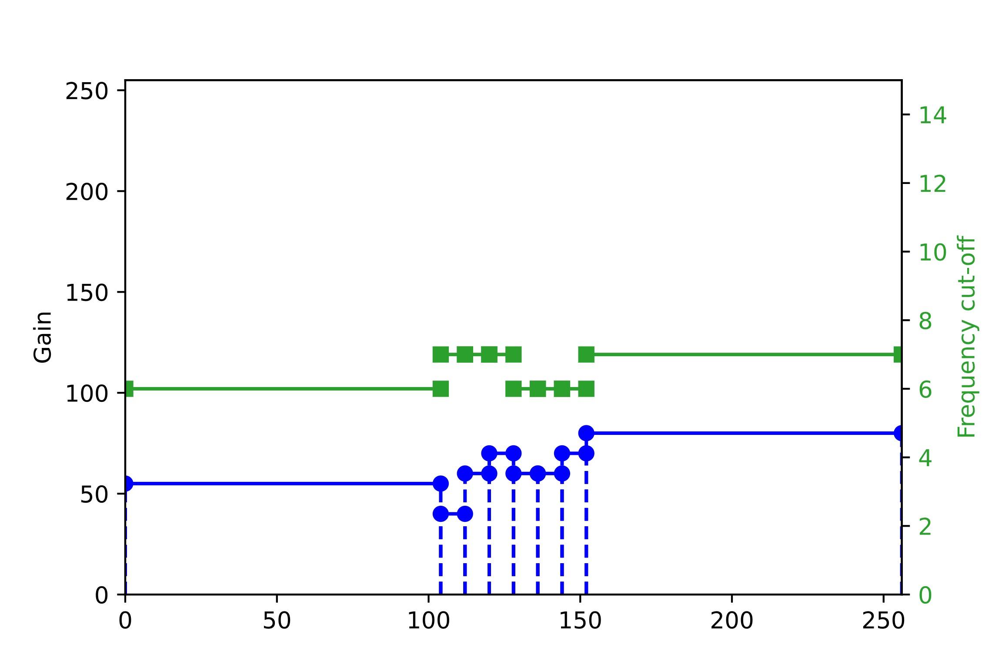
Figure 2 – Film grain parameters used for CrowdRun in JVET-AD0382 (Luma, Cb, and Cr from top to bottom and left to right)
Notes:
- Horizontal axis corresponds to target image sample value (or “intensity”), normalized to 8-bits.
- Here, log2ScaleFactor equals 4, which means that the gain axis is scaled down by 2^4 = 16, for an 8-bit target image (for a 10-bit target image, is it scaled down 4 times less).

Tool chain, future plans
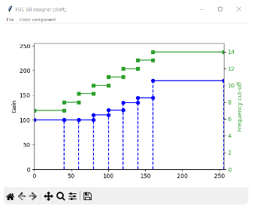
Encoder
Decoder
FGS
source picture
FilmGrainApp
decoded picture
regrained picture
Analyzer
.cfg
Preview window
FGC SEI designer (main window)
insert SEI messages
execute
execute
Figure 3 – Film grain experimental tool chain
Figure 3 depicts a tool chain that could be used to experiment with film grain synthesis. Items in green are under construction.
It is planned to connect the FGC SEI designer tool to an external film grain synthesizer, so that immediate feedback of adjustments can be shown in a preview window.
Further work include:
- Estimate initial parameters when provided with the source and clean pictures (by e.g. connecting an external analyzer)
- Support of auto-regressive mode, and potentially translations between FF and AR modes
- Compare source / clean / re-grained pictures in the preview window

Conclusion
A graphical tool to display and adjust film grain parameters is provided, to encourage and ease experimentation of film grain synthesis technology.

