    Joint Video Experts Team (JVET)  of ITU-T SG 16 WP 3 and ISO/IEC JTC 1/SC 29  32nd Meeting, Hannover, DE, 13–20 October 2023 | Document: JVET-AF0166-v2

Title: | Non-EE2: Intra TMP fusion probing
Status: | Input document to JVET
Purpose: | Proposal
Author(s) or  Contact(s): | Jian-Liang Lin  Po-Han Lin  Hongtao Wang  Yao-Jen Chang  Zhi Zhang  Vadim Seregin  Marta Karczewicz | Tel:  Email: | jilin@qti.qualcomm.com  pohanlin@qti.qualcomm.com  hongtaow@qti.qualcomm.com  yjchang@qti.qualcomm.com  zhizhang@qti.qualcomm.com  vseregin@qti.qualcomm.com  martak@qti.qualcomm.com
Source: | Qualcomm Incorporated
_____________________________

Abstract
This contribution proposes an Intra TMP fusion probing method to select a fusion candidate with minimum probing cost from a fusion candidate list. The probing cost is derived as the SAD between the reference and current block’s probing lines. The simulation results on top of ECM-10.0 are summarized as follows:
AI(Y/U/V): -0.09 %/ -0.04 %/ -0.11 %, EncT 102.1 %, DecT 101.5 %

Introduction
In ECM-10.0, Intra TMP candidate list is constructed from candidates derived by L-shape, left or above template based on the template matching cost which is calculated as the SAD between the template of the reference block and the template of current block. For Intra TMP fusion mode, multiple Intra TMP candidates are linear combined according to the fusion weights derived from the template matching costs or derived by MSE minimization method. A flag intra_tmp_fusion_weight_type is signaled to indicate which weight derivation method is used and an index intra_tmp_fusion_idx is signaled to indicate which candidate set is selected for Intra TMP fusion.

Proposed method
In Intra TMP fusion mode, a flag is first signalled to indicate whether this proposed fusion probing mode is enabled. When it is enabled, a fusion candidate with minimum probing cost is selected from a fusion candidate list without signaling the intra_tmp_fusion_weight_type and intra_tmp_fusion_idx. The probing cost is derived as the SAD between the pixels in the probing line of the fused template and current block’s template. The probing line as shown in Figure 1 is similar to probe samples proposed in JVET-AE0140. The fusion weights derivation is the same as in ECM-10.0, but the pixels in probing line are excluded. The template matching cost of probing line is weighted by 2 in Intra TMP candidate search process.
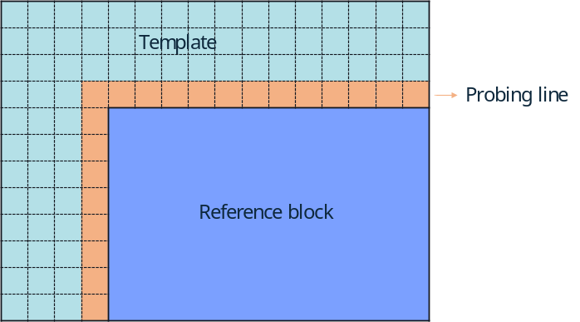
Figure 1: The template and probing line for Intra TMP

Experiment result
The proposed method was implemented on top of ECM-10.0 and tested under the common test conditions [3].

 | All Intra Main 10
 | Over ECM9
 | Y | U | V | EncT | DecT
Class A1 | -0.04% | -0.12% | -0.10% | 103.2% | 99.2%
Class A2 | -0.10% | -0.07% | -0.16% | 102.1% | 100.2%
Class B | -0.10% | -0.09% | -0.14% | 102.3% | 102.7%
Class C | -0.09% | 0.06% | 0.07% | 101.9% | 102.6%
Class E | -0.10% | 0.05% | -0.26% | 101.0% | 101.8%
Overall | -0.09% | -0.04% | -0.11% | 102.1% | 101.5%
Class D | -0.03% | -0.01% | 0.05% | 102.2% | 100.2%
Class F | -0.05% | 0.08% | 0.27% | 100.8% | 102.8%
Class TGM | -0.04% | -0.12% | -0.10% | 103.2% | 99.2%

References
[1] ECM-10.0, https://vcgit.hhi.fraunhofer.de/ecm/ECM/-/tree/ECM-10.0.
[2] A. Filippov, V. Rufitskiy, K. Suverov “Non-EE2: LIC extensions”, JVET-AE0140, April 2023.
[3] M. Karczewicz, Y. Ye, “Common Test Conditions and evaluation procedures for enhanced compression tool testing”, JVET-AE2017, April 2023.

Patent rights declaration(s)
Qualcomm Incorporated may have current or pending patent rights relating to the technology described in this contribution and, conditioned on reciprocity, is prepared to grant licenses under reasonable and non-discriminatory terms as necessary for implementation of the resulting ITU-T Recommendation | ISO/IEC International Standard (per box 2 of the ITU-T/ITU-R/ISO/IEC patent statement and licensing declaration form).

