    Joint Video Experts Team (JVET)  of ITU-T SG 16 WP 3 and ISO/IEC JTC 1/SC 29  32nd Meeting, Hannover, DE, 13–20 October 2023 | Document: JVET-AF0161-v2

Title: | AHG12: Harmonized IBC/ITMP search area with adaptive sampling
Status: | Input document to JVET
Purpose: | Proposal
Author(s) or  Contact(s): | D. Ruiz Coll,  B. Chen,  Karam Naser  Philippe Bordes  Fabrice Le Léannec  Franck Galpin | Tel:  Email: | duizcoll@ofinno.com,  bchen@ofinno.com,  karam.naser@interdigital.com
Source: | Ofinno, InterDigital
_____________________________

Abstract
This contribution proposes the harmonization of the IBC and IntraTMP search areas. The IBC and IntraTMP tools use the reconstructed samples of the current picture to select a candidate prediction block for the current block. The IBC search area comprises a constant number of CTUs, while the IntraTMP search area is based on the current block dimension, which is mainly smaller than the IBC search area. IntraTMP searches for the most similar L-shaped, Top-Only, or Left-Only template that matches the template of the current block in the search area. In IntraTMP, a constant sampling factor of 3 is applied in the horizontal and vertical search directions to alleviate the template-matching complexity. However, the extension of the IntraTMP search area demands more searches. This contribution proposes two methods to determine an adaptive sampling factor when the IntraTMP search region is extended to the IBC search region.
On top of ECM-10.0, simulation results are reported as follows:
Test-1: Sampling rate based on the searching distance.
AI: Class F: {-0.43%, -0.35%, -0.28%, 100.9%, 105.0%},
AI: Class TGM: {-0.70%, -0.72 %, -0.73%, 101.5%, 108.3%};
RA: Class F: {-0.16%, -0.00%, -0.04%, 100.5%, 100.5%},
RA Class TGM: {-0.43%, -0.54 %, -0.52%, 100.2%, 102.6%};
Test-2: Sampling rate based on the IntraTMP regions dimension.
AI: Class F: {-0.29%, -0.26%, -0.14%, 101.4%, 104.1%},
AI: Class TGM: {-0.43%, -0.43 %, -0.48%, 100.4%, 101.1%};
Test-3: Combination of Test-1 and Test-2.
AI: Class F*: {-0.32%, -0.32%, -0.24%, 100.8%, 101.5%},
AI: Class TGM: {-0.32%, -0.33%, -0.36%, 101.1%, 100.0%};

Introduction
The IBC search region includes the reconstructed samples of the current CTU, all the left neighbor CTUs of the same row of the current CTU, and two CTU rows for a CTU size of 128 or one CTU row for a CTU size of 256. In JVET-V0130 [1], the IntraTMP search area is set proportional to the width (W) and height (H) block dimensions, using a multifactor parameter denoted as 'a', which controls the gain/complexity trade-off. The boundaries of the IntraTMP search area, are set as follows:
$$SearchRangeWidth= a * W; SearchRangeHeight = a * H; ∀ a=5$$
In [2], an extension of the IntraTMP search area was proposed for the block size of 4 and 8 samples, determining the search region boundaries as:
$$SearchRangeWidth= max⁡(5 * W,64)$$
$$SearchRangeHeight =max⁡( 5 * H, 64)$$
Its effect on practice is a set to use a variable multifactor parameter 'a' based on the current block dimensions, as shown in Table 1;

Block size (W, H) | 64 | 32 | 16 | 8 | 4
Multifactor ‘a’ | 5 | 5 | 5 | 8 | 16
Table 1. Multifactor 'a' based on block dimension.
In ECM-10.0, the IntraTMP search area is divided into 6 rectangular regions, as depicted in Fig. 1:
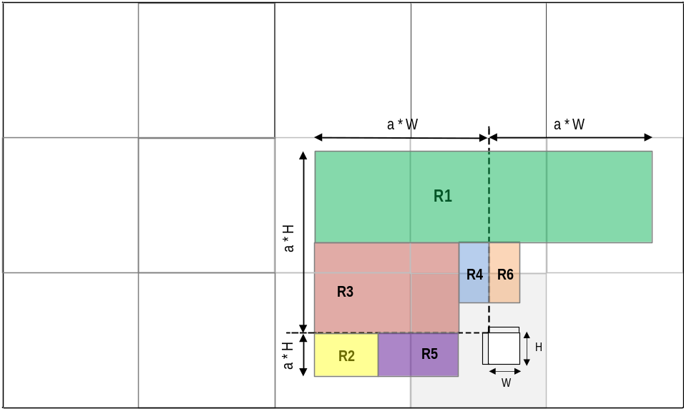

Figure 1. IntraTMP search area divided into 6 regions in ECM-10.0.

The IntraTMP candidate BV search is performed in two steps:
- The spare searching: to reduce the searching complexity, the template-matching is carried out on all regions using a $SamplingFactor$ of 3. The 30 BV candidates with the lowest SAD template cost are selected and ranked in cost ascending order.
- The refinement searching: the 30 initial sparse candidates are defined in a window of 3x3 pixels. The 19 candidates with the lowest SAD template cost are selected for a "short IntraTMP list." These candidates are available for the two IntraTMP fusion modes and the Multi-candidate mode, which signals an index to the decoder indicating the best candidate among the 19 candidates in the list.

Proposal
JVET-AE0166 and JVET-AE0198 contributions proposed to extend the IntraTMP search region to the same as the IBC search region, allowing the use of the same reconstructed buffer for both tools. This feature is particularly desirable from the hardware point of view, considering that the reconstructed buffer uses a high-cost on-chip memory. This contribution harmonizes the number of regions proposed in both contributions and proposes some improvements described below.
To cover the whole IBC reference region, the number of IntraTMP regions is increased by one compared to ECM-10. The boundaries of the farthest original regions (R1, R2, and R3) have been modified to cover the whole IBC search region as it is depicted in Fig. 2:
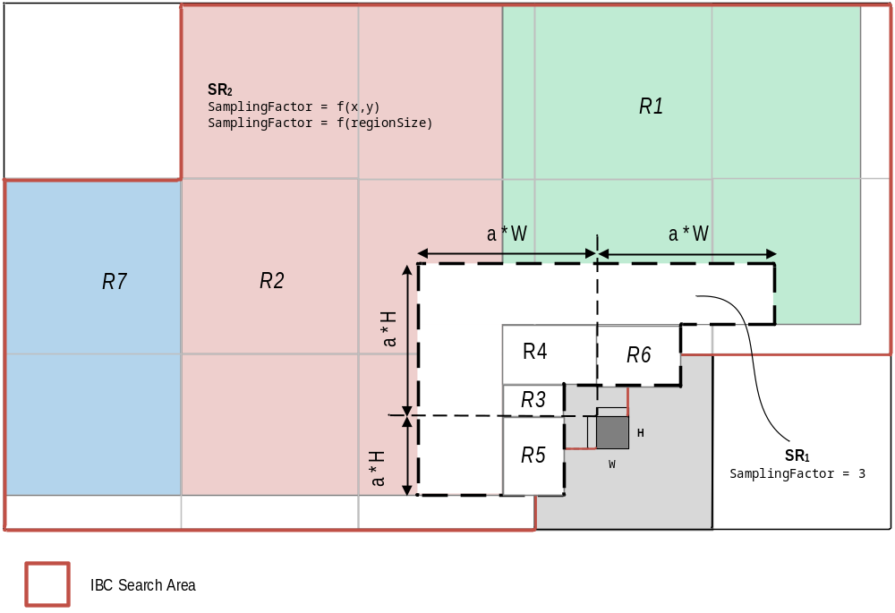
Figure 1IntraTMP search area adjusted to the IBC search area.
The regular search area remains the same as in ECM-10, constrained by the $SearchRangeWidth$ and $SearchRangeHeight$ parameters, which are proportional to the current block dimensions. The sample rate inside the regular search area (${SR}_{1}$) remains constant ($SamplingFactor = 3$). The scanning order also remains invariant, scanning first the nearest regions (R3, R4, R5, and R6) and following with the external regions (R1, R2, and R7).
The search mechanism is modified as follows:
- The searching process in the farthest region (R7) is pruned if the normalized TMP cost of the last BV candidate in the sparse list is less than a threshold, calculated as follows, where W and H are the current block horizontal and vertical size respectively:
CostThreshold= -32*W*H+236
- To avoid the searching exceeding the IBC reference area, the multifactor parameter ‘a’ is set to 4 for block sizes of 64 samples.
- To reduce the number of accesses to the sparse candidate's list, the search regions on the right side of the current block (R1 and R6) are scanned in the inverse direction, from left to right, checking before the most probable candidates.
This contribution studies two methods of adapting the sampling rate outside the regular search area to reduce the complexity of the search extension. These methods propose using an adaptive sampling rate (${SR}_{2}$) calculated according to specific parameters, as described below.

Test-1: Sampling rate based on the searching distance.
The block vector in IntraTMP components can be considered as independent random variables (BV.x and BV.y), and their probability distributions are close to a normal distribution with mean µ and standard deviation σ:
$$BV.x \sim N(µ_{x}, σ_{x})$$
$$BV.y \sim N(µ_{y}, σ_{y})$$
As can be observed in the example of FIG. 2, the horizontal boundaries of the regular search region ($±SearchRangeWidth$) are far from the two standard deviations (2σ), which comprises a probability close to 68%.
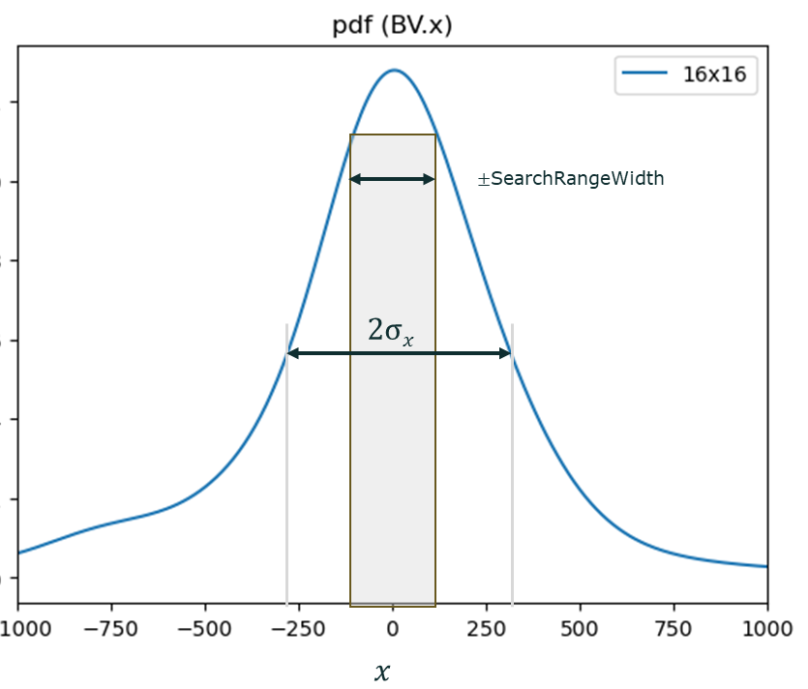
Figure 2. Example of the Probability Density Function of the BV.x for a 16x16 block
Therefore, the sampling factor for positions in the extended search region is increased according to the distance from the current block. To reduce complexity, this contribution proposes a stepwise adjustment of the sampling rate, inversely proportional to the probability of finding a BV candidate in the extended area. The sampling factor is predetermined according to the estimated distribution and stored in a table for the different block dimensions. In this proposal, the sampling rate is set to a minimum value of 3 for the regular search region (a*W, a*H), to a maximum sampling factor of 64. An example is depicted in Fig. 3.

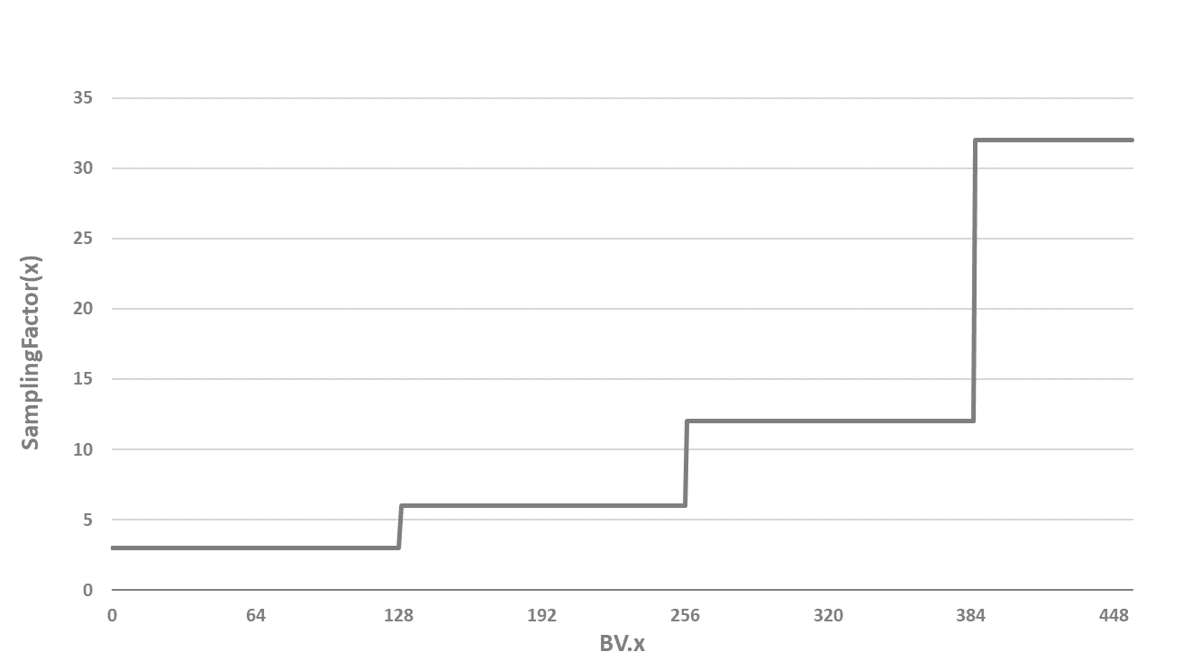
Test-2: Sampling rate based on the IntraTMP regions dimension.
A new subsampling factor is determined for each region ($Ri$) according to the region dimensions as follows:

$$SamplingFactorWidth(Ri) = Width(Ri)/ F*BlkW$$
$$SamplingFactorHeight(Ri) = Height(Ri)/ F*BlkH$$

where ‘$F$’ is the ECM constant that controls the gain/complexity trade-off. Therefore, the added number of template comparisons remains small for all the added regions. The new sampling rate factors are only applied at the extended region location, using the same sampling factor ($SamplingFactor = 3$) inside the regular research region.
Test-3: Combination of Test-1 and Test-2
This test combines both methods as following:
- The multifactor parameter 'a' for 8and 4 sizes, is unified to 5.
- The sampling factor for both methods is calculated as is described above (SamplingFactor1,SamplingFactor2)
- The largest sampling factor is selected for the current location:
  - SamplingFactor= max(SamplingFactor1,SamplingFactor2)

Experimental Results
The proposed methods are tested on top of ECM-10.0 software [3] under JVET ECM common test conditions [4] in AI and RA configurations. The following results were obtained:
Test-1: Sampling rate based on the searching distance.

Table 2. Method-1 results over ECM-10.0 for AI
 | All Intra Main 10
 | Over ECM-10.0
 | Y | U | V | EncT | DecT | VmPeak
Class F | -0.43% | -0.35% | -0.28% | 100.9% | 105.0% | 100.0%
Class TGM | -0.70% | -0.72% | -0.73% | 101.5% | 108.3% | 100.0%
Overall | -0.57% | -0.54% | -0.51% | 101.2% | 106.7% | 100.0%

Table 3. Method-1 results over ECM-10.0 for RA
 | RA Intra Main 10
 | Over ECM-10.0
 | Y | U | V | EncT | DecT | VmPeak
Class F | -0.16% | 0.00% | -0.04% | 100.5% | 100.5% | 99.8
Class TGM* | -0.43% | -0.54% | -0.52% | 100.2% | 102.6% | 100.0%
Overall | -0.29% | -0.27% | -0.28% | 100.4% | 101.1% | 99.9%

* Reference data for the “Console” sequence are used for test

Test-2: Sampling rate based on the IntraTMP regions dimension.

 | All Intra Main 10
 | Over ECM-10.0
 | Y | U | V | EncT | DecT | VmPeak
Class F* | -0.30% | -0.27% | -0.15% | 101.4% | 104.1% | 99.7%
Class TGM | -0.43% | -0.43% | -0.48% | 100.5% | 102.2% | 99.5%
Overall | -0.37% | -0.35% | -0.32% | 101.0% | 103.2% | 99.6%

Test-3: Combination of method-1 and method-2.

 | All Intra Main 10
 | Over ECM-10.0
 | Y | U | V | EncT | DecT | VmPeak
Class F* | -0.32% | -0.32% | -0.24% | 100.8% | 101.5% | 100.1%
Class TGM | -0.32% | -0.33% | -0.36% | 101.1% | 100.6% | 100.0%
Overall | -0.32% | -0.32% | -0.30% | 100.9% | 101.0% | 100.1%

- References
- K. Naser, T. Poirier, F. Le Léannec, G. Martin-Cocher, “EE2: Intra Template Matching”, JVET-V0130, April 2021.
- F. Wang, L. Zhang, Y. Yu, H. Yu, D. Wang, “Non-EE2: multi-candidate IntraTMP”, JVET-AC0068, January 2023
- https://vcgit.hhi.fraunhofer.de/ecm/ECM/-/tags/ECM-10.0
- M. Karczewicz and Y. Ye, "Common Test Conditions and evaluation procedures for enhanced compression tool testing," Joint Video Experts Team (JVET) of ITU-T SG 16 WP 3 and ISO/IEC JTC 1/SC 29, JVET-AE2017, 31st meeting, Geneve, Jul. 2023.

Patent rights declaration(s)
Ofinno, LLC may have current or pending patent rights relating to the technology described in this contribution and, conditioned on reciprocity, is prepared to grant licenses under reasonable and non-discriminatory terms as necessary for implementation of the resulting ITU-T Recommendation | ISO/IEC International Standard (per box 2 of the ITU-T/ITU-R/ISO/IEC patent statement and licensing declaration form).
InterDigital may have current or pending patent rights relating to the technology described in this contribution and, conditioned on reciprocity, is prepared to grant licenses under reasonable and non-discriminatory terms as necessary for implementation of the resulting ITU-T Recommendation | ISO/IEC International Standard (per box 2 of the ITU-T/ITU-R/ISO/IEC patent statement and licensing declaration form).

