    Joint Video Experts Team (JVET)  of ITU-T SG 16 WP 3 and ISO/IEC JTC 1/SC 29  32nd Meeting, Hannover, DE, 13–20 October 2023 | Document: JVET-AF0161-v1

Title: | AHG12: Harmonized IBC/ITMP search area with adaptive sampling
Status: | Input document to JVET
Purpose: | Proposal
Author(s) or  Contact(s): | D. Ruiz Coll,  B. Chen,  Karam Naser  Philippe Bordes  Fabrice Le Léannec  Franck Galpin | Tel:  Email: | duizcoll@ofinno.com,  bchen@ofinno.com,  karam.naser@interdigital.com
Source: | Ofinno, InterDigital
_____________________________

Abstract
This contribution proposes the harmonization of the IBC and IntraTMP search areas. The IBC and IntraTMP tools use the reconstructed samples of the current picture to select a candidate prediction block for the current block. The IBC search area comprises a constant number of CTUs, while the IntraTMP search area is based on the current block dimension, which is mainly smaller than the IBC search area. IntraTMP searches for the most similar L-shaped, Top-Only, or Left-Only template that matches the template of the current block in the search area. In IntraTMP, a constant sampling factor of 3 is applied in the horizontal and vertical search directions to alleviate the template-matching complexity. However, the extension of the IntraTMP search area demands more searches. This contribution proposes two methods to determine an adaptive sampling factor when the IntraTMP search region is extended to the IBC search region.
On top of ECM-10.0, simulation results are reported as follows:
Method-1: Sampling rate based on the searching distance.
AI: Class F: {-0.57%, -0.54%, -0.51%, 101.2%, 106.7%},
AI: Class TGM: {-0.68%, -0.68 %, -0.69%, 102.5%, 114.5%};
Method-2: Sampling rate based on the IntraTMP regions dimension.
AI: Class F*: {-0.55%, -0.45%, -0.42%, 104.9%, 119.9%},
AI: Class TGM: {-1.03%, -1.01 %, -1.02%, 106.1%, 134.9%};

Introduction
The IBC pre-defined search region includes the reconstructed samples of the current CTU, all the left neighbor CTUs of the same row of the current CTU, and two CTU rows for a CTU size of 128 or one CTU row for a CTU size of 256. In JVET-V0130 [1], the IntraTMP search area is set proportional to the width (W) and height (H) block dimensions, using a multifactor parameter denoted as 'a', which controls the gain/complexity trade-off. The boundaries of the IntraTMP search area, is set as follows:
$$SearchRangeWidth= a * W; SearchRangeHeight = a * H; ∀ a=5$$
In [2], an extension of the IntraTMP search area was proposed for the block size of 4 and 8 samples, determining the search region boundaries as:
$$SearchRangeWidth= max⁡(5 * W,64)$$
$$SearchRangeHeight =max⁡( 5 * H, 64)$$
Its effect on practice is a set to use a variable multifactor parameter 'a' based on the current block dimensions, as shown in Table 1;

Block size (W,H) | 64 | 32 | 16 | 8 | 4
Multifactor ‘a’ | 5 | 5 | 5 | 8 | 16
$$SearchRangeWidth$$ | 320 | 160 | 80 | 64 | 64
$$SearchRangeHeight$$ | 320 | 160 | 80 | 64 | 64
Table 1. Multifactor 'a' and IntraTMP search are dimensions based on block dimension.
In ECM-10.0, with the aim to adjust the IntraTMP search area to the reconstructed samples, it is divided into 6 rectangular regions, as depicted in Fig. 1:

Figure 2. IntraTMP search area for a block size of 64x64 (CTU size 128)

The IntraTMP candidate searching is performed in two steps:
- The spare searching: the template-matching is carried out on all regions using a $SamplingFactor$ of 3, which reduces the searching complexity. The 30 candidates with the lowest SAD cost are selected and ranked in cost ascending order.
- The refinement searching: the 30 initial sparse candidates are defined in a window of 3x3 pixels. The 19 candidates with the lowest SAD template cost are selected for a "short IntraTMP list." These candidates are available for the two IntraTMP fusion modes and also for the Multi-candidate mode, which signals an index to the decoder indicating the best candidate among the 19 candidates in the list.

Proposal
This contribution proposes to extend the IntraTMP search region to the same as the IBC search region, allowing the use of the same reconstructed buffer for both tools. This feature is particularly desirable from the hardware point of view, considering that the reconstructed buffer uses a high-cost on-chip memory.
With the aim to cover the whole IBC reference region, the number of IntraTMP regions is increased by one compared to ECM-10. The boundaries of the farthest original regions (R1, R2, and R3) have been modified to cover the whole IBC search region as follows:
Figure 1. IntraTMP search regions adjusted to the IBC search area.
The regular search area remains the same as in ECM-10, constrained by the $SearchRangeWidth$ and $SearchRangeHeight$ parameters which are proportional to the current block dimensions. The sample rate inside the regular search area (${SR}_{1}$) remains constant ($SamplingFactor = 3$). The scanning order also remains invariant, scanning first the nearest regions (R3, R4, R5, and R6) and following with the external regions (R2, R7, and R1).
To reduce the increased complexity resulting from search area extension, this contribution studies two methods of adapting the sampling rate outside the regular search area. These methods propose using a larger sampling rate (${SR}_{2}$) calculated according to certain parameters, as described below.

Method-1: Sampling rate based on the searching distance.
The block vector (BV.y, BV.y) in IntraTMP components can be considered as independent random variables (BV.y and BV.y), and their probability distributions are close to a normal distribution with mean µ and standard deviation σ:
$$BV.x \sim N(µ_{x}, σ_{x})$$
$$BV.y \sim N(µ_{y}, σ_{y})$$
As can be observed in the example of FIG. 2, the horizontal boundaries of the regular search region ($±SearchRangeWidth$) are far from the two standard deviations (2σ), which comprises a probability close to 68%.
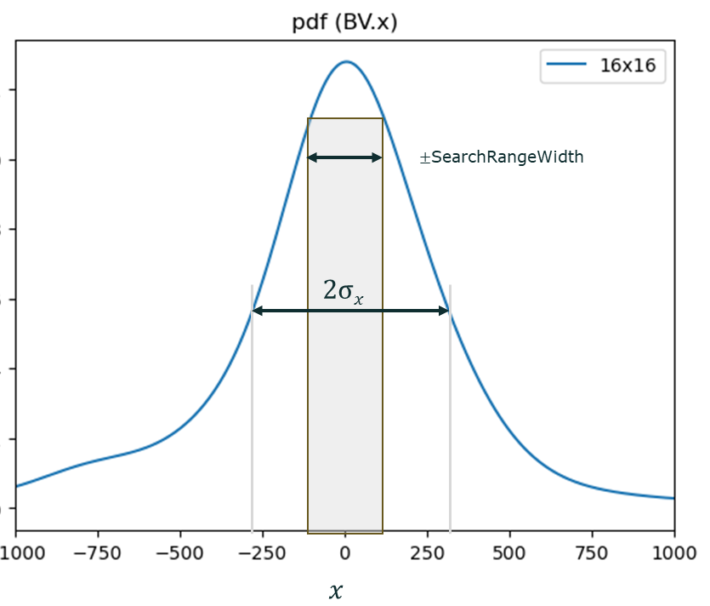
Figure 2. Example of the Probability Density Function of the BV.x for a 16x16 block
Therefore, the sampling factor for positions in the extended search region should increase according to the distance from the current block. To reduce complexity, the sampling factor is set based on a multiple of the current block dimension.

Method-2: Sampling rate based on the IntraTMP regions dimension.
A new subsampling factor is determined for each region ($Ri$) according to the region dimensions as follows:

$$SamplingFactorWidth(Ri) = Width(Ri)/ F*BlkW$$
$$SamplingFactorHeight(Ri) = Height(Ri)/ F*BlkH$$

where ‘$F$’ is the ECM constant that controls the gain/complexity trade-off. Therefore, the added number of template comparisons remains small for all the added regions. The new sampling rate factors are only applied at the extended region location, using the same sampling factor ($SamplingFactor = 3$) inside the regular research region.

Experimental Results
The proposed method is tested on top of ECM-9.0 software [3] under JVET ECM common test conditions [4] in AI and RA configurations. The following results were obtained:
Test-1: Sampling rate based on the searching distance.

 | All Intra Main 10
 | Over Method-1
 | Y | U | V | EncT | DecT | VmPeak
Class F | -0.43% | -0.35% | -0.28% | 100.9% | 105.0% | 100.0%
Class TGM | -0.70% | -0.72% | -0.73% | 101.5% | 108.3% | 100.0%
Overall | -0.57% | -0.54% | -0.51% | 101.2% | 106.7% | 100.0%

 | RA Intra Main 10
 | Over Method-1
 | Y | U | V | EncT | DecT | VmPeak
Class F | x.xx% | x.xx% | x.xx% | xxx.x% | xxx.x% | xxx.x%
Class TGM | x.xx% | x.xx% | x.xx% | xxx.x% | xxx.x% | xxx.x%
Overall | x.xx% | x.xx% | x.xx% | xxx.x% | xxx.x% | xxx.x%

Test-2: Sampling rate based on the IntraTMP regions dimension.

 | All Intra Main 10
 | Over Method-2
 | Y | U | V | EncT | DecT | VmPeak
Class F* | -0.55% | -0.45% | -0.42% | 104.9% | 119.9% | 100.0%
Class TGM | -1.03% | -1.01% | -1.02% | 106.1% | 134.9% | 100.0%
Overall | -0.79% | -0.73% | -0.72% | 106.1% | 127.7% | 100.0%

* ArenaOfValue : Reference data for QP22 and QP27 are used for test

- References
- K. Naser, T. Poirier, F. Le Léannec, G. Martin-Cocher, “EE2: Intra Template Matching”, JVET-V0130, April 2021.
- F. Wang, L. Zhang, Y. Yu, H. Yu, D. Wang, “Non-EE2: multi-candidate IntraTMP”, JVET-AC0068, January 2023
- https://vcgit.hhi.fraunhofer.de/ecm/ECM/-/tags/ECM-10.0
- M. Karczewicz and Y. Ye, "Common Test Conditions and evaluation procedures for enhanced compression tool testing," Joint Video Experts Team (JVET) of ITU-T SG 16 WP 3 and ISO/IEC JTC 1/SC 29, JVET-AE2017, 31st meeting, Geneve, Jul. 2023.

Patent rights declaration(s)
Ofinno, LLC may have current or pending patent rights relating to the technology described in this contribution and, conditioned on reciprocity, is prepared to grant licenses under reasonable and non-discriminatory terms as necessary for implementation of the resulting ITU-T Recommendation | ISO/IEC International Standard (per box 2 of the ITU-T/ITU-R/ISO/IEC patent statement and licensing declaration form).
InterDigital may have current or pending patent rights relating to the technology described in this contribution and, conditioned on reciprocity, is prepared to grant licenses under reasonable and non-discriminatory terms as necessary for implementation of the resulting ITU-T Recommendation | ISO/IEC International Standard (per box 2 of the ITU-T/ITU-R/ISO/IEC patent statement and licensing declaration form).

