    Joint Video Experts Team (JVET)  of ITU-T SG 16 WP 3 and ISO/IEC JTC 1/SC 29  32nd Meeting, Hannover, DE, 13–20 October 2023 | Document: JVET-AF0060-v2

Title: | AHG 8: An exemplar software implementation for temporal resampling for VCM
Status: | Input document of JVET
Purpose: | Proposal
Author(s) or  Contact(s): | Shurun Wang  Jie Chen  Yan Ye  (Alibaba)  Shiqi Wang  (City University of Hong Kong) | Email: | shurun.wsr@alibaba-inc.com  jiechen.cj@alibaba-inc.com  yan.ye@alibaba-inc.com  shiqwang@cityu.edu.hk
Source: | Alibaba, City University of Hong Kong
_____________________________

Abstract
Sections on using temporal resampling to improve coding efficiency for video coding for machines have been included in JVET-AD2030 “Optimization of encoders and receiving systems for machine analysis of coded video content (draft 2)” at the conceptual level, but without providing any detail. This contribution proposes a temporal resampling software implementation for inclusion in JVET-AD2030. The proposed implementation can achieve 22.12%, 30.03% and 75.68% average Pareto BD-rate improvements for random access (RA), low delay (LD) and all intra (AI) configurations for SFU-HW dataset under the common test conditions for optimization of encoders and receiving systems for machine analysis of coded video content as defined in JVET-AE2031, when VTM version is 20.0 and temporal resampling ratio is 4. For TVD dataset, 45.39%, 35.50% and 73.72% average Pareto can be achieved for RA, LD and AI configurations, respectively.
When VTM version is 12.0, it is reported that the following performance could be achieved:
For object tracking
temporal resampling ratio 2: -30.32% (RA), -23.41% (LD)
temporal resampling ratio 4: -44.20% (RA), -34.38% (LD), -77.35% (AI)
For object detection
temporal resampling ratio 2: -19.80% (RA), -20.52% (LD), -52.79% (AI)
temporal resampling ratio 4: -21.34% (RA), -29.67% (LD), -75.05% (AI)

Framework
Fig. 1 shows a typical temporal resampling-based compression framework in the JVET-AD2030 draft technical report [1]. Before encoding, the input video ${\{I_{i}\}}_{i=0}^{n-1}$ is downsampled with a temporal resampling factor $f (f=4$, for example), as shown in Fig. 1 (a). The output, downsampled video $\left\{I_{i}\right\}, i=0,4,8,12,…$, is compressed with the VVC encoder. At the decoder side, the decompressed downsampled video $\left\{I_{i}^{'}\right\}, i=0,4,8,12,…$, is decoded and reconstructed with the VVC decoder. The reconstructed video ${\{I_{i}^{'}\}}_{i=0}^{n-1}$ is the output of video frame interpolation, based on the resampling factor $f$ transmitted as metadata along with the VVC bitstream, as shown in Fig. 1 (b).
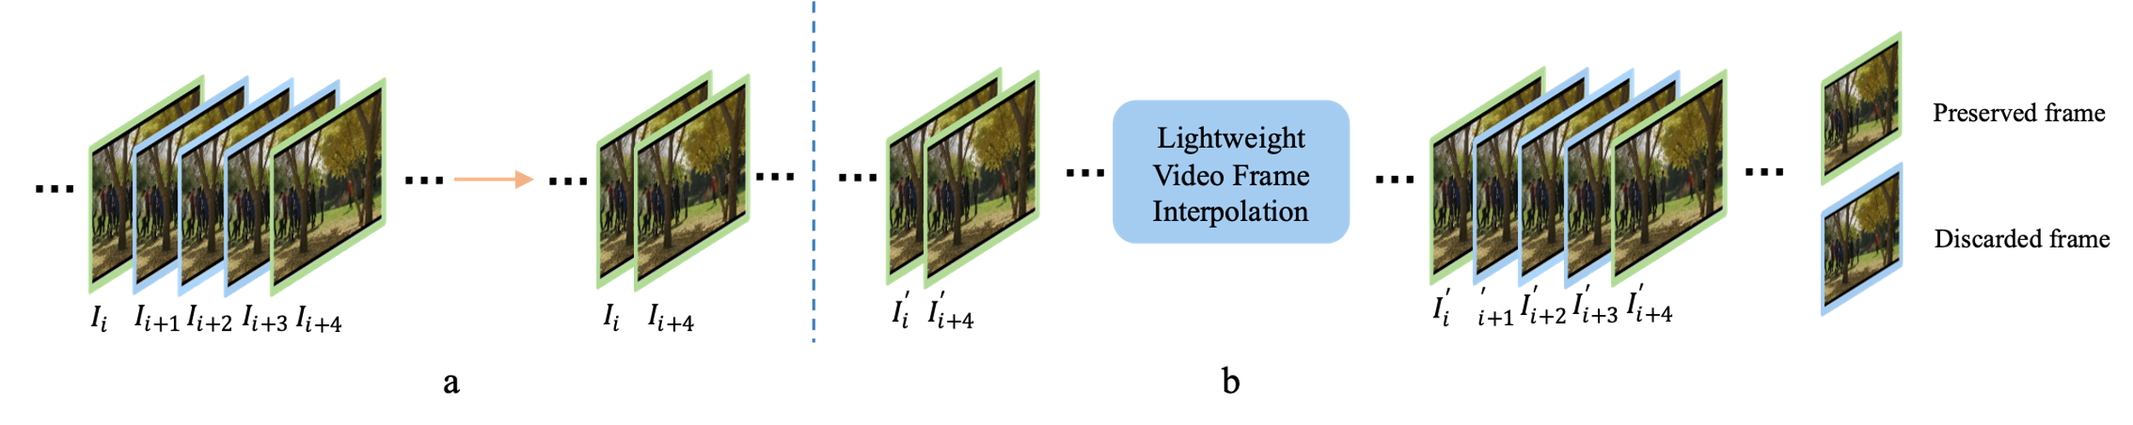
Fig. 1 Typical temporal resampling-based compression framework.
Within the context of JVET AHG8, downsampling and upsampling are studied as non-normative operations, i.e. downsampling is performed as pre-processing and upsampling as post-processing. This means the upsampling network needs to be sent to the decoder, and for this contribution, we propose that the NNPF SEI can achieve this goal. In NNPF SEI, setting syntax element nnpfc_purpose as 0x08 and setting syntax element nnpfc_mode_idc as 0 can be used to indicate the picture rate upsampling purpose and then the upsampling neural network can be sent using Neural Network Coding / ISO/IEC 15938-17 or MPEG-7 part 17 (NNC).The value of other syntax elements can be set as in Table 1.
Table 1 An example setting of the syntax element values of NNPF for proposed temporal resampling.
Syntax | Value | Syntax | Value
nnpfc_purpose | 0x08 | nnpfc_out_order_idc | 2
nnpfc_mode_idc | 0 | nnpfc_out_tensor_luma_bitdepth_minus8 | 2
nnpfc_num_input_pics_minus1 | 1 | nnpfc_out_tensor_chroma_bitdepth_minus8 | 2
nnpfc_interpolated_pics[ i ] | $f-$1 | nnpfc_chroma_loc_info_present_flag | 0
nnpfc_component_last_flag | 0 | nnpfc_overlap | 0
nnpfc_inp_format_idc | 1 | nnpfc_constant_patch_size_flag | 1
nnpfc_auxiliary_inp_idc | 0 | nnpfc_patch_width_minus1 | CroppedWidth − 1
nnpfc_inp_order_idc | 2 | nnpfc_patch_height_minus1 | CroppedHeight − 1
nnpfc_inp_tensor_luma_bitdepth_minus8 | 2 | nnpfc_padding_type | 0
nnpfc_inp_tensor_chroma_bitdepth_minus8 | 2 | nnpfc_complexity_info_present_flag | 0
nnpfc_out_format_idc | 1 | nnpfc_metadata_extension_num_bits | 0

Sending the temporal upsampling model results in extra bandwidth expense. To reduce the transmission expense of the temporal upsampling model, AMT-S, an open-source lightweight temporal upsampling model in [3], is used in this contribution as the temporal upsampling model.

Exampler software implementation
The exampler temporal resampling software implementation is attached to this contribution.
The source code directory of the temporal resampling software for OFM is structured as follows:
- README.txt: contains introduction for the temporal resampling part of OFM
- Temporal_resampling: contains source code for the temporal resampling framework of OFM
  - Scripts: contains scripts to encode and decode SFU and TVD video datasets
  - Temporal_resampling: contains the implementation of the temporal resampling algorithm
  - encoder_main.py: source code to encode the input video with temporal downsampling and video encoder
  - decoder_main.py: source code to decode the bitstream with video decoder and temporal upsampling, for the reconstructed output video
For the installation and usage of the exampler software implementation, please refer to the README.txt for detailed information.

Performance
We first evaluate the performance of the proposed temporal resampling network following the common test conditions specified in JVET-AE2031 [2] , when the VTM version is 20.0 and temporal resampling ratio is 4. As shown in Table 2, on SFU-HW dataset, the proposed implementation could achieve obvious performance improvement in terms of both Pareto-BD-rate and BD-mAP. Specifically, performance improvements could be observed for both monotonic and non-monotonic rate-mAP curves, as shown in Fig. 2.a and Fig. 2.b, respectively. On TVD dataset for the object tracking task, the performance of the proposed algorithm is shown in Table 3. Similarly, obvious performance improvements could also be observed for both monotonic and non-monotonic rate-MOTA curves, as shown in Fig. 3.a and Fig. 3.b, respectively.

Table 2 Performance of temporal resampling algorithm on SFU-HW test dataset under RA, LD and AI configurations. “#NUM!” indicates the performance cannot be calculated due to the nonmonotonic phenomenon, the same as below.
RA | Object Detection | End-to-End BD-Rate [%] |  |  | End-to-End BD-mAP
RA | Object Detection | mAP | mAP (low4) | Pareto mAP
SFU-HW | Class A | -33.16% | -27.88% | -33.16% | 2.79
SFU-HW | Class B | #NUM! | #NUM! | -13.63% | 4.05
SFU-HW | Class C | -31.05% | -37.38% | -31.05% | 2.75
SFU-HW | Class D | -18.90% | -20.10% | -18.90% | 3.08
SFU-HW | Average | #NUM! | #NUM! | -22.12% | 3.08

LD | Object Detection | End-to-End BD-Rate [%] |  |  | End-to-End BD-mAP
LD | Object Detection | mAP | mAP (low4) | Pareto mAP
SFU-HW | Class A | #NUM! | -16.49% | -24.74% | -0.41
SFU-HW | Class B | -36.54% | -38.35% | -18.57% | 9.94
SFU-HW | Class C | #NUM! | #NUM! | -36.54% | 5.69
SFU-HW | Class D | #NUM! | #NUM! | -36.32% | 5.21
SFU-HW | Average | #NUM! | #NUM! | -30.03% | 6.38

AI | Object Detection | End-to-End BD-Rate [%] |  |  | End-to-End BD-mAP
AI | Object Detection | mAP | mAP (low4) | Pareto mAP
SFU-HW | Class A | -73.38% | -73.63% | -73.38% | 21.94
SFU-HW | Class B | -77.47% | -77.83% | -77.47% | 29.24
SFU-HW | Class C | -76.36% | -78.77% | -76.36% | 17.59
SFU-HW | Class D | -73.79% | -75.16% | -73.79% | 18.77
SFU-HW | Average | -75.68% | -76.98% | -75.68% | 21.87
Table 3 Performance of temporal resampling algorithm on TVD test dataset under RA, LD and AI configurations.
RA | Object Tracking | End-to-End BD-Rate [%] |  |  | End-to-End BD-MOTA
RA | Object Tracking | MOTA | MOTA (low4) | Pareto MOTA
TVD | TVD-01-1 | -48.92% | -56.27% | -48.92% | 6.43
TVD | TVD-01-2 | #NUM! | #NUM! | -48.95% | 4.25
TVD | TVD-01-3 | #NUM! | -60.47% | -44.28% | 3.78
TVD | TVD-02-1 | -53.96% | -59.79% | -53.96% | 5.33
TVD | TVD-03-1 | -34.74% | -30.58% | -34.74% | 5.77
TVD | TVD-03-2 | ########## | -38.35% | -39.44% | 3.28
TVD | TVD-03-3 | -47.40% | -45.04% | -47.40% | 4.50
TVD | Average | #NUM! | #NUM! | -45.39% | 4.76

LD | Object Tracking | End-to-End BD-Rate [%] |  |  | End-to-End BD-MOTA
LD | Object Tracking | MOTA | MOTA (low4) | Pareto MOTA
TVD | TVD-01-1 | -22.69% | -30.63% | -22.69% | 1.98
TVD | TVD-01-2 | #NUM! | -37.66% | -38.36% | 3.11
TVD | TVD-01-3 | -44.47% | -40.46% | -44.47% | 4.69
TVD | TVD-02-1 | #NUM! | -46.56% | -46.03% | 1.26
TVD | TVD-03-1 | -31.88% | -30.18% | -31.88% | 5.66
TVD | TVD-03-2 | #NUM! | #NUM! | -22.41% | 2.20
TVD | TVD-03-3 | #NUM! | -43.40% | -42.68% | 3.74
TVD | Average | #NUM! | #NUM! | -35.50% | 3.23

AI | Object Tracking | End-to-End BD-Rate [%] |  |  | End-to-End BD-MOTA
AI | Object Tracking | MOTA | MOTA (low4) | Pareto MOTA
TVD | TVD-01-1 | -74.17% | -74.30% | -74.17% | 18.21
TVD | TVD-01-2 | -69.28% | -70.39% | -69.28% | 13.61
TVD | TVD-01-3 | -70.57% | -73.47% | -70.57% | 11.25
TVD | TVD-02-1 | -75.99% | -71.18% | -75.99% | 8.48
TVD | TVD-03-1 | -77.18% | -78.53% | -77.18% | 17.71
TVD | TVD-03-2 | -73.70% | -74.72% | -73.70% | 12.69
TVD | TVD-03-3 | -75.13% | -74.39% | -75.13% | 15.49
TVD | Average | -73.72% | -73.85% | -73.72% | 13.92
It is worth mentioning that the transmission expense of the temporal upsampling model is not included in the performance evaluation. The lightweight temporal upsampling model is 12,038,295 bytes before compression and 2,503,279 bytes after NNC standard is used to compress it losslessly. This is a fixed, one-time overhead for the entire duration of the coded video sequence.
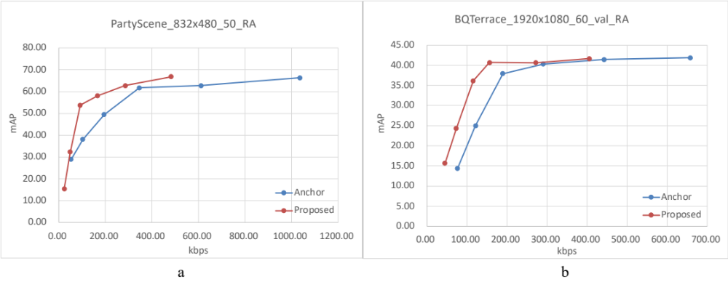
Fig. 2 The rate-mAP curves for object detection on SFU-HW dataset sequences under RA configuration. PartyScene sequence with monotonic rate-mAP curve (a) and BQTerrace sequence with non-monotonic rate-mAP curve (b).

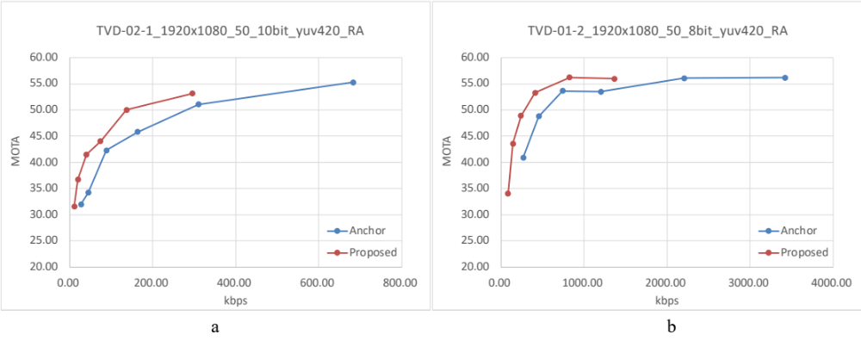
Fig. 3 The rate-MOTA curves for object tracking on TVD dataset sequences under RA configuration. TVD-02-1 sequence with monotonic rate-mAP curve (a) and TVD-01-2 sequence with non-monotonic rate-mAP curve (b).

When the VTM version is 12.0, the performance is further evaluated with temporal resampling ratio 2 and 4. When temporal resampling ratio is 2, the performance on SFU-HW dataset for object detection under RA, LD and AI configurations is shown in Table 4. The performance on TVD dataset for object tracking inder RA, LD and AI configurations is also shown in Table 5.

Table 4 Performance of temporal resampling algorithm on SFU-HW test dataset under RA, LD and AI configurations, with VTM version 12.0 and temporal resampling ratio is 2.
RA | Object Detection | End-to-End BD-Rate [%] |  |  | End-to-End BD-mAP
RA | Object Detection | mAP | mAP (low4) | Pareto mAP
SFU-HW | Class A | #NUM! | #NUM! | -48.98% | 3.50
SFU-HW | Class B | -13.23% | -14.96% | -13.23% | 2.36
SFU-HW | Class C | -20.04% | -20.28% | -20.04% | 2.44
SFU-HW | Class D | #NUM! | #NUM! | -18.82% | 1.56
SFU-HW | Average | #NUM! | #NUM! | -19.80% | 2.23

LD | Object Detection | End-to-End BD-Rate [%] |  |  | End-to-End BD-mAP
LD | Object Detection | mAP | mAP (low4) | Pareto mAP
SFU-HW | Class A | -11.46% | -13.74% | -11.46% | 1.88
SFU-HW | Class B | #NUM! | #NUM! | -16.05% | 3.89
SFU-HW | Class C | -24.02% | -25.32% | -24.02% | 2.68
SFU-HW | Class D | -23.75% | -27.45% | -23.75% | 2.73
SFU-HW | Average | #NUM! | #NUM! | -20.52% | 3.01

AI | Object Detection | End-to-End BD-Rate [%] |  |  | End-to-End BD-mAP
AI | Object Detection | mAP | mAP (low4) | Pareto mAP
SFU-HW | Class A | -55.21% | -55.89% | -55.21% | 9.98
SFU-HW | Class B | -54.38% | -55.28% | -54.38% | 14.60
SFU-HW | Class C | -53.71% | -55.52% | -53.71% | 9.52
SFU-HW | Class D | -49.68% | -52.47% | -49.68% | 9.93
SFU-HW | Average | -52.79% | -54.54% | -52.79% | 11.25

Table 5 Performance of temporal resampling algorithm on TVD test dataset under RA and LD configurations, with VTM version 12.0 and temporal resampling ratio is 2.
RA | Object Tracking | End-to-End BD-Rate [%] |  |  | End-to-End BD-MOTA
RA | Object Tracking | MOTA | MOTA (low4) | Pareto MOTA
TVD | TVD-01-1 | -31.41% | -36.75% | -31.41% | 2.71
TVD | TVD-01-2 | #NUM! | #NUM! | -26.56% | 1.78
TVD | TVD-01-3 | #NUM!# | -34.40% | -35.73% | 3.32
TVD | TVD-02-1 | -29.17% | -14.26% | -29.17% | 2.18
TVD | TVD-03-1 | -21.44% | -18.10% | -21.44% | 2.78
TVD | TVD-03-2 | -33.42% | -40.07% | -33.42% | 2.40
TVD | TVD-03-3 | -34.52% | -37.33% | -34.52% | 3.22
TVD | Average | #NUM! | #NUM! | -30.32% | 2.63

LD | Object Tracking | End-to-End BD-Rate [%] |  |  | End-to-End BD-MOTA
LD | Object Tracking | MOTA | MOTA (low4) | Pareto MOTA
TVD | TVD-01-1 | #NUM! | -22.12% | -27.60% | 2.37
TVD | TVD-01-2 | #NUM! | -29.83% | -28.88% | 2.45
TVD | TVD-01-3 | #NUM! | -27.82% | -15.79% | 1.16
TVD | TVD-02-1 | #NUM! | #NUM! | -39.80% | 4.60
TVD | TVD-03-1 | -24.16% | -25.05% | -24.16% | 4.10
TVD | TVD-03-2 | -7.60% | -10.18% | -7.60% | 0.34
TVD | TVD-03-3 | -20.05% | -20.11% | -20.05% | 1.70
TVD | Average | #NUM! | #NUM! | -23.41% | 2.39

Similarly, when temporal resampling ratio is 4, the performance on SFU-HW dataset for object detection under RA, LD and AI configurations is shown in Table 6. The performance on TVD dataset for object tracking inder RA, LD and AI configurations is also shown in Table 7.

Table 6 Performance of temporal resampling algorithm on SFU-HW test dataset under RA, LD and AI configurations, with VTM version 12.0 and temporal resampling ratio is 4.
RA | Object Detection | End-to-End BD-Rate [%] |  |  | End-to-End BD-mAP
RA | Object Detection | mAP | mAP (low4) | Pareto mAP
SFU-HW | Class A | -37.49% | -28.83% | -37.49% | 3.38
SFU-HW | Class B | #NUM! | #NUM! | -15.57% | 2.92
SFU-HW | Class C | -21.61% | -24.67% | -21.61% | 3.13
SFU-HW | Class D | #NUM! | #NUM! | -22.81% | 2.51
SFU-HW | Average | #NUM! | #NUM! | -21.34% | 2.89
LD | Object Detection | End-to-End BD-Rate [%] |  |  | End-to-End BD-mAP
LD | Object Detection | mAP | mAP (low4) | Pareto mAP
SFU-HW | Class A | -8.96% | -10.52% | -8.96% | 1.25
SFU-HW | Class B | #NUM! | -19.03% | -21.18% | 9.57
SFU-HW | Class C | -34.42% | -36.25% | -34.42% | 5.23
SFU-HW | Class D | -38.60% | -37.24% | -38.60% | 5.48
SFU-HW | Average | #NUM! | -29.27% | -29.67% | 6.34
AI | Object Detection | End-to-End BD-Rate [%] |  |  | End-to-End BD-mAP
AI | Object Detection | mAP | mAP (low4) | Pareto mAP
SFU-HW | Class A | -79.63% | -79.94% | -79.63% | 18.42
SFU-HW | Class B | -76.12% | -76.74% | -76.12% | 26.82
SFU-HW | Class C | -74.76% | -77.08% | -74.76% | 17.00
SFU-HW | Class D | -73.12% | -74.86% | -73.12% | 18.12
SFU-HW | Average | -75.05% | -76.51% | -75.05% | 20.48

Table 7 Performance of temporal resampling algorithm on TVD test dataset under RA, LD and AI configurations, with VTM version 12.0 and temporal resampling ratio is 4.
RA | Object Tracking | End-to-End BD-Rate [%] |  |  | End-to-End BD-MOTA
RA | Object Tracking | MOTA | MOTA (low4) | Pareto MOTA
TVD | TVD-01-1 | -47.23% | -50.09% | -47.23% | 5.92
TVD | TVD-01-2 | -46.70% | -45.17% | -46.70% | 3.88
TVD | TVD-01-3 | #NUM! | -55.88% | -47.77% | 4.57
TVD | TVD-02-1 | -39.26% | -31.40% | -39.26% | 3.62
TVD | TVD-03-1 | -30.77% | -26.88% | -30.77% | 3.89
TVD | TVD-03-2 | -50.02% | -56.84% | -50.02% | 4.35
TVD | TVD-03-3 | -47.64% | -49.45% | -47.64% | 4.99
TVD | Average | #NUM! | -45.10% | -44.20% | 4.46
LD | Object Tracking | End-to-End BD-Rate [%] |  |  | End-to-End BD-MOTA
LD | Object Tracking | MOTA | MOTA (low4) | Pareto MOTA
TVD | TVD-01-1 | -29.77% | -27.17% | -29.77% | 3.72
TVD | TVD-01-2 | #NUM! | -30.74% | -32.39% | 3.30
TVD | TVD-01-3 | #NUM! | -39.19% | -27.79% | 1.78
TVD | TVD-02-1 | #NUM! | #NUM! | -54.23% | 3.95
TVD | TVD-03-1 | -33.21% | -28.48% | -33.21% | 6.71
TVD | TVD-03-2 | -23.32% | -22.54% | -23.32% | 1.99
TVD | TVD-03-3 | -39.95% | -40.76% | -39.95% | 3.61
TVD | Average | #NUM! | #NUM! | -34.38% | 3.58
AI | Object Tracking | End-to-End BD-Rate [%] |  |  | End-to-End BD-MOTA
AI | Object Tracking | MOTA | MOTA (low4) | Pareto MOTA
TVD | TVD-01-1 | -74.29% | -74.56% | -74.29% | 17.86
TVD | TVD-01-2 | -72.81% | -72.75% | -72.81% | 14.10
TVD | TVD-01-3 | -77.57% | -80.21% | -77.57% | 12.18
TVD | TVD-02-1 | #NUM! | -76.61% | -77.94% | 9.06
TVD | TVD-03-1 | -78.57% | -80.24% | -78.57% | 17.42
TVD | TVD-03-2 | #NUM! | #NUM! | -79.35% | 12.71
TVD | TVD-03-3 | -80.91% | -81.90% | -80.91% | 16.86
TVD | Average | #NUM! | #NUM! | -77.35% | 14.31

Conclusion
An exemplar software implementation for temporal resampling for VCM is presented in this contribution. The proposed software is based on an open source lightweight temporal resampling model, and the model is sent using the NNPF SEI message. Simulation shows that temporal resampling is effective and performs superior to VVC under various coding configurations. Specifically, when VTM version is 20.0 and temporal resampling ratio is 4, the proposed implementation can achieve 22.12%, 30.03% and 75.68% average Pareto BD-rate improvements for random access (RA), low delay (LD) and all intra (AI) configurations for SFU-HW dataset. On TVD dataset, 45.39%, 35.50% and 73.72% Pareto BD-rate improvements could be achieved for RA, LD and AI configurations. Obvious performance improvement could be achieved with different VTM versions and temporal resampling ratios. It is suggested to include information about the temporal resampling algorithm and the software implementation into the next version of the technical report for optimization of encoders and receiving systems for machine analysis of coded video content (JVET-AF2030).

References
- J. Chen, C. Hollmann, S. Liu, “Optimization of encoders and receiving systems for machine analysis of coded video content (draft 3),” Joint Video Experts Team (JVET) of ITU-T SG 16 WP 3 and ISO/IEC JTC 1/SC 29 output document JVET-AE2030, 31st JVET meeting, Geneva, July 2023 (available online at https://jvet-experts.org/).
- S. Liu, C. Hollmann, “Common test conditions for optimization of encoders and receiving systems for machine analysis of coded video content,” Joint Video Experts Team (JVET) of ITU-T SG 16 WP 3 and ISO/IEC JTC 1/SC 29 output document JVET-AE2031, 31st JVET meeting, Geneva, July 2023 (available online at https://jvet-experts.org/).
- Li, Z., Zhu, Z. L., Han, L. H., Hou, Q., Guo, C. L., and Cheng, M. M., “AMT: All-Pairs Multi-Field Transforms for Efficient Frame Interpolation,” In Proceedings of the IEEE/CVF Conference on Computer Vision and Pattern Recognition (CVPR), 2023.

Patent rights declaration(s)
Alibaba group and City University of Hong Kong may have current or pending patent rights relating to the technology described in this contribution and, conditioned on reciprocity, is prepared to grant licenses under reasonable and non-discriminatory terms as necessary for implementation of the resulting ITU-T Recommendation | ISO/IEC International Standard (per box 2 of the ITU-T/ITU-R/ISO/IEC patent statement and licensing declaration form).

___________________

