    Joint Video Experts Team (JVET)  of ITU-T SG 16 WP 3 and ISO/IEC JTC 1/SC 29  32nd Meeting, Hannover, DE, 13–20 October 2023 | Document: JVET-AF0041-v3

Title: | AhG11: HOP full results
Status: | Input document to JVET
Purpose: | Proposal
Author(s) or  Contact(s): | F. Galpin,  D. Rusanovskyy  Y. Li,  L. Wang,  Z. Xie  Y.Li  R. Chang  J. Li  E. Alshina | Author(s) or  Contact(s): | franck.galpin@interdigital.com  dmytror@qti.qualomm.com  yli30@qti.qualcomm.com  liqiangwang@tencent.com  xiezhihuang@oppo.com  yue.li@bytedance.com  renjiechang@tencent.com  lijunru@bytedance.com  elena.alshina@huawei.com
Source: | InterDigital, Qualcomm, ByteDance, Tencent, Oppo, Huawei
_____________________________

Abstract
A Unified Filter Architecture for the High-performance Operation Point (HOP) was defined at JVET-AD0380 and includes filter architecture, training process and training test set. Training strategy and intermediate results were presented in JVET-AE0191. This contribution gives the full results of HOP training for each stage.

Introduction
At meeting AD, the HOP model design and training procedure was decided in JVET-AD0380. The training procedure is decomposed into 3 stages. The first 2 stages were successfully analyzed and validated in JVET-AE0191. The last stage strategy was refined in JVET-AE0289 and JVET-AE0291. This document presents the full official results for the whole training procedure.
Note:
- In results, since there were only changes of few bits in the SPS for NNVC in VTM mode, it is considered that NNVC in VTM mode gives the same results for v4.0 to v6.0.
- In results, since NN intra and LOP.1 did not change, it is considered that NNVC 5.1 and NNVC 6.0 anchors are the same.

Stage I

Validation loss stage I
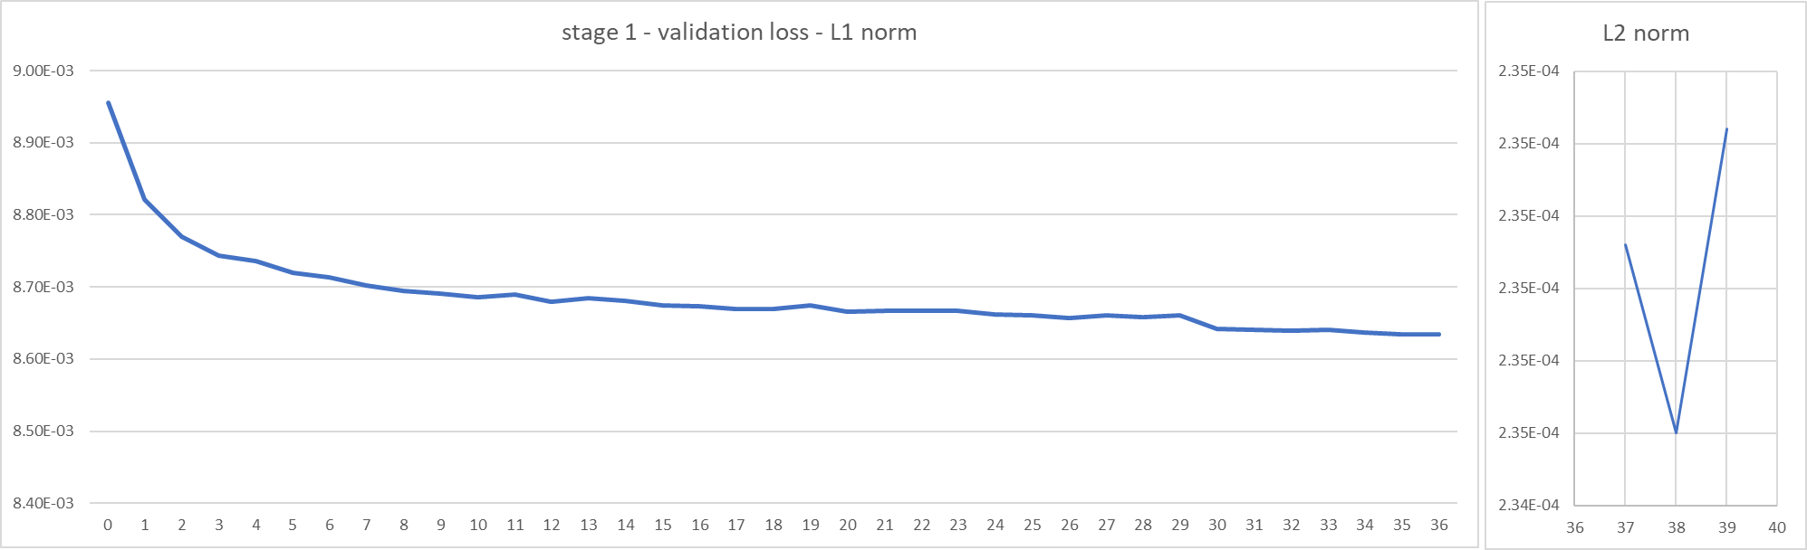
Validation loss for stage I is shown in the graph above.

Results of stage I
A model was selected among several proponents as the official model of stage I. The official model can be found in the NNVC repository (see JVET-AE0289). Results of the official model can be found below.

Table 1 Inference test results for Stage I model, epoch 39, float vs VTM anchor; RA with NnlfHopDebugOption=1 (Source: Qualcomm)

 | st1.ep39.float vs VTM anchor
 | All Intra |  |  | Random Access
 | Y-PSNR | U-PSNR | V-PSNR | Y-PSNR | U-PSNR | V-PSNR
Class A1 | -6.77% | -16.63% | -20.62% | -1.46% | -5.94% | -6.21%
Class A2 | -7.21% | -20.46% | -19.53% | -3.24% | -11.10% | -9.46%
Class B | -7.02% | -18.96% | -18.54% | -2.54% | -11.79% | -9.96%
Class C | -8.25% | -18.69% | -21.13% | -2.54% | -11.50% | -10.79%
Class E | -10.58% | -21.18% | -22.14%
Overall | -7.88% | -19.13% | -20.23% | -2.46% | -10.41% | -9.33%
Class D | -8.09% | -18.18% | -21.44% | -2.59% | -12.19% | -12.18%

Stage II

Validation loss
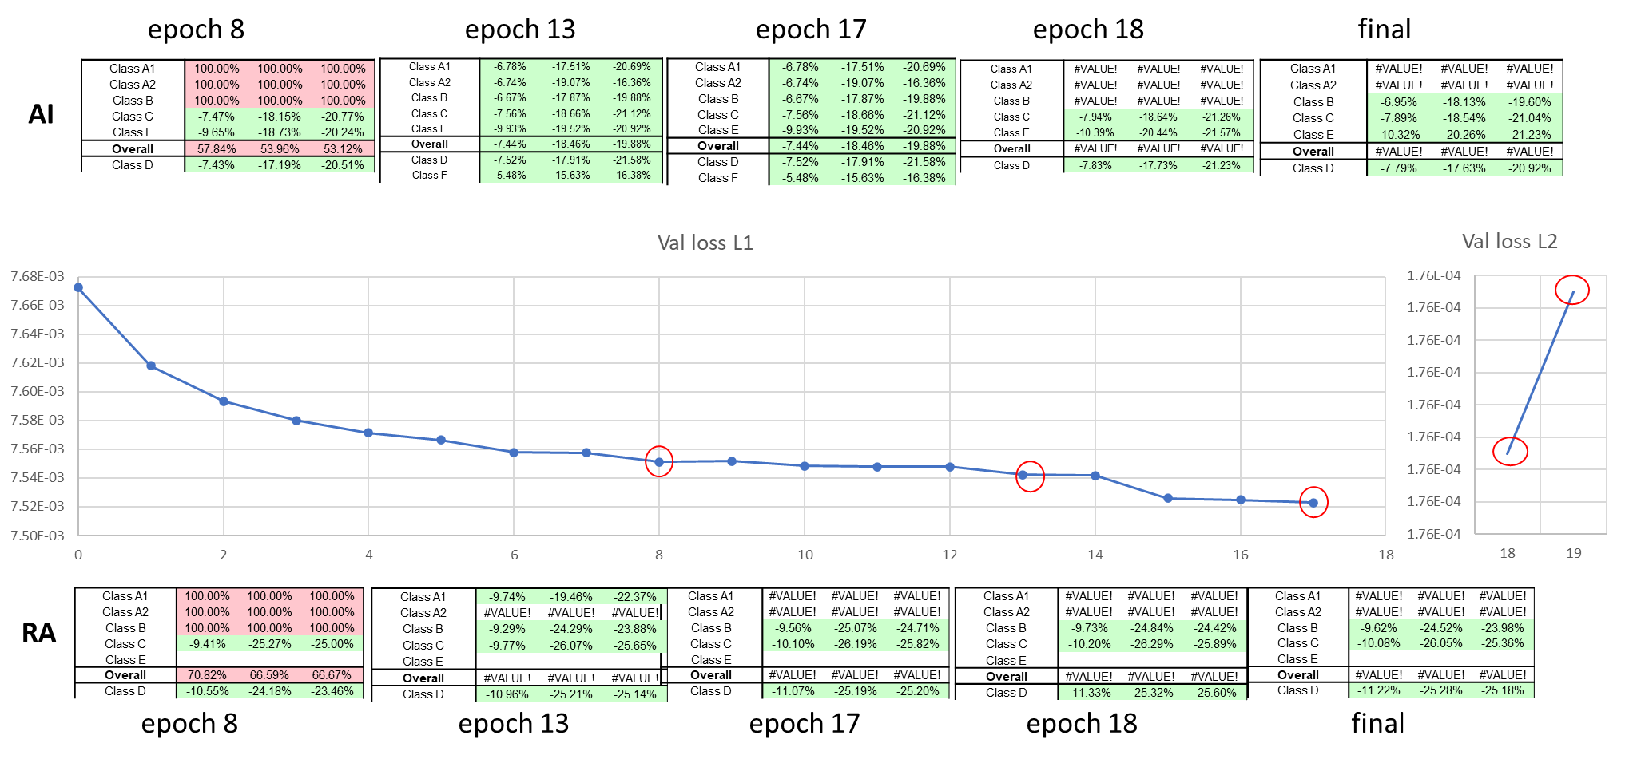
Figure 1 Intermediate results during stage 2 training
The figure above shows the evolution of validation loss as well as CTC results using the model of stage II at several epochs.

Results of stage II
A model was selected among several proponents as the official model of stage II. The model was further integerized and used to produce the official stage III dataset. The official model can be found in the NNVC repository (see JVET-AE0289).

Table 2 NNVC 4.0 vs NNVC 5.1 VTM + HOP (source InterDigital)
 | NNVC 4.0 vs NNVC-5.1 VTM+HOP
 | All Intra |  |  | Random Access
 | Y-PSNR | U-PSNR | V-PSNR | Y-PSNR | U-PSNR | V-PSNR
Class A1 | -7.05% | -17.89% | -20.06% | -9.65% | -18.14% | -22.49%
Class A2 | -6.97% | -19.25% | -16.77% | -10.08% | -22.08% | -17.55%
Class B | -7.00% | -18.24% | -19.89% | -8.92% | -23.34% | -22.97%
Class C | -7.95% | -18.65% | -21.27% | -9.65% | -24.98% | -24.39%
Class E | -10.39% | -20.44% | -21.57%
Overall | -7.78% | -18.81% | -19.98% | -9.49% | -22.48% | -22.17%
Class D | -7.83% | -17.73% | -21.23% | -10.89% | -24.02% | -24.54%
Class F | -5.53% | -16.45% | -16.17% | -5.30% | -16.51% | -14.82%

Integerized model
Using a naïve quantization (all quantizers equal to 1<<11), the following results are obtained compared to float model.

Table 3 NNVC 4.0 vs NNVC 5.1 VTM + HOP (source InterDigital)
 | Int16 vs float, st2.ep18
 | All Intra |  |  | Random Access
 | Y-PSNR | U-PSNR | V-PSNR | Y-PSNR | U-PSNR | V-PSNR
Class A1 | -0.03% | 0.07% | -0.04% | 0.07% | 0.71% | 0.21%
Class A2 | 0.11% | 0.16% | -0.29% | 0.06% | 0.50% | -0.20%
Class B | 0.02% | -1.15% | -0.36% | 0.10% | 0.53% | 0.30%
Class C | 0.00% | -0.23% | -0.35% | 0.13% | 0.76% | 0.59%
Class E | 0.02% | -0.04% | -0.11%
Overall | 0.02% | -0.34% | -0.25% | 0.09% | 0.62% | 0.26%
Class D | 0.00% | -0.05% | -0.18% | -0.02% | -0.21% | -0.16%

Stage III
Training was conducted independently by multiple companies following the guidelines provided in JVET- JVET-AE0191 and JVET-AE0289 and utilizing training software of NNVC-5.1. Training data set for Stage III has been produced with quantized Stage II model as adopted from JVET-AE0291. Training scheduler was changed comparing to the scheduler of Stage II: instead of having 2 learning rate decay at epoch 15 and 17, an additional decay was added at epoch 18 (see JVET-AE0191).

Validation loss
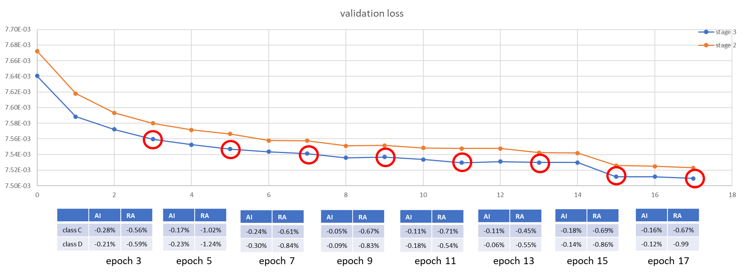
The following graph shows the evolution of the validation loss as well as the performance difference with the stage II model at the same epoch.

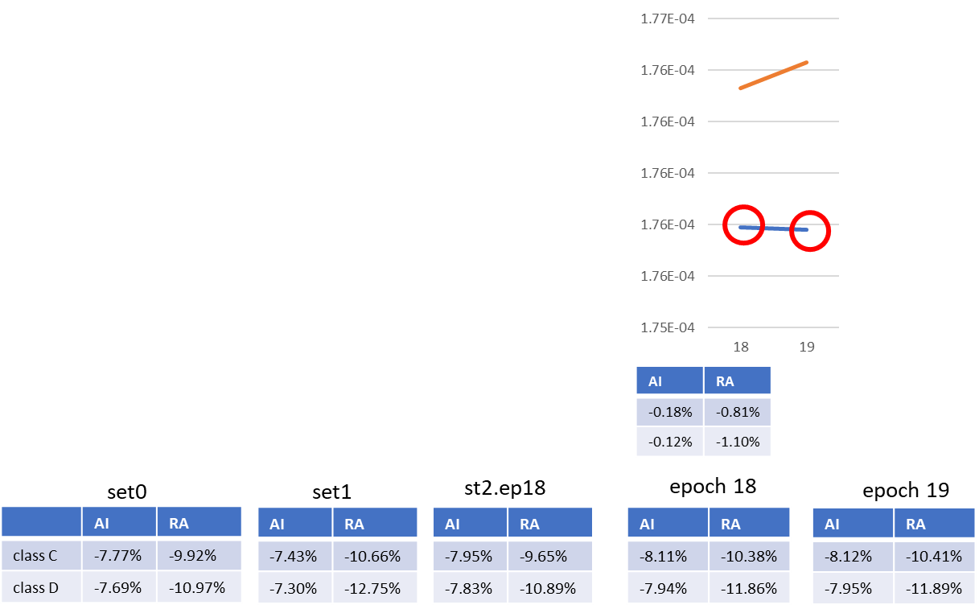

Inference results of stage III
Inference testing was conducted independently by multiple companies (Interdigital, Qualcomm, Tencent, OPPO) utilizing their own trained models and different version of NNVC (targeting different purpose).

Inference test from Qualcomm
Inference testing in Qualcomm was conducted with NNVC5.1, to make Stage III results comparable with inference HOP results submitted to JVET-AE meeting.
Table 3 provides inference comparative results of HOP3 Stage III float vs. VTM results of NNVC5.1. Comparing to Stage II results, 3rd stage of the training provided ~0.7% luma bd-rate reduction in RA on average.

Table 4 NNVC 5.1 HOP St3 float vs. NNVC5.1 VTM (source Qualcomm)
 | HOP_St3_ep19_float vs vtm
 | All Intra |  |  | Random Access
 | Y-PSNR | U-PSNR | V-PSNR | Y-PSNR | U-PSNR | V-PSNR
Class A1 | -7.15% | -17.88% | -21.43% | -10.62% | -21.27% | -26.95%
Class A2 | -7.09% | -19.27% | -17.10% | -10.83% | -23.48% | -18.77%
Class B | -7.09% | -18.05% | -19.85% | -9.65% | -25.91% | -25.46%
Class C | -8.11% | -18.42% | -21.04% | -10.46% | -26.77% | -26.60%
Class E | -10.56% | -20.36% | -21.71%
Overall | -7.91% | -18.69% | -20.23% | -10.30% | -24.73% | -24.72%
Class D | -7.95% | -18.14% | -21.60% | -11.89% | -26.78% | -28.03%

Integer implementation of HOP Stage III model was achieved with NNVC5.1 and uniform quantization of the model with q=11 (weightQ= weight <<11) and int16 arithmetic of NNVC.

Table 5 NNVC 5.1 HOP St3 int16 vs. NNVC5.1 VTM (source Qualcomm)
 | HOP_St3_ep19_int vs vtm
 | All Intra |  |  | Random Access
 | Y-PSNR | U-PSNR | V-PSNR | Y-PSNR | U-PSNR | V-PSNR
Class A1 | -7.01% | -17.96% | -21.87% | -10.38% | -21.21% | -26.79%
Class A2 | -6.98% | -19.21% | -17.29% | -10.71% | -23.36% | -19.15%
Class B | -7.07% | -19.06% | -20.13% | -9.54% | -25.71% | -25.39%
Class C | -8.11% | -18.59% | -21.38% | -10.21% | -26.21% | -26.22%
Class E | -10.51% | -20.43% | -21.76%
Overall | -7.85% | -19.03% | -20.50% | -10.12% | -24.47% | -24.64%
Class D | -7.94% | -17.86% | -21.48% | -11.92% | -26.66% | -27.97%

Impact of quantization of the HOP St3 model trained in Qualcomm and int16 implementation in NNVC5.1 is demonstrated in Table 5. Presented inference results show that utilized quantization has negligible impact on the AI results, however introduced a bd-rate penalty around 0.1% for luma in RA configurations.

Table 6 Impact of the int16 HOP implementation (q=11) vs float, NNVC 5.1 (source Qualcomm)
 | BD-rate: hop3.1_19_int vs hop3.1_19_float
 | All Intra |  |  | Random Access
 | Y-PSNR | U-PSNR | V-PSNR | Y-PSNR | U-PSNR | V-PSNR
Class A1 | 0.15% | -0.05% | -0.47% | 0.28% | 0.18% | 0.27%
Class A2 | 0.12% | 0.08% | -0.24% | 0.14% | 0.23% | -0.47%
Class B | 0.03% | -1.17% | -0.36% | 0.12% | 0.30% | 0.13%
Class C | 0.01% | -0.20% | -0.41% | 0.08% | 0.41% | 0.12%
Class E | 0.06% | -0.08% | -0.02%
Overall | 0.07% | -0.38% | -0.31% | 0.14% | 0.29% | 0.04%
Class D | 0.01% | 0.29% | 0.16% | -0.03% | 0.21% | 0.08%

Inference test in Interdigital:
The following results were obtained using NNVC-6.0 (commit bf862678) in VTM mode, with HOP Stage III model trained by Interdigital. This version corresponds to the new anchor of NNVC for HOP tests.

Table 7 NNVC 4.0 vs NNVC 6.0rc VTM + HOP float (source InterDigital)
 | NNVC 4.0 vs NNVC-6.0rc VTM+HOP float
 | All Intra |  |  | Random Access
 | Y-PSNR | U-PSNR | V-PSNR | Y-PSNR | U-PSNR | V-PSNR
Class A1 | -7.18% | -18.19% | -21.99% | -10.64% | -21.11% | -25.77%
Class A2 | -7.13% | -19.97% | -18.55% | -10.82% | -23.70% | -22.55%
Class B | -7.02% | -18.74% | -19.64% | -9.67% | -26.01% | -24.26%
Class C | -8.12% | -18.58% | -21.17% | -10.50% | -27.46% | -27.27%
Class E | -10.55% | -20.81% | -21.89%
Overall | -7.90% | -19.16% | -20.57% | -10.31% | -24.96% | -25.02%
Class D | -7.95% | -17.88% | -21.47% | -11.92% | -26.82% | -27.43%
Class F | -5.28% | -15.73% | -15.93% | -5.83% | -18.50% | -17.02%

Using a naïve quantization (all quantizers equal to 1<<11), the following results are obtained.

Table 8 NNVC 4.0 vs NNVC 6.0rc VTM + HOP int16 (source InterDigital)
 | NNVC 4.0 vs NNVC-6.0rc VTM+HOP int16
 | All Intra |  |  | Random Access
 | Y-PSNR | U-PSNR | V-PSNR | Y-PSNR | U-PSNR | V-PSNR
Class A1 | -7.20% | -18.27% | -22.13% | -10.52% | -20.62% | -25.85%
Class A2 | -7.09% | -20.09% | -18.85% | -10.79% | -23.75% | -22.69%
Class B | -6.98% | -19.22% | -19.78% | -9.65% | -25.88% | -24.33%
Class C | -8.08% | -18.41% | -21.09% | -10.49% | -27.44% | -27.39%
Class E | -10.45% | -20.65% | -21.76%
Overall | -7.86% | -19.27% | -20.64% | -10.27% | -24.82% | -25.12%
Class D | -7.92% | -17.77% | -21.44% | -11.88% | -26.75% | -27.45%
Class F | -5.27% | -15.78% | -15.91% | -5.81% | -18.45% | -17.28%

Table 9 NNVC 6.0rc VTM+HOP float vs int16 (source InterDigital)
 | NNVC-6.0rc VTM+HOP float vs int16
 | All Intra |  |  | Random Access
 | Y-PSNR | U-PSNR | V-PSNR | Y-PSNR | U-PSNR | V-PSNR
Class A1 | -0.01% | -0.09% | -0.17% | 0.14% | 0.78% | -0.11%
Class A2 | 0.04% | -0.23% | -0.40% | 0.03% | -0.04% | -1.39%
Class B | 0.05% | -0.56% | -0.16% | 0.02% | 0.19% | -0.09%
Class C | 0.04% | 0.23% | 0.14% | 0.01% | 0.05% | -0.13%
Class E | 0.11% | 0.21% | 0.20%
Overall | 0.05% | -0.12% | -0.07% | 0.04% | 0.22% | -0.36%
Class D | 0.03% | 0.14% | 0.07% | 0.05% | 0.10% | -0.03%
Class F | 0.01% | -0.04% | -0.03% | 0.02% | 0.07% | -0.32%

Impact of integerization is negligible also for this model.

Inference test from Tencent
The floating and integer results were obtained using NNVC-6.0 (commit 25f4ae94) with HOP Stage III model trained by Tencent.

Table 10 NNVC 4.0 vs NNVC 6.0rc VTM + HOP float (source Tencent)
 | NNVC 4.0 vs NNVC-6.0rc VTM+HOP float
 | All Intra |  |  | Random Access
 | Y-PSNR | U-PSNR | V-PSNR | Y-PSNR | U-PSNR | V-PSNR
Class A1 | -6.89% | -17.72% | -21.65% | -10.33% | -20.80% | -26.80%
Class A2 | -6.99% | -19.10% | -16.77% | -10.69% | -23.58% | -19.27%
Class B | -7.04% | -18.14% | -19.68% | -9.56% | -25.65% | -25.47%
Class C | -8.03% | -18.60% | -20.68% | -10.46% | -26.94% | -26.93%
Class E | -10.44% | -20.34% | -21.66%
Overall | -7.79% | -18.70% | -20.08% | -10.18% | -24.61% | -24.88%
Class D | -7.87% | -17.56% | -20.65% | -11.81% | -26.35% | -27.80%
Class F | -5.55% | -16.03% | -15.82% | -5.81% | -17.71% | -16.61%

The integer model of HOP Stage III was obtained using the quantization scripts provided by InterDigital (all quantizers equal to 1<<11).

Table 11 NNVC 4.0 vs NNVC 6.0rc VTM + HOP int16 (source Tencent)
 | NNVC 4.0 vs NNVC-6.0rc VTM+HOP int16
 | All Intra |  |  | Random Access
 | Y-PSNR | U-PSNR | V-PSNR | Y-PSNR | U-PSNR | V-PSNR
Class A1 | -6.95% | -17.70% | -21.52% | -10.26% | -19.96% | -26.52%
Class A2 | -6.96% | -19.21% | -17.08% | -10.65% | -23.39% | -19.21%
Class B | -7.01% | -18.97% | -20.08% | -9.52% | -25.50% | -25.27%
Class C | -8.01% | -18.61% | -20.78% | -10.37% | -26.72% | -26.76%
Class E | -10.42% | -20.37% | -21.73%
Overall | -7.78% | -18.95% | -20.25% | -10.12% | -24.29% | -24.71%
Class D | -7.86% | -17.46% | -20.72% | -11.80% | -26.43% | -28.04%
Class F | -5.53% | -16.05% | -15.81% | -5.81% | -17.76% | -16.77%

Table 12 NNVC 6.0rc VTM+HOP float vs NNVC 6.0rc VTM+HOP int16 (source Tencent)
 | NNVC-6.0rc VTM+HOP float vs int16
 | All Intra |  |  | Random Access
 | Y-PSNR | U-PSNR | V-PSNR | Y-PSNR | U-PSNR | V-PSNR
Class A1 | -0.06% | 0.02% | 0.15% | 0.07% | 1.23% | 0.38%
Class A2 | 0.04% | -0.19% | -0.39% | 0.05% | 0.32% | 0.08%
Class B | 0.04% | -0.97% | -0.50% | 0.04% | 0.24% | 0.27%
Class C | 0.02% | -0.01% | -0.08% | 0.09% | 0.30% | 0.24%
Class E | 0.02% | -0.02% | -0.06%
Overall | 0.01% | -0.30% | -0.20% | 0.06% | 0.47% | 0.25%
Class D | 0.02% | 0.13% | -0.05% | 0.02% | -0.13% | -0.33%
Class F | 0.03% | -0.03% | 0.03% | 0.00% | -0.02% | -0.15%

Inference test from OPPO
The integer results were obtained using NNVC-6.0 (commit 25f4ae94) with HOP Stage III model trained by OPPO.
The integer model of HOP Stage III was obtained using the quantization scripts provided by InterDigital (all quantizers equal to 1<<11).

Table 13 NNVC 4.0 vs NNVC 6.0rc VTM + HOP int16 (source OPPO)
 | NNVC 4.0 vs NNVC-6.0rc VTM+HOP int16
 | All Intra |  |  | Random Access
 | Y-PSNR | U-PSNR | V-PSNR | Y-PSNR | U-PSNR | V-PSNR
Class A1 | -7.28% | -17.86% | -21.65% | -10.64% | -19.76% | -24.70%
Class A2 | -6.91% | -18.79% | -16.88% | -10.63% | -21.84% | -18.22%
Class B | -6.96% | -18.95% | -19.27% | -9.51% | -24.68% | -23.95%
Class C | -7.97% | -18.23% | -21.19% | -10.26% | -25.75% | -26.58%
Class E | -10.40% | -19.88% | -21.50%
Overall | -7.80% | -18.74% | -20.07% | -10.16% | -23.41% | -23.65%
Class D | -7.88% | -17.03% | -21.19% | -11.84% | -25.94% | -27.41%
Class F | -5.36% | -15.29% | -15.41% | -5.69% | -17.71% | -17.15%

NNVC-6.0 anchor vs NNVC-6.0+HOP
Note: anchor used is NNVC-5.1 since there is no change on anchor.
Note: full results (with MS-SSIM) are available in the xls.
This version corresponds to the new anchor of NNVC for HOP tests.

Table 14 NNVC 6.0 vs NNVC 6.0 + HOP int16 (source InterDigital)
 | NNVC 4.0 vs NNVC-6.0rc VTM+HOP int16
 | All Intra |  |  | Random Access
 | Y-PSNR | U-PSNR | V-PSNR | Y-PSNR | U-PSNR | V-PSNR
Class A1 | -2.58% | -15.45% | -18.02% | -5.41% | -17.63% | -22.03%
Class A2 | -3.12% | -15.30% | -13.68% | -5.71% | -19.22% | -19.10%
Class B | -2.88% | -14.39% | -14.82% | -5.06% | -19.76% | -18.79%
Class C | -3.63% | -12.62% | -15.24% | -5.52% | -19.47% | -20.33%
Class E | -4.52% | -16.74% | -18.11%
Overall | -3.31% | -14.72% | -15.81% | -5.38% | -19.15% | -19.91%
Class D | -2.98% | -13.49% | -16.04% | -5.84% | -19.48% | -19.97%
Class F | -2.82% | -12.02% | -12.45% | -3.74% | -13.98% | -13.51%

Additional results - Impact of stage III dataset

Inference test from Qualcomm
To assess impact of the “integer” dataset (Dataset 2) for Stage III (produced with JVET-AE0291) comparing to the “float” dataset (Dataset 1) produced with float32 model of Stage II, 2 trainings were performed and results can be found in Table 6.

Table 15 Comparative performance of HOP St3 float model trained over Dataset2, comparing to the float model trained over Dataset 1, NNVC 5.1 (source Qualcomm)
 | Dataset2 HOP St3 vs Dataset1 HOP St3
 | All Intra |  |  | Random Access
 | Y-PSNR | U-PSNR | V-PSNR | Y-PSNR | U-PSNR | V-PSNR
Class A1 | 0.09% | -0.51% | -1.42% | 0.06% | -0.62% | -0.88%
Class A2 | -0.07% | -0.45% | -0.55% | -0.08% | -1.10% | 0.65%
Class B | -0.02% | -0.15% | -0.34% | -0.08% | -0.45% | -0.69%
Class C | -0.08% | -0.19% | -0.07% | -0.12% | -0.42% | 0.36%
Class E | -0.07% | -0.23% | 0.01%
Overall | -0.03% | -0.28% | -0.44% | -0.06% | -0.61% | -0.18%
Class D | -0.01% | -0.34% | -0.54% | -0.11% | -1.07% | -0.23%

Inference test from ByteDance
The following results were obtained using NNVC-5.1, which is the reference software for NNVC during JVET-AE meeting, with HOP Stage III model trained by Bytedance. The dataset was the float version of the dataset.

Table 16 NNVC 5.1 vtm anchor vs NNVC 5.1 vtm + HOP float (source Bytedance)
 | NNVC 5.1 vs NNVC-5.1 VTM+HOP float
 | All Intra |  |  | Random Access
 | Y-PSNR | U-PSNR | V-PSNR | Y-PSNR | U-PSNR | V-PSNR
Class A1 | -7.19% | -18.22% | -21.93% | -10.68% | -21.66% | -27.01%
Class A2 | -7.00% | -19.25% | -17.23% | -10.76% | -23.57% | -19.14%
Class B | -7.05% | -18.21% | -19.66% | -9.62% | -25.87% | -25.45%
Class C | -8.05% | -18.67% | -21.31% | -10.47% | -26.98% | -27.29%
Class E | -10.43% | -20.44% | -21.75%
Overall | -7.85% | -18.86% | -20.35% | -10.29% | -24.86% | -24.99%
Class D | -7.92% | -18.22% | -21.39% | -11.87% | -26.78% | -28.46%
Class F | -5.55% | -15.80% | -16.13% | -5.87% | -18.15% | -17.04%

Using a naïve quantization (all quantizers equal to 1<<11), the following results are obtained.

Table 17 NNVC 5.1 vtm anchor vs NNVC5.1 vtm + HOP int16 (source Bytedance)
 | NNVC 5.1 vs NNVC-5.1 VTM+HOP int16
 | All Intra |  |  | Random Access
 | Y-PSNR | U-PSNR | V-PSNR | Y-PSNR | U-PSNR | V-PSNR
Class A1 | -7.26% | -18.06% | -20.95% | -10.42% | -21.31% | -26.71%
Class A2 | -6.96% | -19.16% | -17.06% | -10.66% | -23.40% | -19.09%
Class B | -6.98% | -18.86% | -19.73% | -9.53% | -25.63% | -25.21%
Class C | -7.97% | -18.58% | -21.29% | -10.39% | -26.69% | -27.30%
Class E | -10.31% | -20.36% | -21.77%
Overall | -7.80% | -18.96% | -20.17% | -10.16% | -24.60% | -24.85%
Class D | -7.86% | -18.03% | -21.45% | -11.78% | -26.47% | -28.17%
Class F | -5.53% | -15.84% | -16.08% | -5.85% | -17.93% | -17.00%
Similar results are found for the float dataset, which confirm the validity of using the generated using the int16 model.

Conclusion
The official results of the full training of HOP are presented and validated by several proponents. It is proposed to integrate the model of stage III as the new official model for HOP.

Patent rights declaration(s)
InterDigital, Qualcomm, ByteDance, Tencent, Oppo, Huawei may have current or pending patent rights relating to the technology described in this contribution and, conditioned on reciprocity, is prepared to grant licenses under reasonable and non-discriminatory terms as necessary for implementation of the resulting ITU-T Recommendation | ISO/IEC International Standard (per box 2 of the ITU-T/ITU-R/ISO/IEC patent statement and licensing declaration form).

