    Pareil Joint Video Experts Team (JVET)  of ITU-T SG 16 WP 3 and ISO/IEC JTC 1/SC 29  31st Meeting, Geneva, CH, 11–19 July 2023 | Document: JVET-AE0191-v6

Title: | AhG11 - EE1-0 High Operation Point model
Status: | Input document to JVET
Purpose: | Proposal
Author(s) or  Contact(s): | F. Galpin,  S. Eadie,  Y. Li,  L. Wang,  Z. Xie  D. Rusanovskyy  Y.Li  R. Chang  J. Li  E. Alshina | Tel:  Email: | franck.galpin@interdigital.com  seadie@qti.qualcomm.com  yue.li@bytedance.com  liqiangwang@tencent.com  xiezhihuang@oppo.com  dmytror@qti.qualomm.com  renjiechang@tencent.com  yli30@qti.qualcomm.com  lijunru@bytedance.com  elena.alshina@huawei.com
Source: | InterDigital, Qualcomm, ByteDance, Tencent, Oppo, Huawei

Abstract
A Unified Filter Architecture for the High-performance Operation Point (HOP) was defined at JVET-AD0380 and includes filter architecture, training process and training test set. Every design element and training procedure for this architecture were carefully selected though multiple rounds of earlier EE1 tests. Following JVET-AD meeting, a unified dataset and unified training procedure was implemented by multiple participants, and training conducted in parallel independently to allow cross-check.
This contribution reports on the progress of unified filter implementation and achieved simulation results.
Intermediate (after Stage II, epoch 18) results demonstrate the performance of the model: -7.78%, -18.81%, -19.98% BD-rate change in Y, U and V components for AI configuration and -9.49%, -22.48%, -22.17% BD-rate change in Y, U and V components for RA configuration.
It is suggested to adopt EE1-0 into NNVC common software and enable it by default for HOP. It is also suggested to make training strategy defined for EE1-0 a part of NNVC SW. It is also suggested to continue practice of joint training activity for most promising NN-based tools studied in EE1. Identified dis-convergence of training at Stage II can be one of aspects to study in further EE1 tests.

Introduction
During the 30th meeting of JVET, a new common model for High Operation Point has been designed by the group, keeping the best of existing filter set #0 and filter set #1 of NNVC-4.0. The model is described in JVET-AD0380. The software to create this model has been developed and the model has been created.

Model overview

Figure 1 Overall design of HOP model
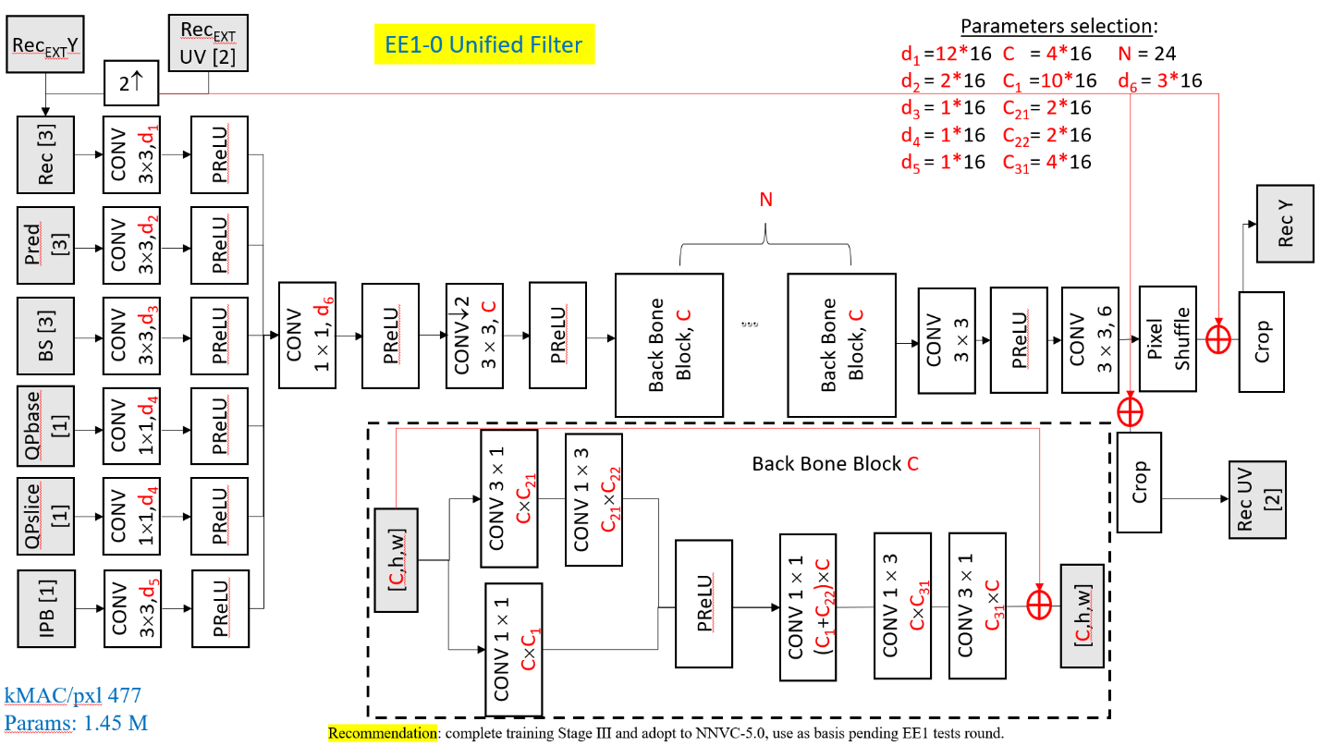
Figure 1 shows the overall design of the model.
Table 1 gives the characteristics of the model.
Table 1 NN Filter network structure aspects
Unified
high tier filter
Joint YUV | √
Intra = Inter model | √
Prediction | √
BS | √
QP base | √
QP slice | √
IPB | √
CONV for side Info | √
Variable number Channels | √
Long Skip connection | √
Long/wide Activation | √
Number ResBlocks | N^{(*)}
Conv Decomposed | √^{(**)}
multi-scale feature extraction | √
Number of channels | ×16
Training Environment | pytorch 1.9
Table 2 gives the model application characteristics.
Table 2 NN Filter interface aspects
Unified
Filter
Pre-processing and post-processing of chroma | √
Enable DBF/SAO | Both
Blending with the DBF/SAO | DBF(*)
Slice-level/Block-level blending with adaptive scale factor | √
Slice-level/Block-level blending with fixed scale factor | √
Separate adaptive scale factor for U and V | √
Base QP adjustment | (-5, +5)
Encoder-only Optimization | ×
Temporal filter | ×
Adaptive inference granularity (128 or 256 block implicit) | √
Configurable inference size (64 or 128 block explicit) | √
configurable block extension size | √
configuration QP params number | √
block-level QP adaptation | √
(*) NNLF comes after De-block but before SAO

Training process
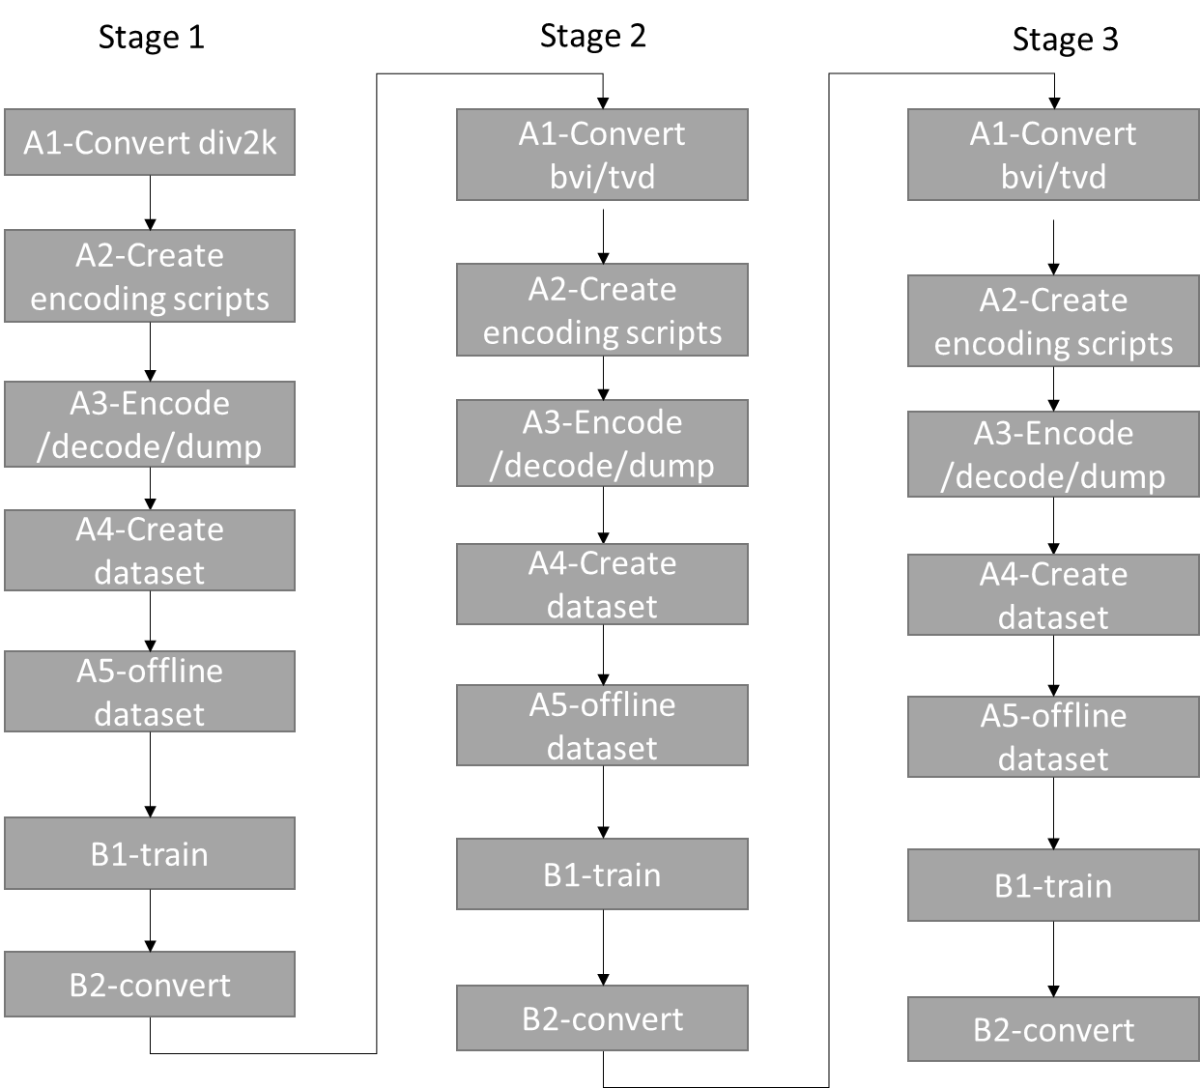
Figure 2 Training steps for HOP model creation
All instructions to train the model can be found in the associated readme.md of the directory training/training_scripts/NN_Filtering_HOP of the repository https://vcgit.hhi.fraunhofer.de/jvet-ahg-nnvc/VVCSoftware_VTM. The training is composed of a series of automatic steps, alternating data dumping, dataset creation, training, and model conversion.
The conversion steps, depending on the stages, include RGB to YUV conversion, data augmentation, or sequence extension (see training description below).

Table 3. Network Information for NN-based Video Coding Tool Testing in Training Stage
Network Information in Training Stage
Mandatory | GPU Type | GPU: Tesla-V100-SXM2-32GB/ Tesla-A100-40GB
Mandatory | Framework: | PyTorch v1.9
Mandatory | Number of GPUs per Task | 1
Mandatory | Epoch: | Stage 1: 40, stage 2: 20 (19), stage 3: xx
Mandatory | Batch size: | 64
Mandatory | Training time: | 6-12h/epoch
Mandatory | Training data information: | DIV2K, BVI-DVC, TVD
Mandatory | Training configurations for generating compressed training data (if different to VTM CTC): | See below
 | Loss function: | L1, L2
Optional
Optional | Number of iterations
Optional | Patch size | 128$×$128
Optional | Learning rate: | 1e-4
Optional | Optimizer: | ADAM
Optional | Preprocessing: | Data augmentation
Optional | Other information:

Training description
- Training Model stage I
  - Data extraction for intra from vanilla VTM
    - encoder turns on md5sum, just NNVC-5.0 all NNVC tools disabled, encoder_intra_vtm.cfg, just first frame
    - QPs = 22,27,32,37,42 + 19,24,29,34,39
    - DIV2K (4:4:4 RGB YUV420 10 bits, version ffmpeg to be specified,
    - Rotation, flipping, down-sampling (list of output + md5sum)
    - Reconstruction is extracted before de-block
    - All CTUs are extracted (except those on the border)
  - Model stage I training from scratch for Intra data:
    - Random initialization
    - Use all CTUs
    - Learning Rate scheduler: 0.1 decay at epoch 30 and 34
    - Norm switch: L1 up to epoch 37, then L2
    - 40 epochs total
- Training Model stage II
  - Data extraction with model#1:
    - encoder turns on md5sum, NNVC-5.0 + Model stage I for I-frames only, encoder_ra_model1.cfg, 65 frames (last is duplicated), Intra Period 64, GOP=32.
    - QPs = 22,27,32,37,42
    - List of sequences
      - TVD: 65 frames, 20 sequences
      - BVI (YUV420), 620 sequences
      - All reconstructed CTU are extracted before de-block for a subset of frames + DVI2K training data as in training stage I
  - Model stage II training with extracted data:
    - Random initialization
    - Use all CTUs
    - Rotation and flipping on the fly
    - Learning Rate scheduler: 0.1 decay at epoch 15 and 17
    - Norm switch: L1 up to epoch 18, then L2
    - 19 epochs total
- Training stage III
  - Data extraction with Model stage II:
    - encoder turns on md5sum, NNVC-5.0 + Model stage II (both Intra and Inter frames), encoder_ra_vtm.cfg + model stage 2, 65 frames (last is duplicated), Intra Period 64, GOP=32.
    - QPs = 22,27,32,37,42
    - Same sequences and frames as for stage 2
  - Model Stage III training with extracted data:
    - Random initialization
    - Use all CTUs
    - Rotation and flipping (on the fly augmentation)
    - Learning Rate scheduler: 0.1 decay at epoch 15 and 17
    - Norm switch: L1 up to epoch 18, then L2
    - 19 epochs total

Inference
Table 4. Network Information for NN-based Video Coding Tool Testing in Inference Stage
Network Information in Inference Stage
Mandatory | HW environment:
Mandatory | GPU Type | N/A
Mandatory | Framework: | SADL
Mandatory | Number of GPUs per Task | 0
Mandatory | Total Parameter Number | 1.45 M/model
Mandatory | Parameter Precision (Bits) | 16 (I)
Mandatory | Memory Parameter (MB) | 2.8 MB/model
Mandatory | Multiply Accumulate (kMAC/pixel) | 477K/pixel (assuming block-level input)
Optional
Optional | Total Conv. Layers | 154
Optional | Total FC Layers | 0
Optional | Total Memory (MB)
Optional | Batch size: | 1
Optional | Patch size | 128×128, 256×256
Optional | Changes to network configuration or weights required to generate rate points
Optional | Peak Memory Usage
Optional | Other information:
The table above shows the inference properties of the HOP model.

Training results

Stage 1

Loss and performance evolution
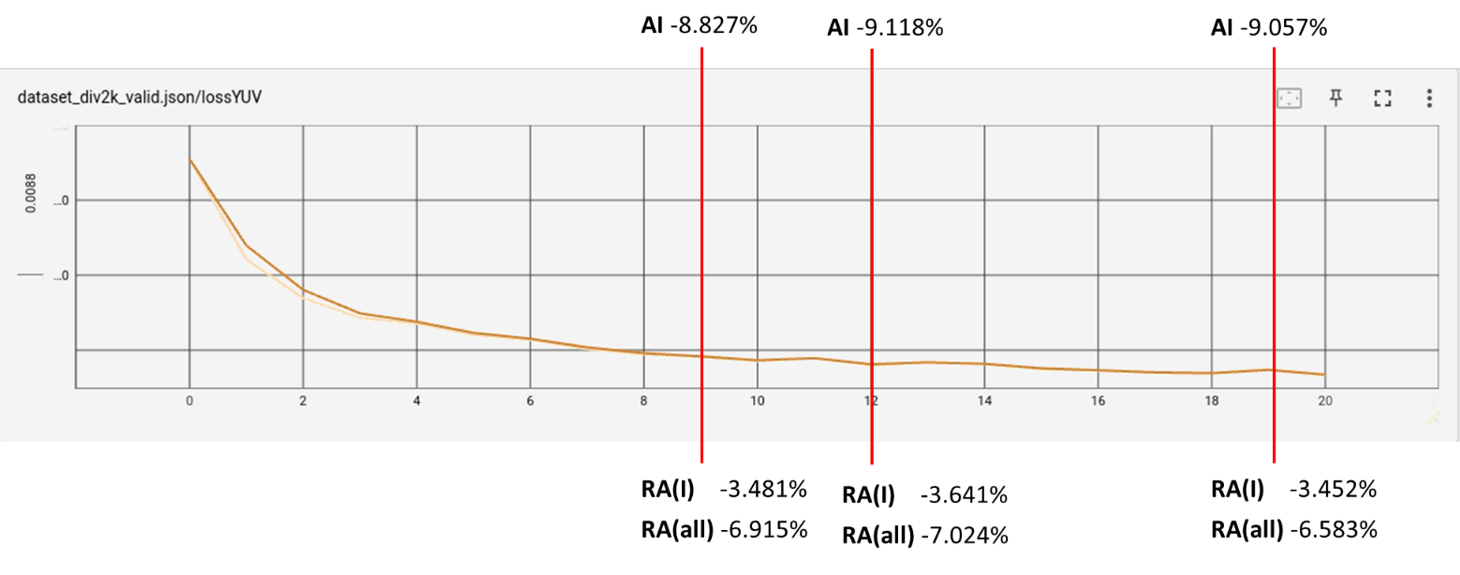
Figure 3 Stage 1 partial training results
The figure above shows the validation loss evolution as well as impact on CTC class D by using intermediate models at epoch 9, 12 and 19. As expected, the performance, especially for AI is increasing during the training epochs.

Integerization impact
Stage I model with encoder parameters NnlfHopDebugOption=1 is intended for Stage II training data extraction, therefore, its performance and stability across different sequences had to be prioritized.
Inference tests have been conducted with Stage I model from multiple epoch points, and model after 40th epoch (10days of training), seems to provide sufficient gain and stable performance. Simulation results for this model and NnlfHopDebugOption=1 are shown in Table 4. Table 5 shows simulation results produced with the model quantized with 11 bits. NnIntra tools was disabled for both test configurations.
Despite average results being close for floating and integer implementations, it was observed, that integer model underperformed noticeably for several sequences, namely RaceHorses, BlowingBubbles, BQSquare show penalty around 0.6%/4%/5% for Y/Cb/Cr, respectively. To avoid potential implications of content dependency, floating point model was decided to be used for Stage II training data extraction.

Table 5 Inference test results for Stage I model, epoch 39, float vs VTM anchor; RA with NnlfHopDebugOption=1 (Source: Qualcomm)

 | st1.ep39.float vs VTM anchor
 | All Intra |  |  | Random Access
 | Y-PSNR | U-PSNR | V-PSNR | Y-PSNR | U-PSNR | V-PSNR
Class A1 | -6.77% | -16.63% | -20.62% | -1.46% | -5.94% | -6.21%
Class A2 | -7.21% | -20.46% | -19.53% | -3.24% | -11.10% | -9.46%
Class B | -7.02% | -18.96% | -18.54% | -2.54% | -11.79% | -9.96%
Class C | -8.25% | -18.69% | -21.13% | -2.54% | -11.50% | -10.79%
Class E | -10.58% | -21.18% | -22.14%
Overall | -7.88% | -19.13% | -20.23% | -2.46% | -10.41% | -9.33%
Class D | -8.09% | -18.18% | -21.44% | -2.59% | -12.19% | -12.18%

Table 6 Inference test results for Stage I model, epoch 39, int16 vs VTM anchor; RA with NnlfHopDebugOption=1 (Source: Qualcomm)
 | st1.ep39.int16 vs VTM anchor
 | All Intra |  |  | Random Access
 | Y-PSNR | U-PSNR | V-PSNR | Y-PSNR | U-PSNR | V-PSNR
Class A1 | -6.82% | -16.72% | -20.63% | -1.42% | -5.91% | -6.16%
Class A2 | -7.13% | -20.51% | -19.75% | -3.22% | -11.05% | -9.45%
Class B | -6.98% | -19.50% | -18.88% | -2.54% | -11.71% | -9.90%
Class C | -8.23% | -18.87% | -21.35% | -2.33% | -10.40% | -9.63%
Class E | -10.59% | -21.20% | -22.19%
Overall | -7.86% | -19.35% | -20.42% | -2.40% | -10.07% | -8.99%
Class D | -8.07% | -18.19% | -21.59% | -2.31% | -11.24% | -11.60%

Number of epochs impact

Limited test was conducted by Qualcomm to assess performance of Stage 1 with longer training, inference results for model extracted from epoch 50. The longer training (+3 days) have introduced bd-rate improvement of 0.1%/0.9%0.3% for Y, Cb and Cr, respectively. It was access that such improvement may be justified by noticeably longer training.

The table below shows the impact of number of epochs on the training between 30 and 40 epochs (test by Tencent and ByteDance). Given the improved performance, it was decided to use 40 epochs for stage 1 training.

Table 7 NNVC 5.1 VTM + HOP 30 epochs vs NNVC 5.1 VTM + HOP 40 epochs (source Tencent and ByteDance)
 | 30 epochs vs 40 epochs
 | All Intra |  |  | Random Access
 | Y-PSNR | U-PSNR | V-PSNR | Y-PSNR | U-PSNR | V-PSNR
Class A1 | -0.41% | -4.37% | -4.38% | 0.14% | -3.33% | -1.07%
Class A2 | -1.18% | -6.36% | -6.45% | -0.95% | -4.91% | -5.86%
Class B | -1.00% | -5.23% | -3.98% | -0.72% | -4.97% | -3.77%
Class C | -1.26% | -4.30% | -5.13% | -0.60% | -3.19% | -3.51%
Class E | -1.58% | -6.64% | -6.95%
Overall | -1.09% | -5.30% | -5.21% | -0.56% | -4.15% | -3.58%
Class D | -1.00% | -4.08% | -4.43% | -0.37% | -2.96% | -3.03%

××

Experimental results – Stage 2 model

Validation loss
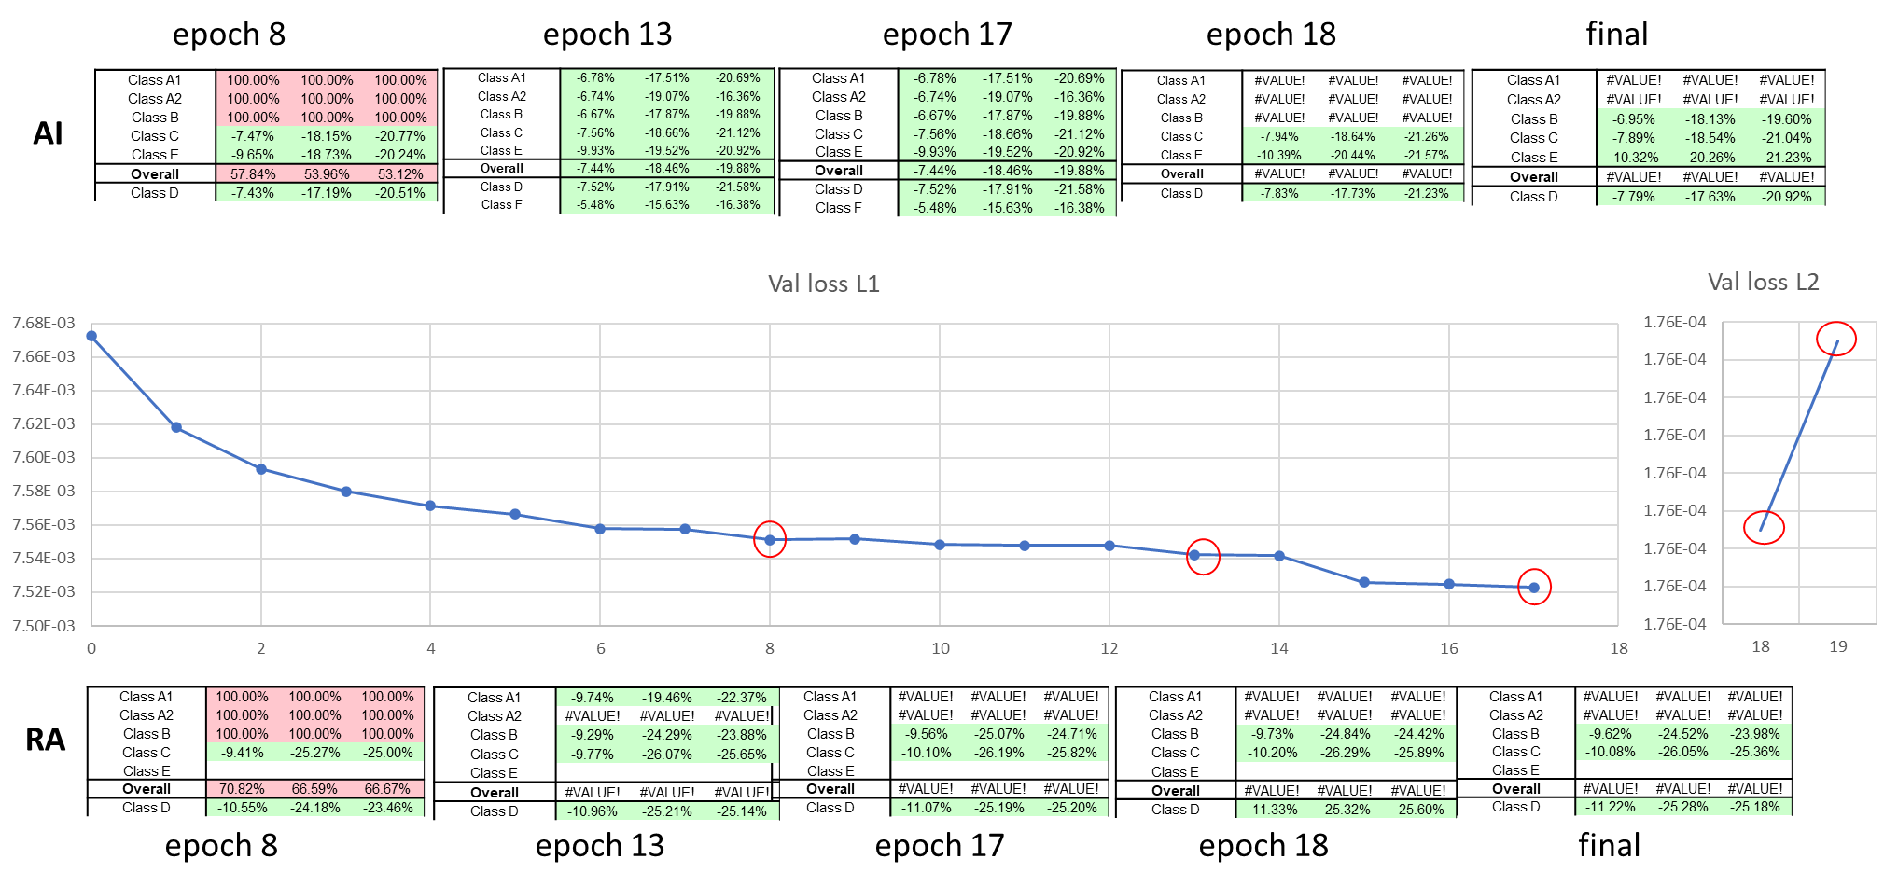
Figure 4 Intermediate results during stage 2 training
The figure above shows the evolution of validation loss as well as CTC results using the intermediate models. As expected, loss is decreasing and CTC results performance is increasing during the training for the first part of the training using L1 norm. At epoch 15, we can see that learning rate decay allows to further decrease the loss.
However, after switching to L2 norm (from epoch 18), one can notice a first performance improvement but then a performance decrease after that.

NNVC-5.0 VTM vs NNVC-5.1 VTM + HOP intermediate only
These early results are obtain using model of epoch 18 of the HOP training process in float.
At least 2 proponents were able to trained stage 2 and it is observed that results are similar for both proponents.

Results 1
These results were obtained using the training results of InterDigital.

Table 8 NNVC 4.0 vs NNVC 5.1 VTM + HOP (source InterDigital)
 | NNVC 4.0 vs NNVC-5.1 VTM+HOP
 | All Intra |  |  | Random Access
 | Y-PSNR | U-PSNR | V-PSNR | Y-PSNR | U-PSNR | V-PSNR
Class A1 | -7.05% | -17.89% | -20.06% | -9.65% | -18.14% | -22.49%
Class A2 | -6.97% | -19.25% | -16.77% | -10.08% | -22.08% | -17.55%
Class B | -7.00% | -18.24% | -19.89% | -8.92% | -23.34% | -22.97%
Class C | -7.95% | -18.65% | -21.27% | -9.65% | -24.98% | -24.39%
Class E | -10.39% | -20.44% | -21.57%
Overall | -7.78% | -18.81% | -19.98% | -9.49% | -22.48% | -22.17%
Class D | -7.83% | -17.73% | -21.23% | -10.89% | -24.02% | -24.54%
Class F | -5.53% | -16.45% | -16.17% | -5.30% | -16.51% | -14.82%

Results 2
These results were obtained using the training results of ByteDance, which give similar results.

Table 9 NNVC 4.0 vs NNVC 5.1 VTM + HOP (source ByteDance)
 | NNVC 4.0 vs NNVC-5.1 VTM+HOP
 | All Intra |  |  | Random Access
 | Y-PSNR | U-PSNR | V-PSNR | Y-PSNR | U-PSNR | V-PSNR
Class A1 | -7.25% | -17.84% | -20.96% | -9.96% | -18.28% | -22.14%
Class A2 | -6.99% | -19.16% | -16.83% | -10.09% | -21.88% | -17.67%
Class B | -7.01% | -18.24% | -19.86% | -8.83% | -23.63% | -22.86%
Class C | -7.95% | -18.37% | -20.97% | -9.53% | -24.56% | -24.46%
Class E | -10.39% | -20.39% | -21.56%
Overall | -7.82% | -18.72% | -20.07% | -9.49% | -22.46% | -22.10%
Class D | -7.82% | -17.82% | -20.98% | -10.87% | -24.08% | -24.15%
Class F | -5.52% | -16.16% | -15.92% | -5.35% | -16.02% | -14.94%

Results 3

These results were obtained using the training results of Oppo, which give similar results.

Table 10 NNVC 4.0 vs NNVC 5.1 VTM + HOP (source Oppo)
 | NNVC 4.0 vs NNVC-5.1 VTM+HOP
 | All Intra |  |  | Random Access
 | Y-PSNR | U-PSNR | V-PSNR | Y-PSNR | U-PSNR | V-PSNR
Class A1 | -7.10% | -17.83% | -21.74% | -10.08% | -17.89% | -22.39%
Class A2 | -6.89% | -18.32% | -16.19% | -9.92% | -20.68% | -17.02%
Class B | -6.96% | -17.82% | -18.90% | -8.84% | -22.21% | -22.04%
Class C | -8.02% | -18.38% | -20.81% | -9.63% | -24.50% | -23.67%
Class E | -10.52% | -20.30% | -21.33%
Overall | -7.80% | -18.44% | -19.75% | -9.52% | -21.65% | -21.54%
Class D | -7.89% | -17.40% | -20.71% | -10.93% | -24.92% | -22.62%
Class F | -5.42% | -16.03% | -16.28% | -5.44% | -16.38% | -14.88%

NNVC-4.0 vs NNVC-5.1+HOP intermediate
These early results are obtained using model of epoch 18 of the HOP training process in float.
Additionally, performance of Stage II epoch 18 float model was accessed in combination with NnIntra tool being enabled. Inference results shown in Table 11.

Table 11 NNVC-4.0 vs NNVC 5.1+HOP (Source: Qualcomm)
 | st2.ep18.float vs VTM anchor
 | All Intra |  |  | Random Access
 | Y-PSNR | U-PSNR | V-PSNR | Y-PSNR | U-PSNR | V-PSNR
Class A1 | -10.68% | -21.06% | -23.14% | -11.40% | -19.55% | -23.89%
Class A2 | -9.41% | -21.30% | -18.29% | -11.21% | -22.70% | -18.40%
Class B | -9.67% | -21.48% | -22.68% | -10.31% | -24.40% | -24.03%
Class C | -10.54% | -21.61% | -24.10% | -10.98% | -26.08% | -25.55%
Class E | -14.21% | -24.38% | -25.32%
Overall | -10.75% | -21.89% | -22.78% | -10.89% | -23.54% | -23.28%
Class D | -10.25% | -20.77% | -24.08% | -12.05% | -25.05% | -25.70%

NNVC-5.0 anchor vs NNVC-5.1 HOP
These early results are obtained using model of epoch 18 of the HOP training process in float.
The results in Table 12 show the benefit of HOP over LOC model.

Table 12 NNVC-5.0 nachor vs NNVC 5.1+HOP (source InterDigital)
 | st2.ep18.float + NnIntra vs NNVC-5.1 (LOP + nnIntra)
 | All Intra |  |  | Random Access
 | Y-PSNR | U-PSNR | V-PSNR | Y-PSNR | U-PSNR | V-PSNR
Class A1 | -2.45% | -14.85% | -15.81% | -4.50% | -15.30% | -18.83%
Class A2 | -3.02% | -14.36% | -11.15% | -4.98% | -17.70% | -13.77%
Class B | -2.88% | -13.90% | -15.16% | -4.32% | -17.27% | -17.62%
Class C | -3.50% | -12.91% | -15.35% | -4.65% | -16.79% | -17.31%
Class E | -4.40% | -16.48% | -17.90%
Overall | -3.22% | -14.34% | -15.10% | -4.57% | -16.83% | -17.01%
Class D | -2.90% | -13.35% | -15.66% | -4.82% | -16.61% | -17.22%
Class F | -3.10% | -12.86% | -12.87% | -3.33% | -12.04% | -10.99%

Integerized model
Using a naïve quantization (all quantizers equal to 1<<11), the following results are obtained compared to float model.

 | Int16 vs float, st2.ep18
 | All Intra |  |  |  |  | Random Access
 | Y-PSNR | U-PSNR | V-PSNR | EncT | DecT | Y-PSNR | U-PSNR | V-PSNR | EncT | DecT
Class A1 | -0.03% | 0.07% | -0.04% | 97% | 89% | 0.07% | 0.71% | 0.21% | 96% | 92%
Class A2 | 0.11% | 0.16% | -0.29% | 97% | 85% | 0.06% | 0.50% | -0.20%
Class B | 0.02% | -1.15% | -0.36% | 98% | 89% | 0.10% | 0.53% | 0.30% | 96% | 86%
Class C | 0.00% | -0.23% | -0.35% | 104% | 102% | 0.13% | 0.76% | 0.59% | 102% | 96%
Class E | 0.02% | -0.04% | -0.11% | 105% | 99%
Overall | 0.02% | -0.34% | -0.25% | 99% | 91% | 0.09% | 0.62% | 0.26%
Class D | 0.00% | -0.05% | -0.18% | 101% | 90% | -0.02% | -0.21% | -0.16% | 103% | 96%

Experimental results – stage 3

Loss and performance monitoring (intermediate results)
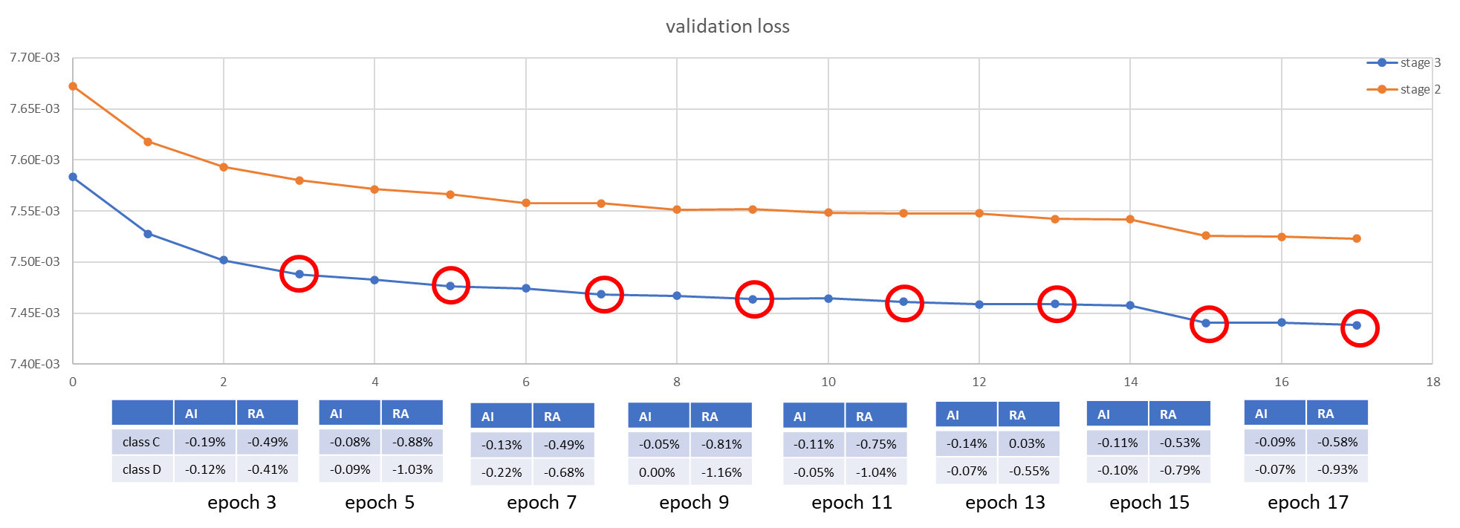
Figure 5 Stage 3 - loss evolution and performance difference with stage 2 (source InterDigital)
In the figure above, we show current loss and the performance on class C and D compared to the same epoch at stage 2. Note that dataset is slightly different: intra period has been set to 32 instead of 64 in order to speedup dataset generation.

The last 2 epochs, corresponding to L2 norm are shown below.
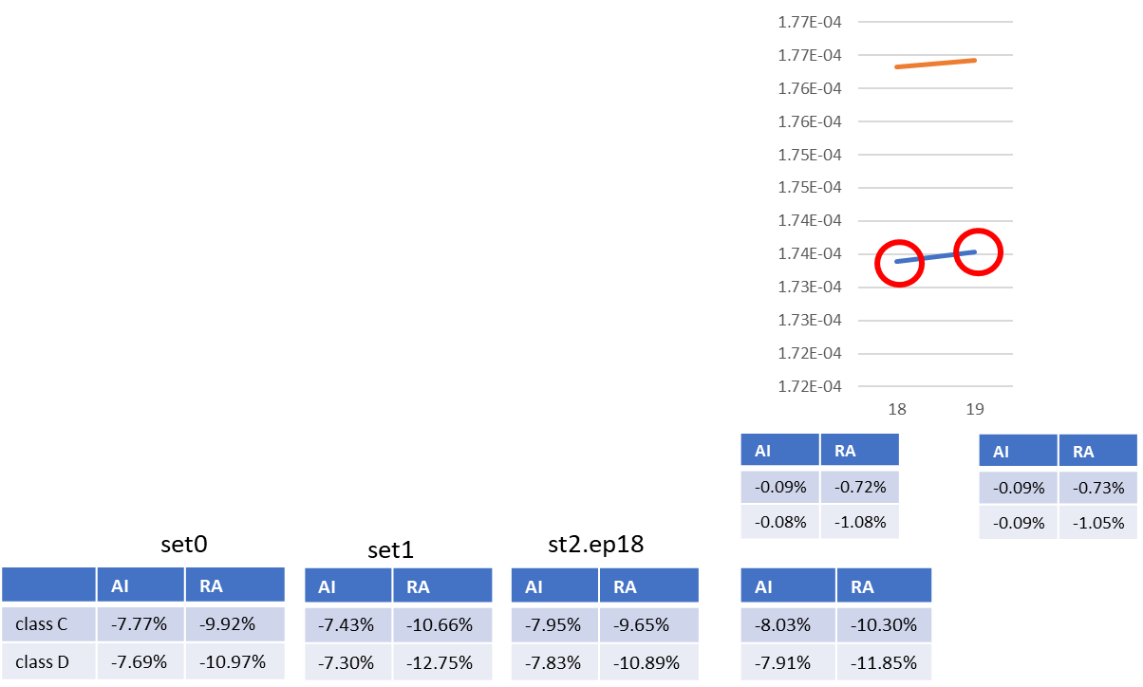
Figure 6 Stage 3 - loss evolution and performance difference with stage 2, L2 epochs (source InterDigital)
The stage 3 training profile follows the one of stage 2. The same issue for last epoch, likely due to a learning rate too high is also observed but impact is lower.

Compared to stage 2, an increase in performance of ~1% is observed for RA configuration on class C and D and ~0.1% for class AI. The absolute performances are in par with previous set0 and set1, with better performance on AI (-0.6%) but worse on RA (+0.6%) compared to filterset1.

Additional training results and tests

Stage 2

L2 norm replacement
The 2 last steps of stage 2 are using L2 norm. It was observed that, while the first L2 step gives some gains, the next ones are decreasing the performance.
We show some results with replacing the L2 norm by a L1 smooth norm (similar to Huber norm).

Epoch 18
We show results on class C and D on epoch 18, restarting the training from epoch 17 but switching to L1smooth norm at epoch 18 instead of L2 norm.
Results for epoch 18 are below.

Table 13 NNVC 5.1 VTM +HOP epoch 18. L2 norm vs L1 smooth norm (source InterDigital)
 | NNVC 4.0 vs NNVC-5.1 VTM+HOP
 | All Intra |  |  | Random Access
 | Y-PSNR | U-PSNR | V-PSNR | Y-PSNR | U-PSNR | V-PSNR
Class A1 | #VALUE! | #VALUE! | #VALUE! | #VALUE! | #VALUE! | #VALUE!
Class A2 | #VALUE! | #VALUE! | #VALUE! | #VALUE! | #VALUE! | #VALUE!
Class B | #VALUE! | #VALUE! | #VALUE! | #VALUE! | #VALUE! | #VALUE!
Class C | -0.03% | -0.06% | 0.06% | -0.12% | -0.15% | -0.28%
Class E | #VALUE! | #VALUE! | #VALUE!
Overall | #VALUE! | #VALUE! | #VALUE! | #VALUE! | #VALUE! | #VALUE!
Class D | -0.02% | -0.08% | 0.02% | -0.13% | 0.25% | -0.10%
Class F

Results for last epoch

Table 14 NNVC 5.1 VTM +HOP epoch 19. L2 norm vs L1 smooth norm (source InterDigital)
 | NNVC 4.0 vs NNVC-5.1 VTM+HOP
 | All Intra |  |  | Random Access
 | Y-PSNR | U-PSNR | V-PSNR | Y-PSNR | U-PSNR | V-PSNR
Class A1 | -0.03% | -0.68% | -0.31% | -0.09% | -0.79% | -0.68%
Class A2 | -0.08% | -0.68% | -0.60% | #VALUE! | #VALUE! | #VALUE!
Class B | -0.09% | -0.28% | -0.32% | -0.19% | -0.75% | -0.74%
Class C | -0.10% | -0.23% | -0.28% | -0.25% | -0.53% | -0.85%
Class E | -0.09% | -0.43% | -0.41%
Overall | -0.08% | -0.42% | -0.37% | #VALUE! | #VALUE! | #VALUE!
Class D | -0.07% | -0.27% | -0.50% | -0.25% | 0.06% | -0.59%
Class F | -0.08% | -0.28% | -0.28%

It is observed that the L1smooth norm gives better results. Especially, the last epoch 19 does not degrade the model as much as L2 norm but does not bring additional gain either.

Sum-up of last epochs
We show results on impact of several hyper-parameters for class C and D (luma only).
Norm | Learning rate | Epoch 17 | Epoch 18 | Epoch 19
17: L1, 18-19: L2 | 17-19:1e-6 | -9.54% class C  -10.63% class D | -9.65% class C  -10.89% class D | -9.53% class C  -10.77% class D
17:L1, 18-19:L1smooth | 17-19:1e-6 | -9.54% class C  -10.63% class D | -9.74% class C  -11.00% class D | -9.75% class C  -11.00% class D
17-19:L1 (lr same) | 17-19:1e-4 | -9.06% class C  -10.24% class D | -9.30% class C  -10.49% class D | -9.31% class C  -10.50% class D
17: L1, 18-19: L2 | 17-18:1e-6, 19:1e-7 | -9.54% class C  -10.63% class D | -9.65% class C  -10.89% class D | -9.64% class C  -10.91% class D
17: L1, 18-19: L2 | 17:1e-6, 18-19: 1e-7 | -9.54% class C  -10.63% class D | -9.71% class C  -10.98% class D | -9.74% class C  -11.00% class D

It is observed that learning rate decrease and L2 norm does improve performance from epoch 17 to 18.
It is also observed that L1smooth norm is better than L2 norm for the last 2 epochs.
It is observed that L1 norm without decay does not bring gains.
It is observed that additional LR decay for the last epoch allows to maintain gains of epoch 18 but does not bring additional gains.
It is observed that decreasing the LR before starting the L2 norm epochs allows more gain and does not decrease performance.

Conclusions
A Unified Filter Architecture for the High-performance Operation Point (HOP) was defined at JVET-AD0380 and includes model architecture, training process and training test set.
All design elements and training procedures for this architecture were carefully selected though multiple rounds of EE1 tests. During this meeting cycle, a unified dataset and unified training procedure was implemented by multiple participants, and training conducted in parallel. Parallel implementation conducted by several independent parties allowed to cross-check every stage of the training and dataset preparation.
It is suggested to adopt EE1-0 into NNVC common software and enable it by default for HOP. It is also suggested to make training strategy found in EE1-0 the part of NNVC SW. It is also suggested to continue practice of joint training activity for most promising NN-based tools studied in EE1. Identified dis-convergence of training at Stage II can be one of aspects to study in further EE1 tests.
It is suggested to change the tail of the training hyperparameters to avoid the loss during the L2 norm training. In practice the LR decay epochs would become [15,17,18] instead of [15,17].

References
JVET-AD0380 “BoG report on NN-filter design unification”, E. Alshina, F. Galpin

Patent rights declaration(s)
InterDigital, Qualcomm, ByteDance, Tencent, Oppo, Huawei may have current or pending patent rights relating to the technology described in this contribution and, conditioned on reciprocity, is prepared to grant licenses under reasonable and non-discriminatory terms as necessary for implementation of the resulting ITU-T Recommendation | ISO/IEC International Standard (per box 2 of the ITU-T/ITU-R/ISO/IEC patent statement and licensing declaration form).

