    Joint Video Experts Team (JVET)  of ITU-T SG 16 WP 3 and ISO/IEC JTC 1/SC 29  31st Meeting, Geneva, CH, 11–19 July 2023 | Document: JVET-AE0177-v2

Title: | Non-EE2: Local illumination compensation with slope adjustment
Status: | Input document to JVET
Purpose: | Proposal
Author(s) or  Contact(s): | Yang Wang¹, Kai Zhang², Yuwen He², Hongbin Liu¹, Li Zhang²  ¹Fangheng Building, No.27, 3rd Ring West Rd, Haidian District, 100098, Beijing, China  ²8910 University Center Lane, San Diego, CA 92122, USA | Tel:  Email: | wangyang.cs@bytedance.com  zhangkai.video@bytedance.com  lizhang.idm@bytedance.com
Source: | Bytedance Inc.
_____________________________

Abstract
This contribution presents a method of local illumination compensation with slope adjustment, in which an adjustment parameter is used to modify parameters of LIC. On top of ECM-9.0, simulation results of the proposed method are reported (estimated) as below:
RA: {-0.10%, -0.22%, -0.17%; 112.7%, 99.6%};
LDB: {-0.10%, -0.18%, -0.31%; 120.8%, 100.4%}.

Introduction
LIC is an inter prediction technique to model local illumination variation between a template of the current block and a template of its reference block, as an estimation of that between the current block and the reference block. The parameters of the model can be denoted by a scale α and an offset β, which forms a linear equation, p’ [ x ] = α × p [ x ] + β, to compensate illumination changes, where p[x] is a reference sample pointed to by MV at a location x on reference picture and p’[x] is the prediction value generated by LIC.
In addition, slope adjustment of CCLM was proposed in [1] and adopted in ECM. As shown in Figure 1, the adjustment parameter (u) is used to update the derived linear model in CCLM. Similarly, slope adjustment can also be used to update the LIC model.
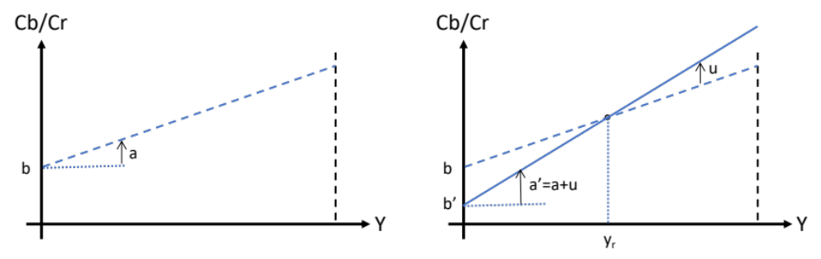
Figure 1. Illustration of the effect of the slope adjustment parameter “u”. Left: model created in CCLM without adjustment. Right: model updated using slope adjustment.

Proposed method
A method of local illumination compensation with slope adjustment is proposed, in which an adjustment parameter is used to update the LIC parameters similar to the slope adjustment of CCLM. The adjustment parameter is signalled for AMVP mode.

Simulation results
The proposed method is implemented on top of ECM-9.0 [2]. Simulations are performed following the common test conditions of EE2 [3]. The simulation results compared to ECM-9.0 are shown in Table 1.
Table 1: Coding performance compared to ECM-9.0
 | Random access Main 10 |  |  |  |  | Low delay B Main 10
 | Y | U | V | EncT | DecT | Y | U | V | EncT | DecT
Class A1 | -0.07% | -0.25% | -0.11% | 115.9% | 100.1%
Class A2 | -0.13% | -0.27% | -0.22% | 110.8% | 96.6%
Class B | -0.11% | -0.19% | -0.15% | 109.6% | 100.2% | -0.11% | -0.22% | -0.28% | 119.9% | 100.9%
Class C | -0.10% | -0.21% | -0.19% | 115.8% | 100.9% | -0.07% | -0.21% | -0.50% | 121.5% | 100.3%
Class E |  |  |  |  |  | -0.15% | -0.09% | -0.14% | 121.3% | 99.6%
Overall | -0.10% | -0.22% | -0.17% | 112.7% | 99.6% | -0.10% | -0.18% | -0.31% | 120.8% | 100.4%
Class D | -0.05% | -0.26% | -0.21% | 115.2% | 100.3% | -0.24% | 0.29% | -0.08% | 117.9% | 100.9%
Class F | -0.25% | -0.21% | -0.24% | 109.2% | 100.4% | -0.29% | 0.11% | -0.42% | 111.4% | 100.4%

Conclusions
In this contribution, LIC with slope adjustment is proposed. It is recommended to study the proposed method in EE2.

Reference
- J. Lainema, A. Aminlou, P. Astola, and R. G. Youvalari, “EE2-1.1: Slope adjustment for CCLM,” Document of Joint Video Experts Team, JVET-Z0049, by teleconference, April 2022.
- ECM-9.0, https://vcgit.hhi.fraunhofer.de/ecm/ECM/-/tree/ECM-9.0.
- M. Karczewicz, and Y. Ye, “Common test conditions and evaluation procedures for enhanced compression tool testing,” Document of Joint Video Experts Team, JVET-AD2017, Antalya, TR, 21–28 April 2023.

Patent rights declaration(s)
Bytedance Inc. may have current or pending patent rights relating to the technology described in this contribution and, conditioned on reciprocity, is prepared to grant licenses under reasonable and non-discriminatory terms as necessary for implementation of the resulting ITU-T Recommendation | ISO/IEC International Standard (per box 2 of the ITU-T/ITU-R/ISO/IEC patent statement and licensing declaration form).

