    Joint Video Experts Team (JVET)  of ITU-T SG 16 WP 3 and ISO/IEC JTC 1/SC 29  31st Meeting, Geneva, CH, 11–19 July 2023 | Document: JVET-AE0102-v2

Title: | EE2-4.3: Context modeling for transform coefficients for LFNST/NSPT
Status: | Input document to JVET
Purpose: | Proposal
Author(s) or  Contact(s): | Pavel Nikitin, Muhammed Coban, Cagan S. Coban, Bappaditya Ray, Vadim Seregin, Marta Karczewicz (Qualcomm) | Tel:  Email: | {pnikitin, mcoban, ccoban, bray, vseregin,  martak}@qti.qualcomm.com
Source: | Qualcomm Incorporated
_____________________________

Abstract
This contribution reports test results of EE2-4.3, where modification of the way how the context modelling is done for LFNST/NSPT. The proposed method uses the previous 5 coefficients in the coding order to model the contexts of sig_coeff_flag, coeff_abs_level_greaterX_flag, and for the derivation of Rice parameter for parsing the remainder of the coefficient, rather than using the causal 2D neighborhood for the context derivation.
The following results are obtained on top of ECM-9.0:
AI: -0.14% (Y), -0.20% (U), -0.18 % (V), 101% (EncT),100% (DecT).
RA: -0.13% (Y), -0.33% (U), -0.19 % (V), 100% (EncT),100% (DecT).

Test description
In ECM, the causal 2D neighborhood of coefficients is used to model the context to parse the sig_coeff_flag, gt1_flag, gt2_flag as shown in Figure 1(left).

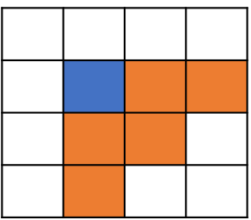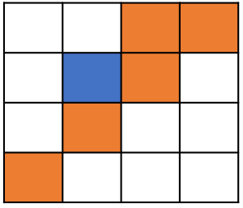
Figure 1. Coefficients used to model the context in ECM (left), proposal (right)
In order to model the context for a currently parsed coefficient when LFNST/NSPT is applied, the previous 5 coefficients in the coding order are used shown in Figure 1(right), rather than using the causal 2D neighborhood of context derivation. In ECM, the lfnstIdx is signalled after all the coefficients in a CU. For this proposal, lfnstIdx is signalled after all last_sig_coeff_pos syntax elements in a CU since lfsntIdx is required for parsing the transform coefficients.

For LFNST, a set of DCT-II coefficients in the ROI are vectorized using raster scan. The remaining DCT-II coefficients are set to zero. The vectorized coefficients are transformed using LFNST and placed into the coefficient block using diagonal reordering, as shown in Figure 2.

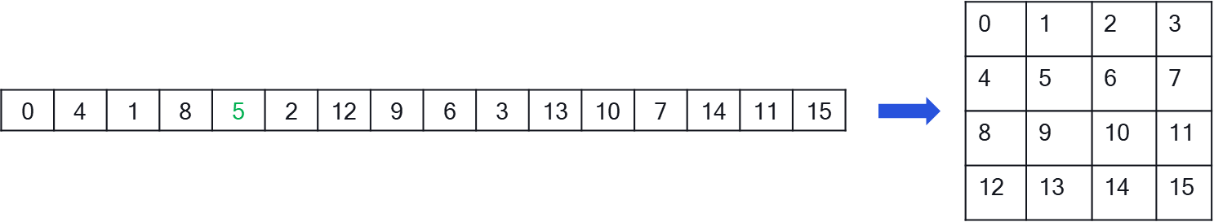Figure 2. LFNST coefficients reordering

When we decode coefficient at scan position equal to five in ECM we will use causal 2-D neigborhood to model the context, as shown in Figure 3, In proposed method we are using the closest coeffiecients to the decoded one as shown in Figure 4.
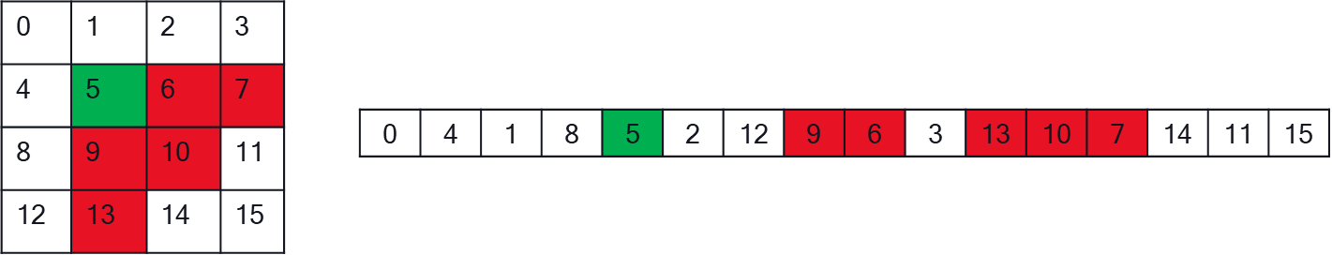
Figure 3. Context modeling for LFNST coefficients in ECM

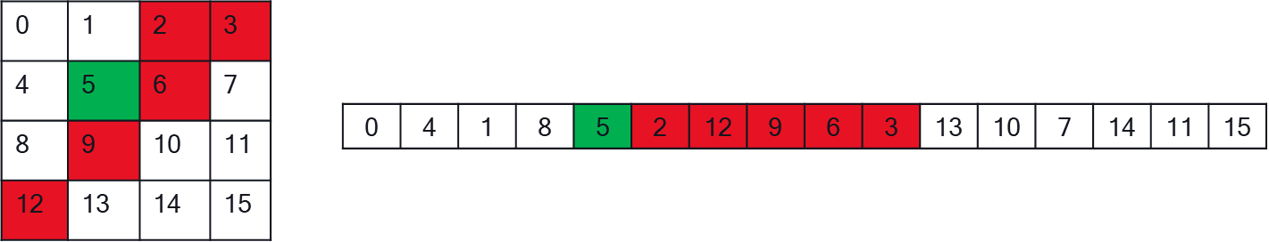
Figure 4. Context modeling for LFNST coefficients in TEST4.3

Experimental results
The proposed method was implemented on top of ECM-9.0 and test results under common test conditions JVET-AD2017 are summarized in the next tables.

 | All Intra Main10
 | Over ECM9
 | Y | U | V | EncT | DecT
Class A1 | -0.11% | 0.09% | -0.10% | 99% | 100%
Class A2 | -0.12% | -0.38% | -0.21% | 101% | 101%
Class B | -0.16% | -0.19% | -0.14% | 102% | 101%
Class C | -0.15% | -0.33% | -0.32% | 101% | 100%
Class E | -0.18% | -0.20% | -0.14% | 102% | 100%
Overall | -0.14% | -0.20% | -0.18% | 101% | 100%
Class D | -0.15% | -0.28% | -0.23% | 102% | 100%
Class F | -0.12% | -0.01% | -0.14% | 98% | 100%

 | Random Access Main 10
 | Over ECM9
 | Y | U | V | EncT | DecT
Class A1 | -0.13% | -0.40% | -0.07% | 100% | 100%
Class A2 | -0.13% | -0.39% | -0.32% | 100% | 100%
Class B | -0.15% | -0.29% | -0.24% | 100% | 100%
Class C | -0.10% | -0.27% | -0.12% | 100% | 100%
Class E
Overall | -0.13% | -0.33% | -0.19% | 100% | 100%
Class D | -0.15% | -0.81% | -0.18% | 100% | 100%
Class F | -0.12% | -0.02% | -0.05% | 100% | 100%

References
[1] ECM-9.0, https://vcgit.hhi.fraunhofer.de/ecm/ECM/-/tree/ECM-9.0
[2] P. Garus et al, EE2-4.2: “Non-Separable Primary Transform for Intra Coding”, JVET-AC0130, Jan. 2023

Patent rights declaration(s)
Qualcomm may have current or pending patent rights relating to the technology described in this contribution and, conditioned on reciprocity, is prepared to grant licenses under reasonable and non-discriminatory terms as necessary for implementation of the resulting ITU-T Recommendation | ISO/IEC International Standard (per box 2 of the ITU-T/ITU-R/ISO/IEC patent statement and licensing declaration form).

