    Joint Video Experts Team (JVET)  of ITU-T SG 16 WP 3 and ISO/IEC JTC 1/SC 29  31st Meeting, Geneva, CH, 11–19 July 2023 | Document: JVET-AE0100-v1

Title: | EE2-2.1: Block vector guided CCCM
Status: | Input document to JVET
Purpose: | Proposal
Author(s) or  Contact(s): | Ramin G. Youvalari  Döne Bugdayci Sansli  Pekka Astola  Jani Lainema | Tel:  Email: | ramin.ghaznavi-youvalari@nokia.com  done.bugdayci_sansli@nokia.com  pekka.astola@nokia.com  jani.lainema@nokia.com
Source: | Nokia
_____________________________

Abstract
This contribution reports the results for EE2 Test 2.1a and Test 2.1b which were proposed in JVET-AD0100. The method proposes a new convolutional cross-component model which uses block vectors of the co-located IBC or intraTMP coded luma blocks to identify the reference area for deriving the CCCM model. The proposed block vector guided CCCM (BVG-CCCM) method uses an 11-tap filter for cross-component prediction. The mode is signalled with a context coded flag which is conditioned on co-located luma block’s mode. Two tests are conducted in this EE. In Test 2.1a, the block vectors of IBC coded blocks from co-located luma are used for determining the CCCM reference area. Whereas, in Tests 2.1b, the mode can use block vectors of both IBC and intraTMP coded blocks from co-located luma to determine the CCCM reference area. The prediction part is done as in ECM-9.0 where the co-located luma block samples are used. The impact on coding efficiency and runtimes of the tests over ECM-9.0 are reportedly {for Y, U, V, EncT, DecT}:
Test 2.1a:
CTC classes: AI { -0.00%, -0.06%, -0.06%, 100%, 100%}, RA { -0.00%, -0.04%, -0.04%, 100%, 100%}
Class F: AI { 0.01%, -0.40%, -0.13%, 100%, 99%}, RA { -0.11%, -0.33%, -0.27%, 100%, 100%}
Class TGM: AI { -0.57%, -1.03%, -0.94%, 101%, 99%}, RA { -0.09%, -0.22%, -0.19%, 98%, 100%}
Test 2.1b:
CTC classes: AI { -0.01%, -0.13%, -0.13%, 100%, 100%}, RA { -0.01%, -0.09%, -0.01%, 100%, 100%}
Class F: AI { -0.04%, -0.33%, -0.30%, 100%, 100%}, RA { -0.06%, -0.33%, -0.34%, 99%, 100%}
Class TGM: AI { -0.61%, -1.09%, -1.06%, 101%, 99%}, RA { -0.14%, -0.31%, -0.26%, 98%, 100%}

Introduction
Convolutional cross-component model (CCCM) [1] predicts chroma samples from reconstructed luma samples using a 7-tap filter. Similar to CCLM, CCCM has the option of using either a single or a multi-model variant. The multi-model variant uses two models, one model derived for samples above the average luma reference value and another model for the rest of the samples (following the spirit of the CCLM design). Multi-model CCCM mode can be selected for PUs which have at least 128 reference samples available.
The CCCM filter consist of a 5-tap plus sign shape spatial component, a nonlinear term, and a bias term. The input to the spatial 5-tap component of the filter consists of a center (C) luma sample which is collocated with the chroma sample to be predicted and its above/north (N), below/south (S), left/west (W) and right/east (E) neighbors as illustrated below.
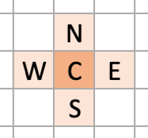
Figure 1: Spatial part of the convolutional filter
The nonlinear term P is represented as power of two of the center luma sample C and scaled to the sample value range of the content:
P = ( C*C + midVal ) >> bitDepth
The bias term B represents a scalar offset between the input and output (similarly to the offset term in CCLM) and is set to middle chroma value (512 for 10-bit content).
Output of the filter is calculated as a convolution between the filter coefficients c_{i} and the input values and clipped to the range of valid chroma samples:
predChromaVal = c₀C + c₁N + c₂S + c₃E + c₄W + c₅P + c₆B

Proposed Method
The block vector guided CCCM (BVG-CCCM) method, in JVET-AD0100 [2], is proposed for improving the coding efficiency of ECM. The BVG-CCCM method uses block vectors of the co-located luma blocks, coded in IBC or intraTMP modes, to determine the reference area for calculating the CCCM parameters. Then the reference area in luma and corresponding area in chroma channel is used to calculate the CCCM parameters. The prediction uses the calculated model parameters and co-located luma samples to do the CCCM prediction. Figure 2 illustrates the reference area in BVG-CCCM method.
The mode is enabled only in intra slices. Moreover, an SPS-level flag is introduced for enabling or disabling the mode.
The BVG-CCCM mode uses an 11-tap filter for cross-component prediction as below:

predChromaVal = c₀C + c₁N + c₂S + c₃E + c₄W + c₅P(C) + c₆P(N) + c₇P(S) + c₈P(W) + c₉P(E)+ c₁₀B

The input to the spatial 5-tap component of the filter consists of a center (C) luma sample which is collocated with the chroma sample to be predicted and its above/north (N), below/south (S), left/west (W) and right/east (E) neighbors as illustrated in Figure 1.
The nonlinear term P is represented as power of two of the corresponding luma sample and B is the bias term.
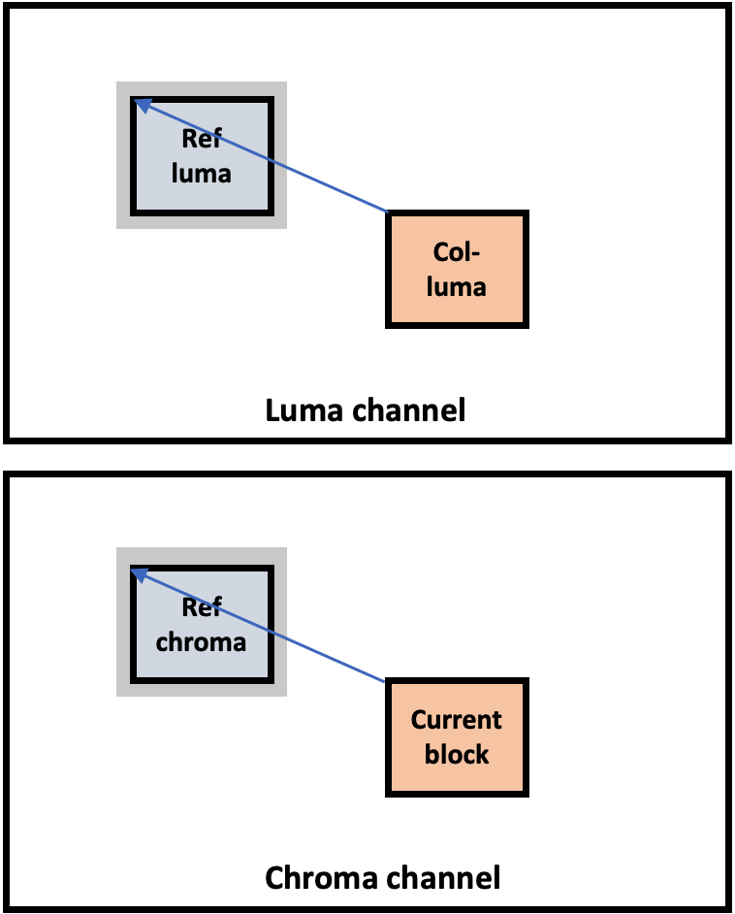
Figure 2: Illustrates reference area for BVG-CCCM
Similar to Direct Block Vector (DBV) mode in ECM-9.0, five locations, as shown in Figure 3, in collocated luma block area are scanned and the associated block vectors are then used for determining the reference area for parameter calculation in BVG-CCCM method.
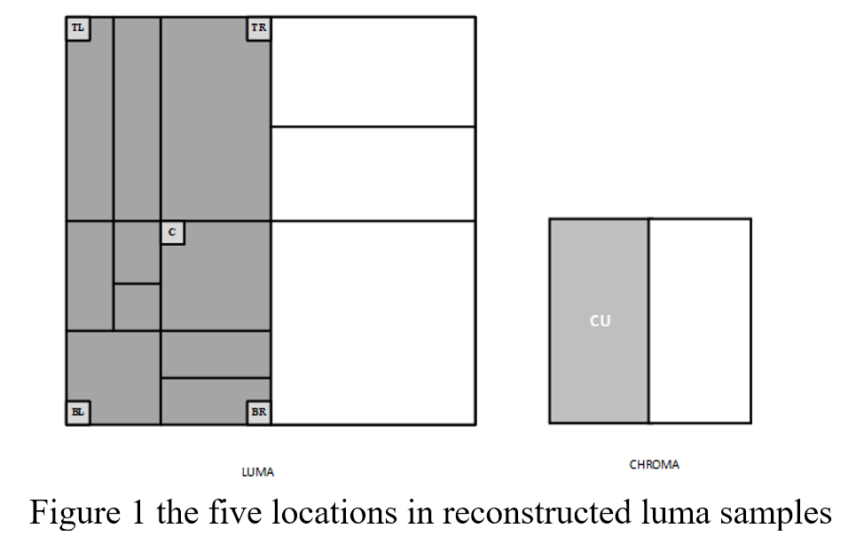
Figure 3: Locations used for block vector derivation from co-located luma block.
Two tests are conducted in this EE:
Test 2.1a: the mode only uses block vector(s) of the IBC coded blocks from co-located luma area.
Test 2.1b: the mode can use block vector(s) of both IBC and intraTMP coded blocks from co-located luma area.

Bitstream Signalling
Usage of the mode is signalled with a CABAC coded PU level flag. The BVG-CCCM flag is signalled if co-located block is coded in IBC or intraTMP modes and the cross-component index is LM_CHROMA_IDX or MMLM_CHROMA_IDX.

Encoder Operation
The encoder performs two additional RD for the BVG-CCCM for single-model and multi-model CCCM variants.

Simulation Results
Tables below summarize the coding efficiency and runtime impact of the proposed method in each EE test in ECM-9.0 [3] using the JVET common test conditions [4].
Results for Test 2.1a:
 | All Intra Main10
 |  |  | Over ECM-9.0
 | Y | U | V | EncT | DecT
Class A1 | 0.01 % | 0.05 % | 0.00 % | 99 % | 100 %
Class A2 | -0.03 % | -0.16 % | -0.19 % | 99 % | 99 %
Class B | 0.00 % | -0.10 % | -0.13 % | 100 % | 100 %
Class C | 0.00 % | -0.07 % | -0.02 % | 100 % | 100 %
Class E | 0.01 % | -0.02 % | 0.09 % | 100 % | 99 %
Overall | 0.00 % | -0.06 % | -0.06 % | 100 % | 100 %
Class D | 0.01 % | 0.04 % | 0.14 % | 100 % | 97 %
Class F | 0.01 % | -0.40 % | -0.13 % | 100 % | 99 %
Class TGM | -0.57 % | -1.03 % | -0.94 % | 101 % | 99 %

 | Random Access Main10
 |  |  | Over ECM-9.0
 | Y | U | V | EncT | DecT
Class A1 | 0.00 % | -0.02 % | 0.02 % | 102 % | 99 %
Class A2 | -0.05 % | -0.10 % | -0.23 % | 103 % | 100 %
Class B | 0.01 % | 0.04 % | -0.02 % | 99 % | 100 %
Class C | 0.03 % | -0.11 % | 0.03 % | 98 % | 100 %
Class E
Overall | 0.00 % | -0.04 % | -0.04 % | 100 % | 100 %
Class D | 0.05 % | -0.48 % | 0.13 % | 99 % | 101 %
Class F | -0.11 % | -0.33 % | -0.27 % | 100 % | 100 %
Class TGM | -0.09 % | -0.22 % | -0.19 % | 98 % | 100 %

Results for Test 2.1b:
 | All Intra Main10
 |  |  | Over ECM-9.0
 | Y | U | V | EncT | DecT
Class A1 | 0.00 % | 0.01 % | -0.03 % | 100 % | 100 %
Class A2 | -0.05 % | -0.40 % | -0.37 % | 99 % | 100 %
Class B | 0.00 % | -0.19 % | -0.22 % | 100 % | 100 %
Class C | 0.00 % | -0.08 % | -0.01 % | 100 % | 100 %
Class E | 0.00 % | 0.02 % | -0.01 % | 100 % | 100 %
Overall | -0.01 % | -0.13 % | -0.13 % | 100 % | 100 %
Class D | 0.01 % | 0.05 % | 0.21 % | 100 % | 99 %
Class F | -0.04 % | -0.33 % | -0.30 % | 100 % | 100 %
Class TGM | -0.61 % | -1.09 % | -1.06 % | 101 % | 99 %

 | Random Access Main10
 |  |  | Over ECM-9.0
 | Y | U | V | EncT | DecT
Class A1 | 0.01 % | 0.00 % | 0.07 % | 99 % | 100 %
Class A2 | -0.05 % | -0.15 % | -0.25 % | 102 % | 100 %
Class B | -0.01 % | -0.14 % | -0.07 % | 99 % | 100 %
Class C | 0.01 % | -0.05 % | 0.18 % | 99 % | 99 %
Class E
Overall | -0.01 % | -0.09 % | -0.01 % | 100 % | 100 %
Class D | 0.04 % | -0.11 % | 0.27 % | 98 % | 99 %
Class F | -0.06 % | -0.33 % | -0.34 % | 99 % | 100 %
Class TGM | -0.14 % | -0.31 % | -0.26 % | 98 % | 100 %

Conclusion
This contribution reports results of EE2 Test 2.1 where the block vector guided CCCM method is proposed to further improve the coding efficiency of intra coding in ECM-9.0. The experiments showed that the method provides high coding gains in screen content sequences without introducing any noticeable encoder and decoder runtimes. It is suggested to adopt the proposed method in ECM-10.0.

References
- Coban et.al, “Algorithm description of Enhanced Compression Model 9 (ECM 9)”, JVET-AD2025, Apr. 2023.
- R. G. Youvalari, D. Bugdayci Sansli, P. Astola, J. Lainema, “AHG12: Block vector guided CCCM,” JVET-AD0100, Apr. 2023.
- ECM-9.0 reference software, https://vcgit.hhi.fraunhofer.de/ecm/ECM.git
- M. Karczewicz, Y. Ye, “Common Test Conditions and evaluation procedures for enhanced compression tool testing”, JVET-Y2017, Jan. 2022.

Patent rights declaration(s)
Nokia may have current or pending patent rights relating to the technology described in this contribution and conditioned on reciprocity, is prepared to grant licenses under reasonable and non-discriminatory terms as necessary for implementation of the resulting ITU-T Recommendation | ISO/IEC International Standard (per box 2 of the ITU-T/ITU-R/ISO/IEC patent statement and licensing declaration form).

