    Joint Video Experts Team (JVET)  of ITU-T SG 16 WP 3 and ISO/IEC JTC 1/SC 29  30th Meeting, Antalya, TR, 21–28 April 2023 | Document: JVET-AD0276-v2

Title: | AHG4: experiments in preparation of film grain visual tests
Status: | Input document to JVET
Purpose: | Information
Author(s) or  Contact(s): | P. de Lagrange  T. Filoche  F. Urban | Email: | philippe.delagrange@interdigital.com
Source: | InterDigital
_____________________________

Abstract
This document reports about some experiments in preparation of visual tests planned in JVET-AC2022 for FGC SEI visual tests on top of VVC, more specifically the first category which goal is to assess the visual improvement brought by film grain synthesis over a wide range of coding quality. Internal testing in InterDigital labs were performed and indicate that the test planned can show a measurable impact of film grain synthesis on visual quality, which can be translated to bitrate savings.
It is further recommended to add tests at a higher quality range using a direct comparison method, since film grain synthesis at high quality is expected to have a much larger impact on bitrate than for the quality range commonly used for DCR tests.

Introduction
The film grain visual test plan described in JVET-AC2022 considers a first test category where the quality improvement brought by film grain synthesis based on the FGC SEI is to be assessed, using a traditional DCR test. That test involves rating the visual quality of video sequences encoded at different rates, and with or without film grain synthesis on top of the decoded video.
A first set of experiments were reported in JVET-AC0181, which consisted in encoding candidate sequences for all QPs from 12 to 51, to collect objective metrics, identify the point where encoding starts to impair grain, and what points were relevant to span the MOS range, as required for the planned DCR test. Another outcome was that the grain is removed very quickly as QP increases above 16, and all points relevant for the DCR test are grain-free.
Internal test in InterDigital labs were then performed with the candidate sequences currently available and tentative film grain parameters, so that the feasibility of the test and its outcome is verified before performing dry runs at the 30th JVET meeting.

Test conditions

Coding and grain synthesis conditions
The sequences were encoded with VTM 17.0, using the default random-access configuration file (which enables the motion-compensated temporal filter).
Encoded bitstreams were then decoded to yuv files, and film grain synthesis was performed on top of those using the “VFGS” software available at https://vcgit.hhi.fraunhofer.de/jvet-ahg-fgt/vfgs. Both versions were rated during visual tests, the anchor being the original decode, and the test having film grain synthesis on top.
The VFGS software is used because it works on any YUV input file, independently from the decoder, and has the features needed for the test (grain strength adjustment, control of output bit depth, etc). An example commandline is shown below:
vfgs -h 2160 -w 3840 -c OldTownCross.cfg -g 110 --outdepth 8 <input.yuv> <output.yuv>
The “-g <percent>” parameter controls global grain strength (computing modified parameters internally), and the “--outdepth” parameter can be used to create 8-bit output even when input is 10-bit (dithering).
For the purpose of this test, grain strength was varied as described in Table 1, which is experimental and subject to change in subsequent tests.
Table 1 – Grain injection gain depending on QP
QP | Gain
25..29 | 100 %
30..34 | 105 %
35..39 | 110 %
40..44 | 120 %

Test sequences and rate points
Test sequences contain film grain or similar camera noise, so that grain added by synthesis does not disturb the opinion of viewers, and so that the value of preserving the original aspect can be assessed. Sequences and QPs used for experiments are those described in JVET-AC2022 and listed in Table 2.
- Two outdoor scenes from the 2004 SVT Multiformat Test Set (also known as “FairyTale”), shot on Kodak Vision 250D film and scanned at UHD resolution. The grain is coming from the actual film stock, the scanner being virtually noise-free, but with some digital clipping in highlights and shadows. Each pixel covers about 8.3µm of the film.
  - The “CrowdRun” scene has high spatial and temporal complexity. Grain is prominent on light areas like the cloudy sky and white house.
  - The “OldTownCross” scene has low motion (camera moving forward) and high detail. The grain is similar to CrowdRun but even stronger, and really prominent almost everywhere.
- One indoor scene from the 2015 Netflix Chimera test sequence, shot with a RED Epic Dragon digital camera at 4096x2160 resolution. This scene is said to attempt to recreate a codec-challenging sequence from House of Cards. The grain is coming from digital camera noise, which has different characteristics from the two test sequences from SVT.
This sequence is dark, has very low motion (slow camera move, characters speaking), a few detailed zones, and large areas with subtle gradients where noise is prominent.

Table 2 – Candidate test sequences and QP settings
Test sequence & format | QPs | Thumbnail
CrowdRun (from SVT FairyTale)  3840×2160, 50fps, 500 frames  Kodak Vision 250D film | 29  34  38  42 | 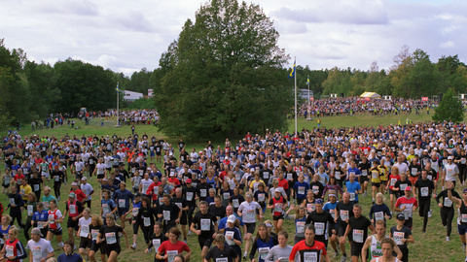
OldTownCross (from SVT FairyTale)  3840×2160, 50fps, 500 frames  Kodak Vision 250D film | 29  34  38  42 | 
DinnerScene (from Netflix Chimera)  4096×2160, 60fps, 600 frames  RED Epic Dragon digital camera | 29  32  36  40 | 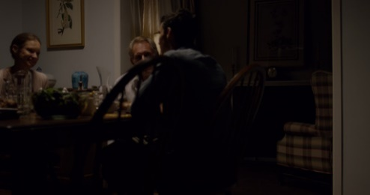

Film grain characteristics
The film grain parameters are specific to each sequence and considered part of test material. They were manually tuned to fit original grain, using a high-quality noise-free VTM encoding as a denoised basis (QP in the 22..26 range, selecting of noise-free frame typically in a high temporal layer). The frequency filtering model was chosen as it is easier to tune manually.

Test method
Visual tests were performed in InterDigital labs using the degradation category rating (DCR) test method [2][3], where the reference and the test videos are shown successively (see Figure 1), and where the viewer is asked to rate the test video on the 11-grade impairment scale shown in Table 3.

Vote n
Reference video
Impaired video
2s
10s
2s
10s
6s
Figure 1: DCR basic test cell
Table 3 – Meaning of 11-level impairment scale (Rec. ITU-R BT.500-14 Table 2-4)
Score | Impairment
10 | Imperceptible
9 | Slightly perceptible | somewhere
8 | Slightly perceptible | everywhere
7 | Perceptible | somewhere
6 | Perceptible | everywhere
5 | Clearly perceptible | somewhere
4 | Clearly perceptible | everywhere
3 | Annoying | somewhere
2 | Annoying | everywhere
1 | Severely annoying | somewhere
0 | Severely annoying | everywhere
The test involved a panel of 19 viewers (with a mix of experts and non-experts), in a controlled environment. The setup consisted in an LG OLED55C1 UHD screen in a dark room with controlled lighting. The viewers were placed at 1.5 time the height of the screen. At most two viewers simultaneously performed the test (except for one session with 3 viewers).
Raw videos and text messages were played through HDMI in YUV4:2:0 deep-color mode, using the MPV player.

Test results

Player issues
We had to use a raw video player for this test, since bitrates required to preserve film grain were too high and neither the TV nor other devices were capable of playing encoded files in real time (several codecs were tested).
We could not manage to play 60Hz UHD 10-bit raw video through HDMI using a PC that had a DeckLink 4K extreme card, even though the TV was supporting that resolution and frame rate in YUV deep color mode: we observed severe banding issues (on DinnerScene grain-free versions) that were not present on an SDI monitor. We resorted to a workstation with an nVidia GPU board, and HDMI configured to YUV4:2:2 12-bit. In this mode, playing YUV was still not perfect; we suspect spurious RGB/YUV conversions with loss of precision, as the GPU plane was reported as ARGB 2:10:10:10 bits. Also, the SSD speed was potentially an issue. In the end, we dithered all videos to 8-bits using VFGS and a special configuration file (basically a 0.5 sigma gaussian noise), which gave satisfying results.

General comments
The following comments were collected during test preparation work and preliminary viewing session by a few experts. They helped refine the test conditions of the actual test.
Grain model and parameters used look good enough for the purpose of the test, as, even though it was not explicitly asked, no viewer commented about the quality of the grain nor detected a difference from original.
Comments were made about the strength of the grain, which was said to be very strong on OldTownCross. Some viewers preferred the clean version, so it was clearly stated that the score should reflect the similarity to original, and that the focus should be on the visibility of coding defects rather than the presence of grain, and also that the removal of grain is a form of impairment (can not be rated 10/10).
The increased grain strength at low quality (see Table 1) may have been distracting instead of helpful, depending on the content:
- on CrowdRun it was judged to look artificial at QP 42
- on OldTownCross it was said to be helpful at QP 42, efficiently hiding coding defects and making the viewer think that the blurriness introduced by encoding was coming from bad capture.
Another observation is that it is difficult to compare qualities of grainy and clean versions of the same content. During preliminary viewing session test cells were grouped per sequence and per anchor (no grain)/test (grain synthesis). The order in which videos were presented could have created strong biases. Also training and repeated or slower motion viewing was helpful to identify coding defects and judge whether the grainy version was better: votes were much less reliable on unknown sequences, especially the first viewing occurrences.
For the formal test with full randomization, it has then been decided to randomize differently for each viewing session (with max two viewers), to help balance the ordering biases. It was also decided to have a training session where viewers can get used to the test content and the type of impairments (e.g. show originals and various coding qualities, either with or without grain synthesis).
During the formal test, more comments were collected:
- for OldTownCross the reference was said to be of poor quality and very grainy
- CrowdRun was said to be difficult to rate because of the many runners in fast motion. During the training it was then suggested to focus on more stable areas (grass, tree, sky, flags)
- for DinnerScene, the scene cut at the end with a short time on the face close-up was disturbing a bit the viewers

Video sequence issues
The first 600 frames of the DinnerScene sequence have been taken, which seemed to be problematic since a scene cut happens just 1.5 second before the end. It is recommended to study an alternate version with the scene cut in the middle.
Also, still on DinnerScene, the quality of QP 29 and QP 32 encodings were difficult to distinguish on the first part without film grain synthesis, and surprisingly a bit easier when film grain was added. It is recommended to study if replacing QP 32 with a higher one would be relevant.
Furthermore, it was noted that, when driven by the player PC, the TV applied some sort of dithering with a fixed pattern in dark areas, which causes a “dirty window” effect (only visible when film grain is not applied) and might have been distracting.

MOS curves
Raw votes are available in attached spreadsheet. To draw the rate/MOS curves below, two outliers were rejected out of the 19 viewers.
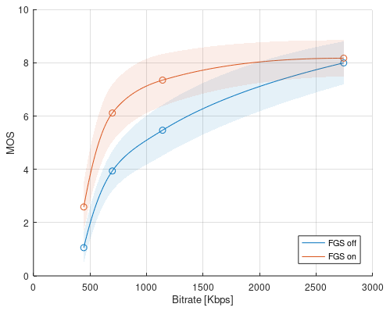  Figure 2 – MOS curves for OldTownCross | 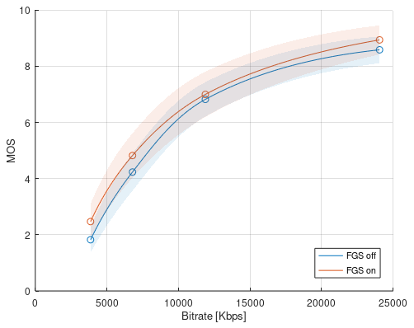  Figure 3 – MOS curves for CrowdRun
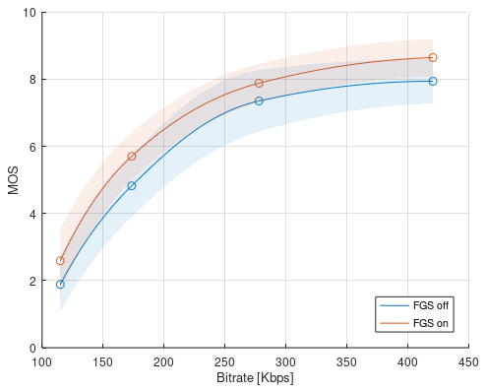
Figure 4 – MOS curves for DinnerScene

Further work: testing at high quality
It is recommended to also assess the effect of grain synthesis at very high coding quality, since bitrate savings are expected to be much higher than for the quality range used for DCR tests.
Preliminary work involved assessment of bitrate savings at high quality using two high quality points (much above the lowest QPs listed in Table 2), with the highest quality point mostly preserving grain. For example, DinnerScene at QP16 without FGS compared to QP20 with FGS (which has 88% lower bitrate, so almost a division by 10).
It was noted that, at high quality, film grain synthesis is highly helpful when grain is impaired in an irregular fashion by encoding: without grain synthesis, the irregularity can be very disturbing, while grain synthesis evens this effect out, helping the viewer to focus on the video itself. For example, the benefit is obvious on DinnerScene at QP 20 and 21.
So for the high quality tests, the encoded base used for FGS-on test point does not necessarily completely eliminates grain. The focus is on underlying texture/detail preservation.
A direct comparison method was used, as shown in Figure 2, and potentially taking time for repeated viewing. This could be considered a detectability test, and may need expert viewers that are more used to detect subtle defects.
It may be useful to assess two QP pairs for each sequence, one where FGS-on version is better, and one where it is worse (e.g. 16/20 and 16/21 for DinnerScene), to do some sort of bracketing.

Vote
Reference video
Video A

Video B
2s
10s
6s

Video A

Video B
2s
10s
2s
10s
2s
10s
2s
10s
Figure 5: Direct comparison test cell

Conclusion
The test performed in InterDigital labs confirmed that the first category of tests planned in JVET-AC2022 can be rolled out and can show a measurable benefit of film grain synthesis, which was here in the range of 20% bitrate savings.
It was identified that a good quality raw video player and display is essential to perform the test, especially a system that is capable of displaying unaltered 10-bit YUV at 4K resolution and 60Hz.
Preliminary tests at a higher quality range indicate that film grain synthesis at high quality can have a much larger impact on bitrate than for the quality range commonly used for DCR tests. Assessing it in a formal test is recommended. Since tests at high quality can not use the DCR method, a direct comparison method or detectability test is recommended.
Finally, since the benefit of film grain synthesis is dependent on test content, more test sequences are highly welcome.

References
- Rec. ITU-T H.274 | ISO/IEC 23002-7, Versatile supplemental enhancement information messages for coded video bitstreams
- Recommendation ITU-R BT.500-14 (2019), Methodologies for the subjective assessment of the quality of television images.
- Recommendation ITU-T P.910 (2008), Subjective video quality assessment methods for multimedia applications.
- https://github.com/InterDigitalInc/VersatileFilmGrain, Versatile Film Grain synthesis software

