    Joint Video Experts Team (JVET)  of ITU-T SG 16 WP 3 and ISO/IEC JTC 1/SC 29  30th Meeting, Antalya, TR, 21–28 April 2023 | Document: JVET-AD0219-v1

Title: | EE2-4.2/4.3/4.4a: Residual based classifier and modified filter shape for ALF
Status: | Input document to JVET
Purpose: | Proposal
Author(s) or  Contact(s): | Ikram Jumakulyyev, Nan Hu, Zhi Zhang, Vadim Seregin, Marta Karczewicz, Han Huang  5775 Morehouse Drive, San Diego, CA 92121, USA | Tel:  Email: | ijumakul@qti.qualcomm.com  nanh@qti.qualcomm.com
Source: | Qualcomm Incorporated
_____________________________

Abstract
This contribution reports results of EE tests 4.2, 4.3 and 4.4a. In test 4.2, an additional residual-based classifier for ALF is tested. In test 4.3, a modified ALF filter shape with more filter coefficients used for fixed-filter outputs is tested. Finally, in test 4.4a, the combination of 4.2 and 4.3 is tested. On top of ECM-8.0, simulation results of the proposed methods are reported as follows.
 | All intra |  |  | Random access |  |  | Low delay B
 | BD-rate Y | EncT | DecT | BD-rate Y | EncT | DecT | BD-rate Y | EncT | DecT
Test 4.2 | 0.00% | 98% | 100% | -0.12% | 99% | 99% | -0.21% | 99% | 98%
Test 4.3 | -0.01% | 100% | 103% | -0.07% | 100% | 101% | -0.09% | 101% | 102%
Test 4.4a | -0.01% | 99% | 103% | -0.17% | 101% | 99% | -0.28% | 100% | 100%

Introduction
In ALF process of ECM-8.0, a luma CTB can reference a signalled filter set in an adaptive parameter set (APS). For each filter set, a flag is signalled to indicate either a Laplacian-based classifier or a band-based classifier is applied to a 2x2 reconstructed luma block. For each class, a specific filter is applied among the different filters in the filter set.
The filter shape of a signalled ALF contains 4 types of inputs: neighbouring reconstructed samples (taps #0-#19), outputs from the two fixed filters (taps #20-#27), samples before the deblocking filter (taps #28-#30), residual samples and the filtered residual sample after applying the first fixed filter (taps #31-#32). In total, there are 33 filter coefficients.
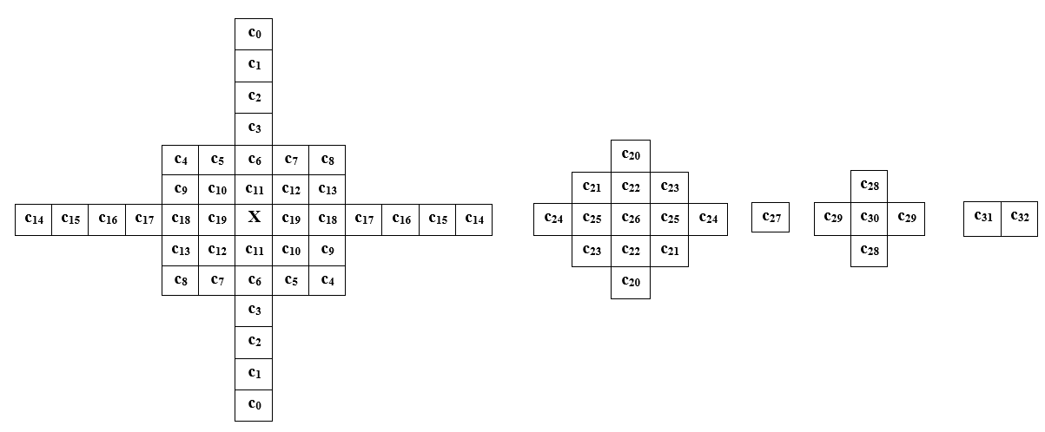
Figure 1. Filter shape of the signalled ALF filter in ECM-8.0.

Proposed methods

Test 4.2 – residual based classifier
Test 4.2 introduces a third classifier based on luma residual sample values. For each 2x2 luma block, the sum of absolute values of the residual samples in a neighbouring 8x8 window is calculated, and the class index is derived as:
classIdx = sum >> (sample bit depth – 4).
The value of classIdx is in the range of 0 to 24, same as in ECM-8.0. The classifier usage is signalled for each luma filter set in APS.

Test 4.3 – modified ALF shape
Test 4.3 increases the filter length applied to the samples obtained after utilizing the first fixed filter. Compared to the filter shape in ECM-8.0 shown in Figure 1, the overall number of filter coefficients for a signalled luma filter is increased by 2 as shown in Figure 2. Comparing to ECM-8.0, the length of the filter that is applied to the neighboring reconstructed samples (taps #0-#9) is reduced and the length of the filter applied to the samples after the fixed-filter (taps #10-#29) is increased.
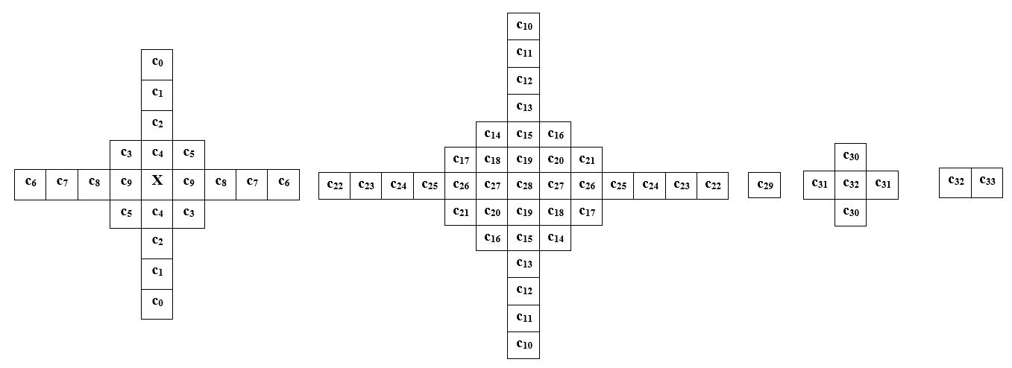
Figure 2. Proposed filter shape of the signalled ALF filter.

Test 4.4a
It is a combination of Test 4.2 (residual based classifier) and Test 4.3 (modified ALF shape).

Simulation Results
The EE tests were implemented on top of the ECM-8.0 and tested following common test conditions described in JVET-Y2017.
Table 1. Results of Test 4.2.
 | All Intra Main 10
 | Over ECM-8.0
 | Y | U | V | EncT | DecT
Class A1 | 0.00% | 0.00% | 0.01% | 98% | 102%
Class A2 | 0.01% | 0.01% | 0.00% | 99% | 101%
Class B | 0.00% | 0.00% | 0.00% | 99% | 100%
Class C | 0.00% | 0.00% | 0.00% | 99% | 99%
Class E | 0.00% | 0.00% | 0.00% | 97% | 99%
Overall | 0.00% | 0.00% | 0.00% | 98% | 100%
Class D | 0.00% | 0.00% | 0.00% | 98% | 100%
Class F | 0.00% | -0.02% | -0.02% | 98% | 99%
 | Random access Main 10
 | Over ECM-8.0
 | Y | U | V | EncT | DecT
Class A1 | -0.10% | 0.01% | -0.05% | 99% | 99%
Class A2 | -0.06% | 0.00% | 0.06% | 99% | 98%
Class B | -0.11% | 0.03% | -0.07% | 100% | 99%
Class C | -0.18% | -0.07% | -0.04% | 100% | 99%
Class E
Overall | -0.12% | -0.01% | -0.03% | 99% | 99%
Class D | -0.12% | 0.07% | 0.08% | 102% | 99%
Class F | -0.08% | -0.03% | 0.11% | 101% | 99%
 | Low delay B Main 10
 | Over ECM-8.0
 | Y | U | V | EncT | DecT
Class A1
Class A2
Class B | -0.13% | -0.05% | 0.03% | 99% | 99%
Class C | -0.32% | 0.18% | 0.10% | 98% | 97%
Class E | -0.21% | 0.56% | -0.38% | 101% | 99%
Overall | -0.21% | 0.18% | -0.05% | 99% | 98%
Class D | -0.12% | -0.19% | 0.02% | 101% | 95%
Class F | -0.07% | -0.12% | -0.13% | 100% | 97%
Table 2. Results of Test 4.3.
 | All Intra Main 10
 | Over ECM-8.0
 | Y | U | V | EncT | DecT
Class A1 | -0.03% | 0.00% | 0.00% | 100% | 104%
Class A2 | -0.02% | 0.01% | 0.01% | 100% | 104%
Class B | 0.00% | 0.00% | 0.00% | 101% | 104%
Class C | -0.03% | 0.01% | 0.01% | 100% | 102%
Class E | 0.01% | 0.01% | 0.01% | 99% | 103%
Overall | -0.01% | 0.01% | 0.01% | 100% | 103%
Class D | -0.02% | 0.02% | 0.02% | 100% | 103%
Class F | -0.01% | -0.01% | -0.01% | 100% | 102%
 | Random access Main 10
 | Over ECM-8.0
 | Y | U | V | EncT | DecT
Class A1 | -0.06% | -0.02% | -0.10% | 100% | 100%
Class A2 | -0.06% | 0.02% | 0.08% | 99% | 100%
Class B | 0.00% | 0.13% | -0.02% | 100% | 102%
Class C | -0.17% | 0.00% | 0.07% | 101% | 102%
Class E
Overall | -0.07% | 0.04% | 0.01% | 100% | 101%
Class D | -0.32% | 0.15% | -0.04% | 102% | 102%
Class F | -0.08% | -0.06% | -0.14% | 100% | 101%
 | Low delay B Main 10
 | Over ECM-8.0
 | Y | U | V | EncT | DecT
Class A1
Class A2
Class B | -0.05% | -0.31% | -0.22% | 101% | 103%
Class C | -0.16% | 0.17% | 0.05% | 100% | 101%
Class E | -0.08% | 0.25% | 0.58% | 101% | 102%
Overall | -0.09% | -0.01% | 0.07% | 101% | 102%
Class D | -0.29% | -0.72% | 0.36% | 101% | 101%
Class F | 0.14% | 0.15% | 0.79% | 100% | 100%

Table 3. Results of Test 4.4a.
 | All Intra Main 10
 | Over ECM-8.0
 | Y | U | V | EncT | DecT
Class A1 | -0.03% | 0.00% | 0.00% | 99% | 104%
Class A2 | -0.02% | 0.01% | 0.01% | 100% | 103%
Class B | 0.00% | 0.00% | 0.00% | 100% | 104%
Class C | -0.03% | 0.01% | 0.01% | 100% | 102%
Class E | 0.01% | 0.01% | 0.01% | 99% | 104%
Overall | -0.01% | 0.01% | 0.01% | 99% | 103%
Class D | -0.02% | 0.02% | 0.02% | 101% | 101%
Class F | -0.01% | -0.01% | -0.01% | 100% | 102%
 | Random access Main 10
 | Over ECM-8.0
 | Y | U | V | EncT | DecT
Class A1 | -0.14% | 0.05% | -0.12% | 100% | 98%
Class A2 | -0.11% | 0.07% | 0.11% | 99% | 97%
Class B | -0.10% | 0.08% | -0.07% | 101% | 100%
Class C | -0.30% | -0.03% | -0.06% | 102% | 101%
Class E
Overall | -0.17% | 0.04% | -0.04% | 101% | 99%
Class D | -0.39% | 0.13% | 0.02% | 106% | 102%
Class F | -0.17% | -0.06% | -0.16% | 106% | 101%
 | Low delay B Main 10
 | Over ECM-8.0
 | Y | U | V | EncT | DecT
Class A1
Class A2
Class B | -0.15% | 0.07% | 0.06% | 99% | 102%
Class C | -0.49% | 0.10% | -0.20% | 99% | 99%
Class E | -0.19% | 0.18% | 0.42% | 105% | 99%
Overall | -0.28% | 0.11% | 0.06% | 100% | 100%
Class D | -0.40% | -0.44% | 0.47% | 103% | 97%
Class F | -0.07% | 0.13% | 0.79% | 102% | 97%

Patent rights declaration(s)
Qualcomm Incorporated may have current or pending patent rights relating to the technology described in this contribution and, conditioned on reciprocity, is prepared to grant licenses under reasonable and non-discriminatory terms as necessary for implementation of the resulting ITU-T Recommendation | ISO/IEC International Standard (per box 2 of the ITU-T/ITU-R/ISO/IEC patent statement and licensing declaration form).

