    Joint Video Experts Team (JVET)  of ITU-T SG 16 WP 3 and ISO/IEC JTC 1/SC 29  30th Meeting, Antalya, TR, 21–28 April 2023 | Document: JVET-AD0212-v5

Title: | AHG11: neural network-based intra prediction with reduced complexity
Status: | Input document to JVET
Purpose: | Proposal
Author(s) or  Contact(s): | Thierry Dumas  Franck Galpin  Philippe Bordes | Tel:  Email: | thierry.dumas@interdigital.com
Source: | Interdigital
_____________________________

Abstract
Following the 29th JVET meeting, 11-20 January 2023, three additional neural network-based coding tools [1, 2, 3] have been integrated into VTM-11-NNVC [4]. In [1], a content-adaptive post-filter takes reconstructed luma and chroma samples of a given reconstructed frame, along with the slice QP, to return a filtered version of these samples. This post-filter consists of four stacks of convolutional layers trained offline. At the encoder side, the multipliers of one of these stacks, which are the coefficients multiplying the result of a convolution before applying the non-linearity, are fine-tuned on the current video sequence. Then, the multipliers update, i.e. the difference between the initial multipliers and their fine-tuned version, are coded using Neural Network compression and Representation (NNR) and sent to the decoder. In [2], two neural networks are used as upsamplers in RPR. For a given luma channel, its low-resolution reconstruction, its low-resolution prediction, the slice QP, and the base QP are fed into the first neural network, and the neural network output is added to the result of the RPR upsampling of the low-resolution reconstruction to obtain the high-resolution reconstruction. For a given pair of chroma channels, the neural network-based upsampling is almost identical to that in luma, but using the second neural network. In [3], a neural network-based intra prediction mode is added to the set of intra prediction modes in VVC.
To limit the complexity of the neural network-based intra prediction mode, each neural network in this mode features a relatively small architecture and weight sparsity is enforced. However, the architecture and weight sparsity policy has not been tuned to each neural network yet. This contribution thus proposes a refined architecture and weight sparsity policy to reach a new tradeoff between mean BD-rate gains and complexity.
It is reported that, on top of VTM-11-NNVC-4, whereas the neural network-based intra prediction mode in [3] yields -3.61%, -3.16%, -3.27% and -1.81%, -0.49%, -0.90% in AI and RA respectively for worst-case complexity of 7.8 kMACs/pixel, the neural network-based intra prediction mode with the refined policy yields -3.38%, -3.00%, -3.18% and -1.72%, -0.61%, -0.99% in AI and RA respectively for worst-case complexity of 4.8 kMACs/pixel.

Introduction
The neural network-based intra prediction mode contains 7 neural networks, each neural network predicting blocks of a different size in $\left\{4×4,8×4,16×4,32×4,8×8,16×8,16×16\right\}$. In terms of estimated complexity in MACs/pixel, the neural network inferences can be viewed as scattered. Indeed, the prediction of a given $16×16$ block via the dedicated neural network takes 1411 MACs/pixel whereas the prediction of a given $4×4$ block via the dedicated neural network takes 7773 MACs/pixel. This mainly comes from the simple policy applied to design the 7 different neural networks. In this contribution, it is proposed to refine the policy defining the architecture of each neural network and the weight sparsity in each of its layer. This way, in terms of complexity, the neural network inferences become less dispersed.

Architecture and weight sparsity policy

Architecture policy
The evolution of the architecture policy from [3] to the current proposition is presented in Table 1 using the definitions in Figure 1. Note that all the mentioned layers are fully-connected. No convolutional layers exist in the presented neural networks.

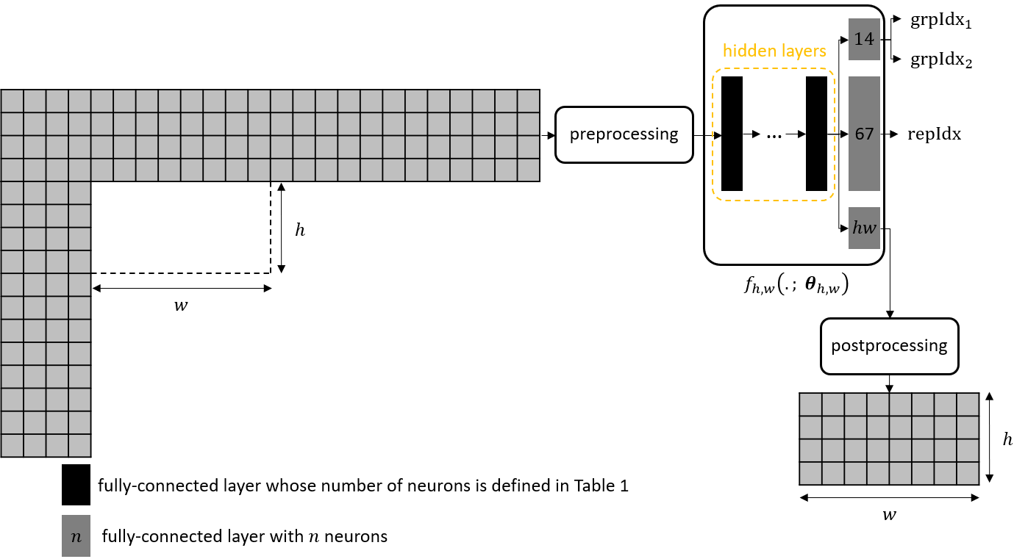
Figure 1: prediction of the current $w×h$ block from its context of reference samples via the neural network $f_{h, w}\left( . , θ_{h,w}\right)$, parametrized by $θ_{h,w}$, belonging to the neural network-based intra prediction mode. Here, $w=8$ and $h=4.$ The dimensions of the context of reference samples, “preprocessing”, “postprocessing”, $repIdx$, ${grpIdx}_{1}$, ${grpIdx}_{2}$ are explained in [3] and [4].

Table 1: architecture policy for each neural network in [3] and in the current proposition.
architecture | [3] | proposition
Number of hidden layers | For 16x16, 3.  For the other six neural networks, 2. | Same.
Number of neurons per hidden layer | 1216. | For 4x4, 8x4, and 16x16, 1216 for the last hidden layer, and 640 for the other hidden layers.  For the other four neural networks, 1216.
Biases | For all layers. | Only for the layer returning $repIdx$ and the layer returning ${grpIdx}_{1}$ and ${grpIdx}_{2}$.

Weight sparsity policy
Compared to [3], in the current proposition, the percentage of non-zero weights in the layer returning $repIdx$ becomes 10% for the neural network predicting blocks of size $4×4$, and 50% for the other six neural networks.

AHG11 template
Network information in training stage
Mandatory | GPU type | GPU: Tesla-P100-16GB
Mandatory | Framework | Tensorflow 2.6
Mandatory | Number of GPUs per task | 1
Mandatory | Epoch | 15
Mandatory | Batch size | 128
Mandatory | Training time | 8 hours to 3 days, depending on the training cycle.
Mandatory | Training data information | The set of images used to create the training sets combines frames extracted from the BVI-DVC dataset, the TVD dataset, the UVG dataset, and the RGB images in the ILSVCR2012 dataset set and DIV2-K, converted into YCbCr.
Mandatory | Training configurations for generating compressed training data | VTM-11-NNVC; QP {22, 27, 32, 37}
Mandatory | Patch size | The neural network predicting $w×h$ blocks is trained on pairs of a $w×h$ block and its context of reference samples.
Mandatory | Learning rate | Decreasing from 1e-4 to 5e-8.
Mandatory | Optimizer | ADAM
Mandatory | Loss function | SATD between the original block and its neural network prediction.
Mandatory | Preprocessing | See [3].
Note that the l1-norm weight-decay terms in the loss function has now disappeared.

Network information (inference)
Parameter number | block size | Parameter number
Parameter number | $$4×4$$  $$8×4$$  $$16×4$$  $$32×4$$  $$8×8$$  $$16×8$$  $$16×16$$ | $$77477$$  $$120816$$  $$182356$$  $$229048$$  $$194023$$  $$238768$$  $$291311$$
Parameter precision | 16-bit signed integer.
MAC/pixel | block size | MACs/pixel
MAC/pixel | $$4×4$$  $$8×4$$  $$16×4$$  $$32×4$$  $$8×8$$  $$16×8$$  $$16×16$$ | $$4837$$  $$3773$$  $$2848$$  $$1789$$  $$3030$$  $$1865$$  $$1138$$
Total conv. layers
Total FC layers | 4 cascaded fully-connected layers for the neural network predicting $16×16$ blocks.  3 cascaded fully-connected layers for the other six neural networks.
Mem (MB) | 4.9 MB for the whole neural network-based intra prediction mode.
GPU Type | No GPU
CPU Type | Xeon 2.4GHz
Framework | SADL (C++ with a single thread)
Given Table 1, from [3] to the current proposition, the worst-case number in MACs/pixel of the neural network-based intra prediction mode drops from 7.8 kMACs/pixel to 4.8 kMACs/pixel.

Experimental results
The test results are presented in Table 2, Table 3, Table 4, and Table 5.

 | All Intra Main10
 | BD-rate Over NNVC-4.0
 | Y-PSNR | U-PSNR | V-PSNR | Y-MSIM | U-MSIM | V-MSIM | EncT | DecT CPU | PSNR Overlap
Class A1 | -4.04% | -3.60% | -3.91% | -4.22% | -3.41% | -3.67% | 157% | 372% | 100%
Class A2 | -2.70% | -2.45% | -2.79% | -2.66% | -2.00% | -2.22% | 160% | 450% | 100%
Class B | -3.02% | -2.58% | -2.86% | -2.82% | -2.28% | -2.37% | 159% | 490% | 100%
Class C | -3.00% | -2.73% | -2.89% | -2.98% | -2.35% | -2.31% | 160% | 571% | 100%
Class E | -4.50% | -4.03% | -3.75% | -4.38% | -3.64% | -2.42% | 160% | 516% | 100%
Overall | -3.38% | -3.00% | -3.18% | -3.32% | -2.67% | -2.56% | 159% | 481% | 100%
Class D | -2.83% | -2.51% | -2.68% | -2.82% | -2.15% | -1.76% | 156% | 628% | 100%
Class F | -2.04% | -1.76% | -1.70% | -1.94% | -1.65% | -1.39% | 138% | 319% | 100%
Table 2: BD-rate gains of VTM-11-NNVC-4 with the neural network-based intra prediction mode using the proposed architecture and weight sparsity policy, 16-bit signed integer, versus VTM-11-NNVC-4.

 | Random access Main10
 | BD-rate Over NNVC-4.0
 | Y-PSNR | U-PSNR | V-PSNR | Y-MSIM | U-MSIM | V-MSIM | EncT | DecT CPU | PSNR Overlap
Class A1 | -2.20% | -0.92% | -1.49% | -2.02% | -0.57% | -1.05% | 129% | 151% | 100%
Class A2 | -1.39% | -0.28% | -0.93% | -1.35% | 0.27% | -0.35% | 128% | 139% | 100%
Class B | -1.70% | -0.39% | -0.71% | -1.59% | 0.07% | 0.18% | 131% | 155% | 100%
Class C | -1.63% | -0.88% | -1.03% | -1.47% | 0.01% | -0.01% | 133% | 183% | 100%
Class E
Overall | -1.72% | -0.61% | -0.99% | -1.60% | -0.03% | -0.22% | 130% | 158% | 100%
Class D | -1.34% | -1.07% | -1.06% | -1.42% | -1.05% | -0.39% | 130% | 176% | 100%
Class F | -1.12% | -0.78% | -0.75% | -0.88% | -0.38% | 0.01% | 131% | 122% | 100%
Table 3: BD-rate gains of VTM-11-NNVC-4 with the neural network-based intra prediction mode using the proposed architecture and weight sparsity policy, 16-bit signed integer, versus VTM-11-NNVC-4.

 | All Intra Main10
 | BD-rate Over NNVC-4.0
 | Y-PSNR | U-PSNR | V-PSNR | Y-MSIM | U-MSIM | V-MSIM | EncT | DecT CPU | PSNR Overlap
Class A1 | -9.98% | -19.51% | -21.06% | -10.03% | -22.16% | -23.58% | 243% | 24327% | 95%
Class A2 | -9.09% | -21.21% | -17.08% | -9.56% | -22.12% | -16.19% | 213% | 20058% | 96%
Class B | -9.21% | -20.94% | -23.78% | -9.09% | -23.45% | -25.51% | 198% | 17690% | 96%
Class C | -9.93% | -21.67% | -24.37% | -9.94% | -23.62% | -25.59% | 186% | 12795% | 96%
Class E | -13.56% | -23.44% | -25.61% | -13.81% | -23.39% | -27.47% | 202% | 19685% | 93%
Overall | -10.20% | -21.32% | -22.65% | -10.30% | -23.04% | -23.98% | 205% | 18045% | 95%
Class D | -9.67% | -21.06% | -25.00% | -8.90% | -24.66% | -26.07% | 179% | 12108% | 97%
Class F | -6.97% | -16.93% | -15.55% | -7.11% | -19.41% | -17.59% | 159% | 15730% | 95%
Table 4: BD-rate gains of VTM-11-NNVC-4 with the neural network-based intra prediction mode using the proposed architecture and weight sparsity policy and Filter-set-1, 16-bit signed integer, versus VTM-11-NNVC-4.

 | Random access Main10
 | BD-rate Over NNVC-4.0
 | Y-PSNR | U-PSNR | V-PSNR | Y-MSIM | U-MSIM | V-MSIM | EncT | DecT CPU | PSNR Overlap
Class A1 | -10.43% | -17.64% | -22.07% | -10.66% | -21.23% | -24.36% | 212% | 31129% | 94%
Class A2 | -10.94% | -20.87% | -16.91% | -10.77% | -21.29% | -15.67% | 199% | 31419% | 95%
Class B | -10.45% | -23.02% | -23.68% | -9.89% | -24.02% | -24.83% | 214% | 33695% | 96%
Class C | -11.93% | -24.23% | -25.58% | -10.70% | -22.26% | -23.02% | 192% | 32233% | 96%
Class E
Overall | -10.94% | -21.84% | -22.51% | -10.44% | -22.45% | -22.42% | 204% | 32320% | 95%
Class D | -13.82% | -24.85% | -28.09% | -10.14% | -23.88% | -24.29% | 183% | 29288% | 96%
Class F | -6.36% | -14.98% | -13.50% | -6.59% | -16.58% | -13.32% | 271% | 15077% | 97%
Table 5: BD-rate gains of VTM-11-NNVC-4 with the neural network-based intra prediction mode using the proposed architecture and weight sparsity policy and Filter-set-1, 16-bit signed integer, versus VTM-11-NNVC-4.

Conclusion
On top of VTM-11-NNVC-4, whereas the neural network-based intra prediction mode in [3] gives -3.61%, -3.16%, -3.27% and -1.81%, -0.49%, -0.90% in AI and RA respectively for worst-case complexity of 7.8 kMACs/pixel, the neural network-based intra prediction mode with the architecture and weight sparsity policy described in Section 2 provides -3.38%, -3.00%, -3.18% and -1.72%, -0.61%, -0.99% in AI and RA respectively for worst-case complexity of 4.8 kMACs/pixel.
On top of VTM-11-NNVC-4, whereas Filter-Set-1 and the neural network-based intra prediction mode in [3] yield -10.40%, -21.46%,-22.80% and -11.02%, -21.82%, -22.49% in AI and RA respectively, Filter-Set-1 and the neural network-based intra prediction with the architecture and weight sparsity policy detailed in Section 2 give -10.20%, -21.32%, -22.65% and -10.94%, -21.84%, -22.51% in AI and RA respectively.
It is suggested to study the modifications of the architecture and weight sparsity policy during the next round of EE1.

References
[1] M. Santamaria, R. Yang, F. Cricri, J. Lainema, H. Zhang, R. G. Youvalari, M. Hannuksela. EE1-1.11 : Content-adaptive post-filter. JVET-AC0055, 29th JVET meeting, Teleconference, 11-20 January 2023.
[2] R. Chang, L. Wang, X. Xu, S. Liu. EE1-2.2: GOP Level Adaptive Resampling with CNN-based Super Resolution. JVET-AC0196, 29th JVET meeting, Teleconference, 11-20 January 2023.
[3] T. Dumas, F. Galpin, P. Bordes. EE1-3.2 : neural network-based intra prediction with learned mapping to VVC intra prediction modes. JVET-AC0116, 29th JVET meeting, Teleconference, 11-20 January 2023.
[4] Y. Li, H. Wang, L. Wang, F. Galpin, J. Ström. Description of algorithms and software in neural network-based video coding (NNVC) version 2. JVET-AC2019, 29th JVET meeting, Teleconference, 11-20 January 2023.

Patent rights declaration(s)
Interdigital may have current or pending patent rights relating to the technology described in this contribution and, conditioned on reciprocity, is prepared to grant licenses under reasonable and non-discriminatory terms as necessary for implementation of the resulting ITU-T Recommendation | ISO/IEC International Standard (per box 2 of the ITU-T/ITU-R/ISO/IEC patent statement and licensing declaration form).

