    Joint Video Experts Team (JVET)  of ITU-T SG 16 WP 3 and ISO/IEC JTC 1/SC 29  30th Meeting, Antalya, TR, 21–28 April 2023 | Document: JVET-AD0211

Title: | EE1-Related: Combination test of EE1-1.3.5 and multi-scale component of EE1-1.6.
Status: | Input document to JVET
Purpose: | Proposal
Author(s) or  Contact(s): | Yun Li  Samuel Eadie  Dmytro Rusanovskyy  Marta Karczewicz | Email: | yli30@qti.qualcomm.com  seadie@qti.qualcomm.com  dmytror@qti.qualcomm.com  martak@qti.qualcomm.com
Source: | Qualcomm
_____________________________

Abstract
Input document JVET-AD0205, after JVET-AB0164 [1], reports results of the EE1-1.3, with the sub-test 1.3.5 studying convolution decompositions in residual blocks of the architecture and achieves 26% complexity reduction. A multi-scale feature extraction (employing point-wise convolution in parallel to 3x3 convolution) was studied in EE1-1.6, and demonstrated coding gain improvement, comparing to FilterSet1.
In this contribution, we present a combination of EE-1 tests 1.3.5 and 1.6. The multi-scale feature extraction component of test 1.6 was integrated into the backbone residual blocks of EE1-1.3.5.
Comparing to NNVC-4.0 anchor (NN tools OFF), proposed combination provides the following BD-Rate gain for RA and AI, respectively:
Model complexity in kMAC/pixel: 353.9 (frame-wise) of (Luma: 283.21, Chroma: 70.71); 447.9 (block-wise) of (Luma: 358.4, Chroma:89.5)
Float: {-10.33%, -24.26%, -25.31%} and {-8.08%, -21.61%, -22.8%}.
Int16: {-10.34%, -24.07%, -25.24%} and {-8.02%, -22.05%, -23.29%}.
Comparing to NNVVC filter set 1, proposed method has 31% lower complexity and demonstrates the following performance:
Float: {-0.81%, -4.52%, -4.92%} and {-0.75%, -4.21%, -3.6%}.
Int16: {-0.81%, -4.25%, -4.83%} and {-0.67%, --4.71%, -4.15%}.
It is proposed to study proposed method in the next round of EE.

Introduction
In the architecture of EE1-1.3.1, with the 3x3 kernel in the residual blocks, a larger receptive field can be captured for a better filtering operation, however with a complexity increase.
The two-stage decomposition decomposes a 3x3xKxK convolution into a 3x1xKxR convolution followed by a 1x3xRxK convolution. This architecture (shown in Figure 1) was studied in Test 1.3.5.a and reportedly achieves 26% complexity reduction vs. original method of EE1-1.3.1, as reported in JVET-AD0205.

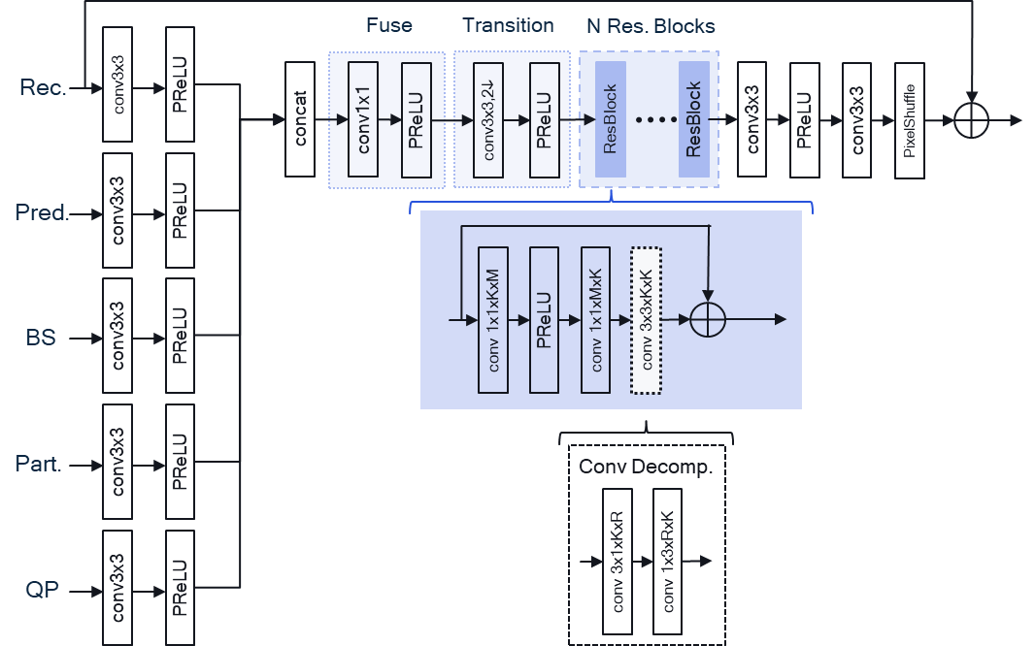
Figure 1. NN-based enhancement filter of EE1-1.3.5a test

In test EE1.6 [2], a multi-scale feature extraction component, shown in Figure2, was introduced through every stage of the network.

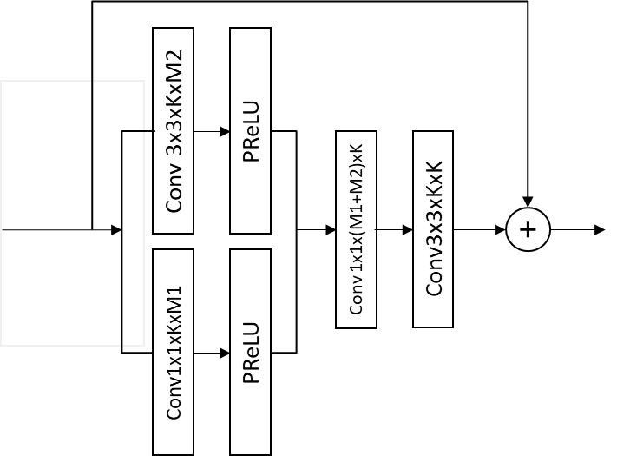
Figure 2. Residual block of EE1-1.6 filter featuring multi-scale feature extraction component.

Proposed method
In this contribution, we proposed to combine network architectures of EE1-1.3.5 and EE1-1.6 by introduce the multi-scale feature extraction component into the residual block of the EE1-1.3.5 backbone, as shown in Figure 3.
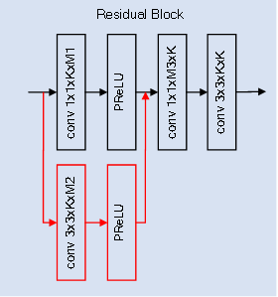
Figure 3. Proposed change to the residual block of EE1-1.3.1.
And as implemented in EE1-1.3.5, all the 3x3 convolutions in the backbone are decomposed by the two-component decomposition method. This resulting architecture is illustrated in Fig. 4. The parameters in our test are the following: K=64, R1=8, R2=44, M1=160, and M2=16.
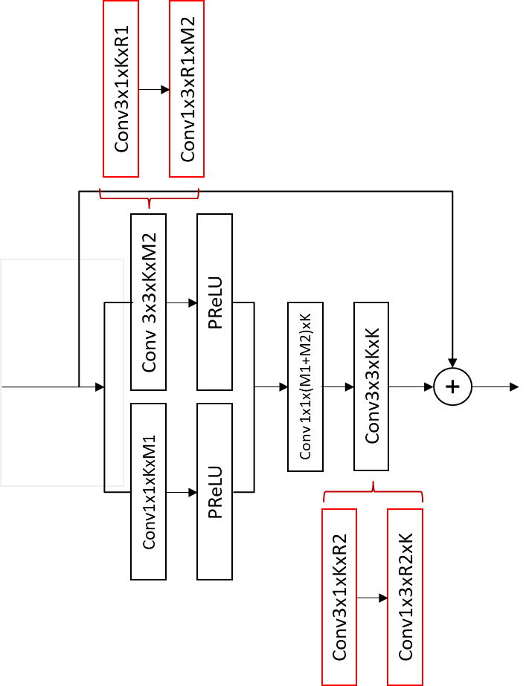
Figure 4. The 3x3 kernels are decomposed by the two-stage decomposition method marked in red.
The method was tested with training and inference which follows the EE1-1.3 testing procedure. The information for the inference and the training stage is presented in Table 1 and 2, respectively.

Table1. Network information for the inference
Network Information in Inference Stage
 | HW environment:
 | GPU Type |  | N/A
 | Framework: |  | SADL
 | Number of GPUs per Task |  | 0
 | Total Parameter Number |  | 1.07M/model
 | Parameter Precision (Bits) |  | 32 or 16
 | Memory Parameter (MB)
 | Multiply Accumulate (kMAC/pixel) block (frame) based |  | 448.9 (353.9 frame-wise)
 | Total Conv. Layers |  | 153
 | Total FC Layers |  | 0
 | Total Memory (MB) | Float | 4.2/model
 | Total Memory (MB) | Int16 | 2.1/model
 | Batch size: |  | 1
 | Patch size |  | 128$×$128, 256$×$256
 | Changes to network configuration or weights required to generate rate points
 | Peak Memory Usage
 | Other information:

Table 2. Network information for the training
Network Information in Training Stage
Mandatory | GPU Type | GPU: NVIDIA Tesla V100-SXM2-32GB
Mandatory | Framework: | PyTorch v1.8
Mandatory | Number of GPUs per Task | 1
Mandatory | Epoch: | 120
Mandatory | Batch size: | 64
Mandatory | Training time: | ~120h
Mandatory | Training data information: | DIV2K, BVI-DVC
Mandatory | Training configurations for generating compressed training data (if different to VTM CTC): | QP {22, 27, 32, 37, 42}
 | Loss function: | L1, L2
Optional | Number of iterations
Optional | Patch size | 144x144
Optional | Learning rate: | 1e-4
Optional | Optimizer: | ADAM
Optional | Preprocessing:
Optional | Other information:
No other changes to NNVC SW of EE1-1.3.5 have been introduced.

Simulation results
Simulations are performed based on the common test conditions for neural network-based video coding technology [3]. The NNVC SW of EE1-1.3.5a was used for inference testing of new model. Both floating point and integer implementation have been tested and reported below.
The BD-rate savings for the Y, Cb and Cr components, respectively, in the AI and RA configurations compared to NNVC 4.0 anchor are shown in Tables 3 and 4 for the floating- and fixed-point inference implementations, respectively.

Table 3 Proposed method (floating point) vs NNVC-4.0
 | AI |  |  | RA
 | Y-PSNR | U-PSNR | V-PSNR | Y-PSNR | U-PSNR | V-PSNR
Class A1 | -7.07% | -20.21% | -21.75% | -9.76% | -19.03% | -21.08%
Class A2 | -7.17% | -22.82% | -22.73% | -10.81% | -23.69% | -26.72%
Class B | -7.41% | -22.07% | -22.70% | -9.86% | -26.64% | -26.29%
Class C | -8.34% | -19.46% | -22.39% | -11.01% | -25.65% | -26.22%
Class E | -10.79% | -23.92% | -24.66%
Overall | -8.08% | -21.61% | -22.80% | -10.33% | -24.26% | -25.31%
Class D | -8.13% | -18.37% | -22.13% | -12.54% | -26.64% | -27.94%
Class F | -6.36% | -19.34% | -18.00% | -6.02% | -18.00% | -16.92%

Table 4 Proposed method (int16) vs NNVC-4.0
 | AI |  |  | RA
 | Y-PSNR | U-PSNR | V-PSNR | Y-PSNR | U-PSNR | V-PSNR
Class A1 | -6.99% | -20.24% | -23.06% | -9.79% | -18.69% | -21.12%
Class A2 | -7.06% | -22.72% | -22.87% | -10.81% | -23.47% | -26.76%
Class B | -7.35% | -24.02% | -23.72% | -9.86% | -26.49% | -26.07%
Class C | -8.30% | -19.13% | -22.23% | -10.99% | -25.53% | -26.16%
Class E | -10.72% | -23.81% | -24.64%
Overall | -8.02% | -22.05% | -23.29% | -10.34% | -24.07% | -25.24%
Class D | -8.09% | -18.19% | -21.95% | -12.51% | -26.85% | -27.81%
Class F | -6.27% | -19.26% | -17.81% | -6.01% | -17.95% | -16.84%

Additionally, proposed method was compared against FilterSet1, with simulation results reported in Tables 5 and 6.
As observed in tables 5 and 6, presented combination test demonstrates improved performance over Filter Set 1, bringing {-0.81%, -4.25%, -4.83%} and {-0.7%, --4.7%, -4.2%} in RA and AI, respectively, at 31% lower computation complexity.

Table 5 Proposed vs Filter set 1 (floating point)

 | AI |  |  | RA
 | Y-PSNR | U-PSNR | V-PSNR | Y-PSNR | U-PSNR | V-PSNR
Class A1 | -0.56% | -4.90% | -4.60% | -1.13% | -3.49% | -0.62%
Class A2 | -0.49% | -4.55% | -9.13% | -1.02% | -4.64% | -12.96%
Class B | -0.77% | -5.65% | -1.99% | -0.83% | -6.02% | -4.58%
Class C | -0.98% | -0.73% | -0.84% | -0.37% | -3.31% | -2.55%
Class E | -0.86% | -5.40% | -3.43%
Overall | -0.75% | -4.21% | -3.60% | -0.81% | -4.52% | -4.92%
Class D | -0.88% | 0.51% | 0.75% | 0.28% | -3.54% | -1.19%
Class F | -1.26% | -5.11% | -4.74% | -0.57% | -4.60% | -5.24%

Table 5 Proposed vs Filter set1 (int16 quantization)

 | AI |  |  | RA
 | Y-PSNR | U-PSNR | V-PSNR | Y-PSNR | U-PSNR | V-PSNR
Class A1 | -0.47% | -4.90% | -6.02% | -1.17% | -3.03% | -0.64%
Class A2 | -0.37% | -4.49% | -9.30% | -1.02% | -4.35% | -13.03%
Class B | -0.70% | -7.91% | -3.25% | -0.84% | -5.81% | -4.31%
Class C | -0.95% | -0.32% | -0.60% | -0.36% | -3.15% | -2.46%
Class E | -0.78% | -5.24% | -3.38%
Overall | -0.67% | -4.71% | -4.15% | -0.81% | -4.25% | -4.83%
Class D | -0.83% | 0.74% | 1.01% | 0.31% | -3.79% | -1.00%
Class F | -1.15% | -4.98% | -4.49% | -0.56% | -4.51% | -5.14%

Conclusion
In this contribution, we present a combination of EE-1 test 1.3.5 and 1.6. The multi-scale feature extraction component of test 1.6 was integrated into the backbone residual blocks of EE1-1.3.5.
Proposed method outperforms the Filter set 1, providing {-0.81%, -4.25%, -4.83%} and {-0.7%, --4.7%, -4.2%} coding gain in RA and AI, respectively, at 31% lower computation complexity.
Comparing to NNVC4.0, the proposed method (with int16 quantization) provides {-10.34%, -24.07%, -25.24%} and {-8.02%, -22.05%, -23.29%} coding gain for RA and AI, respectively.
It is proposed to study the method in the next round of EE.

References
- EE1-1.7: Capacity Ablation of CNN-based in-loop filtering, JVET-AB0164, S. Eadie, H. Wang, M. Coban, M. Karczewicz (Qualcomm)
- EE1-related: In-Loop filter with wide activation and large receptive field, JVET-AA0178, Y. Li, K. Zhang, L. Zhang.
- Common Test Conditions and evaluation procedures for neural network-based video coding technology, JVET-Z2016, E. Alshina, R.-L. Liao, S. Liu, A. Segall.

Patent rights declaration(s)
Qualcomm may have current or pending patent rights relating to the technology described in this contribution and, conditioned on reciprocity, is prepared to grant licenses under reasonable and non-discriminatory terms as necessary for implementation of the resulting ITU-T Recommendation | ISO/IEC International Standard (per box 2 of the ITU-T/ITU-R/ISO/IEC patent statement and licensing declaration form).

