    Joint Video Experts Team (JVET)  of ITU-T SG 16 WP 3 and ISO/IEC JTC 1/SC 29  30th Meeting, Antalya, TR, 21–28 April 2023 | Document: JVET-AD0205-v1

Title: | EE1-1.3: Reduced complexity CNN-based in-loop filtering
Status: | Input document to JVET
Purpose: | Proposal
Author(s) or  Contact(s): | Samuel Eadie  Yun Li  Dmytro Rusanovskyy  Marta Karczewicz | Email: | seadie@qti.qualcomm.com  yli30@qti.qualcomm.com  dmytror@qti.qualcomm.com  martak@qti.qualcomm.com
Source: | Qualcomm
_____________________________

Abstract
This contribution details the architectural improvements on JVET-AC0155 proposed in the EE1-1.3 tests and the corresponding computational complexity and BD-rate changes. Test 1.3.1 reports the baseline performance of the original architecture (from JVET-AC0155) with NNVC-4.0. Test 1.3.2a removes the redundant spatial processing of constant inputs (e.g. QP). Test 1.3.2b removes the partitioning input from the intra-frame models. Test 1.3.3 unifies the intra- and inter-frame models for luma and chroma, respectively. Test 1.3.5a decomposes expensive 3x3 convolutions into separable 3x1 and 1x3 convolutions. Test 1.3.5b proposes a model combining simplifications from the above sub-tests. The training and inference cross-check was performed for tests 1.3.1 and 1.3.5.
The study resulted in a better performance-complexity operating point: the combination test (1.3.5b-float) demonstrates gain over Filter Set 1 (RA-YUV: {-0.3%, -2.3%, -1.6%}, AI: {-0.3%, -2.2%, -1.7%}) with 35% lower computational complexity.
Comparing to NNVC-4.0 anchor (NN tools OFF), these tests provide the following BD-rate savings for RA and AI, respectively:
Test 1.3.1: Complexity 605.9 (478.74 frame-based) kMAC/pxl
Float: {-10.16%, -23.2%, -23.06%} and {-7.88%, -19.81%, -20.99%}
Int16: {-10.16%, -23.11%, -23.1%} and {-7.84%, -20.06%, -21.17%}
Test 1.3.5a: Complexity 447.56 (353.63 frame-based) kMAC/pxl
Float: {-9.9%, -23.14%, -23.06%} and {-7.69%, -20.57%, -21.69%}
Int16: {-9.35%, -23.03%, -23.03%} and {-7.6%, -20.7%, -21.76%}
Test 1.3.5b: Complexity 439.1 (346.94 frame-based) kMAC/pxl
Float: {-9.86%, -23.18%, -22.99%} and {-7.68%, -20.49%, -21.6%}
Int16: {-9.04%, -22.8%, -22.89%} and {-7.35%, -20.67%, -21.67%}
It is proposed to adopt architecture EE-1.3.5b to the reference NNVC SW as it provides a better performance-complexity trade-off in comparison to the current benchmark methods.

Introduction
EE1-1.3 studies approaches to improve the performance/complexity trade-off of the NN-based In Loop Filter from JVET-AC0155 [1]. Specifically, the sub-tests are as follows:
- EE1-1.3.1 reports the baseline performance of the original architecture (from JVET-AC0155) with NNVC-4.0,
- EE1-1.3.2a removes the redundant spatial processing of constant inputs (e.g. QP),
- EE1-1.3.2b removes the partitioning input from the intra-frame models,
- EE1-1.3.3 unifies the intra- and inter-frame models for luma and chroma, respectively,
- EE1-1.3.5a decomposes expensive 3x3 convolutions into separable 3x1 and 1x3 convolutions,
- EE1-1.3.5b proposes a model combining simplifications from these sub-tests.
The BD-Rate savings over NNVC-4.0 and computational complexities resulting from these sub-tests are visualized in Figure 1 and Figure 2, for AI and RA configurations, respectively, alongside the adopted filter sets (FS0, FS1) [4].
The BD-Rate savings are aggregated for visualisation following the YUV 6:1:1 ratio recommended in [7]; block-based kMAC/pixel is computed for each subtest and compared with the values published for FS0 and FS1. The BD-rate savings are shown for both floating-point (circle) and int16 (triangle) for each sub-test.

Figure 1: Performance-complexity operating points for sub-tests in comparison to adopted filters in AI configuration.

Figure 2: Performance-complexity operating points for sub-tests in comparison to adopted filters in RA configuration.
Detailed description of the conducted test and simulation results are provided in Section 4.

Training and Inference Information
The network information in the training and inference stages are outlined in Table 1 and Table 2, respectively, in accordance with the NN CTC [5].

Table 1: Network information in training stage
Network Information in Training Stage
Mandatory | GPU Type | GPU: NVIDIA Tesla V100-SXM2-32GB
Mandatory | Framework: | PyTorch v1.8
Mandatory | Number of GPUs per Task | 1
Mandatory | Epoch: | 120
Mandatory | Batch size: | 64
Mandatory | Training time: | ~120h
Mandatory | Training data information: | DIV2K, BVI-DVC
Mandatory | Training configurations for generating compressed training data (if different to VTM CTC): | QP {22, 27, 32, 37, 42}
 | Loss function: | L1, L2
Optional | Number of iterations
Optional | Patch size | 144x144
Optional | Learning rate: | 1e-4
Optional | Optimizer: | ADAM
Optional | Preprocessing:
Optional | Other information:

Table 2: Network information in inference stage
Network Information in Inference Stage
Sub-test |  | 1.3.1 | 1.3.2a | 1.3.2b | 1.3.3 | 1.3.5a | 1.3.5b
HW environment:
GPU Type |  | N/A
Framework: |  | SADL
Number of GPUs per Task |  | 0
Total Parameter Number (M) |  | 6.008 | 5.995 | 5.998 | 3.0185 | 4.2841 | 4.274
Parameter Precision (Bits) |  | fp32, int16
Memory Parameter (MB)
kMAC/pxl | Block | 605.9 | 605.02 | 589.36 | 613.3 | 447.56 | 439.1
kMAC/pxl | Frame | 478.76 | 478.04 | 472.78 | 484.59 | 353.63 | 346.94
Total Conv. Layers per Model |  | 81 | 80 | 80 | 82 | 105 | 103
Total FC Layers |  | 0
Total Memory (MB) | Float | 22.76 | 22.75 | 22.72 | 11.43 | 16.47 | 16.42
Total Memory (MB) | Int16 | 11.43 | 11.43 | 11.41 | 5.74 | 8.30 | 8.28
Batch size: |  | 1
Patch size |  | 128x128, 256x256
Changes to network configuration or weights required to generate rate points
Peak Memory Usage

Model Quantisation
JVET-AC0155 reported a noticeable mismatch in BD-rate savings between the floating-point and int16 inference runtimes. The software bug responsible for this was later identified and resolved. As such, the mismatch was alleviated for this network architecture (see EE1-1.3.1 in Table 3).

Table 3: Quantization error for sub-tests
Sub-test | Random access Main10 |  |  | All Intra Main10
Sub-test | BD-rate of int16 Over fp32
Sub-test | Y-PSNR | U-PSNR | V-PSNR | Y-PSNR | U-PSNR | V-PSNR
1.3.1 | 0.00% | 0.14% | -0.04% | 0.04% | -0.28% | -0.23%
1.3.2a | 0.02% | -0.01% | 0.15% | 0.00% | -0.34% | -0.11%
1.3.2b | 0.02% | 0.13% | -0.06% | 0.04% | -0.11% | 0.04%
1.3.3 | 0.21% | 0.10% | 0.26% | 0.02% | -0.18% | -0.08%
1.3.5a | 0.59% | 0.15% | 0.06% | 0.11% | -0.19% | -0.11%
1.3.5b | 0.92% | 0.55% | 0.15% | 0.37% | -0.20% | -0.09%

Exploration Experiments
The following sections further detail the sub-test designs and simulation results.

EE1-1.3.1: Baseline
In this sub-test, the network architecture from JVET-AC0155 (Figure 3) was retrained and tested on NNVC-4.0 to provide a baseline for the subsequent sub-tests. The BD-Rate savings in RA and AI configurations are shown for floating-point over the NNVC-4.0 anchor (Table 4), int16 over the NNVC-4.0 anchor (Table 5), and int16 over the adopted Filter Set 1 (Table 6).

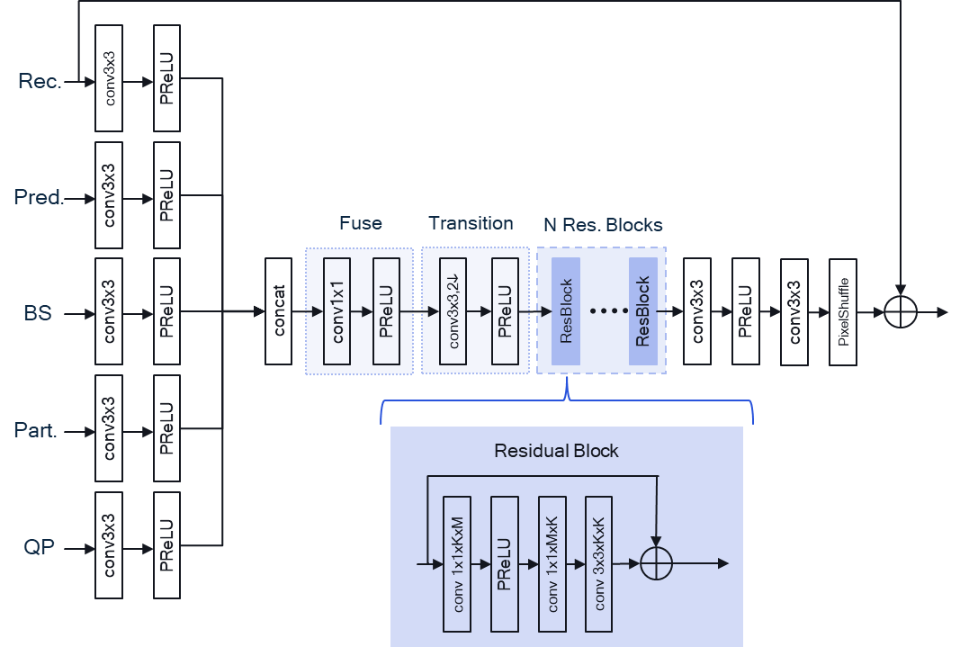

Figure 3: Network architecture for test 1.3.1

Table 4: Method 1.1.3 (Floating-point) BD-rate savings over NNVC4.0
 | Random access Main10 |  |  | All Intra Main10
 | BD-rate 1.3.1 Over VTM-11.0_nnvc-4.0
 | Y-PSNR | U-PSNR | V-PSNR | Y-PSNR | U-PSNR | V-PSNR
Class A1 | -9.64% | -18.89% | -20.47% | -6.92% | -18.89% | -20.21%
Class A2 | -10.69% | -22.52% | -19.35% | -6.97% | -21.06% | -18.96%
Class B | -9.77% | -24.94% | -25.15% | -7.22% | -19.77% | -21.30%
Class C | -10.65% | -24.77% | -25.18% | -8.12% | -18.38% | -21.45%
Class E |  |  |  | -10.52% | -21.48% | -22.64%
Overall | -10.16% | -23.20% | -23.06% | -7.88% | -19.81% | -20.99%
Class D | -12.49% | -26.12% | -28.23% | -7.90% | -17.17% | -21.05%
Class F |  |  |  | -6.29% | -18.28% | -17.72%

Table 5: Method 1.1.3 (int16) BD-rate savings over NNVC4.0
 | Random access Main10 |  |  | All Intra Main10
 | BD-rate 1.3.1_int16 Over VTM-11.0_nnvc-4.0
 | Y-PSNR | U-PSNR | V-PSNR | Y-PSNR | U-PSNR | V-PSNR
Class A1 | -9.65% | -18.80% | -20.65% | -6.87% | -18.77% | -20.15%
Class A2 | -10.62% | -22.30% | -19.35% | -6.92% | -20.99% | -19.10%
Class B | -9.77% | -24.98% | -25.17% | -7.18% | -20.76% | -21.97%
Class C | -10.68% | -24.61% | -25.16% | -8.12% | -18.34% | -21.45%
Class E |  |  |  | -10.48% | -21.52% | -22.57%
Overall | -10.16% | -23.11% | -23.10% | -7.84% | -20.06% | -21.17%
Class D | -12.54% | -25.97% | -28.13% | -7.90% | -17.18% | -20.98%
Class F | -5.99% | -17.31% | -17.34% | -6.27% | -18.34% | -17.76%

Table 6: Comparison of BD-rate savings for 1.3.1 (int16) against Filter Set 1
 | Random access Main10 |  |  | All Intra Main10
 | BD-rate 1.3.1_int16 Over FS1
 | Y-PSNR | U-PSNR | V-PSNR | Y-PSNR | U-PSNR | V-PSNR
Class A1 | -1.02% | -3.17% | -0.01% | -0.34% | -3.03% | -2.59%
Class A2 | -0.81% | -2.84% | -4.05% | -0.22% | -2.16% | -4.77%
Class B | -0.73% | -3.76% | -3.04% | -0.51% | -3.72% | -0.89%
Class C | -0.28% | -2.27% | -1.52% | -0.74% | 0.78% | 0.50%
Class E |  |  |  | -0.51% | -2.20% | -0.52%
Overall | -0.69% | -3.06% | -2.23% | -0.49% | -2.09% | -1.45%
Class D | 0.28% | -2.68% | -1.40% | -0.63% | 2.08% | 2.40%
Class F | -0.53% | -3.73% | -5.78% | -1.16% | -3.88% | -4.42%

EE1-1.3.2: Reduced input feature set
This sub-test studies the reduction of the input feature set to simplify the architecture. Specifically, two methods were investigated: reduced spatial processing over static input data, e.g. QP in this test (could be applicable for IPB data), and the removal of the partitioning information.

EE1-1.3.2a: Simplified Processing of Constant Inputs
This sub-test studies the removal of redundant spatial processing of constant inputs (e.g. QP). In this design, constant inputs are initially processed as scalars, and only reshaped to match other, non-constant inputs prior to the pre-fuse feature concatenation (Figure 4). Relevant input convolutions can be replaced by the multiplication with a 1x1xC_{in}xC_{out} tensor, followed by the addition of the bias parameter. The multiplication tensor can be computed by spatially summing the former 3x3xC_{in}xC_{out} convolution kernel. This simplification results in a negligible BD-Rate difference to the baseline model, as evidenced by simulation results with floating-point (Table 7) and int16 (Table 8) computations.

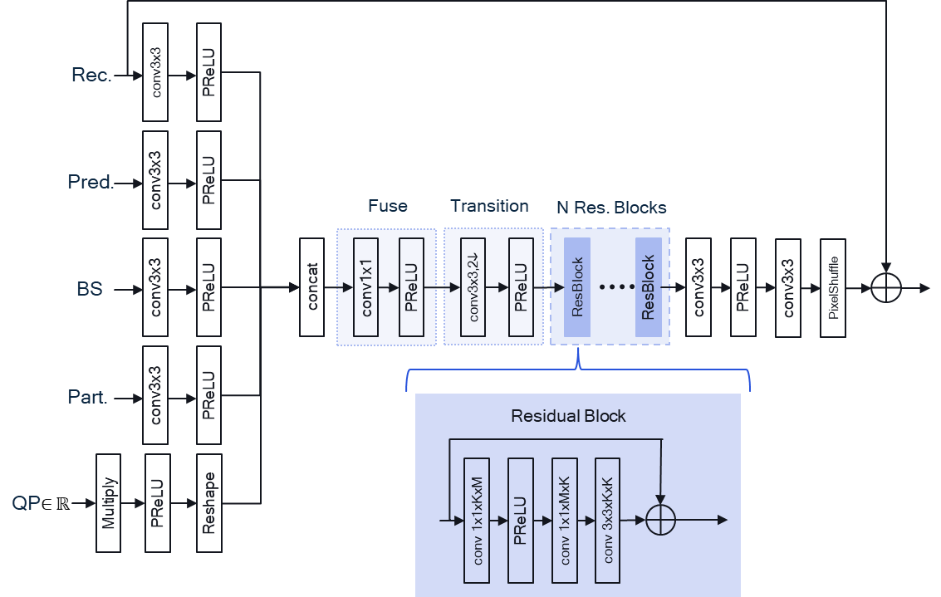

Figure 4: Network architecture for test 1.3.2a

Table 7: BD-Rate Savings of 1.3.2a over baseline 1.3.1 (floating-point)
 | Random access Main10 |  |  | All Intra Main10
 | BD-rate 1.3.2a Over 1.3.1
 | Y-PSNR | U-PSNR | V-PSNR | Y-PSNR | U-PSNR | V-PSNR
Class A1 | 0.03% | 0.46% | -0.06% | 0.00% | -0.22% | -0.06%
Class A2 | 0.05% | -0.03% | -0.08% | -0.02% | 0.21% | 0.01%
Class B | 0.02% | -0.05% | -0.20% | -0.01% | -0.37% | -0.48%
Class C | -0.02% | 0.25% | -0.09% | -0.07% | 0.23% | 0.07%
Class E |  |  |  | -0.02% | -0.02% | 0.01%
Overall | 0.02% | 0.14% | -0.12% | -0.03% | -0.06% | -0.12%
Class D | -0.01% | 0.27% | -0.20% | -0.07% | -0.02% | 0.18%
Class F | #VALUE! | #VALUE! | #VALUE! | -0.04% | -0.02% | 0.01%

Table 8: BD-Rate Savings of 1.3.2a over baseline 1.3.1 (int16)
 | Random access Main10 |  |  | All Intra Main10
 | BD-rate 1.3.2a_int16 Over 1.3.1_int16
 | Y-PSNR | U-PSNR | V-PSNR | Y-PSNR | U-PSNR | V-PSNR
Class A1 | 0.02% | 0.62% | -0.42% | -0.13% | -0.36% | -0.06%
Class A2 | 0.00% | -0.49% | 0.11% | -0.03% | -0.01% | 0.12%
Class B | 0.02% | -0.31% | 0.24% | -0.07% | -0.55% | -0.25%
Class C | 0.08% | 0.26% | 0.21% | -0.05% | 0.42% | 0.12%
Class E |  |  |  | -0.04% | 0.01% | 0.18%
Overall | 0.03% | -0.01% | 0.07% | -0.06% | -0.12% | 0.00%
Class D | 0.07% | -0.36% | -0.35% | -0.06% | 0.05% | 0.15%
Class F | 0.01% | -0.21% | 0.64% | -0.03% | 0.03% | 0.05%

EE1-1.3.2b: Removal of Partitioning Input
This sub-test studies the removal of the partition input from the luma and chroma intra-frame models (Figure 5); partitioning is already not used in the inter-frame models in 1.3.1. It is hypothesised that this input is largely redundant given the boundary strength. This simplification results in a negligible BD-Rate difference to the baseline model, as evidenced by simulation results with floating-point (Table 9) and int16 (Table 10) computations.
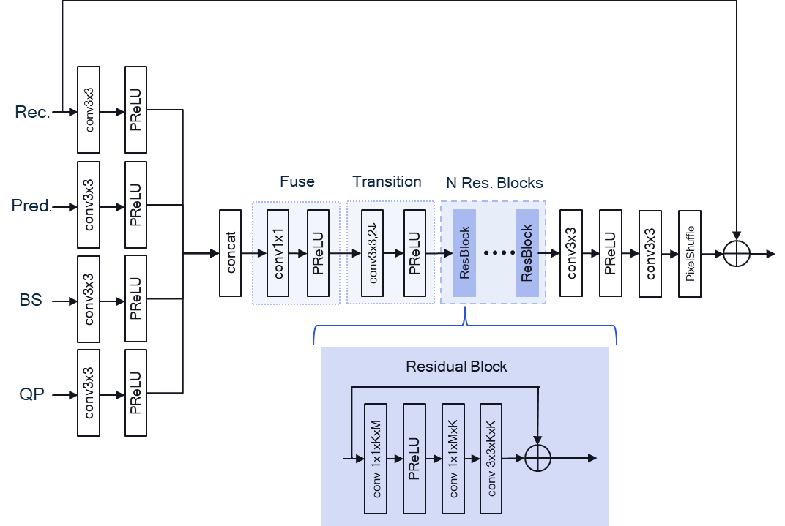

Figure 5: Network architecture for test 1.3.2b

Table 9: BD-Rate Savings of 1.3.2b over baseline 1.3.1, floating-point
 | Random access Main10 |  |  | All Intra Main10
 | BD-rate 1.3.2b Over 1.3.1
 | Y-PSNR | U-PSNR | V-PSNR | Y-PSNR | U-PSNR | V-PSNR
Class A1 | -0.01% | -0.17% | -0.25% | 0.00% | -0.23% | -0.04%
Class A2 | -0.03% | 0.10% | -0.19% | -0.02% | -0.16% | -1.09%
Class B | -0.02% | -0.08% | -0.25% | -0.03% | -0.76% | -0.67%
Class C | -0.05% | -0.06% | -0.12% | -0.07% | -0.40% | -0.16%
Class E |  |  |  | -0.01% | -0.21% | 0.02%
Overall | -0.03% | -0.06% | -0.20% | -0.03% | -0.40% | -0.41%
Class D | -0.04% | 0.16% | 0.19% | -0.06% | -0.29% | 0.02%
Class F | #VALUE! | #VALUE! | #VALUE! | -0.02% | -0.26% | 0.19%

Table 10: BD-Rate Savings of 1.3.2b over baseline 1.3.1, int16
 | Random access Main10 |  |  | All Intra Main10
 | BD-rate 1.3.2b_int16 Over 1.3.1_int16
 | Y-PSNR | U-PSNR | V-PSNR | Y-PSNR | U-PSNR | V-PSNR
Class A1 | 0.02% | 0.14% | -0.17% | -0.03% | -0.32% | -0.11%
Class A2 | #VALUE! | #VALUE! | #VALUE! | 0.01% | -0.16% | -0.99%
Class B | -0.02% | -0.05% | -0.20% | -0.05% | -0.19% | 0.20%
Class C | 0.00% | -0.21% | -0.14% | -0.06% | -0.38% | -0.18%
Class E |  |  |  | -0.01% | -0.07% | 0.15%
Overall | #VALUE! | #VALUE! | #VALUE! | -0.03% | -0.23% | -0.14%
Class D | 0.01% | -0.09% | 0.06% | -0.06% | -0.33% | -0.08%
Class F | -0.03% | -0.22% | -0.06% | -0.04% | -0.18% | 0.27%

EE1-1.3.3: Combined Intra and Inter models
This sub-test studies the merging of intra and inter frame models in order to reduce the total number of models from four to two. In the merged models, the slice type is an additional input to the model (Figure 6); note, that we do not currently use a block-based IPB input for these models [2]. This unification improves chroma BD-Rate savings, has negligible impact on luma BD-Rate savings for intra frames, but shows reduced luma BD-rate savings for inter frames (Table 11, Table 12). It is hypothesised that the former stems from an increased dataset size, while the latter is caused by an imperfect balancing of temporal layers in the new combined training dataset.
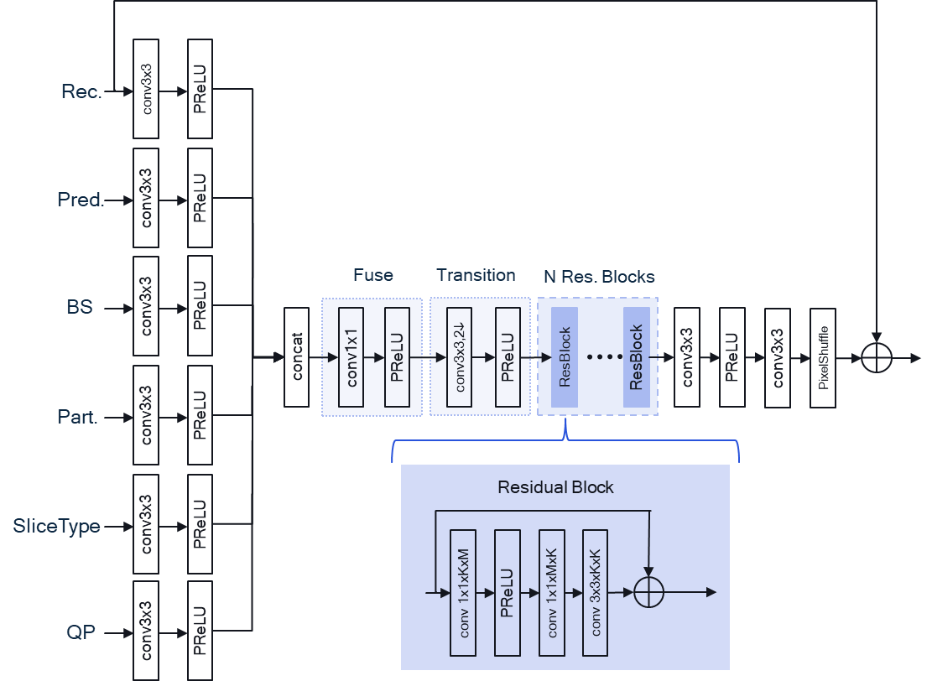
Figure 6: Network architecture for test 1.3.3

Table 11: BD-Rate Savings of 1.3.3 over baseline 1.3.1, floating-point
 | Random access Main10 |  |  | All Intra Main10
 | BD-rate 1.3.3 Over 1.3.1
 | Y-PSNR | U-PSNR | V-PSNR | Y-PSNR | U-PSNR | V-PSNR
Class A1 | 1.04% | -4.02% | -6.91% | 0.07% | -1.06% | -1.36%
Class A2 | 0.70% | -3.09% | -9.71% | 0.34% | -1.05% | -3.68%
Class B | 0.72% | -3.71% | -3.61% | 0.10% | -0.53% | -1.28%
Class C | 0.69% | -0.49% | -1.76% | 0.15% | -1.33% | -1.65%
Class E |  |  |  | 0.15% | -1.95% | -1.69%
Overall | 0.77% | -2.79% | -5.00% | 0.15% | -1.12% | -1.84%
Class D | 0.81% | -0.65% | -0.38% | 0.15% | -2.12% | -1.90%
Class F | #VALUE! | #VALUE! | #VALUE! | 0.14% | -1.84% | -1.89%

Table 12: BD-Rate Savings of 1.3.3 over baseline 1.3.1, int16
 | Random access Main10 |  |  | All Intra Main10
 | BD-rate 1.3.3_int16 Over 1.3.1_int16
 | Y-PSNR | U-PSNR | V-PSNR | Y-PSNR | U-PSNR | V-PSNR
Class A1 | 1.32% | -3.81% | -6.58% | 0.10% | -0.99% | -1.32%
Class A2 | 0.85% | -3.39% | -9.74% | 0.16% | -1.20% | -3.72%
Class B | 0.92% | -3.62% | -3.11% | 0.10% | -0.22% | -0.70%
Class C | 0.88% | -0.67% | -1.53% | 0.15% | -1.25% | -1.52%
Class E |  |  |  | 0.17% | -1.83% | -1.90%
Overall | 0.98% | -2.83% | -4.71% | 0.13% | -1.01% | -1.69%
Class D | 1.00% | -0.50% | -0.25% | 0.16% | -1.96% | -1.81%
Class F | 0.39% | -1.40% | 0.41% | 0.11% | -1.86% | -1.68%

EE1-1.3.4: Real-iterative training
This subtest is withdrawn.

EE1-1.3.5a Convolution Decomposition
This subtest studies the application of convolution decompositions, such as those employed in JVET-AC0106, to reduce the computational complexity of the baseline model from EE1-1.3.1. In this approach, the 3x3xKxK convolution in every backbone residual block is replaced by two spatially-separable convolutions with kernels of size 3x1xKxR and 1x3xRxK, respectively, where R=0.8K is the rank of the approximation (Figure 7). This simplification reduces the complexity by 26% (from 605.9 to 447.56 kMAC/pixel), with a penalty of {0.3%, 0.1%,0.02%}, {0.2%, -1.0%, -0.9%} for RA and AI, respectively. The quantisation of separable convolutions to int16 has so far proven challenging, with some approaches, for example, using int32 instead [3]. The simulation results for the quantized model face a penalty of around 1% for luma on average in the RA configuration. This problem was resolved in the EE1-related proposal JVET-AD0207 [6] using the same network architecture but a refined training strategy. A summary of the simulation results over the NNVC-4.0 anchor is presented in Table 13 and Table 14 for floating point and integer implementations, respectively.

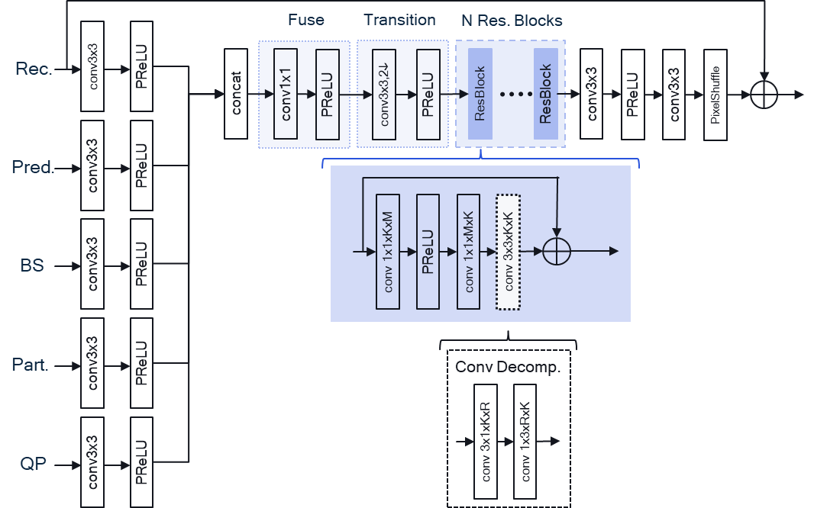
Figure 7: Network architecture for test 1.3.5a

Table 13: BD-Rate Savings of 1.3.5a over NNVC-4.0, (floating-point)
 | Random access Main10 |  |  | All Intra Main10
 | BD-rate 1.3.5a Over 1.3.1
 | Y-PSNR | U-PSNR | V-PSNR | Y-PSNR | U-PSNR | V-PSNR
Class A1 | -9.47% | -18.75% | -20.68% | -6.80% | -19.45% | -20.52%
Class A2 | -10.36% | -22.53% | -19.22% | -6.81% | -21.35% | -20.42%
Class B | -9.49% | -25.09% | -25.31% | -7.05% | -21.35% | -22.43%
Class C | -10.38% | -24.46% | -24.94% | -7.90% | -18.66% | -21.46%
Class E |  |  |  | -10.26% | -22.15% | -23.19%
Overall | -9.90% | -23.14% | -23.06% | -7.69% | -20.57% | -21.69%
Class D | -12.27% | -26.07% | -27.97% | -7.73% | -17.48% | -21.35%
Class F | #VALUE! | #VALUE! | #VALUE! | -6.06% | -18.33% | -17.75%

Table 14: BD-Rate Savings of 1.3.5a over NNVC-4.0, (int16)
 | Random access Main10 |  |  | All Intra Main10
 | BD-rate 1.3.5a_int16 Over 1.3.1_int16
 | Y-PSNR | U-PSNR | V-PSNR | Y-PSNR | U-PSNR | V-PSNR
Class A1 | -8.77% | -18.66% | -21.11% | -6.75% | -19.38% | -20.62%
Class A2 | -9.92% | -22.35% | -19.21% | -6.70% | -21.36% | -20.45%
Class B | -9.02% | -24.99% | -25.12% | -6.98% | -22.04% | -22.71%
Class C | -9.77% | -24.37% | -24.71% | -7.78% | -18.49% | -21.45%
Class E |  |  |  | -10.13% | -22.08% | -23.06%
Overall | -9.35% | -23.03% | -23.03% | -7.60% | -20.70% | -21.76%
Class D | -11.66% | -26.08% | -27.96% | -7.57% | -17.37% | -21.23%
Class F | -5.48% | -17.20% | -16.57% | -5.83% | -18.34% | -17.66%

EE1-1.3.5b Combination Test
This sub-test studies a combination of model simplifications from the aforedescribed sub-tests, including the removal of partitioning, simplified processing of constant inputs, and the decomposition of expensive convolutions (Figure 8). The BD-rate savings are reported over NNVC-4 and FS1 (Table 17, Table 18, Table 19).

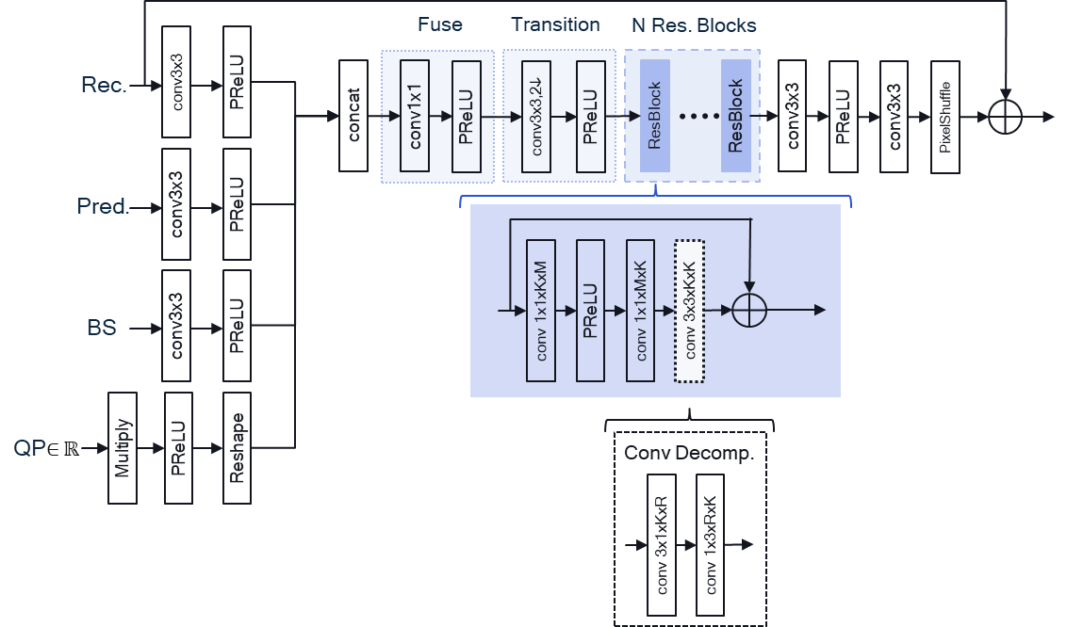

Figure 8: Network architecture for test 1.3.5b

Table 17: Method 1.3.5b (Floating-point) BD-rate savings over NNVC4.0
 | Random access Main10 |  |  | All Intra Main10
 | BD-rate 1.3.5b Over VTM-11.0_nnvc-4.0
 | Y-PSNR | U-PSNR | V-PSNR | Y-PSNR | U-PSNR | V-PSNR
Class A1 | -9.44% | -19.16% | -20.42% | -6.78% | -19.22% | -20.46%
Class A2 | -10.36% | -22.54% | -19.16% | -6.83% | -21.29% | -19.96%
Class B | -9.45% | -24.95% | -25.22% | -7.04% | -20.95% | -22.28%
Class C | -10.33% | -24.48% | -24.98% | -7.86% | -19.03% | -21.75%
Class E |  |  |  | -10.25% | -22.15% | -23.07%
Overall | -9.86% | -23.18% | -22.99% | -7.68% | -20.49% | -21.60%
Class D | -12.12% | -26.21% | -27.97% | -7.69% | -17.91% | -21.42%
Class F | -5.74% | -17.09% | -16.57% | -6.02% | -18.50% | -17.50%

Table 18: Method 1.3.5b (int16) BD-rate savings over NNVC4.0
 | Random access Main10 |  |  | All Intra Main10
 | BD-rate 1.3.5b_int16 Over VTM-11.0_nnvc-4.0
 | Y-PSNR | U-PSNR | V-PSNR | Y-PSNR | U-PSNR | V-PSNR
Class A1 | -8.22% | -18.31% | -20.43% | -6.32% | -19.00% | -20.36%
Class A2 | -9.17% | -21.99% | -19.16% | -6.42% | -21.24% | -20.06%
Class B | -8.68% | -24.71% | -24.96% | -6.75% | -21.99% | -22.67%
Class C | -10.02% | -24.38% | -24.93% | -7.70% | -18.82% | -21.67%
Class E |  |  |  | -9.86% | -22.01% | -22.97%
Overall | -9.04% | -22.80% | -22.89% | -7.35% | -20.67% | -21.67%
Class D | -11.73% | -26.19% | -27.91% | -7.55% | -17.69% | -21.22%
Class F | -5.34% | -17.01% | -16.56% | -5.76% | -18.48% | -17.50%

Table 19: Method 1.3.5b (Floating-point) BD-rate savings over FS1
 | Random access Main10 |  |  | All Intra Main10
 | BD-rate 1.3.5b Over FS1
 | Y-PSNR | U-PSNR | V-PSNR | Y-PSNR | U-PSNR | V-PSNR
Class A1 | -0.78% | -3.65% | 0.26% | -0.24% | -3.66% | -3.00%
Class A2 | -0.52% | -3.20% | -3.84% | -0.12% | -2.53% | -5.79%
Class B | -0.38% | -3.71% | -3.11% | -0.36% | -4.02% | -1.33%
Class C | 0.10% | -2.10% | -1.28% | -0.46% | -0.12% | 0.07%
Class E |  |  |  | -0.25% | -3.08% | -1.29%
Overall | -0.36% | -3.17% | -2.10% | -0.31% | -2.69% | -2.03%
Class D | 0.77% | -3.03% | -1.19% | -0.40% | 1.18% | 1.80%
Class F | -0.26% | -3.45% | -4.82% | -0.89% | -4.11% | -4.15%

Conclusion
This contribution details the architectural improvements on JVET-AC0155 proposed in the EE1-1.3 tests and the corresponding computational complexity and BD-rate changes. The presented combination test (1.3.5b-float) demonstrates improved performance over Filter Set 1 (RA-YUV: {-0.3%, -2.3%, -1.6%}, AI: {-0.3%, -2.2%, -1.7%}) with 35% lower computational complexity, achieving an improved performance-complexity operating point. It is therefore proposed to adopt architecture EE-1.3.5b to the reference NNVC SW as it provides a better performance-complexity trade-off in comparison to the current benchmark methods.

References
- EE1-1.9: Reduced complexity CNN-based in-loop filtering, JVET-AC0155, S. Eadie, M. Coban, M. Karczewicz (Qualcomm)
- EE1-1.5: Combined intra and inter models for luma and chroma, JVET-AC0089, D. Liu, J. Ström, M. Damghanian, P. Wennersten, K. Andersson (Ericsson)
- EE1-1.10: Complexity Reduction on Neural-Network Loop Filter, JVET-AC0106, J. N. Shingala, A. Shyam, A. Suneia, S. P. Badya (Ittiam), T. Shao, A. Arora, P. Yin, Sean McCarthy (Dolby)
- JVET AHG report: NNVC software development AhG14, JVET-AD0014, S. Eadie, F. Galpin, Y. Li, L. Wang, Z. Xie (AhG chairs),
- Common Test Conditions and evaluation procedures for neural network-based video coding technology, JVET-Z2016, E. Alshina, R.-L. Liao, S. Liu, A. Segall.
- EE1-Related: Additional results for EE1-1.3.1 and EE1-1.3.5, JVET-AD0207, Y. Li, S. Eadie, D. Rusanovskyy, M. Karczewicz (Qualcomm)
- Technical Paper ITU-T HSTP-VID-WPOM (07/2020): "Working practices using objective metrics for evaluation of video coding efficiency experiments", ITU-T HSTP-VID-WPOM, 2020

Patent rights declaration(s)
Qualcomm may have current or pending patent rights relating to the technology described in this contribution and, conditioned on reciprocity, is prepared to grant licenses under reasonable and non-discriminatory terms as necessary for implementation of the resulting ITU-T Recommendation | ISO/IEC International Standard (per box 2 of the ITU-T/ITU-R/ISO/IEC patent statement and licensing declaration form).

