    Joint Video Experts Team (JVET)  of ITU-T SG 16 WP 3 and ISO/IEC JTC 1/SC 29  30th Meeting, Antalya, TR, 21–28 April 2023 | Document: JVET-AD0176-v2

Title: | Non-EE2: Improvements on multi-pass DMVR
Status: | Input document to JVET
Purpose: | Proposal
Author(s) or  Contact(s): | Jie Chen  Ru-Ling Liao  Xinwei Li  Yan Ye | Tel:  Email: | {jiechen.cj, ruling.lrl, sid.lxw, yan.ye}@alibaba-inc.com
Source: | Alibaba group
_____________________________

Abstract
In this contribution, it is proposed to extend the current multi-pass DMVR in ECM by adding a new pass where 4x4 subblock level BDOF based motion refinement is applied. It is reported that the proposed method achieves {-0.14%(Y), -0.22%(U), -0.25%(V)} BD-rate performance on top of ECM-8.0.

Introduction
The decoder side motion vector refinement (DMVR) is applied to refine the motion vector inherited from the previously coded blocks in merge mode as the motion information of the previously coded blocks may not be perfectly fit for the current block.
In ECM[1], a multi-pass (DMVR) is applied. There are three passes of motion refinement. In the first pass, bilateral matching (BM) is applied to the coding block (CB). The motion vector pair (MV) of the CB is refined by minimizing the BM cost. In the second pass, the CU is divided into 16x16 subblocks and on top of CU level refined MV pair obtained in the first pass, BM is continually applied on each 16x16 subblock to get a 16x16 subblock level refined MV pair. In the third pass, each 16x16 subblock is further divided into 8x8 subblocks and on top of 16x16 subblock level refined MV pair, bi-directional optical flow (BDOF) based motion refinement is applied. A delta MV pair for each 8x8 subblock is calculated through optical flow equations and the 8x8 subblock level refined MV pair is obtained by adding the delta MV pair to the 16x16 subblock level refined MV pair. And the obtained 8x8 subblock level refined MVs are the final output of multi-pass DMVR process which are used for following motion compensation and stored for both spatial and temporal motion vector prediction as well.

Proposed methods
In this contribution, it is proposed to extend the current multi-pass DMVR by adding another BDOF-based motion refinement pass. The new proposed pass is applied as the 4th pass of the multi-pass DMVR. After the 3rd pass of the current DMVR, the CU is further divided into 4x4 subblocks and the optical flow equations are invoked to calculate a delta MV pair for each 4x4 subblock. The operations in the proposed 4th pass are the same as that in the current 3rd pass of multi-pass DMVR except for the subblock size. With proposed pass, the flow chart of multi-pass DMVR is shown as Figure 1.
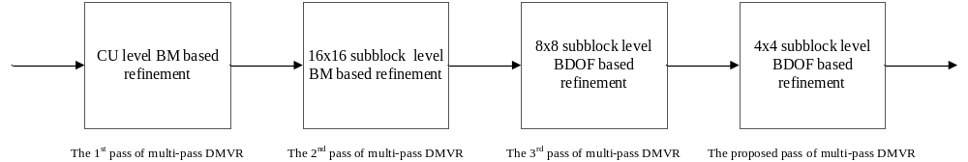
Figure 1. The flow chart of the multi-pass DMVR with the proposed method.

Simulation results
The proposed method is implemented on top of ECM-8.0 and is tested under RA configuration of ECM CTC [2]. The simulation results are shown in Table 1.
Table 1. Test results
 | Random Access Main 10
 | Over ECM-8.0
 | Y | U | V | EncT | DecT
Class A1 | -0.02% | -0.12% | -0.19% | 107% | 116%
Class A2 | -0.25% | -0.38% | -0.32% | 107% | 117%
Class B | -0.11% | -0.18% | -0.19% | 106% | 120%
Class C | -0.20% | -0.23% | -0.30% | 105% | 118%
Class E
Overall | -0.14% | -0.22% | -0.25% | 106% | 118%
class D | -0.30% | -0.26% | -0.44% | 105% | 118%
class F | -0.12% | -0.19% | -0.03% | 104% | 111%

Conclusion
The multi-pass DMVR in ECM-8.0 is extended by adding another BDOF-based motion refinement pass. By doing this, it is reported that overall {-0.14%(Y), -0.22%(U), -0.25%(V)} BD-rate performance can be achieved with 106% encoding time and 118% decoding time. It is suggested to study the proposed method in the next round of EE.

References
- M. Coban, F. Le Léannec, R.-L. Liao, K. Naser, J. Ström, L. Zhang, “Algorithm description of Enhanced Compression Model 8 (ECM 8)”, JVET-AC2025, Jan. 2023
- M. Karczewicz and Y. Ye, “Common Test Conditions and evaluation procedures for enhanced compression tool testing”, JVET-Y2017, Feb. 2022

Patent rights declaration(s)
Alibaba group may have current or pending patent rights relating to the technology described in this contribution and, conditioned on reciprocity, is prepared to grant licenses under reasonable and non-discriminatory terms as necessary for implementation of the resulting ITU-T Recommendation | ISO/IEC International Standard (per box 2 of the ITU-T/ITU-R/ISO/IEC patent statement and licensing declaration form).

