    Joint Video Experts Team (JVET)  of ITU-T SG 16 WP 3 and ISO/IEC JTC 1/SC 29  30th Meeting, Antalya, TR, 21–28 April 2023 | Document: JVET-AD0169-v3

Title: | AHG12: RPR filters for scale factors below 1.5x
Status: | Input document to JVET
Purpose: | Proposal
Author(s) or  Contact(s): | Jonatan Samuelsson-Allendes  Sachin Deshpande | Tel:  Email: | +46721882169  samuelssonj@sharplabs.com
Source: | Sharp Labs of America, Inc.
_____________________________

Abstract
This input document relates to Reference Picture Resampling (RPR) in ECM. The document includes a proposal to add new Motion Compensation (MC) filters for downsampling with scale factors in the range from 1.1x to 1.35x. It is also proposed to modify the non-normative downsampling included in the ECM software for the same range of scale factors, asserted to improve the quality of the downsampled pictures. Combined, these changes result in an average BD-Rate difference (Y/U/V) of -5.70%/-3.31%-2.81% for 1.25x RA, -7.16%/-2.42%-2.00% for 1.25x LD, -9.30%/-4.17%-3.49% for 1.33x RA, and -11.65%/-2.79%-1.86% for 1.33x LD. In the first version of the proposal these average numbers do not include class A1 and A2 for RA, and the BQTerrace sequence is not included in class B for the 1.25x LD test case since the results are not available yet. In the second version of the proposal, the awaited results have been added (except for ParkRunning3 which is still awaited for 1.33x RA). Additionally, run time numbers were corrected and the RA results have been updated for class B, C and D since the class specific settings were not used in the results presented in the first version. In the third version of the document, PSNR1 results and PSNR2 results for the normative aspect were added as well as PSNR2 results for the non-normative aspect tested for class A in VTM. The slide deck was also updated in v3 with some additional slides.

Introduction
Compared to previous video coding standards such as AVC and HEVC, the VVC standard introduces Reference Picture Resampling (RPR) as a tool for adaptively changing resolution within a Coded Layer Video Sequence (CLVS). Two additional sets of filters are included in the Motion Compensation (MC) in VVC; one that is optimized for 1.5x scaling and one that is optimized for 2x scaling. However, reduced resolution for all scale factors from 1x to 2x are supported by the VVC standard.
The scale factors 1.5x and 2x represent scaling between common resolutions, for example 1080p to 720p and 2160p to 1080p, respectively. These scale factors represent a sample count reduction of 56% and 75%, respectively.
In many practical cases, such as in Adaptive Bitrate Streaming (ABR) the resolution difference between different representations will be smaller than 1.5x. The HLS authoring specification from Apple [1] includes for example steps from 720p to 540p (1.33x), 1440p to 1080p (1.33x) and 540p to 432p (1.25x). The Netflix bitrate ladder presented in the “Per-Title Encode Optimization” blog post [2] includes steps from 384p to 288p (1.33x) and 480p to 384p (1.25x).
The scale factors 1.33x and 1.25x represent a sample count reduction of 44% and 36%, respectively.
In VVC, the MC filters for 1.5x will be used when the RPR scale factor is 1.33x, and the regular (1x) MC filters will be used when the RPR scale factor is 1.25x. This leads to suboptimal performance; 1.33x will use RPR filters that are too soft and 1.25x will use RPR filters that are too sharp. It is proposed to introduce one additional set of RPR filters that provide good performance for both these scale factors.
It can also be noted that a recent JVET contribution, JVET-AC0096 [3], proposes to test RPR with 1.25x scaling in addition to 1.5x and 2x scaling. Furthermore, the draft verification test plan for VVC multilayer coding, JVET-AC2021 [4], includes 1.33x scaling in addition to 1.5x and 2x scaling and in JVET-AC0145 [5] (experiments in preparation of dual-layer VVC visual tests), two out of four test cases for spatial scalability uses the scale factor 1.33x. However, for those multilayer coding use cases, RPR is only used for upsampling (and not for downsampling).
It is asserted that adding RPR filters for scale factors in the range 1.1x to 1.35x will improve the performance and help in investigating the efficiency of coding tools for a wider range of test conditions.

Current RPR operation in ECM
Both VTM and ECM supports encoding a subset of the pictures of a video sequence in reduced resolution. This process involves three major steps, as illustrated in Figure 1:
- Non-normative downsampling
- ECM compression (including RPR when picture sizes are different)
- Non-normative upsampling.
This input document proposes changes for step 1 and 2 (for scale factors in the range from 1.1x to 1.35x). No changes are proposed for the third step.
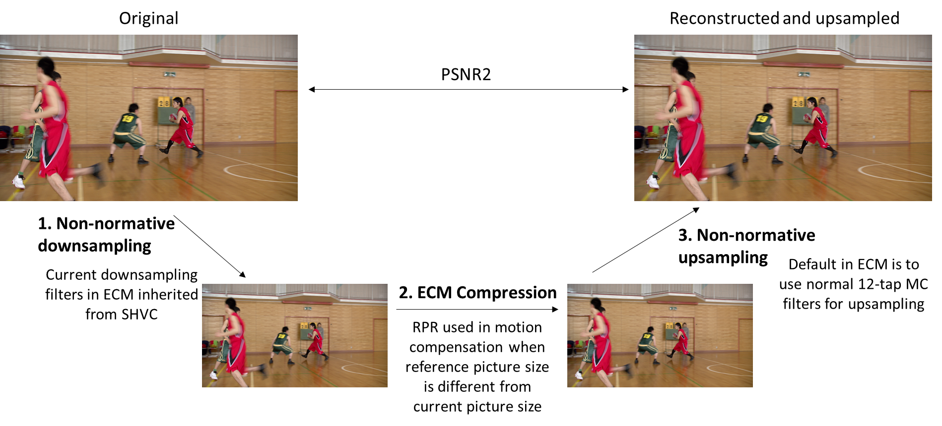
Figure 1. Overview of reduced resolution coding in ECM.
As can be seen in Figure 1, PSNR2 is calculated using the original picture and the picture that has been reconstructed and upsampled.

Proposal

Proposed changes to non-normative downsampling
The downsampling functionality in ECM (and VTM) is based on the filters and thresholds used in the DownConvert application in the SHM software. They have been well studied for the scale factors 1.5x and 2x but it appears that less focus has been given to smaller scale factors such as 1.25x and 1.33x. When the scale factor is between 1.05x and 1.25x, inclusive, a 10-tap cos-windowed sinc filter for ratio 1.5x is used. When the scale factor is above 1.25x (and below 1.67x) a 12-tap cos-windowed sinc filter for ratio 1.67x is used. Both of these filters are too soft for the scale factors 1.25x and 1.33x, and will produce a somewhat blurry picture. Replacing them with a filter adjusted for scaling ratio around 1.33x improves the visual quality as demonstrated in Figure 2 and 3 (where the ECM 12-tap MC filter has been used to restore the original resolution). Visual investigations have been performed to determine a window function and scaling ratio that gives good visual quality and a good balance in minimising blur, aliasing, and ringing. The proposed filter is constructed from a kaiser window with beta equal to 7 and scaling ratio 1.35, with 7-bit coefficient precision. It is proposed to use this filter when the downsampling is in the range from 1.1 to 1.35.

Figure 2. Detail from the BQMall sequence, frame 0.
Left: current 1.33x scaling, Right: proposed 1.33x scaling

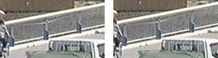
Figure 3. Detail from the BQTerrace sequence, frame 380.
Left: current 1.25x scaling, Right: proposed 1.25x scaling

non_normative_downsampling:
{ 0, 0, 4, -14, 27, 94, 27, -14, 4, 0, 0, 0 },
{ 0, 0, 4, -13, 21, 94, 32, -14, 3, 1, 0, 0 },
{ 0, 0, 4, -12, 16, 93, 39, -15, 3, 1, -1, 0 },
{ 0, 0, 4, -11, 11, 92, 45, -15, 2, 1, -1, 0 },
{ 0, -1, 4, -10, 7, 89, 51, -14, 1, 2, -1, 0 },
{ 0, -1, 4, -8, 2, 86, 57, -13, 0, 2, -1, 0 },
{ 0, -1, 4, -7, -1, 82, 63, -12, -1, 2, -1, 0 },
{ 0, -1, 4, -5, -5, 78, 68, -10, -3, 3, -1, 0 },
{ 0, -1, 3, -4, -8, 74, 74, -8, -4, 3, -1, 0 },
{ 0, -1, 3, -3, -10, 68, 78, -5, -5, 4, -1, 0 },
{ 0, -1, 2, -1, -12, 63, 82, -1, -7, 4, -1, 0 },
{ 0, -1, 2, 0, -13, 57, 86, 2, -8, 4, -1, 0 },
{ 0, -1, 2, 1, -14, 51, 89, 7, -10, 4, -1, 0 },
{ 0, -1, 1, 2, -15, 45, 92, 11, -11, 4, 0, 0 },
{ 0, -1, 1, 3, -15, 39, 93, 16, -12, 4, 0, 0 },
{ 0, 0, 1, 3, -14, 32, 94, 21, -13, 4, 0, 0 },

Proposed changes to RPR
In order to improve the performance for scaling ratios 1.25x and 1.33x it is proposed to introduce an additional set of RPR filters consisting of three tables (respectively for luma, for chroma and for affine). It is proposed to use these RPR filters when the scaling ratio is between 1.1x and 1.35x (in alignment with the proposed non-normative downsampling filter).
In alignment with the current RPR filters in ECM, it is proposed to use 8-bit precision for the filters with filter lengths 12, 6, 10, for luma, chroma, and affine, respectively. The proposed filters are constructed with a kaiser-windowed sinc function with kaiser beta equal to 7 and scaling ratio 1.35 (in alignment with the proposed non-normative downsampling filter). The 10-tap affine filter is constructed from the 12-tap luma filter by moving (adding) the outermost coefficients one step closer to the filter center.

luma:
{ -1, 0, 7, -28, 55, 190, 55, -28, 7, 0, -1, 0},
{ -1, 0, 8, -26, 43, 189, 66, -29, 6, 1, -1, 0},
{ 0, -1, 8, -24, 32, 187, 77, -29, 5, 2, -1, 0},
{ 0, -1, 8, -22, 22, 183, 90, -29, 3, 3, -1, 0},
{ 0, -1, 8, -19, 13, 178, 101, -28, 2, 3, -1, 0},
{ 0, -1, 8, -17, 5, 172, 113, -26, 0, 4, -2, 0},
{ 0, -2, 8, -14, -3, 165, 125, -23, -3, 5, -2, 0},
{ 0, -2, 7, -11, -9, 156, 136, -20, -5, 6, -2, 0},
{ 0, -2, 7, -8, -15, 146, 146, -15, -8, 7, -2, 0},
{ 0, -2, 6, -5, -20, 136, 156, -9, -11, 7, -2, 0},
{ 0, -2, 5, -3, -23, 125, 165, -3, -14, 8, -2, 0},
{ 0, -2, 4, 0, -26, 113, 172, 5, -17, 8, -1, 0},
{ 0, -1, 3, 2, -28, 101, 178, 13, -19, 8, -1, 0},
{ 0, -1, 3, 3, -29, 90, 183, 22, -22, 8, -1, 0},
{ 0, -1, 2, 5, -29, 77, 187, 32, -24, 8, -1, 0},
{ 0, -1, 1, 6, -29, 66, 189, 43, -26, 8, 0, -1},

chroma:
{ -8, 41, 190, 41, -8, 0},
{ -7, 36, 189, 46, -8, 0},
{ -7, 31, 190, 51, -9, 0},
{ -6, 27, 187, 57, -9, 0},
{ -5, 22, 186, 63, -10, 0},
{ -5, 18, 184, 69, -10, 0},
{ -4, 15, 181, 74, -10, 0},
{ -4, 11, 179, 81, -11, 0},
{ -3, 8, 175, 87, -11, 0},
{ -3, 5, 172, 93, -11, 0},
{ -3, 3, 167, 100, -11, 0},
{ -2, 0, 163, 106, -11, 0},
{ -2, -2, 158, 112, -10, 0},
{ -2, -4, 153, 119, -10, 0},
{ -1, -5, 147, 124, -9, 0},
{ -1, -7, 143, 131, -9, -1},
{ -1, -8, 137, 137, -8, -1},
{ -1, -9, 131, 143, -7, -1},
{ 0, -9, 124, 147, -5, -1},
{ 0, -10, 119, 153, -4, -2},
{ 0, -10, 112, 158, -2, -2},
{ 0, -11, 106, 163, 0, -2},
{ 0, -11, 100, 167, 3, -3},
{ 0, -11, 93, 172, 5, -3},
{ 0, -11, 87, 175, 8, -3},
{ 0, -11, 81, 179, 11, -4},
{ 0, -10, 74, 181, 15, -4},
{ 0, -10, 69, 184, 18, -5},
{ 0, -10, 63, 186, 22, -5},
{ 0, -9, 57, 187, 27, -6},
{ 0, -9, 51, 190, 31, -7},
{ 0, -8, 46, 189, 36, -7},

affine:
{ -1, 7, -28, 55, 190, 55, -28, 7, 0, -1},
{ -1, 8, -26, 43, 189, 66, -29, 6, 1, -1},
{ -1, 8, -24, 32, 187, 77, -29, 5, 2, -1},
{ -1, 8, -22, 22, 183, 90, -29, 3, 3, -1},
{ -1, 8, -19, 13, 178, 101, -28, 2, 3, -1},
{ -1, 8, -17, 5, 172, 113, -26, 0, 4, -2},
{ -2, 8, -14, -3, 165, 125, -23, -3, 5, -2},
{ -2, 7, -11, -9, 156, 136, -20, -5, 6, -2},
{ -2, 7, -8, -15, 146, 146, -15, -8, 7, -2},
{ -2, 6, -5, -20, 136, 156, -9, -11, 7, -2},
{ -2, 5, -3, -23, 125, 165, -3, -14, 8, -2},
{ -2, 4, 0, -26, 113, 172, 5, -17, 8, -1},
{ -1, 3, 2, -28, 101, 178, 13, -19, 8, -1},
{ -1, 3, 3, -29, 90, 183, 22, -22, 8, -1},
{ -1, 2, 5, -29, 77, 187, 32, -24, 8, -1},
{ -1, 1, 6, -29, 66, 189, 43, -26, 8, -1},

Results
The proposed filters and thresholds have been implemented in ECM-8.0. They have been tested with the Random Access configuration described in [6] and the Low Delay configuration described in [7]. Since the proposal includes modification of the non-normative downsampling filter, only results for PSNR2 are reported (because the downsampled pictures before encoding will be different between the anchor and the tested configuration).

Results for non-normative changes

Non-normative 1.25x RA
 |  |  | Random access
 |  |  | Over
 | Y | U | V | EncT | DecT
Class A1
Class A2
Class B** | -6.33% | -3.70% | -2.80% | 100% | 99%
Class C** | -9.67% | -4.30% | -3.93% | 100% | 101%
Class E
Overall* | -7.82% | -3.97% | -3.30% | 100% | 100%
Class D** | -12.48% | -1.40% | -1.65% | 99% | 104%
Class F | -10.21% | -9.85% | -10.33% | 100% | 99%
Table 1. Non-normative 1.25x RA
*Results for A1 and A2 awaited.
**Without class-specific settings in both anchor and test.

Non-normative 1.25x LD
 |  |  | Low delay B
 |  |  | Over
 | Y | U | V | EncT | DecT
Class A1
Class A2
Class B* | -3.09% | -1.33% | -1.23% | 100% | 96%
Class C | -8.33% | -2.85% | -2.39% | 100% | 96%
Class E | -7.83% | -1.06% | -0.46% | 100% | 100%
Overall | -6.29% | -1.81% | -1.44% | 100% | 97%
Class D | -10.18% | 0.60% | 0.96% | 99% | 106%
Class F | -9.03% | -8.65% | -9.19% | 100% | 98%
Table 2. Non-normative 1.25x LD

Non-normative 1.33x RA
 |  |  | Random access
 |  |  | Over
 | Y | U | V | EncT | DecT
Class A1
Class A2
Class B | -10.05% | -3.49% | -2.18% | 99% | 100%
Class C | -11.02% | -1.90% | -1.34% | 99% | 113%
Class E
Overall | -10.48% | -2.78% | -1.81% | 99% | 106%
Class D | -10.04% | 1.14% | 0.67% | 98% | 117%
Class F | -4.48% | -1.43% | -1.60% | 98% | 110%
Table 3. Non-normative 1.33x RA
*Results for class A1 and A2 awaited.
**Without class-specific settings in both anchor and test.

Non-normative 1.33x LD
 |  |  | Low delay B
 |  |  | Over
 | Y | U | V | EncT | DecT
Class A1
Class A2
Class B | -7.63% | -2.86% | -2.15% | 99% | 104%
Class C | -10.21% | 0.04% | 0.81% | 99% | 104%
Class E | -12.69% | -0.02% | 1.41% | 99% | 102%
Overall | -9.75% | -1.18% | -0.27% | 99% | 103%
Class D | -7.92% | 3.66% | 2.51% | 99% | 103%
Class F | -3.54% | 0.07% | -0.25% | 98% | 105%
Table 4. Non-normative 1.33x LD

Non-normative 1.25x RA VTM
 | Over VTM-20.0 RPR
 | Y | U | V | EncT | DecT
Class A1 | -0.37% | -1.93% | -0.49% | 102% | 101%
Class A2 | -0.92% | -2.19% | -2.16% | 100% | 100%
Table 4-1. Non-normative 1.25x RA VTM

Non-normative 1.33x RA VTM
 | Over VTM-20.0 RPR
 | Y | U | V | EncT | DecT
Class A1 | -0.86% | -3.66% | -1.04% | 102% | 97%
Class A2 | -1.94% | -3.93% | -3.86% | 101% | 101%
Table 4-2. Non-normative 1.33x RA VTM

Results for proposal (non-normative and normative changes combined)

Proposal 1.25x RA
 |  |  | Random access
 |  |  | Over
 | Y | U | V | EncT | DecT
Class A1* | -0.53% | -2.14% | -0.93% | 101% | 101%
Class A2* | -1.08% | -2.21% | -2.94% | 101% | 100%
Class B* | -6.82% | -3.56% | -2.61% | 100% | 101%
Class C | -11.65% | -4.68% | -4.36% | 100% | 100%
Class E
Overall* | -5.70% | -3.31% | -2.81% | 100% | 100%
Class D | -16.25% | -3.55% | -3.45% | 101% | 102%
Class F | -18.56% | -16.35% | -17.11% | 92% | 93%
Table 5. Proposal 1.25x RA
*Results for class A1, A2, and B without class specific settings.

Proposal 1.25x LD
 |  |  | Low delay B
 |  |  | Over
 | Y | U | V | EncT | DecT
Class A1
Class A2
Class B | -4.42% | -2.28% | -2.24% | 103% | 99%
Class C | -9.31% | -3.02% | -2.78% | 100% | 100%
Class E | -8.88% | -1.87% | -0.58% | 105% | 102%
Overall | -7.16% | -2.42% | -2.00% | 102% | 100%
Class D | -12.34% | -1.70% | -1.40% | 106% | 105%
Class F | -15.78% | -15.26% | -15.26% | 95% | 100%
Table 6. Proposal 1.25x LD

Proposal 1.33x RA
 |  |  | Random access
 |  |  | Over
 | Y | U | V | EncT | DecT
Class A1* | -1.06% | -3.99% | -2.11% | 102% | 101%
Class A2* | -3.99% | -1.75% | -4.35% | 101% | 101%
Class B | -12.02% | -5.01% | -3.72% | 100% | 101%
Class C | -14.75% | -4.45% | -3.81% | 102% | 103%
Class E
Overall* | -9.30% | -4.17% | -3.49% | 101% | 101%
Class D | -14.55% | -2.64% | -3.10% | 105% | 104%
Class F | -13.83% | -9.91% | -10.46% | 100% | 101%
Table 7. Proposal 1.33x RA
*Results for class A1 and A2 without class specific settings.
*Results for ParkRunning3 awaited.

Proposal 1.33x LD
 |  |  | Low delay B
 |  |  | Over
 | Y | U | V | EncT | DecT
Class A1
Class A2
Class B | -8.57% | -3.80% | -2.93% | 104% | 103%
Class C | -13.07% | -2.57% | -1.82% | 103% | 105%
Class E | -14.87% | -1.38% | -0.11% | 102% | 102%
Overall | -11.65% | -2.79% | -1.86% | 103% | 103%
Class D | -10.55% | 0.97% | 0.03% | 104% | 106%
Class F | -12.06% | -8.24% | -9.05% | 101% | 101%
Table 8. Proposal 1.33x LD

PSNR1 results for normative aspect (using the non-normative aspect as anchor)

PSNR1 for normative aspect 1.25x RA
 |  |  | Random access
 |  |  | Over
 | Y | U | V
Class A1
Class A2
Class B | -0.76% | -0.44% | -0.27%
Class C | -2.76% | -1.50% | -1.27%
Class E
Overall | -1.65% | -0.91% | -0.71%
Class D | -5.79% | -2.39% | -2.15%
Class F | -17.88% | -9.15% | -9.62%
Table 9. PSNR1 for normative aspect 1.25x RA

PSNR1 for normative aspect 1.25x LD
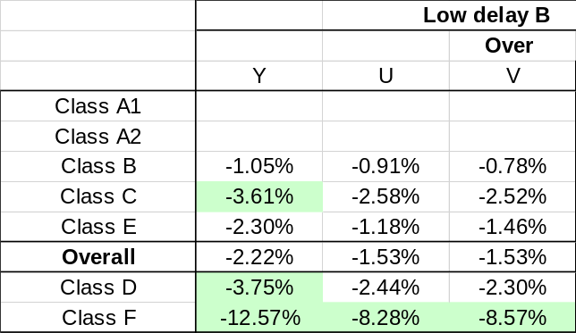
Table 10. PSNR1 for normative aspect 1.25x LD

PSNR1 for normative aspect 1.33x RA
 |  |  | Random access
 |  |  | Over
 | Y | U | V
Class A1
Class A2
Class B | -2.41% | -1.44% | -1.37%
Class C | -5.47% | -2.74% | -2.66%
Class E
Overall | -3.77% | -2.02% | -1.94%
Class D | -7.82% | -3.59% | -3.36%
Class F | -17.25% | -8.70% | -9.00%
Table 11. PSNR1 for normative aspect 1.33x RA

PSNR1 for normative aspect 1.33x LD
Table 12. PSNR1 for normative aspect 1.33x LD

PSNR2 results for normative aspect (using the non-normative aspect as anchor)

PSNR2 for normative aspect 1.25x RA
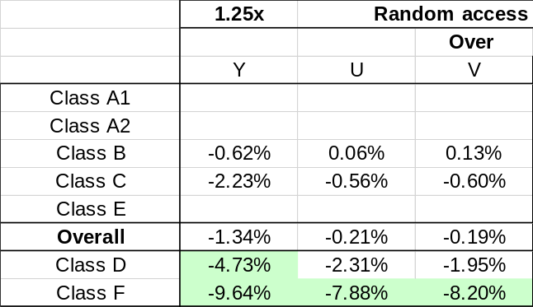
Table 13. PSNR2 for normative aspect 1.25x RA

PSNR2 for normative aspect 1.25x LD
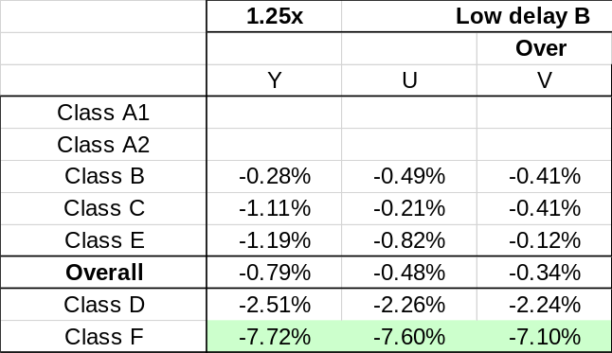
Table 14. PSNR2 for normative aspect 1.25x LD

PSNR2 for normative aspect 1.33x RA
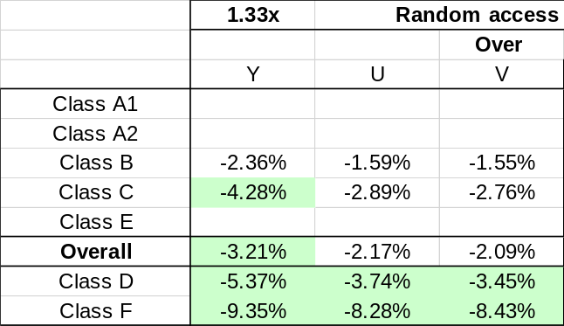
Table 15. PSNR2 for normative aspect 1.33x RA

PSNR2 for normative aspect 1.33x LD
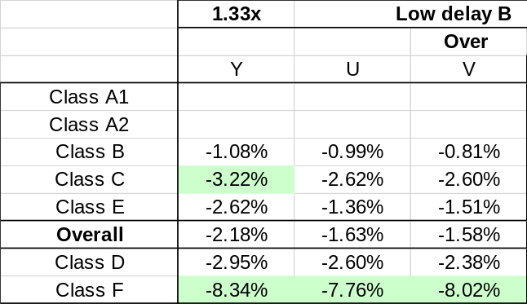
Table 16. PSNR2 for normative aspect 1.33x LD

References
- “HTTP Live Streaming (HLS) Authoring Specification for Apple Devices”, https://developer.apple.com/documentation/http_live_streaming/http_live_streaming_hls_authoring_specification_for_apple_devices
- “Per-Title Encode Optimization”, https://netflixtechblog.com/per-title-encode-optimization-7e99442b62a2
- R. Yu, K. Andersson, “AHG10/12: Suggestion for new CTC for RPR in VTM and ECM”, JVET-AC0096, January 2023.
- S. Iwamura, P. de Lagrange, M. Wien, “Draft verification test plan for VVC multilayer coding”, JVET-AC2021, January 2023.
- P. de Lagrange, “AHG4: experiments in preparation of dual-layer VVC visual tests”, JVET-AC0145, January 2023.
- R. Yu, K. Andersson, “AHG12: RPR luma filter modifications and RPR enabling fixes in ECM”, JVET-Z0062, April 2022.
- J. Luo, V. Seregin, “JVET functionality confirmation test conditions for reference picture resampling”, JVET-Q2015, Jan. 2020.

Patent rights declaration(s)
Sharp Labs of America, Inc., may have current or pending patent rights relating to the technology described in this contribution and, conditioned on reciprocity, is prepared to grant licenses under reasonable and non-discriminatory terms as necessary for implementation of the resulting ITU-T Recommendation | ISO/IEC International Standard (per box 2 of the ITU-T/ITU-R/ISO/IEC patent statement and licensing declaration form).

Acknowledgement
These research results were obtained from the commissioned research (No.05101) by National Institute of Information and Communications Technology (NICT), Japan.

