    Joint Video Experts Team (JVET)  of ITU-T SG 16 WP 3 and ISO/IEC JTC 1/SC 29  30th Meeting, Antalya, TR, 21–28 April 2023 | Document: JVET-AD0164-v1

Title: | AhG14: SADL v5 changes
Status: | Input document to JVET
Purpose: | Proposal
Author(s) or  Contact(s): | Franck Galpin,  Thierry Dumas  Philippe Bordes  Edouard François | Tel:  Email: | firstname.lastname@interdigital.com
Source: | InterDigital Inc.
_____________________________

Abstract
This contribution presents updates in the Small AdHoc Deep Learning (SADL) library. The update contains both some fixes and new features.

Overview
The table below summarizes the framework characteristics:

Language | Pure C++, header only.
Footprint | ~6300 LOC, library ~300kB, no dependency
Optimization | Some SIMD at hot spots, e.g. convolution (conv2D) and automatic sparse matrix-vector multiplication
Compatibility | Onnx to SADL converter
Layer Supports | constants, add, maxPool, matMul (dense and sparse), reshape, ReLU, conv2D (strided, grouped, separated), mul, concat, max, leakyReLU, shape, expand, PReLU, flatten, transpose, Cond2DTranspose, Slicing
Type support | float, int32, int16, int8
Quantization | Support adaptive quantizer per layer
License | BSD 3-Clause

New features

Dynamic Layer parameters
Internal layer parameters are exposed in the API in order to allow dynamic model parameters (requested by some proponents).
Issue to be solved: when converting a model into an ONNX model, some layers have their parameters “fixed” (it is for example partially controlled by the constant folding and dynamic axis parameters during the conversion). A typical example is the reshape layer which will use parameters depending on the input tensor sizes as given when converting the model to ONNX. When converted into SADL, these parameters will be set as a constant as the relationship between the input sizes and the layer parameters is not available anymore in the ONNX model. When using dynamic input sizes into SADL, the model with a reshape layer will not be valid if the input sizes are changed.
Solution: In order to adapt these parameters to the input sizes, internal data of the layer are exposed and can be changed by the user. The logic to change these parameters should be provided by the user.

Example:
For a simple model including a conv2D and a reshape with the following layout:
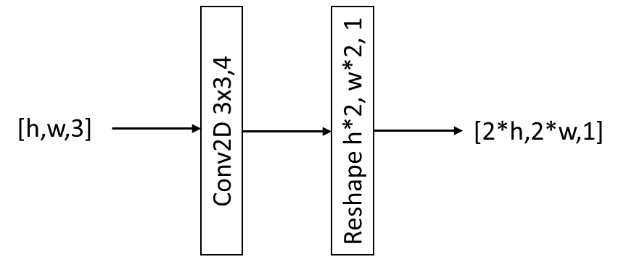
For an input size in ONNX of [16,16,3], the following model is created in SADL:
[INFO] id: 0 op Placeholder
- name: input0
- inputs:
- dim: ( 1 16 16 3 )
- q: 0
[INFO] id: 1 op Const
- name: test_reshape/conv2d/Conv2D/ReadVariableOp:0
- inputs:
- tensor: ( 3 3 3 4 )
- data: 0.10157 -0.0364114 -0.0908029 -0.0219218 ...
- quantizer: 0
[INFO] id: 2 op Conv2D
- name: test_reshape/conv2d/Conv2D:0
- inputs: 0 1
- strides: ( 1 1 1 1 )
- pads: ( 1 1 1 1 )
- groups: 1
- q: 0
[INFO] id: 3 op Const
- name: const_fold_opt__9
- inputs:
- tensor: ( 4 )
- data: 1 32 32 1 ...
- quantizer: 0
[INFO] id: 4 op Reshape
- name: reshape
- inputs: 2 3
One can see that the Reshape layer 4 operation is using the constants inside the Const layer 3 with a tensor of value [1,32, 32, 1]. In order to have a model dynamic to the input sizes, the user is expected to change directly the tensor values (for example for an input [8,8,3], the tensor of layer 3 would be [1,16, 16, 1]) and call the init() function of the model again.

Changes details
Changes are also available in the repository at https://vcgit.hhi.fraunhofer.de/jvet-ahg-nnvc/sadl
- Correct the code to follow the software guidelines in JVET-AC2003
- Add support for more Conv2D types
- Add new unit tests
- Fix MSVC build
- Simplify Conv2D API
- Other bug fixes

Conclusion
It is proposed to update the SADL version in NNVC to the version 5 for the next software version.

Patent rights declaration(s)
InterDigital does not have any current or pending patent rights relating to the technology described in this contribution.

