    Joint Video Experts Team (JVET)  of ITU-T SG 16 WP 3 and ISO/IEC JTC 1/SC 29  30th Meeting, Antalya, TR, 21–28 April 2023 | Document: JVET-AD0152-v3

Title: | EE2-2.2: AMVP with SbTMVP mode
Status: | Input document to JVET
Purpose: | Proposal
Author(s) or  Contact(s): | Ru-Ling Liao  Jie Chen  Yan Ye  Xinwei Li | Tel:  Email: | {ruling.lrl, jiechen.cj, yan.ye, sid.lxw}@alibaba-inc.com
Source: | Alibaba group
_____________________________

Abstract
This contribution reports the simulation results of applying SbTMVP to AMVP mode, which is studied in EE2 Test 2.2. Given a CU coded in AMVP with SbTMVP mode, the CU is predicted in a similar way as that of SbTMVP in merge mode except that the motion shift is signaled in the bitstream instead of being derived from left neighboring block. The motion shift comprises a derived MVP and a signaled MVD. The number of MVD is set to 16 if a picture whose POC distance between current picture and collocated picture is larger than 2. Otherwise, if the picture is a low delay picture, the number of MVD is set to 32. Otherwise, the number of MVD is set to 64. It is reported that on top of ECM-8.0, the overall coding performance impact for {Y, U, V, EncT, DecT} is {-0.07%, -0.02%, -0.04%, 104%, 100%} for RA and {-0.22%, -0.15%, -0.14%, 103%, 100%} for LB. With encoder fast algorithm, the overall coding performance impact is {-0.06%, -0.03%, -0.04%, 102%, 100%} for RA and {-0.22%, 0.06%, 0.04%, 102%, 100%} for LB.

Introduction
This contribution presents the simulation results of EE2 Test 2.2 which studies the AMVP with SbTMVP mode.

Proposed methods
In the EE2-2.2, it is proposed to apply SbTMVP to AMVP mode. When a CU is coded using the proposed mode, the CU is split into 4x4 subblocks, and each subblock derives its own motion from a corresponding subblock in the collocated picture. The collocated picture is fixed to the same collocated picture used in VVC. The corresponding subblock is obtained using MVP with a signaled MVD. The MVP is derived in the same way to that of MVP of normal AMVP mode. The number of MVD is determined according to the following rules:
- If the POC distance between current picture and its collocated picture is larger than 2, the number of MVD is set to 16 which comprises 4 motion directions and 4 motion magnitudes (Figure 1);
- Otherwise, if the current picture is a low delay picture, the number of MVD is set to 32 which comprises 4 motion directions and 8 motion magnitudes (Figure 2);
- Otherwise, the number of MVD is set to 64 which comprises 8 motion directions and 8 motion magnitudes (Figure 3).
In some cases, the corresponding subblock in collocated picture is non-inter coded, that is, the temporal motion information is unavailable; in this case, the motion of center subblock of the CU is used instead. When the motion of the center subblock of the CU is also unavailable, the MVP with the signaled MVD is used instead.
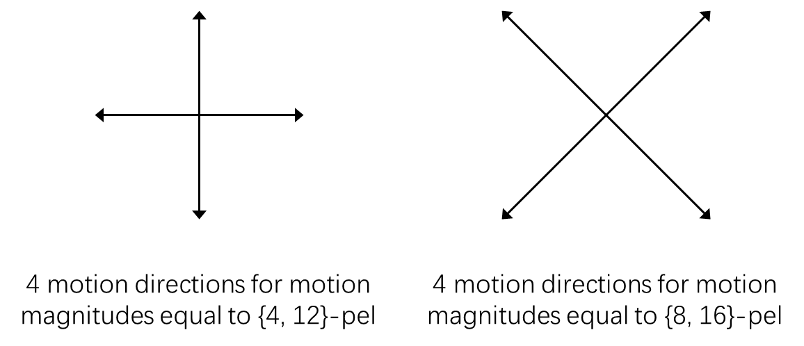
Figure 1. 16 candidates for picture whose POC distance between current picture and collocated picture is larger than 2
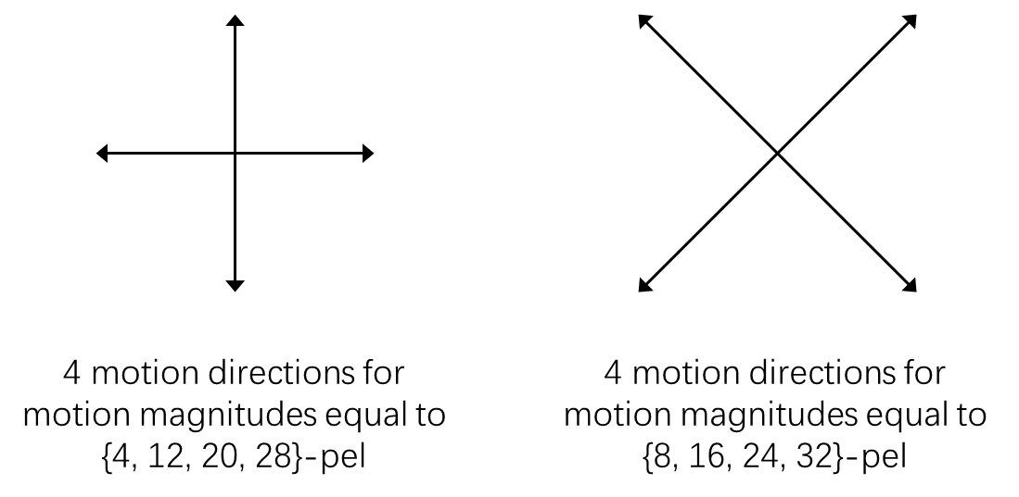
Figure 2. 32 candidates for low delay picture
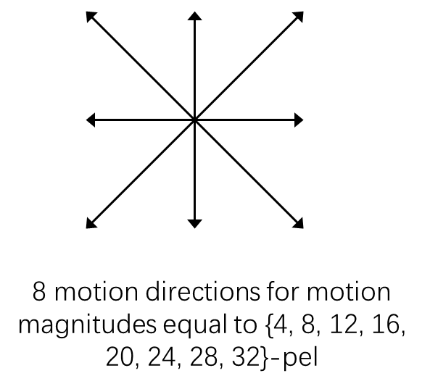
Figure 3. 64 candidates for non-low delay picture whose POC distance between current picture and collocated picture is smaller than or equal to 2
Regarding the syntax design, when a CU is coded using AMVP mode, a flag is signaled to indicate whether the CU is predicted with SbTMVP. If the SbTMVP is used, another flag is signaled to indicate whether MVD exists, and an MVD index is signaled to indicate the motion direction and motion magnitude if MVD exists. The inter prediction direction and reference picture index are directly set to the collocated picture instead of being signalled in the bitstream for the proposed mode. Moreover, the adaptive motion vector resolution (AMVR), local illumination compensation (LIC) and multi-hypothesis prediction (MHP) are not applied to the proposed mode. The OBMC is always applied to the proposed mode without signalling.

Simulation results
The proposed methods are implemented on top of ECM-8.0 and are tested under CTC for enhanced compression tool testing [1] with random access and low delay B configurations. Table 1 shows the simulation results of the proposed method. Table 2 shows the simulation results with an encoder fast algorithm which early terminates the motion estimation of the proposed AMVP with SbTMVP mode according to the cost of normal AMVP mode. Some missing points are copied from the anchor and are marked with *.
Table 1. Simulation results of EE2-2.2
 | Random access Main10
 | Over ECM-8.0
 | Y | U | V | EncT | DecT
Class A1 | -0.05% | -0.02% | -0.03% | 102% | 100%
Class A2 | -0.05% | -0.05% | 0.13% | 103% | 100%
Class B | -0.03% | 0.07% | -0.12% | 104% | 100%
Class C | -0.14% | -0.10% | -0.06% | 104% | 100%
Class E
Overall | -0.07% | -0.02% | -0.04% | 104% | 100%
Class D | -0.10% | 0.25% | 0.02% | 105% | 101%
Class F | -0.08% | 0.02% | 0.03% | 101% | 99%

 | Low delay B Main10
 | Over ECM-8.0
 | Y | U | V | EncT | DecT
Class A1
Class A2
Class B | -0.08% | -0.21% | -0.17% | 102% | 100%
Class C | -0.21% | 0.38% | -0.04% | 101% | 99%
Class E | -0.47% | 0.45% | -0.20% | 107% | 102%
Overall | -0.22% | 0.15% | -0.14% | 103% | 100%
Class D | -0.24% | -0.86% | 0.26% | 101% | 98%
Class F

Table 2. Simulation results of EE2-2.2 with encoder fast algorithm
 | Random access Main10
 | Over ECM-8.0
 | Y | U | V | EncT | DecT
Class A1 | -0.04%* | 0.08%* | 0.00%* | 103%* | 101%*
Class A2 | -0.05%* | -0.13%* | 0.04%* | 102%* | 100%*
Class B | -0.01% | 0.01% | -0.11% | 102% | 100%
Class C | -0.13% | -0.09% | -0.04% | 102% | 100%
Class E
Overall | -0.06%* | -0.03%* | -0.04%* | 102%* | 100%*
Class D | -0.12% | 0.21% | 0.04% | 102% | 100%
Class F | -0.07% | -0.06% | 0.02% | 102% | 100%

 | Low delay B Main10
 | Over ECM-8.0
 | Y | U | V | EncT | DecT
Class A1
Class A2
Class B | -0.08%* | -0.07%* | 0.16%* | 102%* | 101%*
Class C | -0.22% | -0.02% | 0.13% | 103% | 100%
Class E | -0.46% | 0.39% | -0.28% | 103% | 99%
Overall | -0.22%* | 0.06%* | 0.04%* | 102%* | 100%*
Class D | -0.30% | -0.90% | -0.55% | 103% | 100%
Class F

References
- M. Karczewicz and Y. Ye, “Common Test Conditions and evaluation procedures for enhanced compression tool testing,” JVET-Y2017, Feb. 2022.

Patent rights declaration(s)
Alibaba group may have current or pending patent rights relating to the technology described in this contribution and, conditioned on reciprocity, is prepared to grant licenses under reasonable and non-discriminatory terms as necessary for implementation of the resulting ITU-T Recommendation | ISO/IEC International Standard (per box 2 of the ITU-T/ITU-R/ISO/IEC patent statement and licensing declaration form).

