    Joint Video Experts Team (JVET)  of ITU-T SG 16 WP 3 and ISO/IEC JTC 1/SC 29  30th Meeting, Antalya, TR, 21–28 April 2023 | Document: JVET-AD0138 -v1

Title: | [AHG8] QPA with low activity threshold for machine task
Status: | Input document to JVET
Purpose: | Proposal
Author(s) or  Contact(s): | Chul Keun Kim  Dong-Gyu Gwak  Jaehyun Lim  19 Yangjaedaero-11gil  Seocho-gu, Seoul 06772  South Korea | Tel:  Email: | chulkeun.kim@lge.com
Source: | LG Electronics Inc.
_____________________________

Abstract
This contribution proposes a low activity threshold for QPA to reduce bit rate increases in less important areas for machine task. From experimental results, 1.19% performance improvement is observed on average.

Introduction
At the previous JVET meeting, the impact of the perceptual QP adaptation (QPA) on object detection task performance for Open Images dataset was reported [1]. This contribution reports on the object detection performance of the perceptual QP adaptation (QPA) on the SFU-HW video dataset, as well as the object detection performance using QPA with a low activity threshold.

Proposed method
Table 1 presents the object detection task performance with QPA enabled for SFU-HW dataset under the CTC [2]. On average a 2.64% decrease in BD-mAP was observed, although there is an improvement in performance for class C and D.
Table 1. Machine task performance with QPA enabled
 | BD-mAP
Class A | 11.54%
Class B | 9.51%
Class C | -0.17%
Class D | -3.69%
Average | 2.63%

Figure 1 visually represents the result of QP changes using QPA, where "Down" means the QP value is decreased and "UP" means the QP value is increased. The numbers indicate the average activity of the corresponding CTUs. The main effect of perceptual QPA is to increase the QP value in complex areas of the picture, while decreasing it in plane areas. When the background is plane (i.e., has low activity), QP decreases also in the background area, which lead to negative impact on the object detection performance. For example, the object to be detected in Figure 1(a) is cars, but it is also observed that the QP of the road decreases. Similarly, in Figures (b), (c), and (d), a QP decrease in some areas of the background. (target objects for detection in Figure 1 (b): pot, target objects for detection in Figure 1 (c): bicycles, people, benches, target objects for detection in Figure 1 (d): chair, person, sports ball)

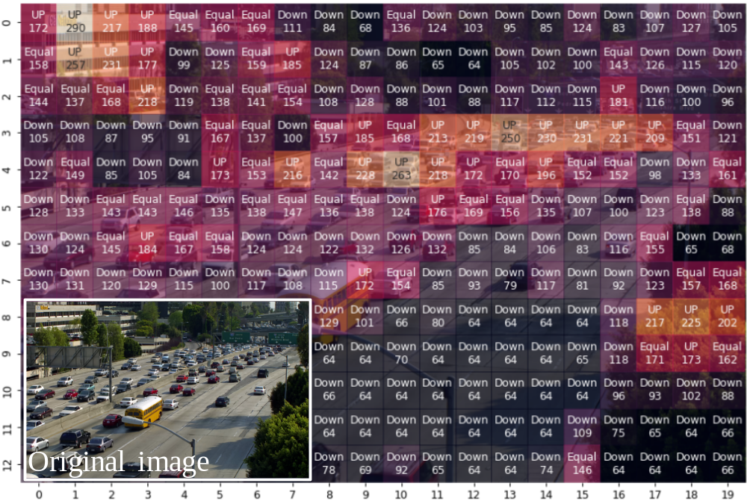
(a)
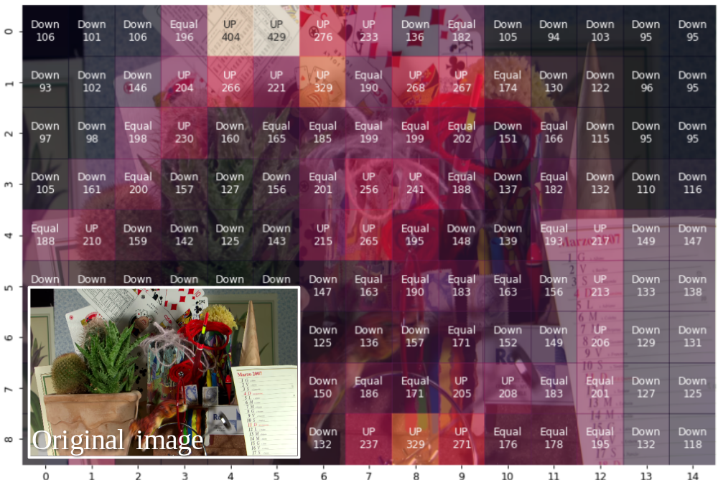
(b)
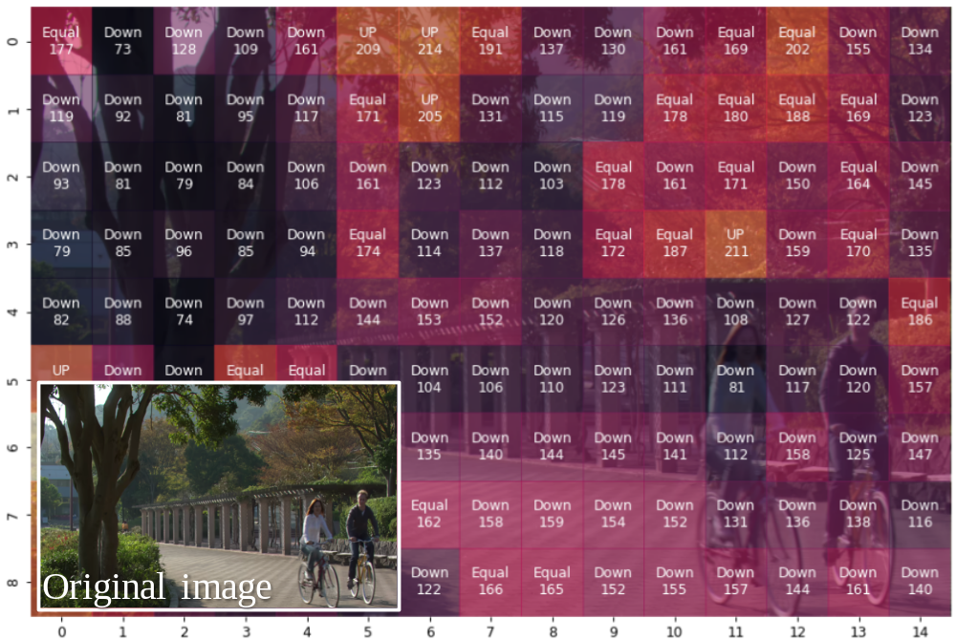
(c)

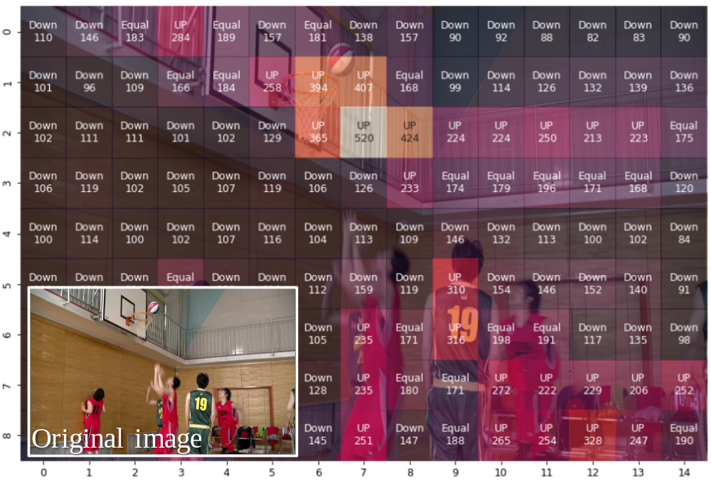
(d)
Figure 1. QP adaptation result according to QPA. (a) Traffic, (b)Cactus, (c) Park Scene, (d) BasketballDrill

In this contribution, a low activity threshold is defined to reduce unnecessary QP reduction in the background. QP adaptation was performed only when the activity of the CTU was greater than the defined low activity threshold. The low activity threshold is obtained by subtracting the standard deviation activity of the frame from the average activity of the frame as shown below.

$${Low}_{threshold}={Activity}_{mean}-{Activity}_{std_deviation}$$

Experimental results
Figure 2 represents QP adaptation result according to QPA with the proposed low activity threshold. It is observed that unnecessary QP decrease is reduced in the road area in Figure 2(a), the potted background area in Figure 2(b), and the tree area in Figure 2(c). Table 2 presents the object detection task performance when QPA was applied with the low activity threshold. Overall, BD-mAP performance is enhanced from 2.65% to -1.19%. Particularly, in the case of traffic and cactus, relatively higher performance change was observed which is -7.2% and -19.0% respectively.
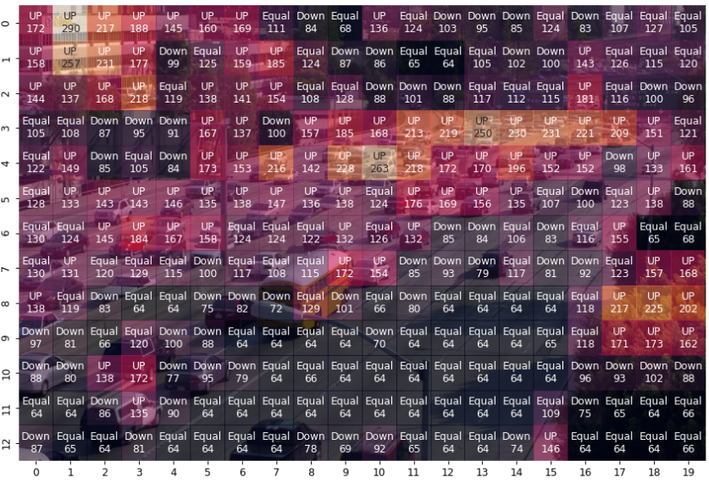
(a)
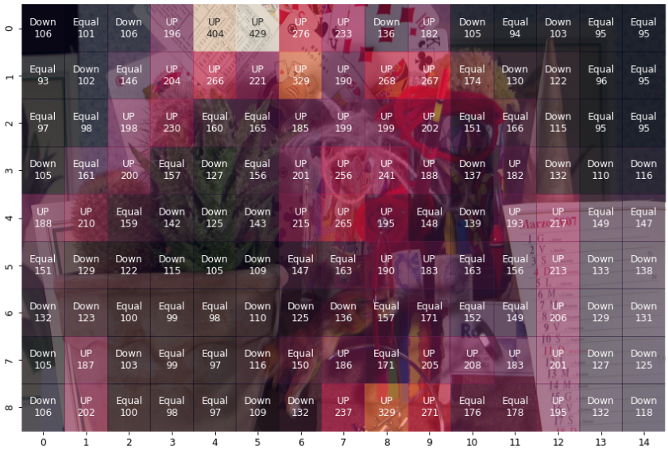
(b)

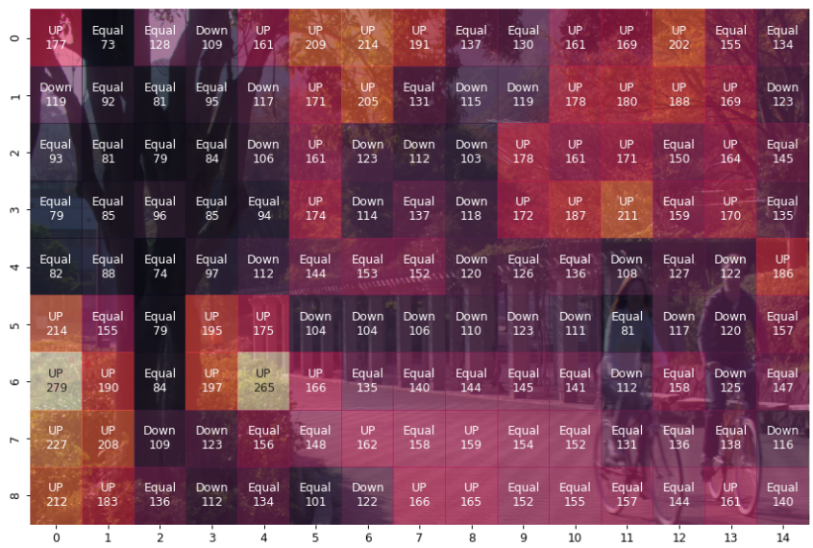
(c)
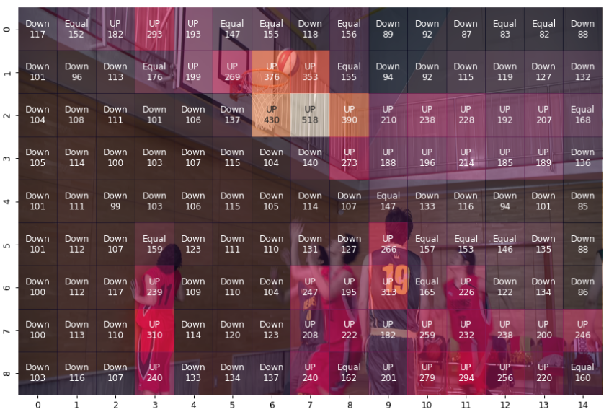
(d)
Figure 2. QP adaptation result according to QPA with low activity threshold. (a) Traffic, (b)Cactus, (c) Park Scene, (d) BasketballDrill

Table 2. Machine task performance with low activity threshold

 | Sequnce | QPA(mAP) | Tested(mAP)
Class A | Traffic | 11.54% | -7.20%
Class B | ParkScene | 16.36% | 4.05%
Class B | Cactus | 7.50% | -19.10%
Class B | BasketballDrive | 9.22% | 13.69%
Class B | BQTerrace | 4.98% | 9.60%
Class C | BasketballDrill | -1.46% | -10.90%
Class C | BQMall | 3.82% | 6.55%
Class C | PartyScene | -0.76% | -6.38%
Class C | RaceHorses | -2.29% | 3.50%
Class D | BasketballPass | -6.14% | -6.09%
Class D | BQSquare | -5.76% | -5.01%
Class D | BlowingBubbles | -1.29% | -0.24%
Class D | RaceHorses | -1.56% | 2.10%
Average |  | 2.63% | -1.19%

Conclusion
This contribution reports the object detection task performance when the perceptual QP adaptation (QPA) with low activity threshold is applied. On average, an improvement of 1.19% is reported. It is suggested to further study on QPA for enhancing the machine tasks performance at the AHG8.

references
- C. Kim, D. Gwak, J. Lim, “[AHG15] Effect of the perceptual QP adaptation (QPA) on machine task performance,” JVET-AC0079, January 2023
- ISO/IEC JTC 1/SC 29/WG 5, “AHG15: On common test conditions for optimization of encoders and receiving systems for machine analysis of coded video content,” Joint Video Experts Team (JVET) of ITU-T SG 16 WP 3 and ISO/IEC JTC 1/SC 29 output document JVET-AC2031, 29th JVET meeting, by teleconference, January 2023

Patent rights declaration(s)
LG electronics may have current or pending patent rights relating to the technology described in this contribution and, conditioned on reciprocity, is prepared to grant licenses under reasonable and non-discriminatory terms as necessary for implementation of the resulting ITU-T Recommendation | ISO/IEC International Standard (per box 2 of the ITU-T/ITU-R/ISO/IEC patent statement and licensing declaration form).

