    Joint Video Experts Team (JVET)  of ITU-T SG 16 WP 3 and ISO/IEC JTC 1/SC 29  30th Meeting, Antalya, TR, 21–28 April 2023 | Document: JVET-AD0114-v2

Title: | Non-EE2: Modification of MV redundancy/similarity check considering LIC during merge candidate list construction
Status: | Input document to JVET
Purpose: | Proposal
Author(s) or  Contact(s): | Kyungyong (Kyle) Kim  Dongcheol Kim  Ju-Hyung (John) Son  Jin Sam Kwak | Email: | kyungyong.kim@wilusgroup.com
Source: | WILUS Inc.
_____________________________

Abstract
This contribution proposes the modification of MV redundancy/similarity check procedure considering LIC usage during merge candidate list construction. A condition has been added to check whether the use of LIC is the same when performing MV redundancy/similarity check on the neighboring blocks with uni-prediction. The modification would allow LIC ON and OFF candidates with similar motion vectors to be included in the merge candidate list, providing an opportunity to selectively apply LIC in CUs using merge mode. Compared with ECM-8.0, the proposed methods achieve -0.03% and -0.04% gain in RA and LDB configurations, respectively, with 99% encoder and 98% decoder run time in LDB configurations of common test condition.
RA: {-0.03%, 0.05%, 0.03%, 100%, 100%}
LDB: {-0.04%, 0.02%, 0.12%, 99%, 98%}

Introduction
In ECM-8.0 [1], local illumination compensation (LIC) is an inter prediction technique to model the local illumination variation between the current block and its reference block, based on the variation between the current block template and the reference block template. In CUs using AMVP uni-prediction, a flag is signaled to indicate the enablement of the LIC. In CUs using merge mode, the LIC flag is inherited from one of the neighboring blocks.
Before adding a candidate to the merge candidate list, a redundancy check or similarity check using ‘mvdSimilarityThresh’ are applied. Candidates with the same or similar motion information are excluded from the merge candidate list. In Fig. 1, candidate B0 is not included to the list because its motion information is the same as candidate A0, which has already been added. Although the motion vector of candidate B0 (mvB0) is the same as the one for candidate A1 (mvA1), the prediction results based on these candidates would be different depending on whether LIC is enabled or disabled. Even if there is a neighboring block using LIC, the current block cannot use LIC because of the similarity check that only considers motion information.
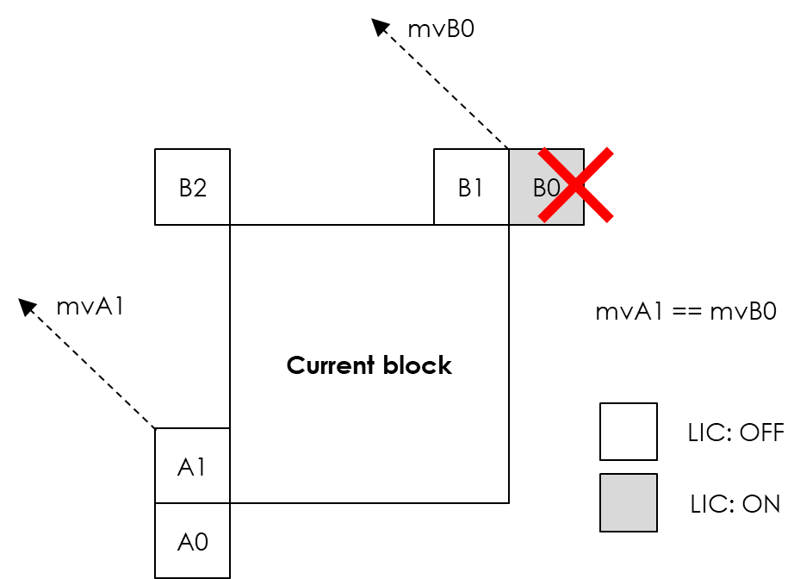
Figure 1. Example of redundancy check

Proposal
This contribution proposes the redundancy/similarity check considering LIC in CUs in merge mode. In the MergeCtx::xCheckSimilarMotion() function, a condition has been added to check whether the use of LIC is the same when performing MV redundancy/similarity check on the neighboring blocks with uni-prediction. This condition is added in the redundancy check and the similarity check based on ‘mvdSimilarityThresh’. By considering both LIC ON and OFF candidates in the merge candidate list, there may be an opportunity to selectively apply LIC in CUs using merge mode.

if (mvFieldNeighbours[(ui << 1)].refIdx == mvFieldNeighbours[(mergeCandIndex << 1)].refIdx )
{
Mv mvDiff = mvFieldNeighbours[(ui << 1)].mv - mvFieldNeighbours[(mergeCandIndex << 1)].mv;
if (mvDiff.getAbsHor() < mvdSimilarityThresh && mvDiff.getAbsVer() < mvdSimilarityThresh)
{
#if JVET-AD0114
if (licFlags[ui] == licFlags[mergeCandIndex])
{
return true;
}
#else
return true;
#endif
}
}

Test Result
The proposed methods were implemented on top of the ECM-8.0 [1]. Simulations were performed by following the common test conditions [2]. More detailed results could be found in the attached excel sheets. The test results are summarized below.

 | Random Access Main 10
 | Over ECM-8.0
 | Y | U | V | EncT | DecT
Class A1 | #VALUE! | #VALUE! | #VALUE! | #NUM! | #NUM!
Class A2 | -0.04% | 0.03% | 0.06% | 101% | 101%
Class B | -0.02% | 0.13% | -0.01% | 100% | 100%
Class C | -0.05% | -0.03% | 0.07% | 100% | 99%
Class E
Overall | #VALUE! | #VALUE! | #VALUE! | #NUM! | #NUM!
Class D | -0.05% | 0.10% | 0.14% | 100% | 100%
Class F | #VALUE! | #VALUE! | #VALUE! | #NUM! | #NUM!
Class TGM | #VALUE! | #VALUE! | #VALUE! | #NUM! | #NUM!
 | Low delay B Main 10
 | Over ECM-8.0
 | Y | U | V | EncT | DecT
Class A1
Class A2
Class B | #VALUE! | #VALUE! | #VALUE! | #NUM! | #NUM!
Class C | -0.06% | 0.18% | 0.32% | 97% | 97%
Class E | -0.05% | 0.35% | -0.06% | 98% | 96%
Overall | #VALUE! | #VALUE! | #VALUE! | #NUM! | #NUM!
Class D | 0.01% | -0.67% | 0.27% | 98% | 97%
Class F | #VALUE! | #VALUE! | #VALUE! | #NUM! | #NUM!
Class TGM | #VALUE! | #VALUE! | #VALUE! | #NUM! | #NUM!
 | Low delay P Main 10
 | Over ECM-8.0
 | Y | U | V | EncT | DecT
Class A1
Class A2
Class B | #VALUE! | #VALUE! | #VALUE! | #DIV/0! | #DIV/0!
Class C | #VALUE! | #VALUE! | #VALUE! | #DIV/0! | #DIV/0!
Class E | -0.12% | -0.65% | -0.03% | #NUM! | #NUM!
Overall | #VALUE! | #VALUE! | #VALUE! | #DIV/0! | #DIV/0!
Class D | -0.13% | -0.15% | 0.70% | #NUM! | #NUM!
Class F | #VALUE! | #VALUE! | #VALUE! | #DIV/0! | #DIV/0!
Class TGM | #VALUE! | #VALUE! | #VALUE! | #DIV/0! | #DIV/0!

Conclusion
This contribution proposes the modification to redundancy and similarity check using LIC in CUs in merge mode. Compared to ECM-8.0, the proposed methods achieve -0.03% and -0.04% gain in RA and LDB configurations, respectively, with 99% encoder and 98% decoder run time in LDB configurations of common test condition.

Reference
[1] M. Coban, and et al., “Algorithm description of Enhanced Compression Model 8 (ECM 8),” JVET-AC2025, January 2023.
[2] M. Karczewicz and Y. Ye, “Common Test Conditions and evaluation procedures for enhanced compression tool testing,” JVET-Y2017, January 2022.

Patent rights declaration(s)
WILUS Inc. may have current or pending patent rights relating to the technology described in this contribution and, conditioned on reciprocity, is prepared to grant licenses under reasonable and non-discriminatory terms as necessary for implementation of the resulting ITU-T Recommendation | ISO/IEC International Standard (per box 2 of the ITU-T/ITU-R/ISO/IEC patent statement and licensing declaration form).

