    Joint Video Experts Team (JVET)  of ITU-T SG 16 WP 3 and ISO/IEC JTC 1/SC 29  30th Meeting, Antalya, TR, 21–28 April 2023 | Document: JVET-AD0109-v1

Title: | AHG11: Neural network loop filter
Status: | Input document to JVET
Purpose: | Proposal
Author(s) or  Contact(s): | Ruiying Yang  Maria Santamaria  Nannan Zou  Francesco Cricri  Ramin G. Youvalari  Jani Lainema  Honglei Zhang  Miska M. Hannuksela  Nokia Technologies, Tampere, Finland | Email: | {ruiying.yang,  maria.santamaria_gomez, nannan.zou,  francesco.cricri,  ramin.ghaznavi-youvalari,  jani.lainema,  honglei.1.zhang,  miska.hannuksela}@nokia.com
Source: | Nokia
_____________________________

Abstract
This document describes a multi-scale attention-based neural network loop filter. It is reported that the proposed NN-based loop filter achieves x.xx% (Y), x.xx% (Cb), x.xx% (Cr) BD-Rate gains compared to NNVC 3.0 in the RA configuration.

Proposal
The proposed NN loop-filter is a multi-scale convolutional neural network (Figure 1) that includes Attention Splitting Blocks (ASB), described in Figure 2. Three scales are utilized.

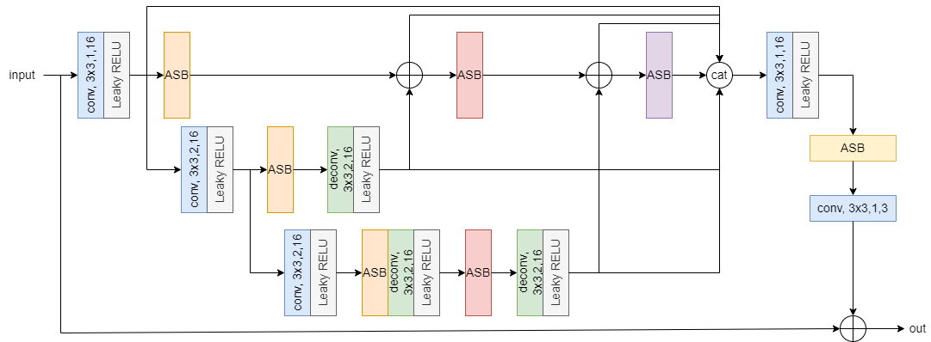
Figure 1. NN architecture. ASB stands for Attention Splitting Block. The mid number of channels is 16.

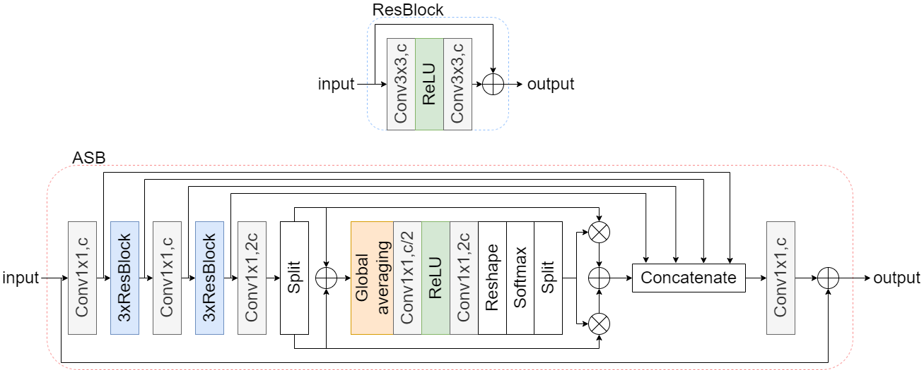
Figure 2. Architecture of an ASB.

The input to the network is made of reconstructed samples, predicted samples, boundary strength, splitting signal computed as the average CU value, sequence QP, slice QP, slice type and temporal layer id.

Training
The previously described architecture is trained for luma (Y component) and chroma channel types (Cb and Cr components) separately. Thus, two separate models are used for filtering luma and chroma. Nevertheless, samples from all the three components are fed in both scenarios.
The reconstructed samples are collected after the deblocking filter has been applied.
For the luma model, the chroma components are up-sampled to match the resolution of the luma component. The auxiliary data also has this size. Finally, the output of the NN has a single channel that corresponds to the luma filtered block.
For the chroma model, the luma components are interleaved creating 4 channels that have the same resolution as the chroma components. This is the size used for the auxiliary data as well. The output of the NN consists of two channels: the filtered Cb block and the filtered Cr block.
The training data consists of BVI-DVC and DIV2K datasets, which were coded with NNVC 2.0 in RA and AI configuration respectively. The loss function, batch size and other training details are described in Table 1, which presents the NN information during training stage.

Table I. Network Information for NN-based Video Coding Tool Testing in Training Stage
Network Information in Training Stage
Mandatory | GPU Type | Nvidia A100-SXM-80GB
Mandatory | Framework: | PyTorch v1.12.1
Mandatory | Number of GPUs per Task | 1
Mandatory | Epoch: | 60
Mandatory | Batch size: | 128
Mandatory | Loss function: | L1
Mandatory | Training time (for 1 model): | 2d 4h
Mandatory | Training data information: | BVI-DVC & DIV2K
Mandatory | Training configurations for generating compressed training data (if different to VTM CTC): | 17, 19, 22, 27, 32, 37, 42
Optional
Optional | Number of iterations
Optional | Patch size | 128x128 luma, 64x64 chroma  (random positions)
Optional | Learning rate: | 1,00E-03
Optional | Learning rate update strategy | Every 10 epochs, the LR is drop by 0,1
Optional | Optimizer: | ADAM
Optional | Preprocessing: | Top-left patch is not considered
Optional | Mini-batch selection process:
Optional | Training data update strategy: | None. Single stage training
Optional | Other information:

Inference
The NN loop-filter is applied after the deblocking filter. The signalling (ON/OFF) is done per channel type (i.e., one signal for luma, and one signal for chroma) at either slice level or CTU level. A scaling factor is also signalled per channel type, to modulate the influence of the NN loop filter as follows:
$$filtered=\left(NNoutput-NNinput\right)*s+NNinput$$
Table 2 summarises the inference details.

Table II. Network Information for NN-based Video Coding Tool Testing in Inference Stage
Network Information in Inference Stage
Mandatory | HW environment:
Mandatory | GPU Type | N/A
Mandatory | Framework: | LibTorch v1.12.1 CPU
Mandatory | Number of GPUs per Task | N/A
Mandatory | Number of Parameters (Each Model) | 164481 for luma model  166354 for chroma model
Mandatory | Total Number of Parameters (All Models) | 330835
Mandatory | Parameter Precision (Bits) | Float 32
Mandatory | Memory Parameter (MB) | 1,26203537
Mandatory | Multiply Accumulate (kMAC/pixel) | Luma 169  Chroma 45
Mandatory | Calculation Method | Block basis
Optional
Optional | Total Conv. Layers | 60
Optional | Total FC Layers
Optional | Total Memory (MB)
Optional | Batch size: | 1
Optional | Patch size | CTU
Optional | Changes to network configuration or weights required to generate rate points
Optional | Peak Memory Usage (Total)
Optional | Peak Memory Usage (per Model)
Optional | Border handling
Optional | Other information:

Simulation results
The NN loop filter was implemented on top of NNVC 3.0 and evaluated in the JVET CTC RA configuration.
The following table shows the BD-rate results.
The encoding and decoding times are not reliable.

Table III. BD-rate over NNVC 3.0 in RA config
 | BD-rate Over NNVC-3.0
 | Y-PSNR | U-PSNR | V-PSNR | Y-MSIM | U-MSIM | V-MSIM | EncT | DecT CPU | PSNR Overlap
Class A1
Class A2
Class B | -3,42 % | -14,57 % | -12,38 % | -3,00 % | -14,31 % | -12,58 % | 711 % | 96834 % | 99 %
Class C | -4,21 % | -14,04 % | -12,90 % | -2,84 % | -11,39 % | -10,54 % | 152 % | 89186 % | 99 %
Class E
Overall
Class D | -6,16 % | -14,78 % | -14,81 % | -3,09 % | -12,29 % | -10,25 % | 155 % | 85752 % | 99 %
Class F | -2,07 % | -9,75 % | -7,65 % | -1,46 % | -10,10 % | -8,68 % | 755 % | 51046 % | 99 %
Class H

Recommendations
Study the proposed approach in the next EE1 round.

Patent rights declaration(s)
Nokia may have current or pending patent rights relating to the technology described in this contribution and, conditioned on reciprocity, is prepared to grant licenses under reasonable and non-discriminatory terms as necessary for implementation of the resulting ITU-T Recommendation | ISO/IEC International Standard (per box 2 of the ITU-T/ITU-R/ISO/IEC patent statement and licensing declaration form).

