    Joint Video Experts Team (JVET)  of ITU-T SG 16 WP 3 and ISO/IEC JTC 1/SC 29  30th Meeting, Antalya, TR, 21–28 April 2023 | Document: JVET-AD0108-v3

Title: | AHG12: Cross-component residual model (CCRM) for inter prediction
Status: | Input document to JVET
Purpose: | Proposal
Author(s) or  Contact(s): | Pekka Astola  Jani Lainema | Email: | firstname.lastname@nokia.com
Source: | Nokia
_____________________________

Abstract
This contribution proposes to apply a cross-component residual model (CCRM) based chroma prediction to improve compression efficiency of inter slices in ECM. The proposed method uses 8-tap convolutional filter to map reconstructed luma into an improved chroma prediction when the CCRM prediction mode is activated by a TU level flag. The filter input consists of 6 spatial luma samples, a nonlinear term, and a bias term. Filter coefficients are derived for each block separately using the prediction signals and the filters are applied to the reconstructed luma signal. The impact on coding efficiency and runtimes over ECM-8.0 is reportedly {for Y, U, V, EncT, DecT}:
RA {-0.15%, -1.37%, -1.74%, 106%, 100%},
LD-B {0.03%, -3.21%, -3.20%, 106%, 100%},
LD-P {0.02%, -3.65%, -3.54%, 107%, 100%}.

Proposed method

Introduction
It is proposed to apply cross-component residual model (CCRM) to predict chroma samples from reconstructed luma samples when the block uses inter prediction or intra block copy (IBC). Fig. 1 illustrates the decoder side of the method. The cross-component filters are derived using the prediction signals of luma and chroma. The derived filters are applied to the reconstructed luma signal producing the final chroma predictions.
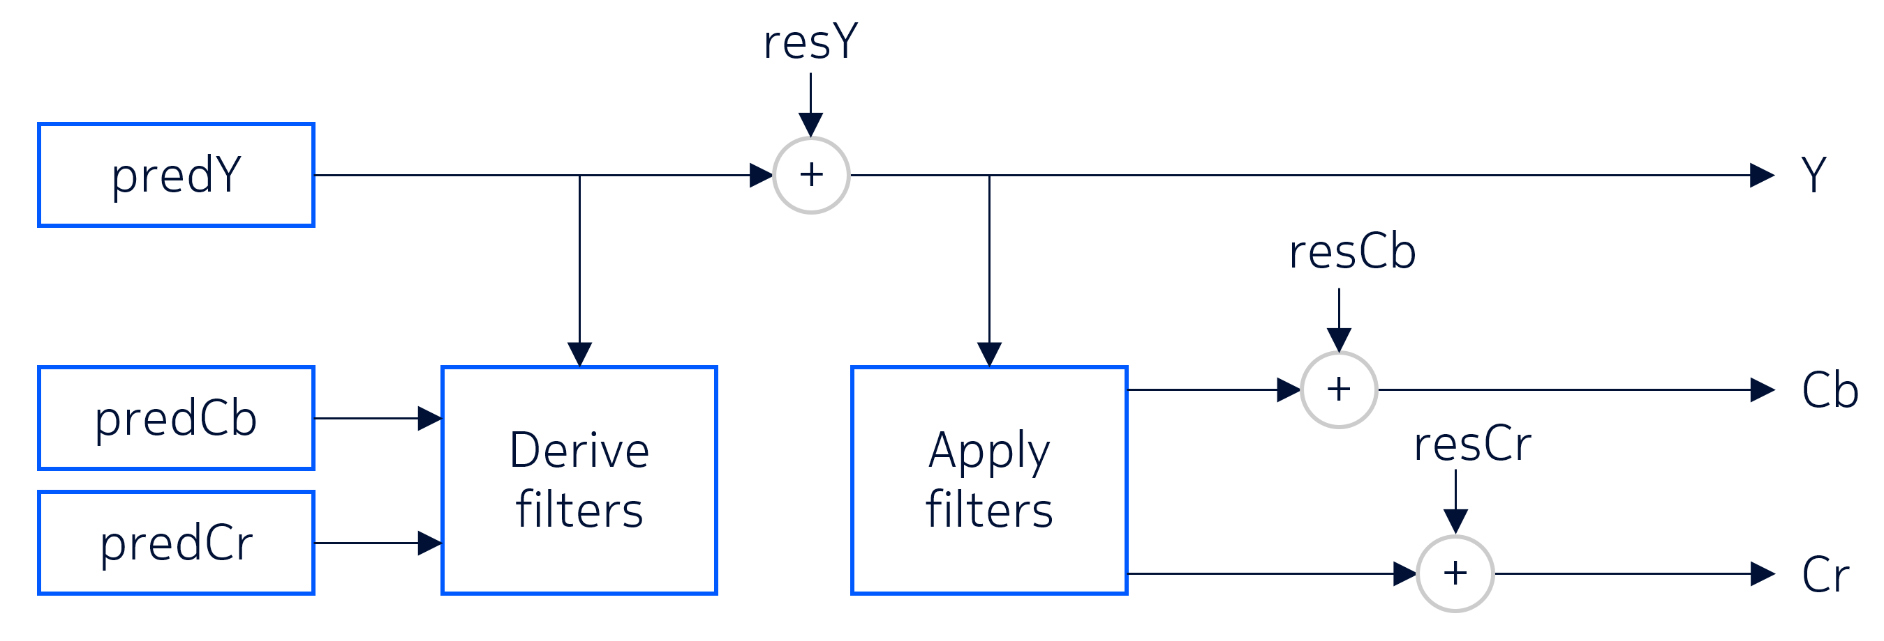
Fig. 1 The proposed method on the decoder.

Convolutional filter and calculation of filter coefficients
The proposed 8-tap filter consist of 6 spatial luma samples, a nonlinear term, and a bias term. The spatial luma samples (L0,…,L5) are obtained from the luma grid selecting the 6 luma samples closest to the chroma position C without down sampling as shown in Fig. 2. The predicted chroma value is obtained as,
predChromaVal = c₀ L0+ c₁L1 + c₂L2 + c₃L3 + c₄L4 + c₅L5 + c₆ nonlinear((L0+L3+1) >> 1) + c₇ B,
where nonlinear is CCCM’s nonlinear operator and B is bias.
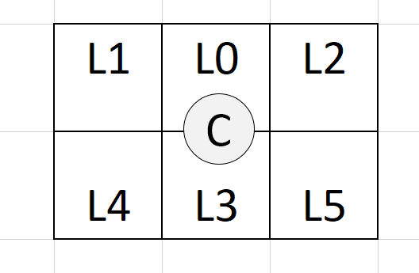
Fig. 2 Luma samples L0,..,L5 in relation to the chroma sample C.

The filter coefficients are derived using ECM’s division-free Gaussian elimination method and the necessary offsets are applied to samples prior to filter derivation.
Intra reference samples are used as additional input samples in filter derivation when the block has less than 64 chroma samples. CCCM’s design of at most 6 rows and columns of intra reference samples is used.
Blocks having 256 chroma samples or more are divided into subblocks that have at most 256 chroma samples. Subblocks containing zero luma residual are skipped.

Bitstream signalling
Usage of the mode is signalled with a CABAC coded TU level flag. One new CABAC context was included to support this. The CCRM flag is only signalled if the TU’s luma Cbf is non-zero and the CU’s predMode is either MODE_INTER or MODE_IBC.

Encoder operation
The encoder performs an RD decision in the transform selection loop for the chroma components when luma Cbf is non-zero and the CU’s predMode is either MODE_INTER or MODE_IBC.

Experimental results
Tables below summarize the coding efficiency and runtime impact of the proposed method in ECM 8.0 using the JVET common test conditions. Reported run times are not accurate.

 | Random Access Main 10
 | Over ECM-8.0
 | Y | U | V | EncT | DecT
Class A1 | -0.34 % | -2.07 % | -3.31 % | 106 % | 102 %
Class A2 | -0.56 % | -2.33 % | -2.94 % | 106 % | 100 %
Class B | 0.06 % | -0.89 % | -0.93 % | 104 % | 100 %
Class C | 0.04 % | -0.74 % | -0.69 % | 107 % | 100 %
Class E
Overall | -0.15 % | -1.37 % | -1.74 % | 106 % | 100 %
Class D | 0.09 % | -0.49 % | -0.45 % | 104 % | 101 %
Class F | -0.03 % | -0.72 % | -0.68 % | 105 % | 99 %
Class TGM | -0.31 % | -0.79 % | -0.86 % | 105 % | 101 %
 | Low delay B Main10
 | Over ECM-8.0
 | Y | U | V | EncT | DecT
Class A1
Class A2
Class B | 0.07 % | -5.85 % | -4.85 % | 107 % | 100 %
Class C | -0.04 % | -2.20 % | -2.98 % | 107 % | 100 %
Class E | 0.05 % | -0.16 % | -0.75 % | 104 % | 98 %
Overall | 0.03 % | -3.21 % | -3.20 % | 106 % | 100 %
Class D | 0.09 % | -3.32 % | -3.47 % | 105 % | 100 %
Class F | -0.01 % | -4.76 % | -4.35 % | 106 % | 99 %
Class TGM | -0.58 % | -3.49 % | -4.49 % | 108 % | 100 %
 | Low delay P Main10
 | Over ECM-8.0
 | Y | U | V | EncT | DecT
Class A1
Class A2
Class B | 0.06 % | -5.80 % | -5.25 % | 108 % | 99 %
Class C | -0.02 % | -2.68 % | -3.30 % | 107 % | 100 %
Class E | 0.01 % | -1.36 % | -1.01 % | 105 % | 100 %
Overall | 0.02 % | -3.65 % | -3.54 % | 107 % | 100 %
Class D | 0.00 % | -3.14 % | -2.99 % | 105 % | 103 %
Class F | 0.07 % | -5.06 % | -5.13 % | 107 % | 102 %
Class TGM | -0.60 % | -4.04 % | -4.97 % | 108 % | 101 %

Conclusion
This contribution proposes cross-component residual model that provides improved coding efficiency for chroma coding in inter slices. It is suggested to study the method in the next round of EEs.

Patent rights declaration(s)
Nokia may have current or pending patent rights relating to the technology described in this contribution and, conditioned on reciprocity, is prepared to grant licenses under reasonable and non-discriminatory terms as necessary for implementation of the resulting ITU-T Recommendation | ISO/IEC International Standard (per box 2 of the ITU-T/ITU-R/ISO/IEC patent statement and licensing declaration form).

