    Joint Video Experts Team (JVET)  of ITU-T SG 16 WP 3 and ISO/IEC JTC 1/SC 29  30th Meeting, Antalya, TR, 21–28 April 2023 | Document: JVET-AD0106-v2

Title: | EE1-1.6: In-loop filter with wide activation and large receptive field
Status: | Input document to JVET
Purpose: | Proposal
Author(s) or  Contact(s): | Yue Li, Kai Zhang,  Li Zhang | Tel:  Email: | yue.li@bytedance.com  zhangkai.video@bytedance.com  lizhang.idm@bytedance.com
Source: | Bytedance Inc.
_____________________________

Abstract
This contribution presents the EE test results of JVET-AC0178, where a unified deep in-loop filter is built upon basic residual blocks with wide activation and large receptive field. The EE test includes two subtests:
EE1-1.6.1: to evaluate techniques proposed in JVET-AC0178 on top of NNVC-4.0
EE1-1.6.2: to take boundary strengths (BS) information as an additional input on top of EE1-1.6.1.
The proposed models are implemented on top of NNVC-4.0 using SADL int16 precision. It is reported that kMAC/pixel is reduced by 16% and the model storage is reduced by 34% compared with NNVC-4.0 filter set #1. BD-rate changes of {Y, Cb, Cr} on top of NNNC-4.0 with NN tools enabled (abbreviated as NNVC-4.0-NnIntra-NnFilterSet1) and NNVC-4.0 with NN tools disabled (abbreviated as NNVC-4.0-Anchor) are reportedly summarized as below:
EE1-1.6.1 (equivalent to JVET-AC0178):
Compared with NNVC-4.0-NnIntra-NnFilterset1 (test is NN-based Intra + proposed filter):
RA: -1.52%, -2.65%, -0.95%, LDB: -2.91%, -4.45%, -3.60%, AI: -0.99%, -0.20%, 1.55%
Compared with NNVC-4.0-Anchor (test is NN-based Intra + proposed filter):
RA: -12.38%, -23.78%, -23.24%, LDB: -11.27%, -23.73%, -23.99%, AI: -11.28%, -21.58%, -21.66%
Compared with NNVC-4.0-Anchor (test is proposed filter only):
RA: -11.04%, -22.99%, -22.26%, LDB: -11.02%, -23.29%, -23.67%, AI: -8.37%, -18.59%, -18.84%
EE1-1.6.2 (EE1-1.6.1+BS input):
Compared with NNVC-4.0-NnIntra-NnFilterset1 (test is NN-based Intra + proposed filter):
RA: -1.65%, -3.39%, -0.86%, LDB: -2.72%, -5.05%, -1.51%, AI: -1.04%, -0.92%, 0.56%
Compared with NNVC-4.0-Anchor (test is NN-based Intra + proposed filter):
RA: -12.50%, -24.34%, -23.19%, LDB: -11.09%, -24.22%, -22.31%, AI: -11.31%, -22.14%, -22.40%
Compared with NNVC-4.0-Anchor (test is proposed filter only):
RA: -11.18%, -23.51%, -22.17%, LDB: -10.84%, -23.85%, -21.98%, AI: -8.46%, -18.99%, -19.46%

Introduction
NNVC common software includes two sets of deep in-loop filter, known as filter set #1 and filter set #0 respectively [1]. The basic building blocks for the two filter sets are shown in Fig.1 (a) and Fig. 1 (b). It can be observed that the residual block in Fig. 1 (a) has relatively larger receptive field while the residual block in Fig. 1 (b) has relatively wider activation. To combine the strengths of both residual blocks, JVET-AC0178 [2] proposes a NN filter design based on a new type of residual block with both wide activation and large receptive field as shown in Fig. 2. In addition, the chroma model is greatly simplified compared with the current one in filter set #1. In EE1-1.6.1, the deep filter presented in JVET-AC0178 is implemented on top of NNVC common software NNVC-4.0 with all NN tools enabled [3]. Based on EE1-1.6.1, EE1-1.6.2 takes BS as additional input. The training procedures of EE1-1.6.1 and EE1-1.6.2 have been crosschecked.
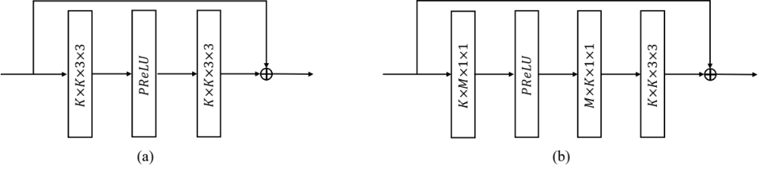
Fig. 1. (a) Residual block in filter set #1. (b) Residual block in filter set #0, M > K.

Proposed method
Section 2.1 - 2.4 present luma CNN structure, chroma CNN structure, inference and training process, respectively. Note that other designs of the proposed method such as parameter selection, residual scaling, combination with deblocking, etc. remain the same as the NN-based filter set #1 in NNVC-4.0.

Luma CNN structure
Fig. 2. gives the architecture of the proposed CNN filter, which comprises three types of basic blocks known as HeadBlock, BackboneBlock, and TailBlock. The design of these blocks follows the principle of wide activation, large receptive field, and multi-scale feature extraction.
HeadBlock is responsible for extracting features from input. $C_{in}$denotes the number of input channels. The proposed model in EE1-1.6.1 takes reconstruction, prediction, slice type, and qp as input, therefore $C_{in}$ is equal to 4. In EE1-1.6.2, $C_{in}$ is equal to 5 due to the additional BS input. $C$ stands for the basic number of feature maps and is set as 64. {$C_{1}$, $C_{2}$} represent numbers of output channels in large activation branch and large receptive field branch, and are set as {160, 32}. $S$ means the stride of convolution and is set as 2 to achieve feature down-sampling. Backbone of the proposed network containing a series of BackboneBlocks achieves feature embedding. $N$, the number of BackboneBlocks, is set as 19. In the end, there is a TailBlock mapping the embedded features from backbone to the final output.
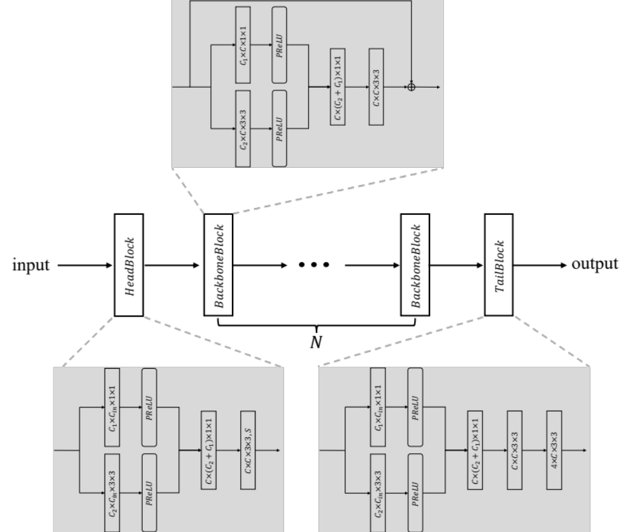
Fig. 2. Architecture of the proposed deep in-loop filter.

Chroma CNN structure
The CNN filter for chroma components has similar architecture as that for luma, but includes less BackboneBlocks and layers. In particular, {$N$, C, $C_{1}$, $C_{2}$} is set as {8, 48, 120, 24}

Inference
SADL is used for performing the inference of the proposed CNN filters in VTM. Both weights and feature maps are represented with int16 precision using a static quantization method. The network information in the inference stage is provided in Table 1 as suggested by [4].
Table 1. Network Information for NN-based Video Coding Tool Testing in Inference Stage
Network Information in Inference Stage
Mandatory | HW environment:
Mandatory | GPU Type | N/A
Mandatory | Framework: | SADL
Mandatory | Number of GPUs per Task | 0
Mandatory | Total Parameter Number | see Section 3.3
Mandatory | Parameter Precision (Bits) | 16 (I)
Mandatory | Memory Parameter (MB) | see Section 3.3
Mandatory | Multiply Accumulate (kMAC/pixel) | see Section 3.3
Optional
Optional | Total Conv. Layers | 85
Optional | Total FC Layers | 0
Optional | Total Memory (MB)
Optional | Batch size: | 1
Optional | Patch size | 144$×$144, 272$×$272
Optional | Changes to network configuration or weights required to generate rate points
Optional | Peak Memory Usage
Optional | Other information:

Training
PyTorch is used as the training platform. DIV2K [5] and BVI-DVC [6] are adopted as the training datasets. The network information in the training stage is provided in Table 2 as suggested by [4].
Table 2. Network Information for NN-based Video Coding Tool Testing in Training Stage
Network Information in Training Stage
Mandatory | GPU Type | GPU: A100-SXM-80GB
Mandatory | Framework: | PyTorch v1.6
Mandatory | Number of GPUs per Task | 4
Mandatory | Epoch: | 60
Mandatory | Batch size: | 64
Mandatory | Training time: | 140h
Mandatory | Training data information: | DIV2K, BVI-DVC
Mandatory | Training configurations for generating compressed training data (if different to VTM CTC): | VTM-11.0 + new MCTF, QP {17, 22, 27, 32, 37, 42}
 | Loss function: | L1, L2
Optional
Optional | Number of iterations
Optional | Patch size | 128$×$128
Optional | Learning rate: | 1e-4
Optional | Optimizer: | ADAM
Optional | Preprocessing:
Optional | Other information:

Experimental results
The proposed CNN-based in-loop filtering method is integrated into NNVC-4.0 (filter set #1) and tested according to the common test conditions defined in [4].

EE1-1.6.1 (equivalent to JVET-AC0178)
BD-rate changes of {Y, Cb, Cr} compared with NNVC-4.0-NnIntra-NnFilterSet1 and NNVC-4.0-Anchor are summarized in Tables below.
Compared with NNVC-4.0-NnIntra-NnFilterSet1, the proposed method brings on average {-1.52%, -2.65%, -0.95%}, {-2.91%, -4.45%, -3.60%}, and {-0.99%, -0.20%, 1.55%} BD-rate changes for {Y, Cb, Cr} under RA, LB, and AI configurations (test is NN-based Intra + proposed filter).
Compared with NNVC-4.0-Anchor, the proposed method brings on average {-12.38%, -23.78%, -23.24%}, {-11.27%, -23.73%, -23.99%}, and {-11.28%, -21.58%, -21.66%} BD-rate changes for {Y, Cb, Cr} under RA, LB, and AI configurations (test is NN-based Intra + proposed filter).
Compared with NNVC-4.0-Anchor, the proposed filter brings on average {-11.04%, -22.99%, -22.26%}, {-11.02%, -23.29%, -23.67%}, and {-8.37%, -18.59%, -18.84%} BD-rate changes for {Y, Cb, Cr} under RA, LB, and AI configurations (test is proposed filter only).
Anchored on NNVC-4.0-NnIntra-NnFilterSet1, test is NN-based Intra + proposed filter
 | Random access Main10
 | BD-rate Over NNVC-4.0-NnIntra-NnFilterSet1
 | Y-PSNR | U-PSNR | V-PSNR | EncT | DecT CPU
Class A1 | -1.63% | -4.16% | -1.41% | 100% | 103%
Class A2 | -1.91% | -2.20% | -2.52% | 102% | 107%
Class B | -1.55% | -3.64% | -0.61% | 103% | 110%
Class C | -1.12% | -0.62% | 0.16% | 99% | 107%
Class E
Overall | -1.52% | -2.65% | -0.95% | 101% | 107%
Class D | -0.50% | -0.74% | 2.99% | 103% | 114%
Class F | -0.34% | -0.83% | -1.88% | 102% | 101%
 | Low delay B Main10
 | BD-rate Over NNVC-4.0-NnIntra-NnFilterSet1
 | Y-PSNR | U-PSNR | V-PSNR | EncT | DecT CPU
Class A1
Class A2
Class B | -2.91% | -4.60% | -1.61% | 101% | 112%
Class C | -2.56% | -3.34% | -3.05% | 101% | 110%
Class E | -3.35% | -5.68% | -7.65% | 102% | 137%
Overall | -2.91% | -4.45% | -3.60% | 101% | 117%
Class D | -2.24% | -1.31% | -1.17% | 99% | 108%
Class F | -1.93% | -3.81% | -3.95% | 102% | 100%
 | All Intra Main10
 | BD-rate Over NNVC-4.0-NnIntra-NnFilterSet1
 | Y-PSNR | U-PSNR | V-PSNR | EncT | DecT CPU
Class A1 | -0.81% | -1.86% | 0.23% | 102% | 104%
Class A2 | -0.80% | -0.03% | -0.28% | 99% | 103%
Class B | -0.81% | 0.77% | 3.93% | 100% | 104%
Class C | -1.28% | 0.48% | 1.48% | 102% | 106%
Class E | -1.29% | -1.24% | 0.82% | 106% | 105%
Overall | -0.99% | -0.20% | 1.55% | 101% | 104%
Class D | -1.11% | 0.22% | 3.14% | 99% | 114%
Class F | 0.36% | 2.41% | 0.84% | 101% | 90%

Anchored on NNVC-4.0-Anchor, test is NN-based Intra + proposed filter
 | Random access Main10
 | BD-rate Over NNVC-4.0-Anchor
 | Y-PSNR | U-PSNR | V-PSNR | EncT | DecT CPU
Class A1 | -11.99% | -20.79% | -23.27% | 206% | 35257%
Class A2 | -12.71% | -22.44% | -19.01% | 199% | 34920%
Class B | -11.93% | -25.63% | -24.12% | 205% | 37309%
Class C | -12.98% | -24.71% | -25.29% | 172% | 30077%
Class E
Overall | -12.38% | -23.78% | -23.24% | 195% | 34371%
Class D | -14.36% | -25.70% | -26.28% | 163% | 28355%
Class F | -6.72% | -15.85% | -14.91% | 259% | 14749%
 | Low delay B Main10
 | BD-rate Over NNVC-4.0-Anchor
 | Y-PSNR | U-PSNR | V-PSNR | EncT | DecT CPU
Class A1
Class A2
Class B | -10.49% | -23.80% | -22.40% | 189% | 38009%
Class C | -11.86% | -24.72% | -24.81% | 168% | 33267%
Class E | -11.78% | -22.28% | -25.55% | 321% | 31845%
Overall | -11.27% | -23.73% | -23.99% | 207% | 34785%
Class D | -13.17% | -26.14% | -28.89% | 148% | 26123%
Class F | -7.38% | -17.27% | -15.00% | 252% | 16615%
 | All Intra Main10
 | BD-rate Over NNVC-4.0-Anchor
 | Y-PSNR | U-PSNR | V-PSNR | EncT | DecT CPU
Class A1 | -10.91% | -21.01% | -20.88% | 244% | 24616%
Class A2 | -9.89% | -21.31% | -17.36% | 221% | 22008%
Class B | -10.13% | -20.39% | -21.03% | 210% | 20952%
Class C | -11.24% | -21.36% | -23.47% | 184% | 14066%
Class E | -14.99% | -24.67% | -25.35% | 218% | 22118%
Overall | -11.28% | -21.58% | -21.66% | 212% | 20041%
Class D | -10.81% | -21.29% | -23.29% | 178% | 12881%
Class F | -6.79% | -15.24% | -15.25% | 154% | 12876%

Anchored on NNVC-4.0-Anchor, test is proposed filter only
 | Random access Main10
 | BD-rate Over NNVC-4.0-Anchor
 | Y-PSNR | U-PSNR | V-PSNR | EncT | DecT CPU
Class A1 | -10.29% | -19.66% | -22.01% | 183% | 33463%
Class A2 | -11.64% | -22.02% | -18.25% | 175% | 33491%
Class B | -10.56% | -25.01% | -23.32% | 185% | 36806%
Class C | -11.74% | -23.68% | -24.11% | 155% | 30194%
Class E
Overall | -11.04% | -22.99% | -22.26% | 174% | 33614%
Class D | -13.27% | -24.76% | -25.22% | 147% | 27845%
Class F | -5.81% | -15.12% | -14.04% | 237% | 14670%
 | Low delay B Main10
 | BD-rate Over NNVC-4.0-Anchor
 | Y-PSNR | U-PSNR | V-PSNR | EncT | DecT CPU
Class A1
Class A2
Class B | -10.13% | -23.53% | -22.15% | 176% | 35970%
Class C | -11.55% | -24.22% | -24.64% | 158% | 32551%
Class E | -11.81% | -21.65% | -24.92% | 303% | 30645%
Overall | -11.02% | -23.29% | -23.67% | 195% | 33426%
Class D | -12.99% | -25.67% | -28.26% | 144% | 27283%
Class F | -7.30% | -17.78% | -14.93% | 241% | 15833%
 | All Intra Main10
 | BD-rate Over NNVC-4.0-Anchor
 | Y-PSNR | U-PSNR | V-PSNR | EncT | DecT CPU
Class A1 | -7.39% | -17.74% | -17.63% | 175% | 23772%
Class A2 | -7.51% | -19.41% | -15.76% | 145% | 20947%
Class B | -7.50% | -17.33% | -18.32% | 144% | 20222%
Class C | -8.68% | -18.50% | -20.56% | 125% | 13345%
Class E | -11.26% | -20.84% | -21.72% | 146% | 21834%
Overall | -8.37% | -18.59% | -18.84% | 145% | 19298%
Class D | -8.38% | -18.87% | -20.46% | 122% | 11149%
Class F | -4.88% | -13.64% | -13.34% | 114% | 12675%

EE1-1.6.2 (EE1-1.6.1+BS input)
BD-rate changes of {Y, Cb, Cr} compared with NNVC-4.0-NnIntra-NnFilterSet1 and NNVC-4.0-Anchor are summarized in Tables below.
Compared with NNVC-4.0-NnIntra-NnFilterSet1, the proposed method brings on average {-1.65%, -3.39%, -0.86%}, {-2.72%, -5.05%, -1.51%}, and {-1.04%, -0.92%, 0.56%} BD-rate changes for {Y, Cb, Cr} under RA, LB, and AI configurations (test is NN-based Intra + proposed filter).
Compared with NNVC-4.0-Anchor, the proposed method brings on average {-12.50%, -24.34%, -23.19%}, {-11.09%, -24.22%, -22.31%}, and {-11.31%, -22.14%, -22.40%} BD-rate changes for {Y, Cb, Cr} under RA, LB, and AI configurations (test is NN-based Intra + proposed filter).
Compared with NNVC-4.0-Anchor, the proposed filter brings on average {-11.18%, -23.51%, -22.17%}, {-10.84%, -23.85%, -21.98%}, and {-8.46%, -18.99%, -19.46%} BD-rate changes for {Y, Cb, Cr} under RA, LB, and AI configurations (test is proposed filter only).
Anchored on NNVC-4.0-NnIntra-NnFilterSet1, test is NN-based Intra + proposed filter

 | Random access Main10
 | BD-rate Over NNVC-4.0-NnIntra-NnFilterSet1
 | Y-PSNR | U-PSNR | V-PSNR | EncT | DecT CPU
Class A1 | -1.77% | -4.72% | -1.05% | 100% | 100%
Class A2 | -2.04% | -2.62% | -3.23% | 100% | 104%
Class B | -1.67% | -4.73% | -0.82% | 101% | 106%
Class C | -1.25% | -1.31% | 1.01% | 99% | 107%
Class E
Overall | -1.65% | -3.39% | -0.86% | 100% | 105%
Class D | -0.33% | -1.13% | 3.90% | 103% | 112%
Class F | -0.44% | -2.22% | -2.75% | 101% | 100%
 | Low delay B Main10
 | BD-rate Over NNVC-4.0-NnIntra-NnFilterSet1
 | Y-PSNR | U-PSNR | V-PSNR | EncT | DecT CPU
Class A1
Class A2
Class B | -2.70% | -4.71% | 0.46% | 100% | 108%
Class C | -2.57% | -4.55% | -0.16% | 99% | 108%
Class E | -2.95% | -6.28% | -6.57% | 103% | 133%
Overall | -2.72% | -5.05% | -1.51% | 100% | 114%
Class D | -2.29% | -1.72% | 3.07% | 101% | 110%
Class F | -1.85% | -2.33% | -2.97% | 104% | 98%
 | All Intra Main10
 | BD-rate Over NNVC-4.0-NnIntra-NnFilterSet1
 | Y-PSNR | U-PSNR | V-PSNR | EncT | DecT CPU
Class A1 | -0.86% | -2.60% | -0.87% | 101% | 101%
Class A2 | -0.80% | -0.21% | -0.72% | 98% | 100%
Class B | -0.84% | -0.94% | 1.84% | 103% | 98%
Class C | -1.36% | 0.02% | 1.52% | 104% | 101%
Class E | -1.34% | -1.14% | -0.16% | 102% | 104%
Overall | -1.04% | -0.92% | 0.56% | 102% | 101%
Class D | -1.17% | -0.58% | 2.88% | 99% | 103%
Class F | 0.72% | 2.45% | 0.74% | 97% | 83%

Anchored on NNVC-4.0-Anchor, test is NN-based Intra + proposed filter
 | Random access Main10
 | BD-rate Over NNVC-4.0-Anchor
 | Y-PSNR | U-PSNR | V-PSNR | EncT | DecT CPU
Class A1 | -12.11% | -21.23% | -23.02% | 206% | 34501%
Class A2 | -12.83% | -22.76% | -19.59% | 196% | 34020%
Class B | -12.04% | -26.45% | -24.28% | 201% | 36137%
Class C | -13.11% | -25.21% | -24.66% | 171% | 29922%
Class E
Overall | -12.50% | -24.34% | -23.19% | 192% | 33638%
Class D | -14.23% | -25.99% | -25.65% | 163% | 27814%
Class F | -6.81% | -16.90% | -15.63% | 256% | 14628%
 | Low delay B Main10
 | BD-rate Over NNVC-4.0-Anchor
 | Y-PSNR | U-PSNR | V-PSNR | EncT | DecT CPU
Class A1
Class A2
Class B | -10.29% | -23.94% | -20.69% | 187% | 36571%
Class C | -11.86% | -25.67% | -22.51% | 164% | 32521%
Class E | -11.40% | -22.76% | -24.75% | 322% | 30931%
Overall | -11.09% | -24.22% | -22.31% | 205% | 33726%
Class D | -13.21% | -26.54% | -25.79% | 151% | 26615%
Class F | -7.30% | -16.06% | -14.08% | 257% | 16247%
 | All Intra Main10
 | BD-rate Over NNVC-4.0-Anchor
 | Y-PSNR | U-PSNR | V-PSNR | EncT | DecT CPU
Class A1 | -10.96% | -21.58% | -21.76% | 243% | 23810%
Class A2 | -9.90% | -21.51% | -17.72% | 218% | 21490%
Class B | -10.15% | -21.72% | -22.56% | 217% | 19731%
Class C | -11.31% | -21.72% | -23.44% | 187% | 13439%
Class E | -15.03% | -24.61% | -26.05% | 211% | 22100%
Overall | -11.31% | -22.14% | -22.40% | 213% | 19323%
Class D | -10.87% | -21.92% | -23.47% | 178% | 11592%
Class F | -6.48% | -15.17% | -15.36% | 149% | 11897%

Anchored on NNVC-4.0-Anchor, test is proposed filter only
 | Random access Main10
 | BD-rate Over NNVC-4.0-Anchor
 | Y-PSNR | U-PSNR | V-PSNR | EncT | DecT CPU
Class A1 | -10.43% | -20.07% | -21.83% | 183% | 33243%
Class A2 | -11.77% | -22.19% | -18.67% | 174% | 32755%
Class B | -10.72% | -25.77% | -23.41% | 183% | 36066%
Class C | -11.87% | -24.27% | -23.49% | 154% | 29520%
Class E
Overall | -11.18% | -23.51% | -22.17% | 173% | 32996%
Class D | -13.16% | -25.07% | -24.44% | 149% | 27305%
Class F | -5.92% | -16.23% | -14.72% | 235% | 14280%
 | Low delay B Main10
 | BD-rate Over NNVC-4.0-Anchor
 | Y-PSNR | U-PSNR | V-PSNR | EncT | DecT CPU
Class A1
Class A2
Class B | -9.92% | -23.62% | -20.11% | 173% | 34481%
Class C | -11.61% | -25.13% | -22.50% | 155% | 31563%
Class E | -11.34% | -22.52% | -24.39% | 304% | 29737%
Overall | -10.84% | -23.85% | -21.98% | 192% | 32263%
Class D | -13.04% | -26.35% | -24.83% | 144% | 26071%
Class F | -7.21% | -15.77% | -13.82% | 237% | 15486%
 | All Intra Main10
 | BD-rate Over NNVC-4.0-Anchor
 | Y-PSNR | U-PSNR | V-PSNR | EncT | DecT CPU
Class A1 | -7.48% | -18.24% | -18.60% | 171% | 23226%
Class A2 | -7.56% | -19.45% | -15.68% | 145% | 20524%
Class B | -7.58% | -18.13% | -19.61% | 138% | 19175%
Class C | -8.80% | -18.88% | -20.60% | 125% | 13422%
Class E | -11.38% | -20.86% | -22.37% | 142% | 20767%
Overall | -8.46% | -18.99% | -19.46% | 142% | 18745%
Class D | -8.46% | -19.43% | -20.67% | 124% | 10862%
Class F | -4.57% | -13.51% | -13.46% | 115% | 11075%

Comparison of kMAC/pixel and memory
 | kMAC/pixel (frame basis) | kMAC/pixel (block basis) | Total Parameter Number | Total parameter memory (int16)
NNVC-4.0 filter set #1 | 532 | 673 | 3.10M | 6.20M
EE1-1.6.1 | 445.5 | 563.8 | 2.054M | 4.108M
EE1-1.6.2 | 446.1 | 564.6 | 2.055M | 4.110M

Conclusions
This contribution presents the test result of a deep in-loop filtering method. The proposed filtering method shows a favorable trade-off in terms of the coding performance and complexity. It is suggested to adopt EE1-1.6 into NNVC common software.

References
- Y. Li, H. Wang, L. Wang, F. Galpin, J. Ström, Description of algorithms and software in neural network-based video coding (NNVC) version 2, JVET-AC2019, by teleconference, January 2023.
- Y. Li, K. Zhang, L. Zhang, EE1-related: In-Loop Filter with Wide Activation and Large Receptive Field, JVET-AC0178, by teleconference, January 2023.
- https://vcgit.hhi.fraunhofer.de/jvet-ahg-nnvc/VVCSoftware_VTM/-/tree/NNVC-4.0
- E. Alshina, R. -L. Liao, S. Liu, A. Segall, Common test conditions and evaluation procedures for neural network-based video coding technology, JVET-AC2016, by teleconference, January 2023.
- https://data.vision.ee.ethz.ch/cvl/DIV2K/ R. Timofte, E. Agustsson, S. Gu, J. Wu, A. Ignatov, L. V. Gool.
- Ma, Di, Fan Zhang, and David R. Bull. "BVI-DVC: A Training Database for Deep Video Compression." arXiv preprint arXiv:2003.13552 (2020).

Patent rights declaration(s)
Bytedance Inc. may have current or pending patent rights relating to the technology described in this contribution and, conditioned on reciprocity, is prepared to grant licenses under reasonable and non-discriminatory terms as necessary for implementation of the resulting ITU-T Recommendation | ISO/IEC International Standard (per box 2 of the ITU-T/ITU-R/ISO/IEC patent statement and licensing declaration form).

