    Joint Video Experts Team (JVET)  of ITU-T SG 16 WP 3 and ISO/IEC JTC 1/SC 29  30th Meeting, Antalya, TR, 21–28 April 2023 | Document: JVET-AD0103-v1

Title: | EE2-1.7: TIMD using selectable template regions
Status: | Input document to JVET
Purpose: | Report
Author(s) or  Contact(s): | Yukinobu Yasugi  Tomohiro Ikai | Tel:  Email: | yasugi.yukinobu@sharp.co.jp
Source: | Sharp Corporation
_____________________________

Abstract
This contribution reports results for EE2 Test 1.7 which were proposed in JVET-AC0048. Test 1.7 proposes a modification of template-based intra derivation (TIMD) mode. This modification allows explicit selection of template from three regions; TL, T and L. Experimental results reportedly show BD-rate -0.07% and -0.04% for AI and RA conditions, respectively.

Introduction
Template-based intra mode derivation (TIMD) on ECM-7.0 implicitly selects a template region to be used from three regions, T(Top)+L(Left), T, and L, depending on the coordinate of the current block. For example, if the block is at the left edge of the frame (x==0), only the template region (T) adjacent to the upper side is used. If the block is at the top of the frame (y==0), the template region (L) adjacent to the left side is used. Otherwise, both the top and left template regions (TL) are used.

Proposed Method
This contribution proposes to introduce a mechanism to explicitly select one of the three types of template regions, even for CUs that are not located at the top or left boundary of the frame.

Changes
- Introduce the following syntax element timd_ref_mode to select a template region.

coding_unit( x0, y0, cbWidth, cbHeight, treeType ) { | Descriptor
…
if( CuPredMode[ x0 ][ y0 ] == MODE_INTRA ) {
…
timd_flag[ x0 ][ y0 ] | ae(v)
if( timd_flag[ x0 ][ y0 ] != 0 )
timd_ref_mode[ x0 ][ y0 ] | ae(v)
…
}
}
timd_ref_mode[ x0 ][ y0 ] specifies the mode of template region. The array indices x0, y0 specify the location (x0, y0) of the top-left luma sample of the considered coding block relative to the top-left luma sample of the picture. The value of timd_ref_mode shall be in the range of 0 to 2, inclusive. When the value of timd_ref_mode[ x0 ][ y0 ] is equal to 0, the upper and left template regions are used if available. When the value of timd_ref_mode[ x0 ][ y0 ] is equal to 1 or 2, the upper or left template region is used, respectively. When timd_ref_mode[ x0 ][ y0 ] is not present, it is inferred to be equal 0.

Experimental results

Table 1: Experimental results of Test 1.7
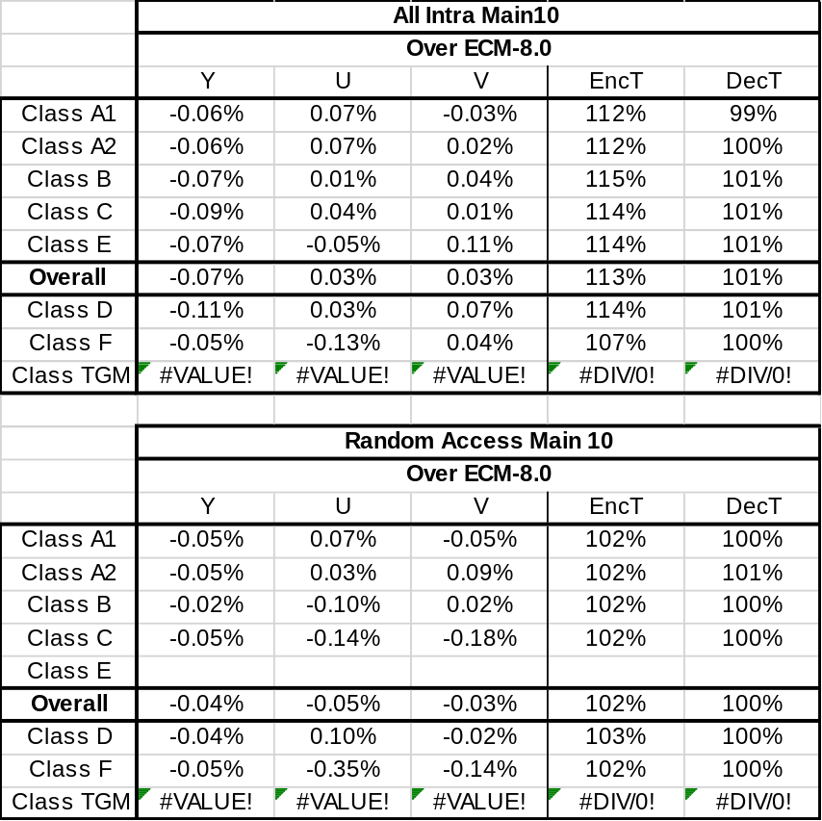

Acknowledgements
These research results were obtained from the commissioned research (No.05101) by National Institute of Information and Communications Technology (NICT), Japan.

Patent rights declaration(s)
Sharp Corporation may have current or pending patent rights relating to the technology described in this contribution and, conditioned on reciprocity, is prepared to grant licenses under reasonable and non-discriminatory terms as necessary for implementation of the resulting ITU-T Recommendation | ISO/IEC International Standard (per box 2 of the ITU-T/ITU-R/ISO/IEC patent statement and licensing declaration form).

