    Joint Video Experts Team (JVET)  of ITU-T SG 16 WP 3 and ISO/IEC JTC 1/SC 29  30th Meeting, Antalya, TR, 21–28 April 2023 | Document: JVET-AD0102-v1

Title: | Proposed verification test plan for content layering
Status: | Input document to JVET
Purpose: | Proposal
Author(s) or  Contact(s): | Shunsuke Iwamura  Shimpei Nemoto  Atsuro Ichigaya | Tel:  Email: | iwamura.s-gc@nhk.or.jp
Source: | NHK
_____________________________

Abstract
This contribution contains an update of a verification test plan of multilayer coding for a content layering use case.

Introduction
A total of four categories of verification tests are considered for VVC multilayer coding: spatial scalability, quality ladder, content layering, and stereo coding. Content layering is the use case where the main content is encoded as base layer and additional content overlaid on top of the main content, which is called sub-content, is encoded as enhancement layer.
In 28th JVET meeting, it was suggested to conduct a functional test of content layering in the 31st JVET meeting planned in Geneva.

Test sites
Functional test is planned to be conducted during 31st JVET meeting held in Geneva.

Functional test coordination
The proposed coordinators of the functional tests are the chairs of AHG4/AG5 in cooperation with NHK. NHK is planned to prepare the VVC multilayer real-time decoder and the related equipment for the functional test and bring them to the test sites. Block diagram of the equipment for the test is illustrated in Figure 1. VVC multilayer bitstream is output from MMT streamer as CMAF over MMT and viewer can select which contents (main or sub) to play out by controlling from Tablet PC.

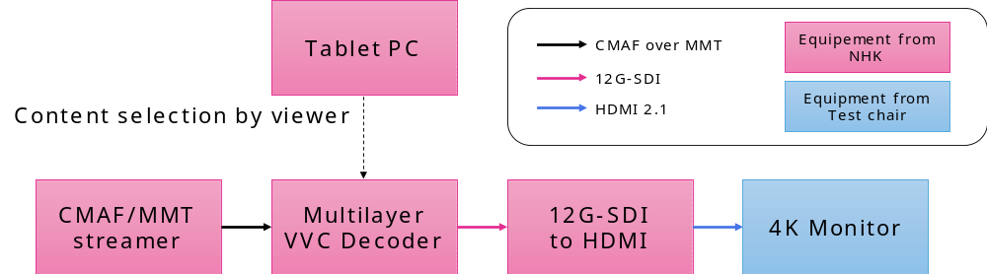
Figure 1. Equipment for the functional test

Table 1. Specifications of multilayer VVC decoder
Profile | Main 10, Multilayer Main 10
Level | 6.3
Number of supported layers | 3 layers
Input Format | CMAF (ISO/IEC 23000-19) on MMT (ISO/IEC 23008-1)
Output Format | Resolution: 1080p, 2160p, 4320p  Frame rate [Hz]: 59.94, 60, 119.88, 120

Sequences
Spatial resolution of the test sequences used in the functional test is 4K, 60Hz. In the test, L-shape sub-content, Picture-in-Picture style sub-content, and transparent overlaying sub-content are validated. Thumbnail and brief explanation is listed in the table below.

Base layer  (Maiko performs traditional Japanese dance) | 
Enhancement layer  (Main content is scaled down and L-shape sub-content is placed in the margin, where sign-language-like content is overlaid)  [Note: The animated character of the sub-content might be replaced later to a camera-captured sign language speaker.] | 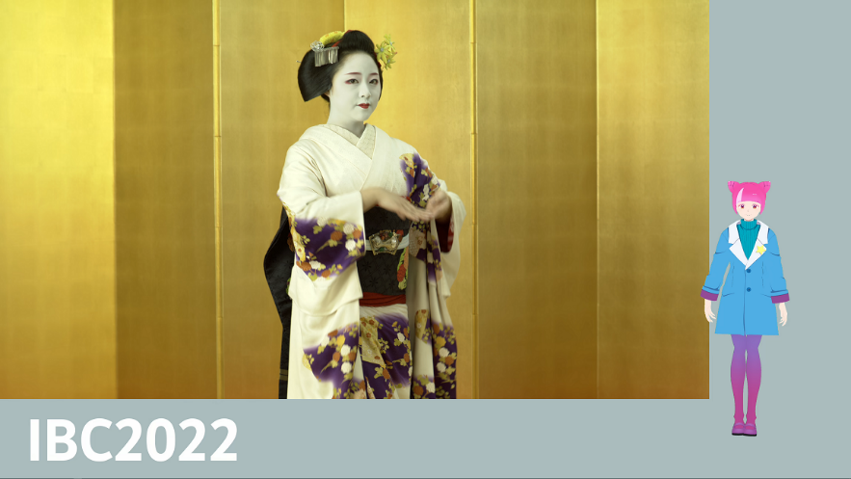

Base layer  (Race horse) | 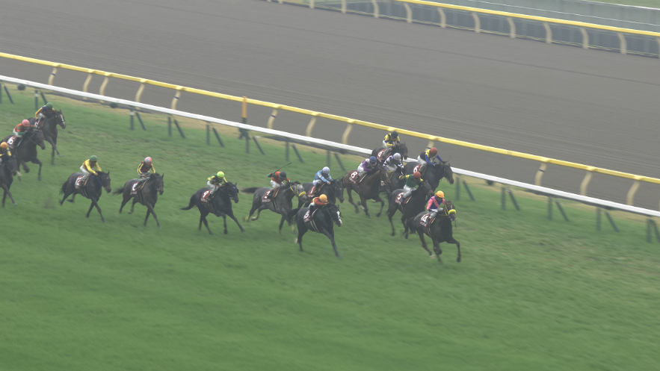
Enhancement layer  (Paddock scene is overlaid on top of main content in picture-in-picture style) | 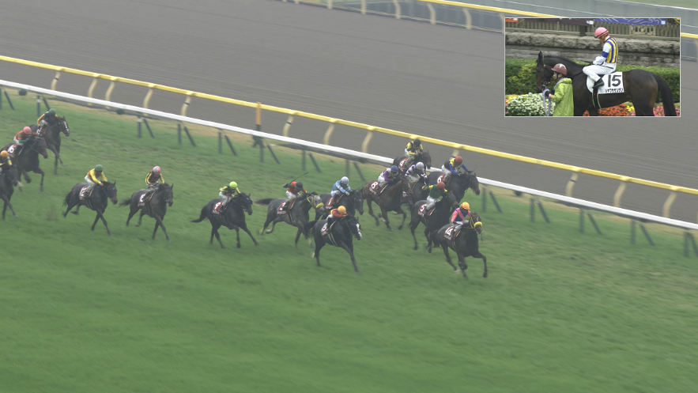

Base layer  (Japanese Festival) | 
Enhancement layer  (Transparent caption is overlaid on top of main content) | 

Coding conditions

Bitstreams
Bitstreams are coded using VTM-18.0, where main content is coded as base layer and sub-content is coded as enhancement layer. For L-shape sub-content, modification for supporting scaling window functionality is added on top of VTM-18.0 [1].

Encoding parameters
Random access configurations are applied, where intra period and GOP size are set equal to 64 and 32, respectively. Rate control is enabled, where 10Mbps for main content and 1Mbps for sub-content are allocated.

Patent rights declaration(s)
NHK may have current or pending patent rights relating to the technology described in this contribution and, conditioned on reciprocity, is prepared to grant licenses under reasonable and non-discriminatory terms as necessary for implementation of the resulting ITU-T Recommendation | ISO/IEC International Standard (per box 2 of the ITU-T/ITU-R/ISO/IEC patent statement and licensing declaration form).

Reference
[1] S. Iwamura, S. Nemoto, A. Ichigaya, “Additional conformance tests of scaling window functionality for multilayer coding,” JVET-AD0101, Apr., 2023.

