    Joint Video Experts Team (JVET)  of ITU-T SG 16 WP 3 and ISO/IEC JTC 1/SC 29  30th Meeting, Antalya, TR, 21–28 April 2023 | Document: JVET-AD0100-v1

Title: | AHG12: Block vector guided CCCM
Status: | Input document to JVET
Purpose: | Proposal
Author(s) or  Contact(s): | Ramin G. Youvalari  Döne Bugdayci Sansli  Pekka Astola  Jani Lainema | Tel:  Email: | ramin.ghaznavi-youvalari@nokia.com  done.bugdayci_sansli@nokia.com  pekka.astola@nokia.com  jani.lainema@nokia.com
Source: | Nokia
_____________________________

Abstract
This contribution proposes a new convolutional cross-component model which uses block vector of the co-located IBC or intraTMP coded luma block to identify the reference area for deriving the CCCM model. The proposed block vector guided CCCM (BVG-CCCM) method uses the same 7-tap filter design of the CCCM method and the co-located luma block’s samples for prediction. The mode is signalled with a context coded flag which is conditioned on co-located luma block’s mode. The impact on coding efficiency and runtimes over ECM-8.0 is reportedly {for Y, U, V, EncT, DecT}:
CTC classes: AI { -0.xx%, -0.xx%, -0.xx%, 10x%, 10x%}, RA { -0.xx%, -0.xx%, -0.xx%, 10x%, 10x%}
Class F: AI { -0.04%, -0.48%, -0.56%, 103%, 100%}, RA { -0.xx%, -0.xx%, -0.xx%, 10x%, 10x%}
Class TGM: AI { -0.63%, -1.18%, -1.01%, 101%, 100%}, RA { -0.xx%, -0.xx%, -0.xx%, 10x%, 10x%}

Introduction
Convolutional cross-component model (CCCM) [1] predicts chroma samples from reconstructed luma samples using a 7-tap filter. Similarly to CCLM, there is an option of using a single model or multi-model variant of CCCM. The multi-model variant uses two models, one model derived for samples above the average luma reference value and another model for the rest of the samples (following the spirit of the CCLM design). Multi-model CCCM mode can be selected for PUs which have at least 128 reference samples available.
The CCCM filter consist of a 5-tap plus sign shape spatial component, a nonlinear term and a bias term. The input to the spatial 5-tap component of the filter consists of a center (C) luma sample which is collocated with the chroma sample to be predicted and its above/north (N), below/south (S), left/west (W) and right/east (E) neighbors as illustrated below.
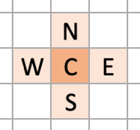
Figure 1: Spatial part of the convolutional filter
The nonlinear term P is represented as power of two of the center luma sample C and scaled to the sample value range of the content:
P = ( C*C + midVal ) >> bitDepth
The bias term B represents a scalar offset between the input and output (similarly to the offset term in CCLM) and is set to middle chroma value (512 for 10-bit content).
Output of the filter is calculated as a convolution between the filter coefficients c_{i} and the input values and clipped to the range of valid chroma samples:
predChromaVal = c₀C + c₁N + c₂S + c₃E + c₄W + c₅P + c₆B
Gradient and location based CCCM (GL-CCCM)
GL-CCCM method [1] uses gradient and location information instead of the 4 spatial neighbor samples in the CCCM filter. The GL-CCCM filter for the prediction is:
predChromaVal = c₀C + c₁G_{y} + c₂G_{x} + c₃Y + c₄X + c₅P + c₆B
Where G_{y} and G_{x} are the vertical and horizontal gradients, respectively, and are calculated as:
G_{y} = (2N + NW + NE) – (2S + SW + SE)
G_{x} = (2W + NW + SW) – (2E + NE + SE)
Moreover, the Y and X parameters are the vertical and horizontal locations of the center luma sample.
The rest of the parameters are the same as CCCM tool. The reference area for the parameter calculation is the same as CCCM method.
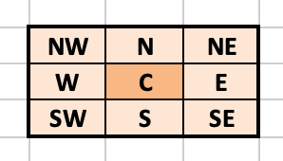
Figure 2: Spatial samples used for GL-CCCM

Proposed Method
In this contribution, block vector guided CCCM (BVG-CCCM) method is proposed for improving the coding efficiency of ECM. The BVG-CCCM method uses block vector of the co-located luma block, coded in IBC or intraTMP mode, to determine the reference area for calculating the CCCM parameters. Then the reference area in luma and corresponding area in chroma channel is used to calculate the CCCM parameters. The prediction uses the calculated model parameters and co-located luma samples to do the CCCM prediction. Figure 3 illustrates the reference area in BVG-CCCM method.

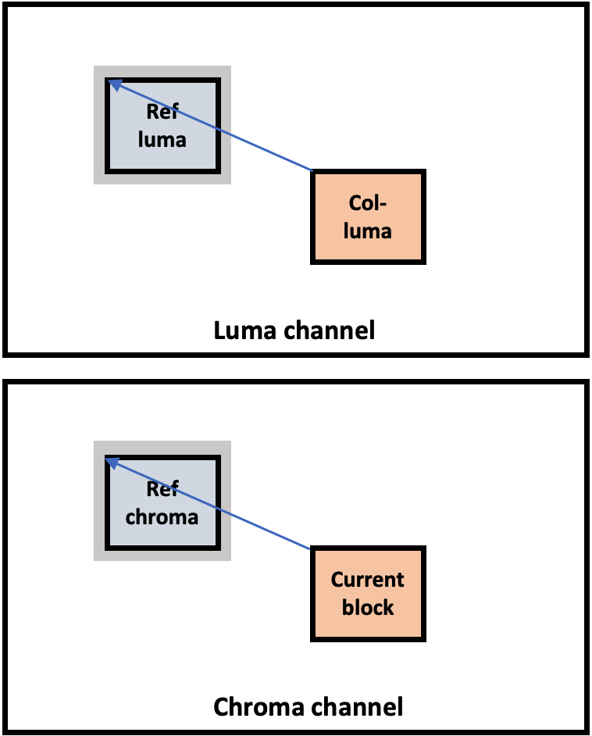
Figure 3: Illustrates reference area for BVG-CCCM

Similar to Direct Block Vector (DBV) mode in ECM-8.0, five locations, as shown in Figure 4, in collocated luma block area are scanned for determining the block vector to be used in BVG-CCCM method.
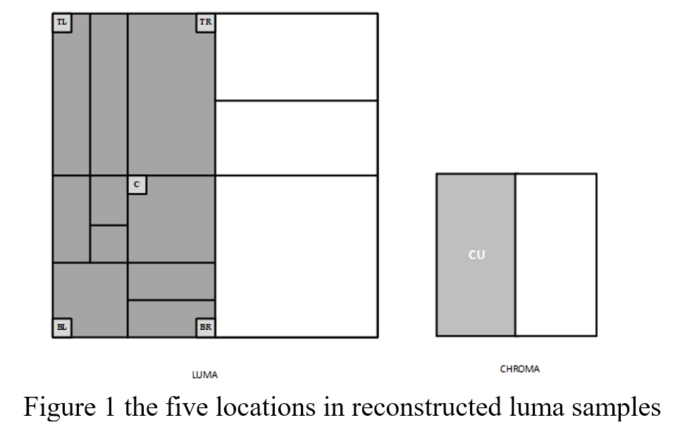
Figure 4: Locations used for block vector derivation from co-located luma block.

Bitstream Signalling
Usage of the mode is signalled with a CABAC coded PU level flag. The BVG-CCCM flag is signalled if co-located block is coded in IBC or intraTMP modes and the cross-component index is LM_CHROMA_IDX or MMLM_CHROMA_IDX.

Encoder Operation
The encoder performs two additional RD for the BVG-CCCM for single-model and multi-model CCCM variants:

Simulation Results
Tables below summarize the coding efficiency and runtime impact of the proposed method in ECM-8.0 [2] using the JVET common test conditions [3].

 | All Intra Main10
 |  |  | Over ECM-8.0
 | Y | U | V | EncT | DecT
Class A1 | 0.00 % | -0.05 % | 0.05 % | 101 % | #NUM!
Class A2 | #VALUE! | #VALUE! | #VALUE! | #NUM! | #NUM!
Class B | #VALUE! | #VALUE! | #VALUE! | #NUM! | #NUM!
Class C | 0.00 % | 0.00 % | -0.12 % | 100 % | #NUM!
Class E | 0.00 % | -0.07 % | -0.03 % | 100 % | #NUM!
Overall | #VALUE! | #VALUE! | #VALUE! | #NUM! | #NUM!
Class D | 0.00 % | -0.16 % | -0.04 % | 99 % | #NUM!
Class F | -0.04 % | -0.48 % | -0.56 % | 103 % | #NUM!
Class TGM | -0.63 % | -1.18 % | -1.01 % | 101 % | #NUM!

 | Random Access Main10
 |  |  | Over ECM-8.0
 | Y | U | V | EncT | DecT
Class A1 | #VALUE! | #VALUE! | #VALUE!
Class A2 | #VALUE! | #VALUE! | #VALUE!
Class B | #VALUE! | #VALUE! | #VALUE!
Class C | #VALUE! | #VALUE! | #VALUE!
Class E | #VALUE! | #VALUE! | #VALUE!
Overall | #VALUE! | #VALUE! | #VALUE!
Class D | #VALUE! | #VALUE! | #VALUE!
Class F | #VALUE! | #VALUE! | #VALUE!
Class TGM | #VALUE! | #VALUE! | #VALUE!

Conclusion
This contribution proposes block vector guided CCCM method to further improve the coding efficiency of intra coding in ECM-8.0. The experiments showed that the method provides 0.04% in Y, 0.48% in Cb% and 0.56% in Cr coding gains for class F, and 0.63% in Y, 1.18% in Cb and 1.01% in Cr coding gains in class TGM using AI configuration over ECM-8.0. It is suggested to study the proposed method in the next EE round.

References
- Coban et.al, “Algorithm description of Enhanced Compression Model 8 (ECM 8)”, JVET-AC2025, Jan. 2023.
- ECM-8.0 reference software, https://vcgit.hhi.fraunhofer.de/ecm/ECM.git
- M. Karczewicz, Y. Ye, “Common Test Conditions and evaluation procedures for enhanced compression tool testing”, JVET-Y2017, Jan. 2022.

Patent rights declaration(s)
Nokia may have current or pending patent rights relating to the technology described in this contribution and conditioned on reciprocity, is prepared to grant licenses under reasonable and non-discriminatory terms as necessary for implementation of the resulting ITU-T Recommendation | ISO/IEC International Standard (per box 2 of the ITU-T/ITU-R/ISO/IEC patent statement and licensing declaration form).

