    Joint Video Experts Team (JVET)  of ITU-T SG 16 WP 3 and ISO/IEC JTC 1/SC 29  30th Meeting, Antalya, TR, 21–28 April 2023 | Document: JVET-AD0099-v1

Title: | EE2-1.15b: Filtered Template Matching based Intra Prediction
Status: | Input document to JVET
Purpose: | Proposal
Author(s) or  Contact(s): | Ramin G. Youvalari  Döne Bugdayci Sansli  Pekka Astola  Jani Lainema | Tel:  Email: | ramin.ghaznavi-youvalari@nokia.com  done.bugdayci_sansli@nokia.com  pekka.astola@nokia.com  jani.lainema@nokia.com
Source: | Nokia
_____________________________

Abstract
This contribution reports results for EE2 Test 1.15b which was proposed in JVET-AC0146. The method in this test proposes to apply a 6-tap filter on the template-matching based intra prediction (intraTMP) mode to improve the prediction performance. The filter input consists of 5 spatial luma samples and a bias term. Filter coefficients are derived via regression based MSE minimization on reconstructed samples over the template areas of the current and reference blocks. A list of four best performing candidates from intraTMP search is created. The filter parameters are calculated for each candidate in the list and the best performing one in terms of template cost after filtering is selected and used as the final candidate. The mode is signaled with a flag conditioned on intraTMP flag. The impact on coding efficiency and runtimes over ECM-8.0 is reportedly {for Y, U, V, EncT, DecT}:
AI { -0.16%, -0.19%, -0.19%, 10x%, 100%}, RA { -0.xx%, -0.xx%, -0.xx%, 100%, 100%}

Introduction
Intra template matching prediction (IntraTMP) copies a reference block from the reconstructed part of the current frame, whose L-shaped template matches the current template [1] . For a predefined search range, the encoder searches for the most similar template to the current template in a reconstructed part of the current frame and uses the corresponding block as a prediction block. The encoder then signals the usage of this mode, and the same prediction operation is performed at the decoder side. Sum of absolute differences (SAD) is used as the cost function during the search, and the mode is signaled at CU level through a dedicated flag when DIMD is not used for current CU.

Proposed Method
The Filtered intraTMP (FTMP) method, in JVET-AC0146 [2], proposed to apply a filter on the intra template matching based prediction block to increase prediction accuracy and adapt the characteristics of the copied block to the local neighbourhood. Reconstructed luma samples over the template area of the reference block are used as inputs to the filter during training and corresponding luma sample in the template of the current block is the target. Parameters are derived using the regression based MSE minimization technique (i.e., gaussian solver) existing in ECM and being utilized by other tools such as CCCM.
The proposed 6-tap filter takes spatial samples from the reconstructed reference block and uses middle value of the operating bit depth (e.g., 512 for 10-bit content) for bias. The formula for each new prediction sample is as follows:
predVal = c₀C + c₁N + c₂S + c₃W + c₄E + c₅b
The input to the spatial 5-tap component of the filter consists of a center (C) luma sample and its above/north (N), below/south (S), left/west (W) and right/east (E) neighbors as illustrated in Figure 1.
Template size and shapes are same as in intraTMP, the template size used for training is 4 lines above and to the left of the current block depending on their availability. Moreover, the search range for FTMP is also the same as intra TMP method.
Figure 1 illustrates the filter shape and training area where the green parts are the boundary region. Reconstructed samples in the boundary region are used in training when available and they are padded with closest available sample when unavailable.
The mode is signaled at CU level with a dedicated flag combined with the intraTMP flag. The FTMP flag is inferred to be zero if intraTMP flag is 0.

Mode to be signaled | Intra TMP flag | FTMP flag
Intra Template Matching | 1 | 0
Filtered Template Matching | 1 | 1

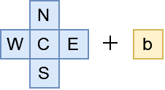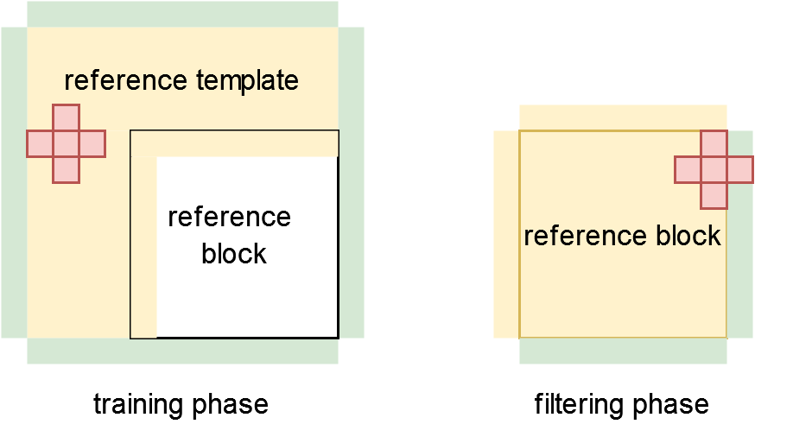
Figure 1. Filter shape and training area of the reference block.
The proposed method uses the current intraTMP’s SAD based search in ECM-8.0 for creating a list of four candidate reference blocks to be filtered. Entry to the candidate list is based on SAD cost of the unfiltered template.
The filter parameters are calculated for each candidate in the list and the best performing one in terms of template cost after filtering is selected and used as the final candidate. The final prediction of the block is then generated by applying the derived filter for the best candidate.

Simulation Results
Tables below summarize the coding efficiency and runtime impact of the proposed method in ECM-8.0 [3] using the JVET common test conditions [4].

 | All Intra Main10
 |  |  | Over ECM-8.0
 | Y | U | V | EncT | DecT
Class A1 | -0.01 % | -0.03 % | -0.07 %
Class A2 | -0.23 % | -0.27 % | -0.25 %
Class B | -0.19 % | -0.23 % | -0.19 %
Class C | -0.05 % | -0.09 % | -0.16 %
Class E | -0.31 % | -0.36 % | -0.27 %
Overall | -0.16 % | -0.19 % | -0.19 %
Class D | -0.02 % | -0.29 % | -0.16 %
Class F | -0.04 % | -0.20 % | -0.19 %
Class TGM | -0.15 % | -0.05 % | -0.12 %

 | Random Access Main10
 |  |  | Over ECM-8.0
 | Y | U | V | EncT | DecT
Class A1 | #VALUE! | #VALUE! | #VALUE!
Class A2 | #VALUE! | #VALUE! | #VALUE!
Class B | -0.10 % | -0.12 % | -0.11 %
Class C | -0.04 % | -0.02 % | 0.09 %
Class E
Overall | #VALUE! | #VALUE! | #VALUE!
Class D | 0.01 % | 0.05 % | -0.19 %
Class F | -0.06 % | -0.44 % | -0.23 %
Class TGM | -0.05 % | -0.10 % | -0.03 %

Conclusion
This contribution reports results of EE2 Test 1.15b where a 6-tap filter is proposed to be applied to intraTMP mode to further improve the coding efficiency of intra coding in ECM-8.0. The experiments showed that the proposed method provides 0.16%, 0.19% and 0.19% coding gains, for Y, Cb and Cr components, in all intra configuration and xx%, xx% and xx% coding gains for Y, Cb and Cr components in random access configuration over ECM-8.0. It is suggested to adopt the proposed method in ECM-9.0.

References
- Coban et.al, “Algorithm description of Enhanced Compression Model 8 (ECM 8)”, JVET-AC2025, Jan. 2023.
- R. G. Youvalari, D. Bugdayci Sansli, P. Astola, J. Lainema, “AHG12: Filtered Template Matching based Intra Prediction (FTMP),” JVET-AC0146, Jan. 2023.
- ECM-8.0 reference software, https://vcgit.hhi.fraunhofer.de/ecm/ECM.git
- M. Karczewicz, Y. Ye, “Common Test Conditions and evaluation procedures for enhanced compression tool testing”, JVET-Y2017, Jan. 2022.

Patent rights declaration(s)
Nokia may have current or pending patent rights relating to the technology described in this contribution and conditioned on reciprocity, is prepared to grant licenses under reasonable and non-discriminatory terms as necessary for implementation of the resulting ITU-T Recommendation | ISO/IEC International Standard (per box 2 of the ITU-T/ITU-R/ISO/IEC patent statement and licensing declaration form).

